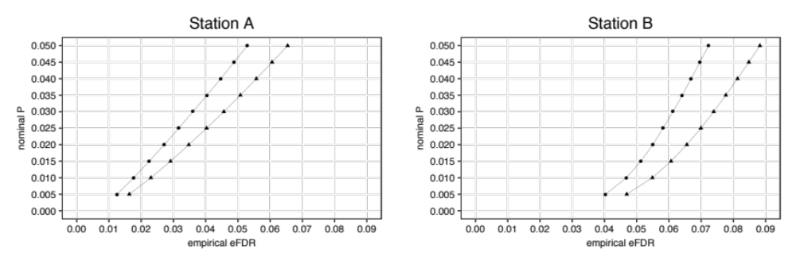
b
a

edgeR DESeq2

Figure S1. Correspondence between nominal P values and empirical FDR. (a) Comparison of gene expression levels between AI-pregnant, NB-pregnant in experimental station A. (b) Comparison of gene expression levels between AI-pregnant, non-pregnant in the experimental station B.

a
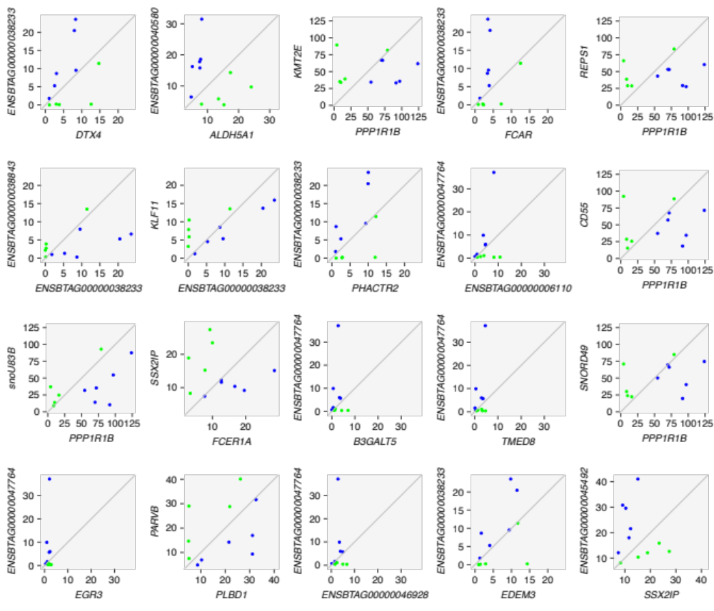
continue on next page…

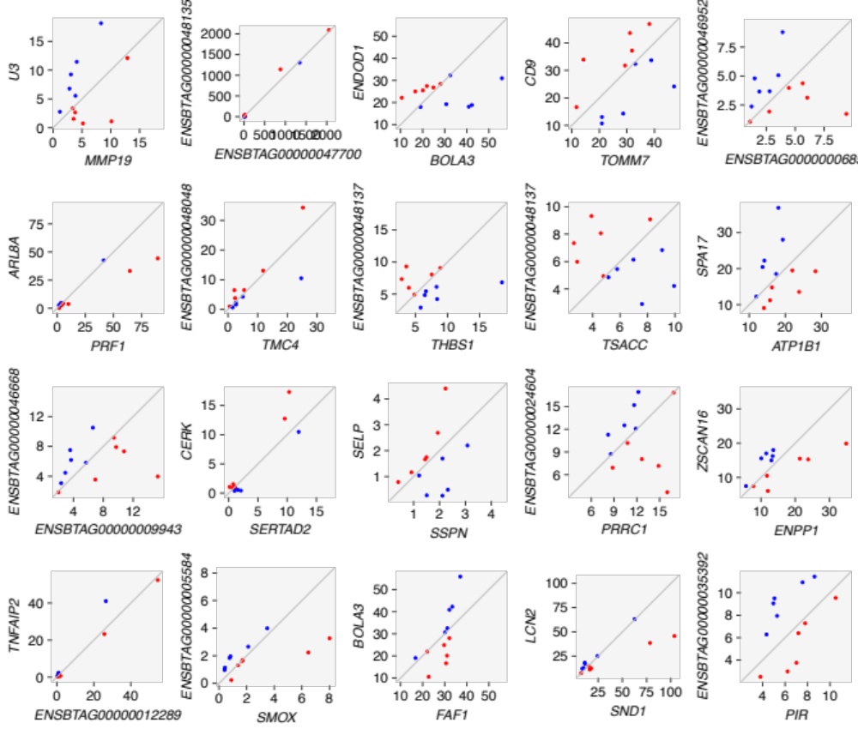
b

Figure S2. Scatterplots of expression levels (FPKM) of the top scoring pairs that distinguish heifers according to pregnancy outcome. Top 20 TSPs for Station A (a) and B (b).
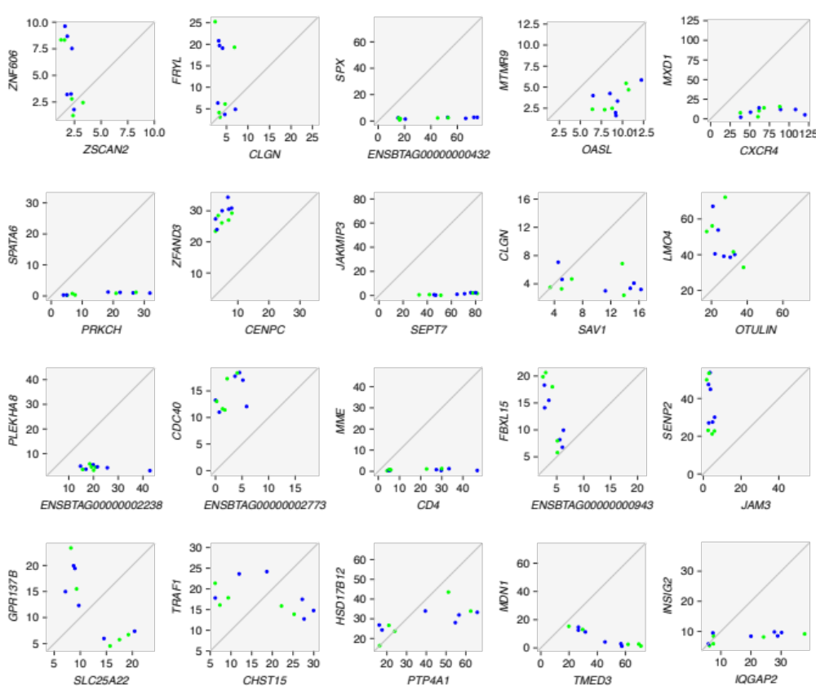

Figure S3. Scatterplots of expression levels (FPKM) of 20 randomly chosen pairs of genes expressed in heifers from station A that did not form top scoring pairs. The charts represent the null hypothesis for the TSP approach

Table S1. Descriptive statistics ($\overline{x}±\hat{σ})$ of the phenotypical data from the heifers used for the sequencing analysis.

Location | Parameter | Pregnant AI | Pregnant NB | P
A | N | 6 | 5 | -
 | Ageª | 412 $±$ 10 | 402 $±$ 11 | 0.36^{d}
 | WW^{b} | 234.6 $±$ 14.3 | 249.5 $±$ 21.2 | 0.14^{d}
 | Pelvic height^{c} | 15.3 $±$ 0.5 | 15.0 $±$ 0.7 | 0.39^{d}
 | Pelvic width^{c} | 11.3 $±$ 0.5 | 11.6 $±$ 1.5 | 1
 | Pelvic area^{c} | 173.8 $±$ 11.0 | 174.8 $±$ 31 | 0.8^{d}
 | BCS | 5.7 $±$ 0.5 | 5.8 $±$ 0.4 | 1e
 | RTS | 4.7 $±$0.5 | 4.2 $±$ 0.8 | 0.7e
Location | Parameter | Pregnant AI | Not Pregnant | P
B | N | 6 | 6 | -
 | Ageª | 428 $±$ 8 | 433 $±$ 10 | 0.4^{d}
 | WW^{b} | 325.8 $±$ 15.4 | 316.4 $±$ 15.4 | 0.5^{d}
 | BCS | 6 $±$ 0 | 6 $±$ 0 | -
 | RTS | 4.5 $±$ 0.5 | 4.2 $±$ 0.4 | 0.5e
BCS: body condition score; RTS: reproductive tract score; WW: weaning weight; ª day; ^{b} kg; ^{c} cm²; ^{d} Krustal-Wallis rank sum test; ^{e} Fisher’s exact test; - Statistical test is not applicable.

Table S2. Number of read-pairs generated and aligned uniquely to the Bos taurus reference genome UMD 3.1.

Sample | N pairs sequenced | N pairs aligned | Alignment (%)
SL220764 | 36,128,269 | 30,457,166 | 84.3
SL220765 | 36,260,080 | 29,334,579 | 80.9
SL220766 | 19,966,449 | 17,252,337 | 86.4
SL220767 | 22,775,841 | 18,158,658 | 79.7
SL220768 | 14,805,290 | 12,403,405 | 83.8
SL220769 | 45,845,646 | 39,345,350 | 85.8
SL220771 | 16,970,202 | 13,927,564 | 82.1
SL220772 | 18,827,465 | 14,700,579 | 78.1
SL220773 | 18,309,120 | 15,031,613 | 82.1
SL220774 | 21,112,166 | 17,454,399 | 82.7
SL220775 | 32,485,522 | 27,287,566 | 84.0
SL253803 | 27,341,041 | 24,446,159 | 89.4
SL253804 | 25,477,964 | 22,971,157 | 90.2
SL253805 | 15,799,927 | 14,684,897 | 92.9
SL253806 | 18,093,354 | 16,667,914 | 92.1
SL253807 | 24,358,249 | 22,330,930 | 91.7
SL253808 | 18,861,053 | 16,636,677 | 88.2
SL253809 | 18,352,301 | 16,562,097 | 90.2
SL253810 | 21,052,090 | 18,776,453 | 89.2
SL253811 | 41,238,769 | 36,636,894 | 88.8
SL253812 | 18,757,099 | 16,756,241 | 89.3
SL253813 | 24,846,720 | 22,760,158 | 91.6
SL253814 | 19,575,486 | 16,879,869 | 86.2
Average | 24,227,831 | 20,933,159 | 86.5

Table S3. Validation of RNA-sequencing results contrasting the gene expression in PWBC between heifers with different pregnancy outcome.

Symbol | RNA-seq |  | qPCR |  | mRNA | Oligonucleotides | Amplicon | x̅ PCR
 | FCª |  | FCª | P | Accession # |  | (bp^{b}) | Efficiency
GAPDH | * |  | - | - | NM_001034034.2 | TGGTGAAGGTCGGAGTGAAC | 91 | 1.9
 |  |  |  |  |  | ATGGCGACGATGTCCACTTT
Location A
ALDH5A1 | 1.23 |  | 2.50 | 0.04 | NM_001192735.1 | CCCCAGCAAAAGAAAGGCG | 99 | 1.9
 |  |  |  |  |  | CTTCCGTGTGATCATGGCACT
FCER1A | -1.15 |  | -1.74 | 0.02 | NM_001100310.2 | GTGGGCAGAATTCAGAGGCT | 88 | 1.9
 |  |  |  |  |  | GCCAGAAATAGTTGCTTTGAGGG
TTLL1 | 1.19 |  | 2.00 | 0.02 | NM_001076171.1 | AGAAGGACGAAAGCGGGAAG | 79 | 1.9
 |  |  |  |  |  | AACAGGTTGTAGTCGGCAGG
SIGLEC14 | -1.22 |  | -1.75 | 0.09 | XM_015458276.1 | TCCGGCTCAACGTCTCCTAT | 98 | 1.9
 |  |  |  |  |  | CTCCAGGATGGGCAGTGAC
Location B
TAC3 | 2.17 |  | 3.04 | 0.05 | NM_181017.2 | GCACCTTCAAGTACCCTCCA | 70 | 1.9
 |  |  |  |  |  | TCTTCACGATGTAGCCCAGG
LOC522763 | 1.92 |  | 8.77 | 0.10 | NM_001102069.1 | GCACCGAGCTCTTGACTGAT | 118 | 1.9
 |  |  |  |  |  | GTGAAGGCTGAAGCTCAGGA
ª FC: Fold change (pregnant NB/pregnant AI(Location A); non-pregnant/pregnant AI (Location B)), ^{b} bp: base pairs.
* GAPDH fold change in Station A: 0.7 and Station B: 0.9

Station A Station B
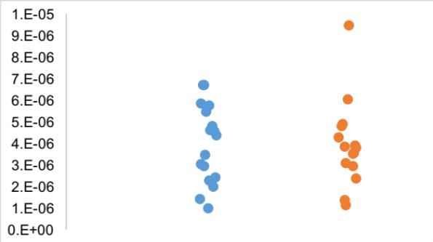
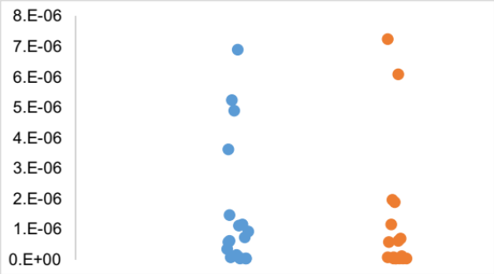
1.9^{-Ct}

Preg AI Preg NB Preg AI not Preg

Figure S4. Real time polymerase chain reaction data points for GAPDH transcripts. Please, see discussion in Livak and Schmittgen [1] and in Schmittgen and Livak [2] for the rationale on plotting the data as 1.9^{-Ct}.

Table S4. Averages of real time polymerase chain reaction data points (2^{-Ct}) for GAPDH transcripts and summary of statistical tests to compare the averages.

Station A | Preg AI | Preg NT | F | P_{(F test)} | t | P_{(t test)}
 | 1.5E-06 | 1.6E-06 | 0.5950 | 0.1471 | -0.0981 | 0.9224
Station B | Preg AI | not Preg | F | P_{(F test)} | t | P_{(t test)}
 | 3.9E-06 | 3.9E-06 | 0.8207 | 0.3492 | 0.0412 | 0.9674

1. Livak KJ, Schmittgen TD: Analysis of relative gene expression data using real-time quantitative PCR and the 2(T)(-Delta Delta C) method. Methods 2001, 25(4):402-408.
2. Schmittgen TD, Livak KJ: Analyzing real-time PCR data by the comparative C(T) method. Nat Protoc 2008, 3(6):1101-1108.

