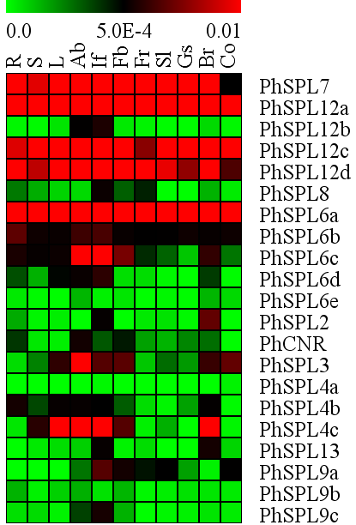
VIII
I
II
III
IV
V
VI
VII
0.00
0.01
5.0E-4
R S L Ab If Fb Fr Sl Gs Br Co
PhSPL7
PhSPL12a
PhSPL12b
PhSPL12c
PhSPL12d
PhSPL8
PhSPL6a
PhSPL6b
PhSPL6c
PhSPL6d
PhSPL6e
PhSPL2
PhCNR
PhSPL3
PhSPL4a
PhSPL4b
PhSPL4c
PhSPL13
PhSPL9a
PhSPL9b
PhSPL9c

