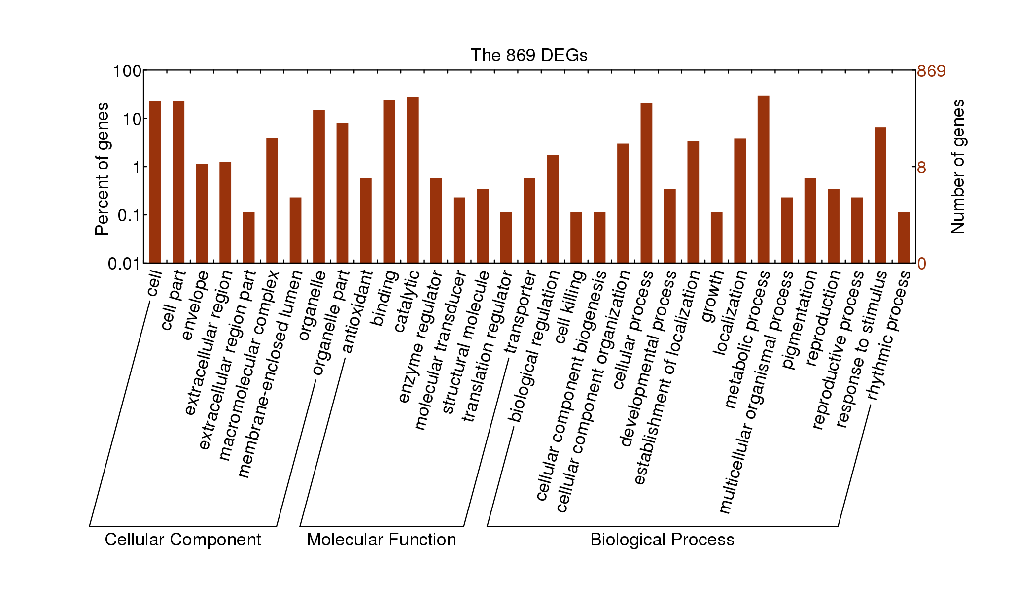
Additional file 9: Figure S3 GO categories assigned to the 869 DEGs. The left y-axis shows the percentages of proteins identified, and the right y-axis shows the protein number. The proteins were categorized according to the annotation of GO, and the number of each category is displayed based on biological process, cellular components, and molecular functions.

