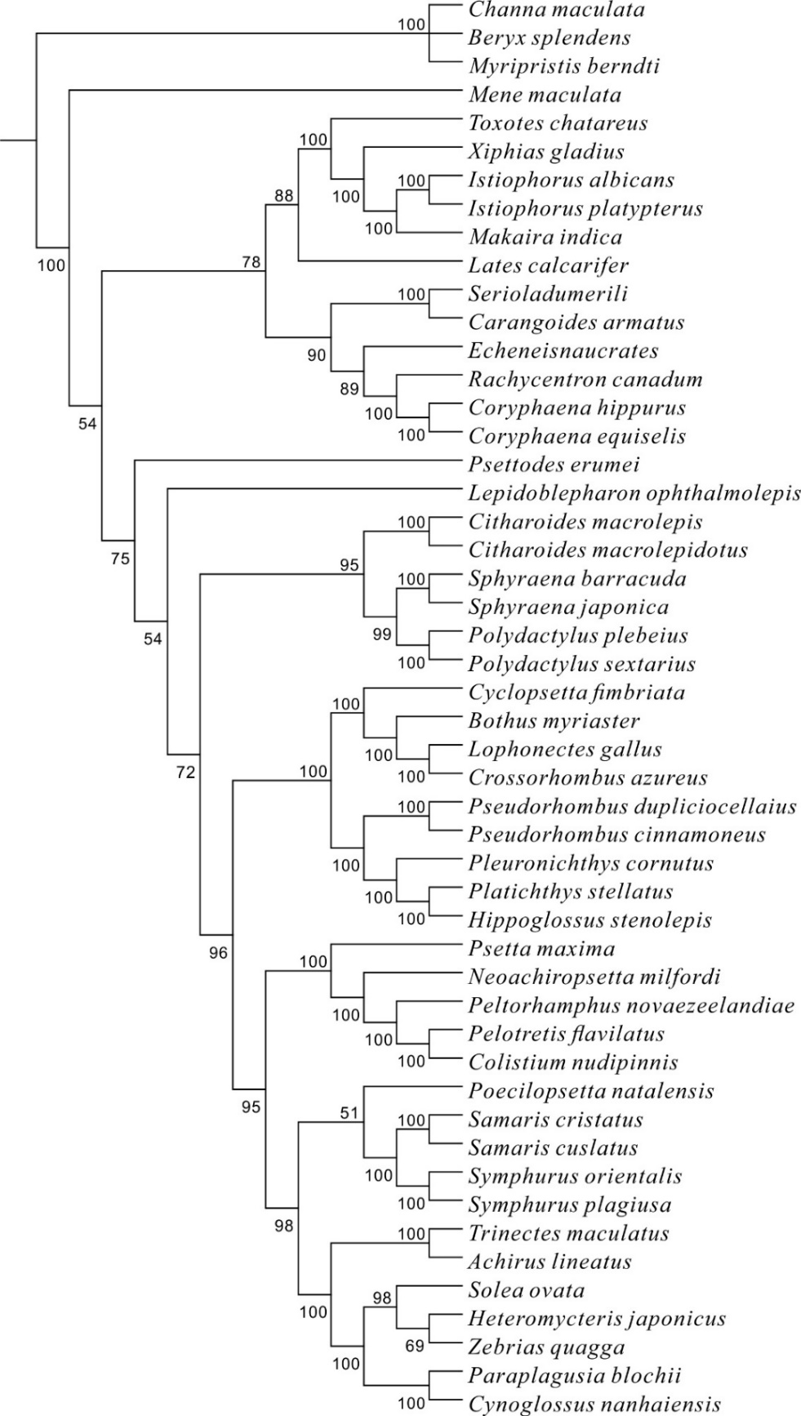
Figure.S1a
Relationships of Carangimorphariae yielded in the Bayesian analysis version 3.2 from the 50 taxa of dataset 1_{N}2_{N}. Numbers above or under the branches indicated Bayesian posterior probabilities (shown as percentages).
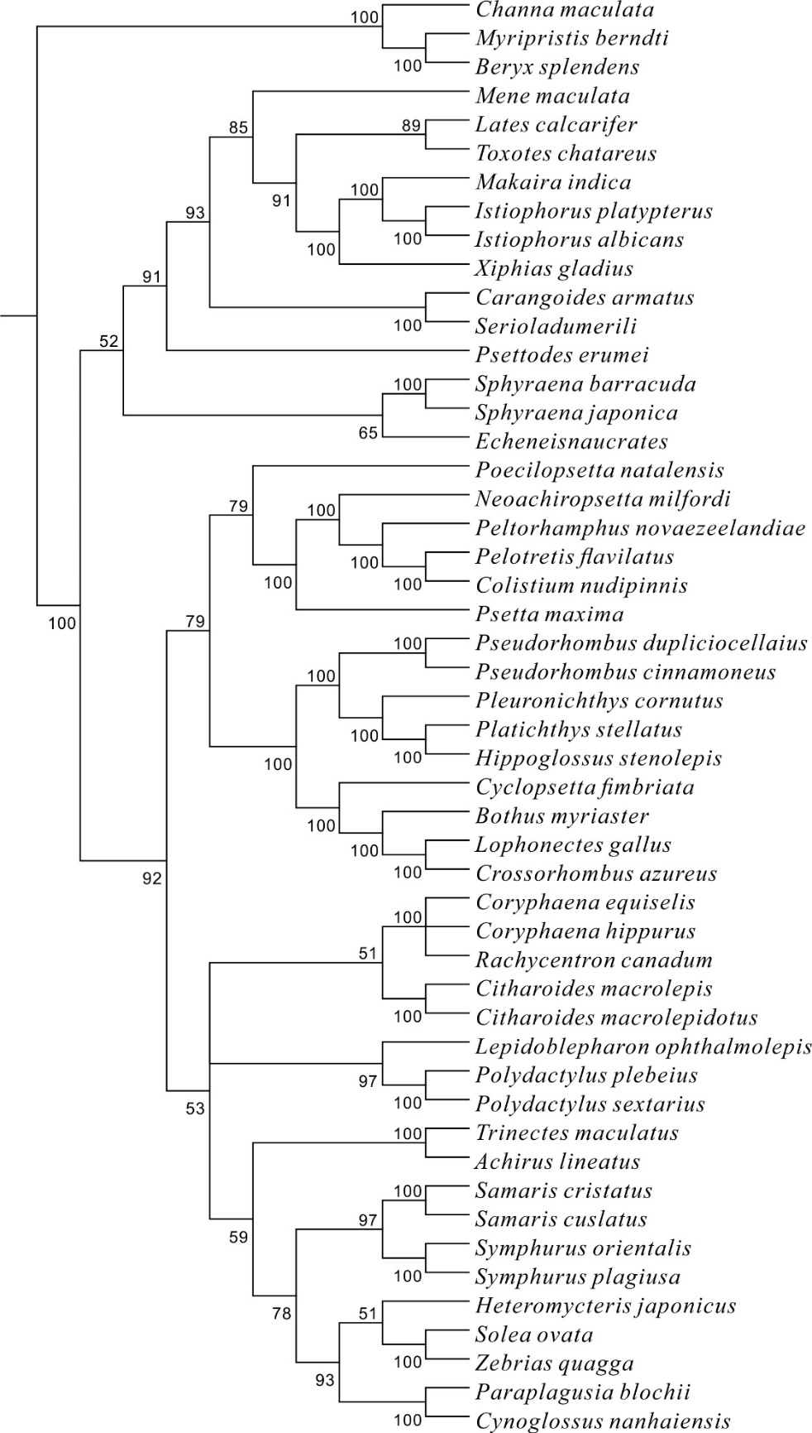
Figure.S1b
Relationships of Carangimorphariae yielded in the Bayesian analysis version 3.2 from 50 taxa of dataset 1_{N}2_{N}3_{RY}. Numbers above or under internal branches indicated Bayesian posterior probabilities (shown as percentages).

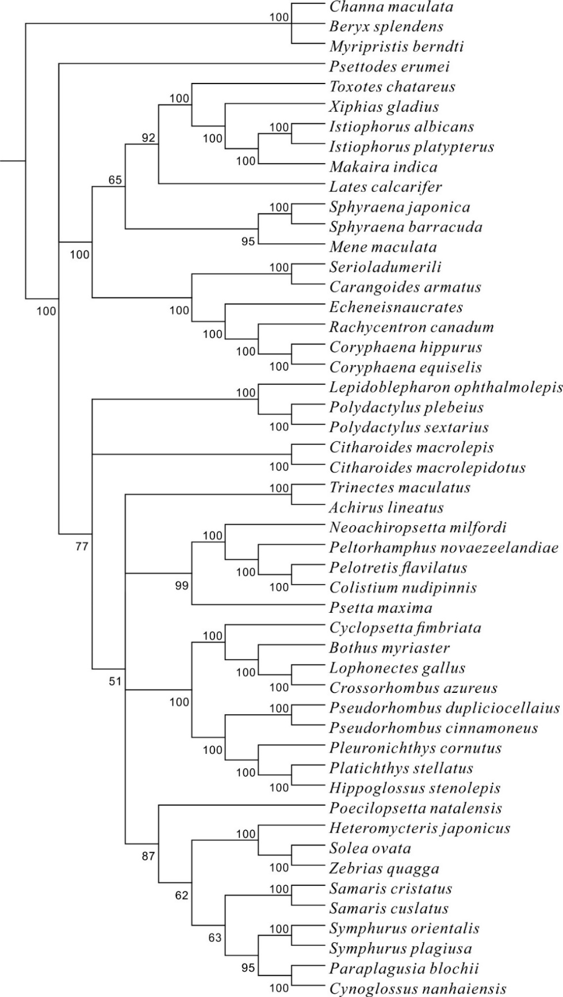
Figure.S1c
Relationships of Carangimorphariae yielded in the Bayesian analysis version 3.2 from the 50 taxa of dataset 1_{N}2_{N}RT. Numbers above or under internal branches indicated Bayesian posterior probabilities (shown as percentages).

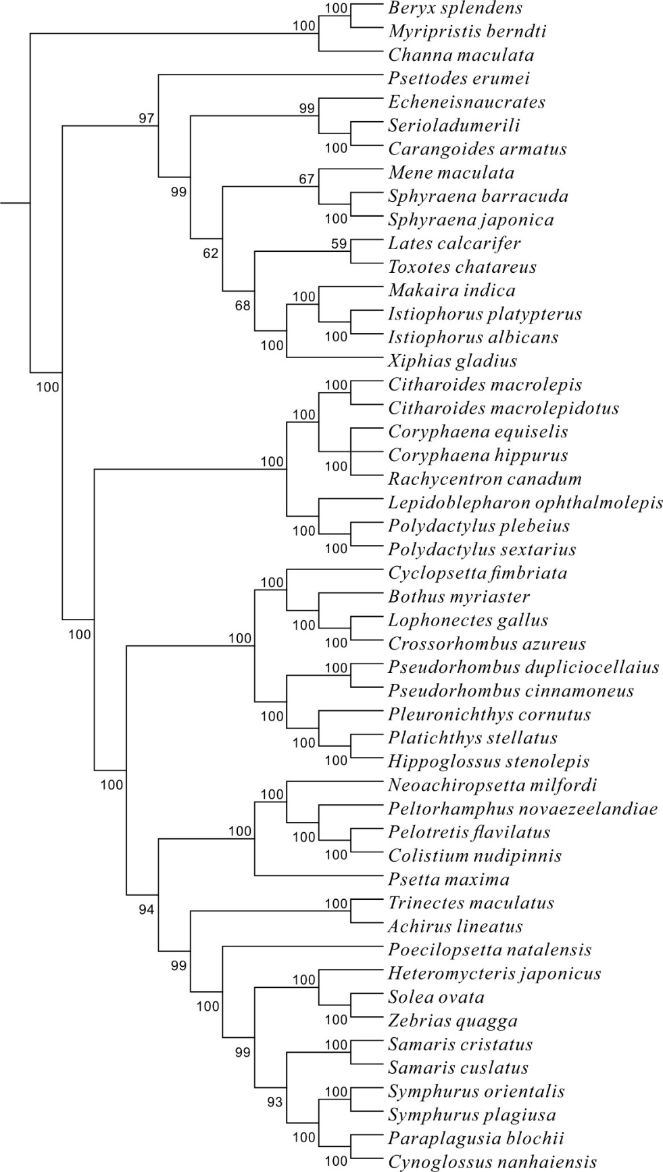
Figure.S1d
Relationships of Carangimorphariae yielded in the Bayesian analysis version 3.2 from 50 taxa of dataset 1_{N}2_{N}3_{RY}RT. Numbers above or under internal branches indicated Bayesian posterior probabilities (shown as percentages).
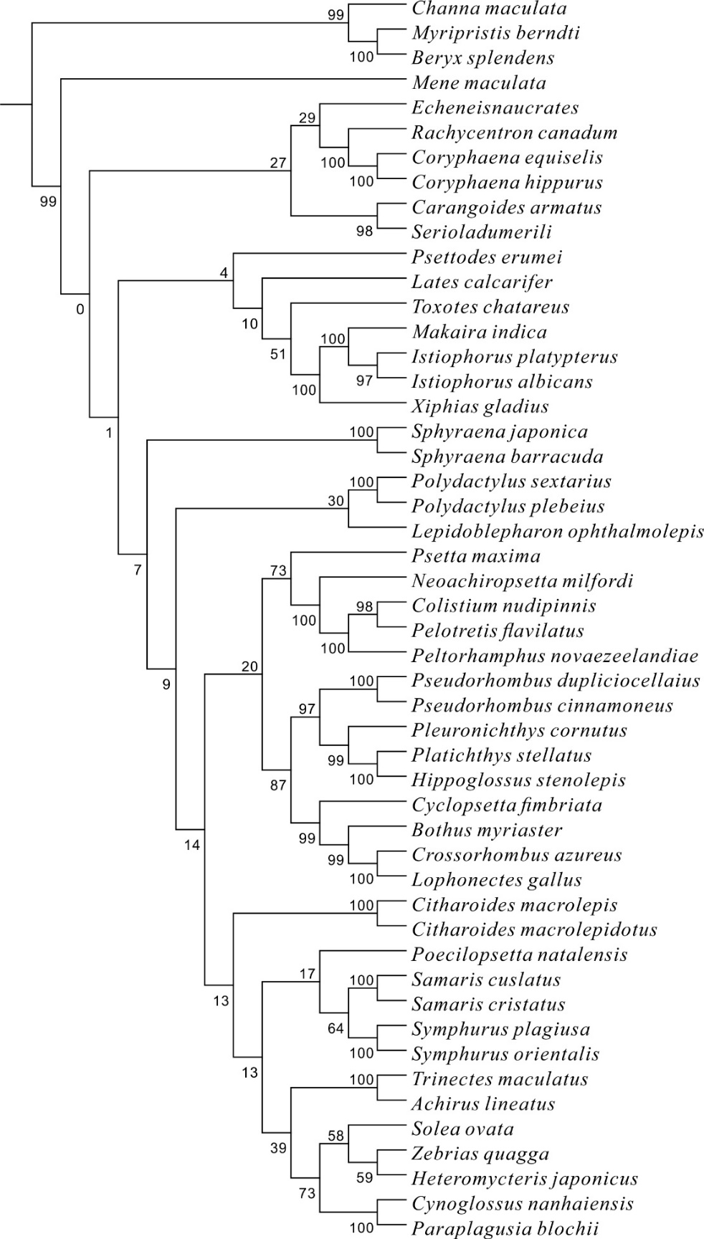
Figure.S1e
A maximum likelihood (ML) tree generated in RAxML version 8.0.0 under a GTR+Γ model of nucleotide evolution. The 50 taxa Mitogenomes were partitioned by codon position (1_{N}2_{N}).
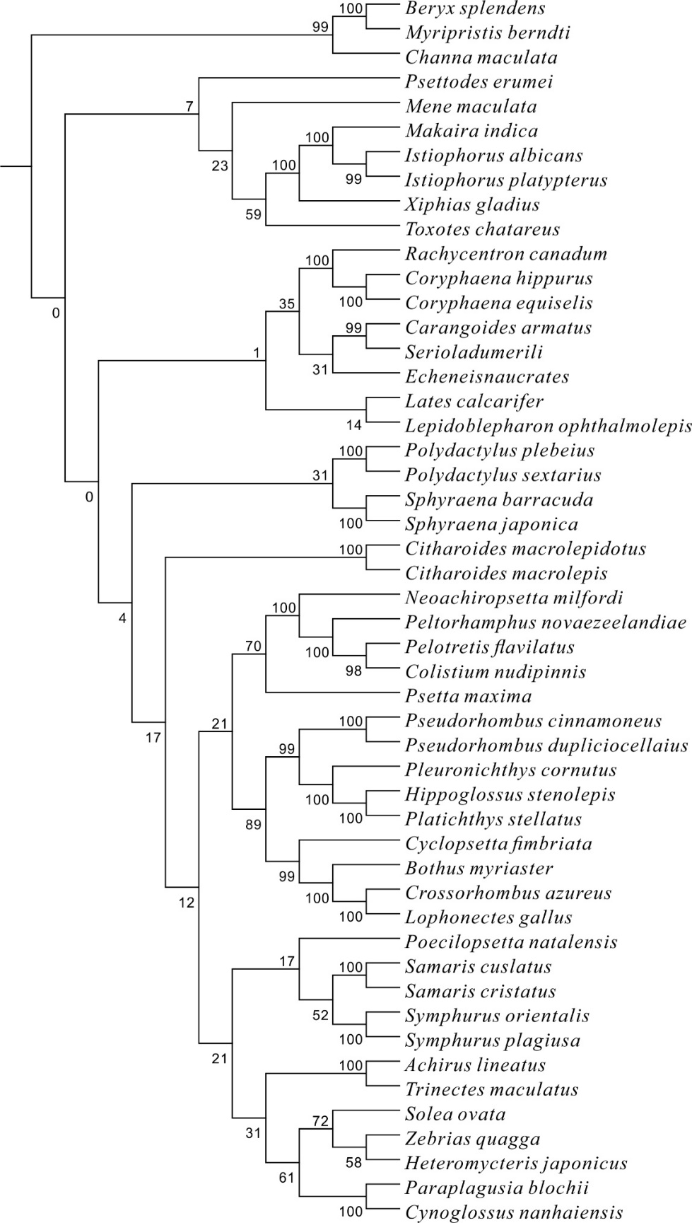
Figure.S1f
A maximum likelihood (ML) tree generated in RAxML version 8.0.0 under a GTR+Γ model of nucleotide evolution. The 50 taxa Mitogenomes were partitioned by codon position with third codons recoded (1_{N}2_{N}3_{RY}).

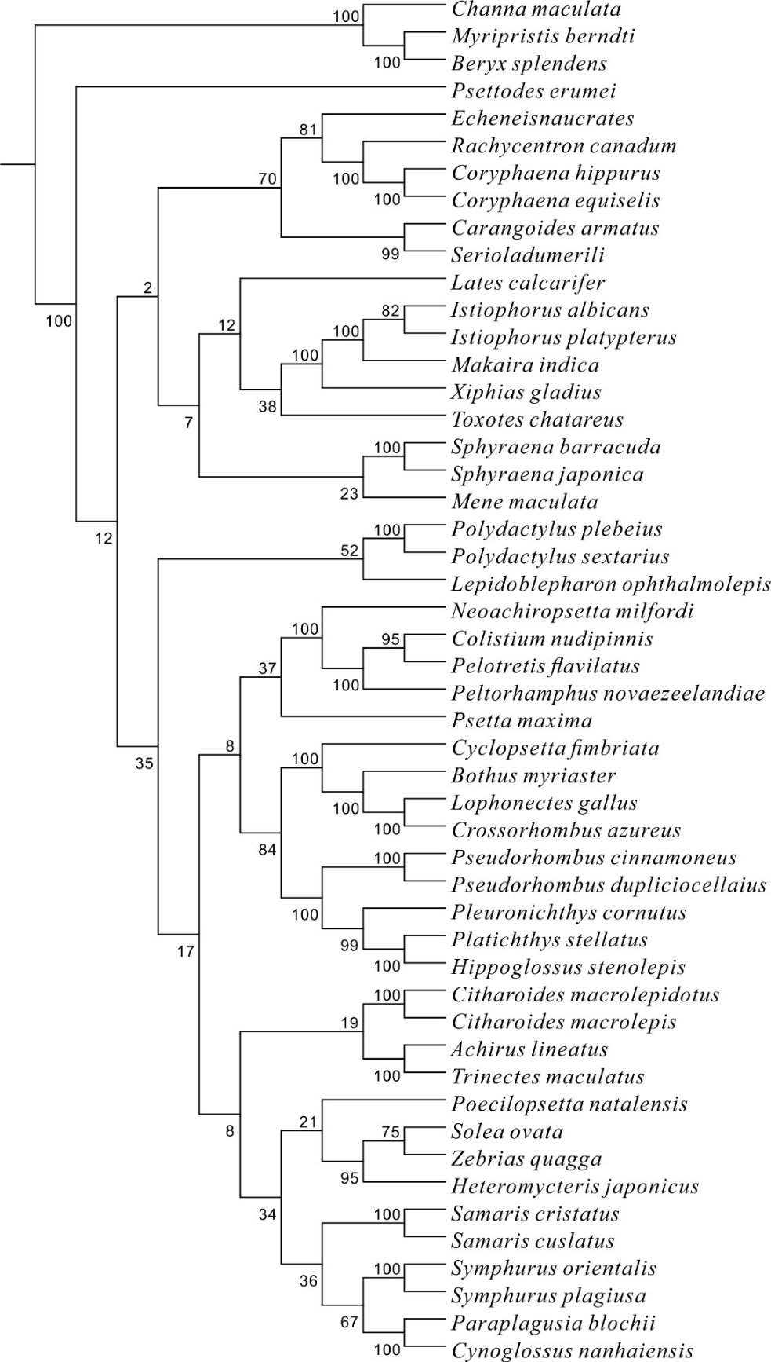
Figure.S1g
A maximum likelihood (ML) tree generated in RAxML version 8.0.0 under a GTR+Γ model of nucleotide evolution. The 50 taxa Mitogenomes were partitioned by codon position, rRNA, and tRNA (1_{N}2_{N}RT).

