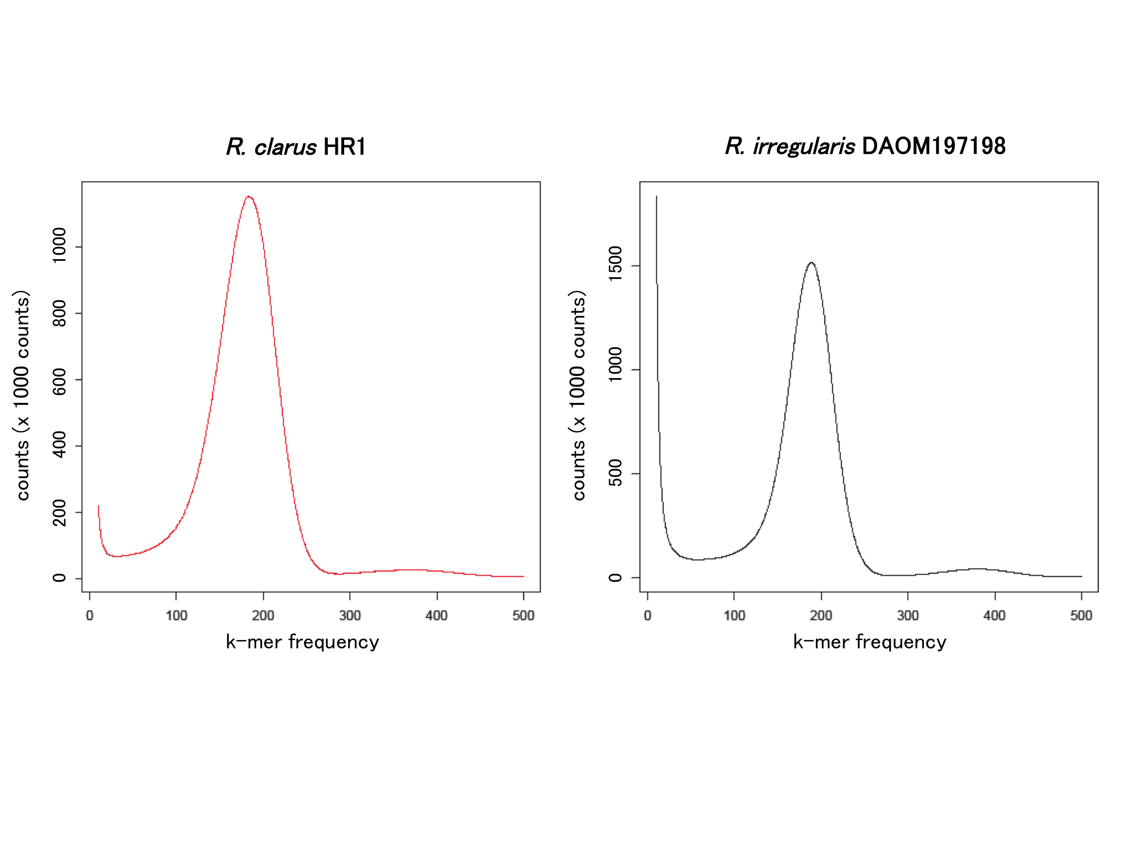
Figure S1 The k-mer (k=31) content of R. clarus (left panel) and R. irregularis (right panel) obtained from HiSeq short-reads analyzed with Jellyfish [65].
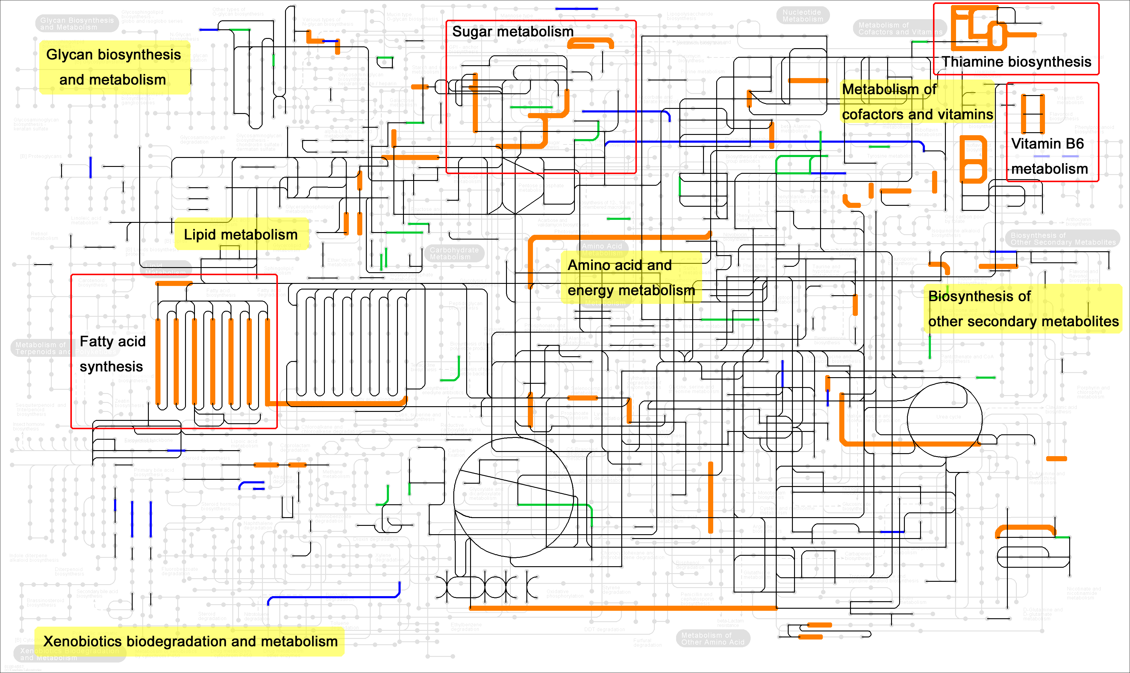
Figure S2 Common missing pathways in two Rhizophagus species. The thick orange lines indicate enzymatic pathways whose genes are absent in R. clarus and R. irregularis but present in Saccharomyces cerevisiae and Aspergillus oryzae. Black lines indicate enzymatic pathways whose genes are present in R. clarus and R. irregularis. Green and blue lines indicate enzymatic pathways whose genes are present in either R. clarus or R. irregularis, respectively.

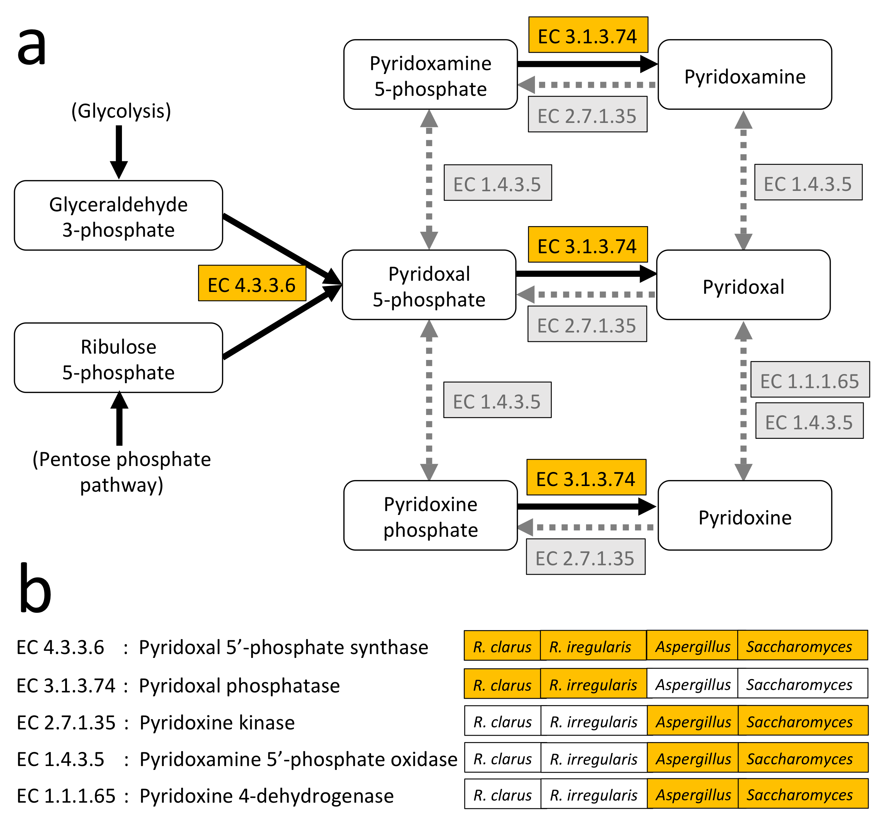
Figure S3 Pathways in vitamin B6 metabolism. a Metabolic pathway maps. KEGG numbers shown with an orange background indicate pathways for which encoding genes are present in AM species. b Distribution of deduced enzymes in four fungal species. If genes encoding the indicated enzyme are present in each species, the species name is shown with an orange background.

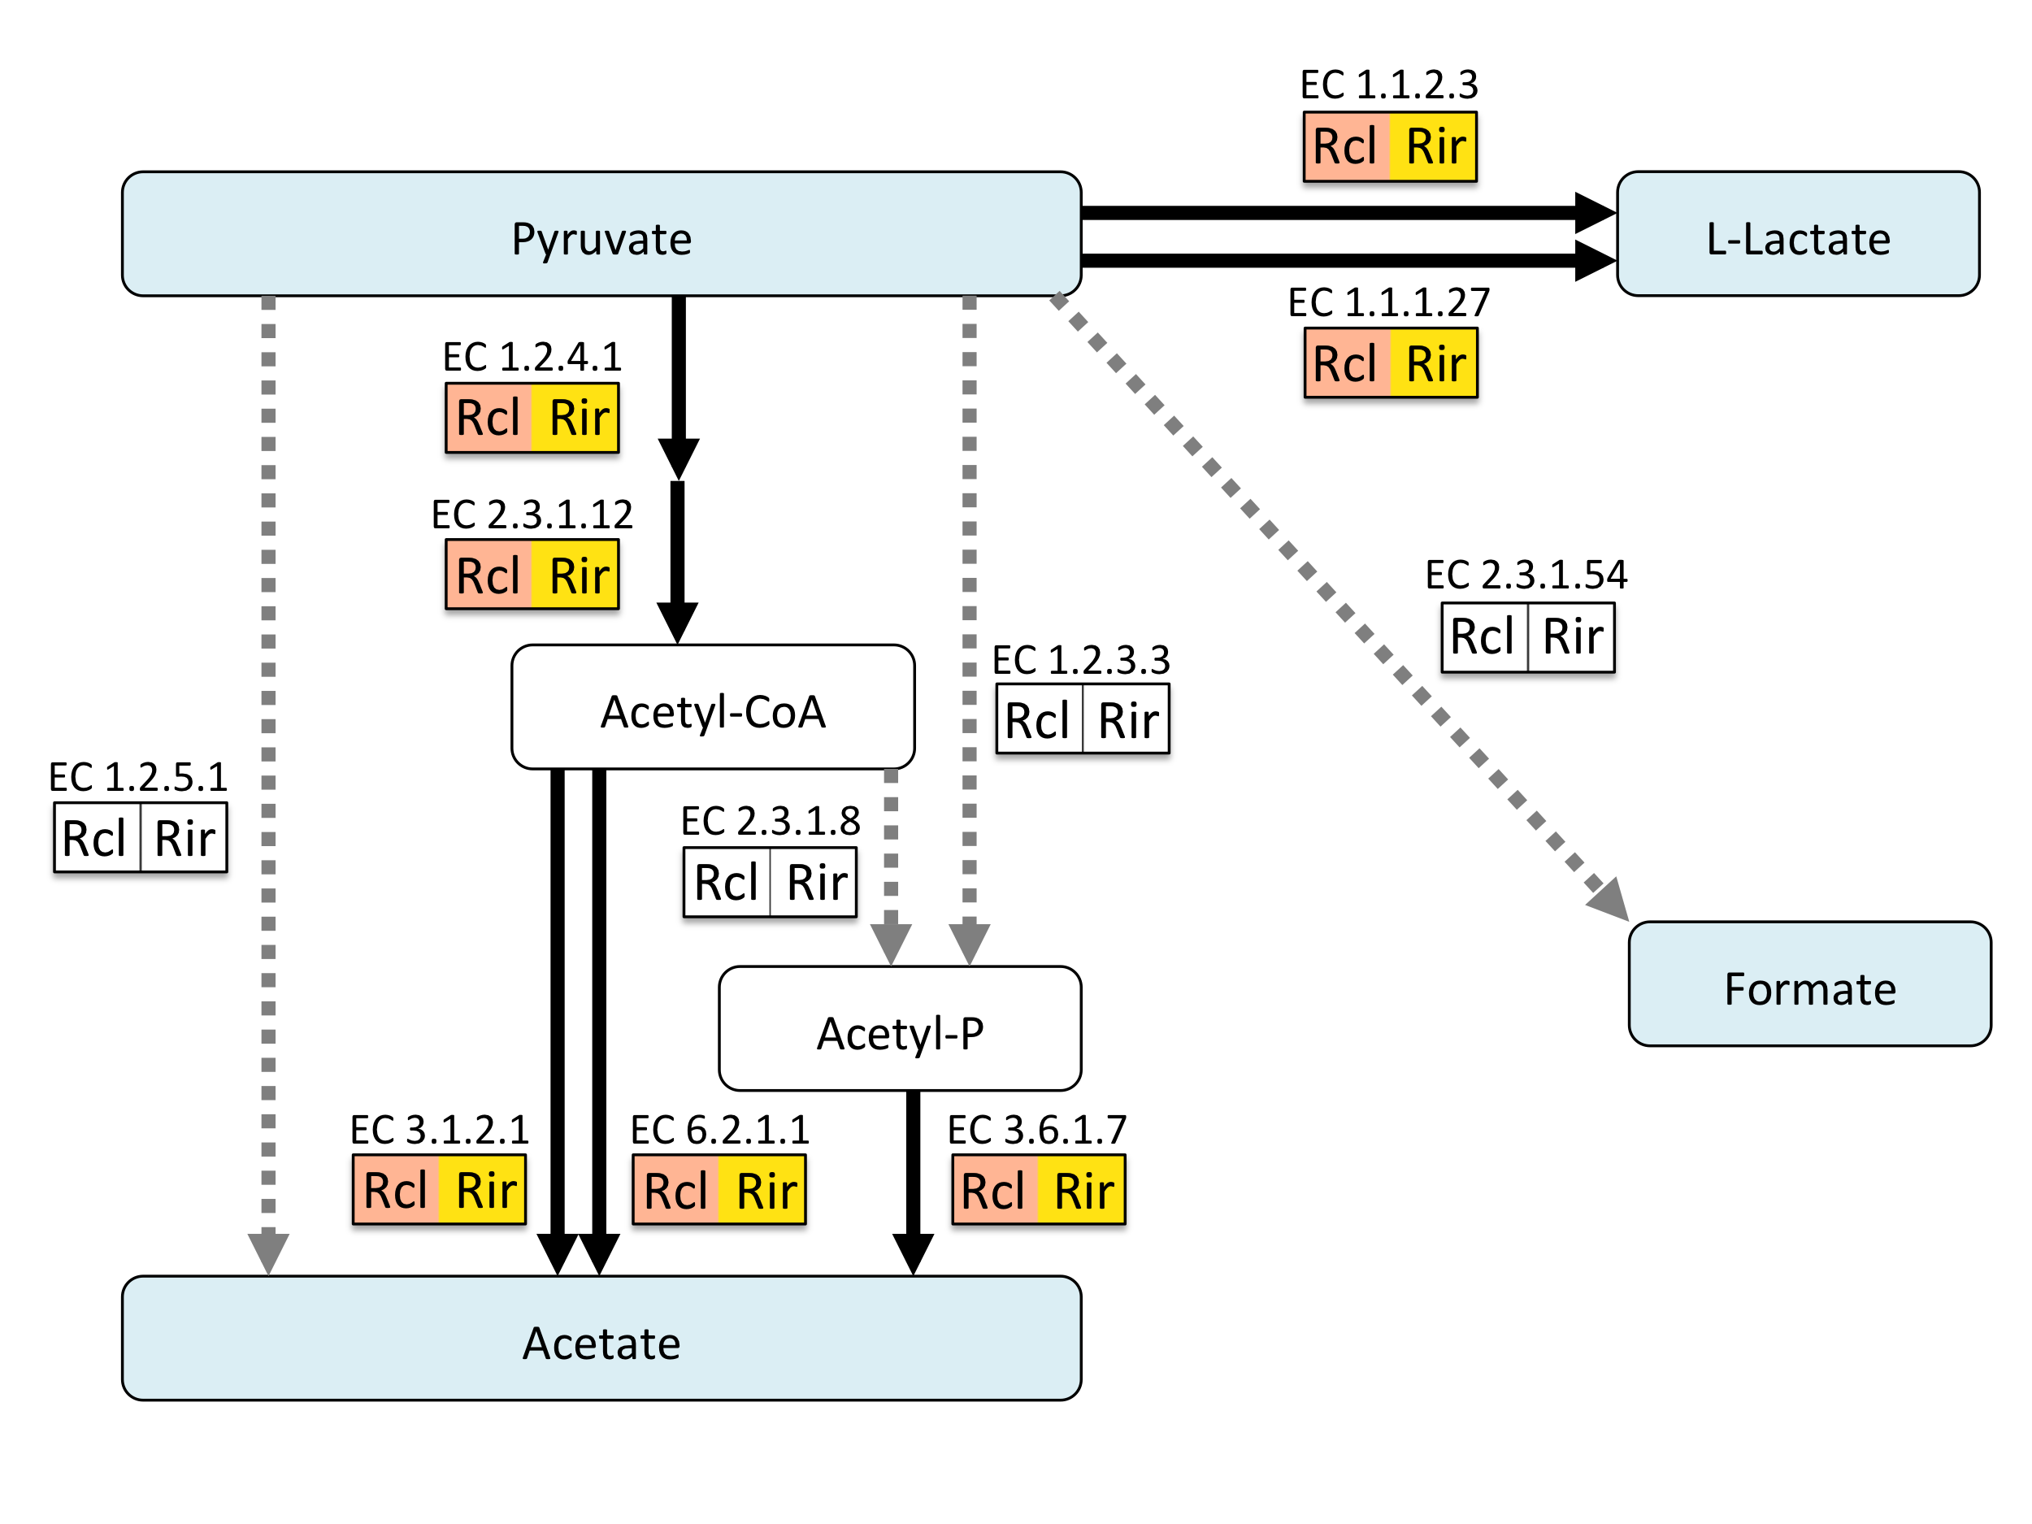
Figure S4 Fermentation pathways converting pyrvate into lactate, formate and acetate, which causes cytosolic acidification. The enzymes present in each AM fungus are colored.

