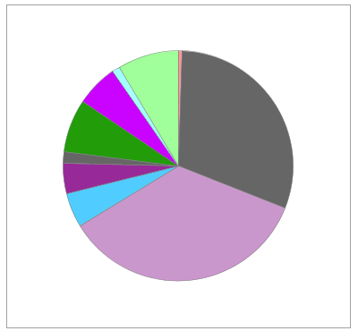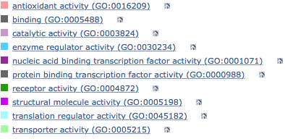
B
A
30,5%
7,5%
5,9%
8,6%
4,3%
4,8%
35,3%
1,6%
1,1%
0,5%
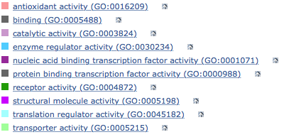
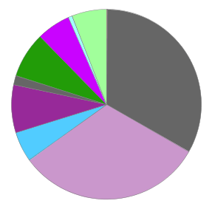
31,8%
5,8%
7,7%
8,2%
33,1%
5,2%
5,8%
1,6%
0,7%

C
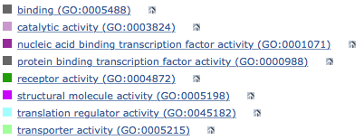
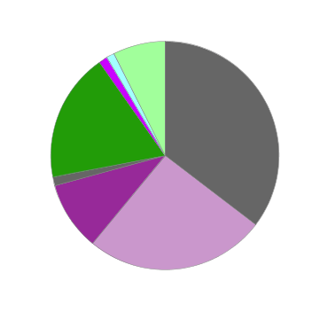
35,4%
1,2%
7,3%
18,3%
9.8%
25,6%
1,2%
1,2%
Additional file 12. Biological processes identified using the list of genes harbored within 2 Mb cis (A), trans (B) and hotspot (C) eQTL regions as the input gene list file. The values shown in the pie chart are the percentage of genes classified to each GO term over the total number of genes in the list used.

