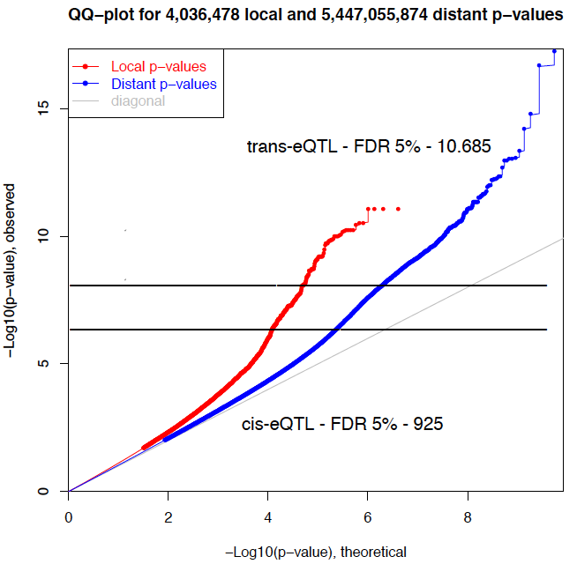

trans-eQTL (FDR 5%): 10,334
cis-eQTL (FDR 5%): 1,268

Additional file 2. QQ-plot of the distribution of p-values for cis-eQTLs (red line) and trans-eQTL (blue line) using mRNA sequencing and animal genotype data. The top horizontal grey line denotes a 5% false discovery rate significance threshold for trans-eQTLs and the bottom one for cis-eQTLs.

