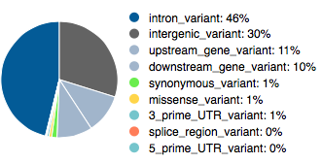
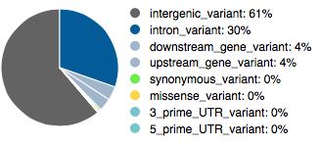
A
B

Additional file 4. Variant annotation by VEP tool for cis-eQTLs (A) and trans-eQTLs (B) identified across the whole Nellore genome.

