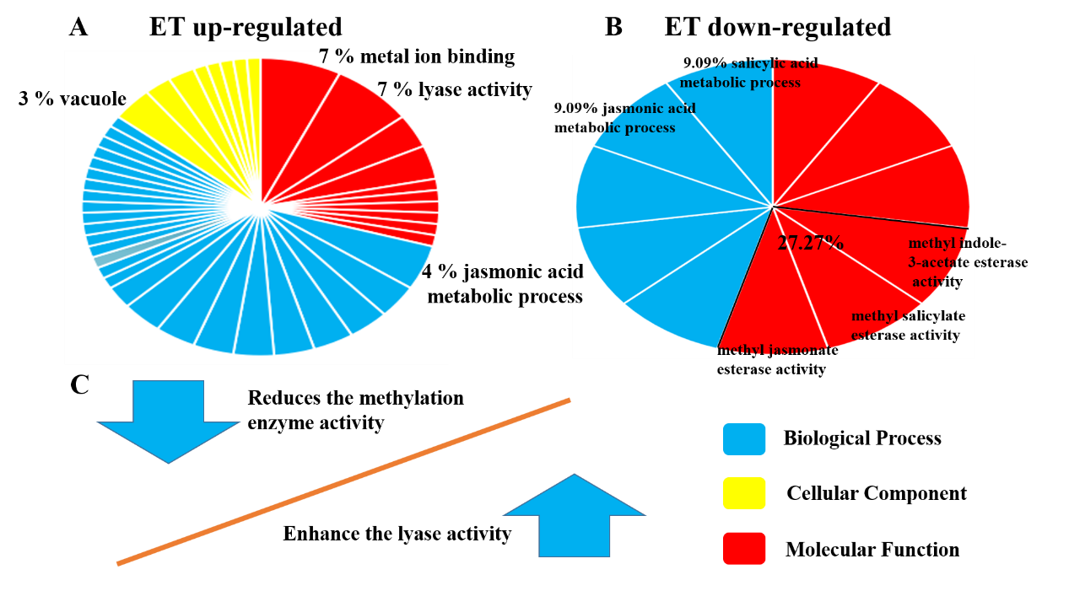
Additional file Figure S2 The effect of ET on metabolic pathway genes
The 197 metabolic pathway genes were further analysis by GO annotation. A. The 33 up-regulated genes in response to ET. B. The 35 down-regulated genes in response to ET. The red part denoted molecular function, the yellow part denoted cellular component, and the blue part denoted biological process. C. The effect of ET on enzyme activity.

