- Myo18b (partial genome DNA sequence)
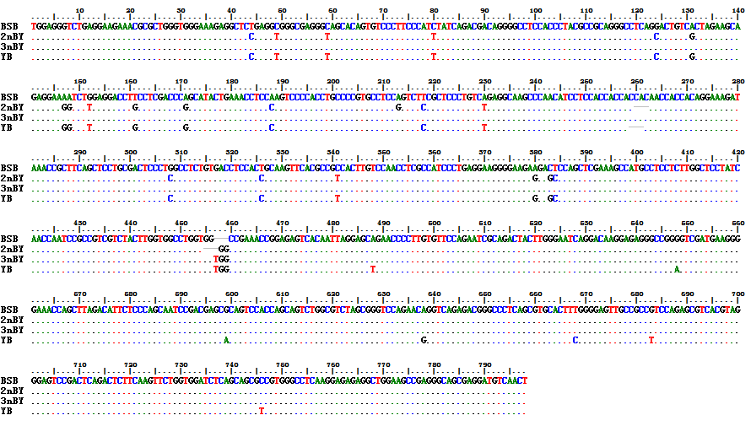

- tiss22 (partial genome DNA sequence)
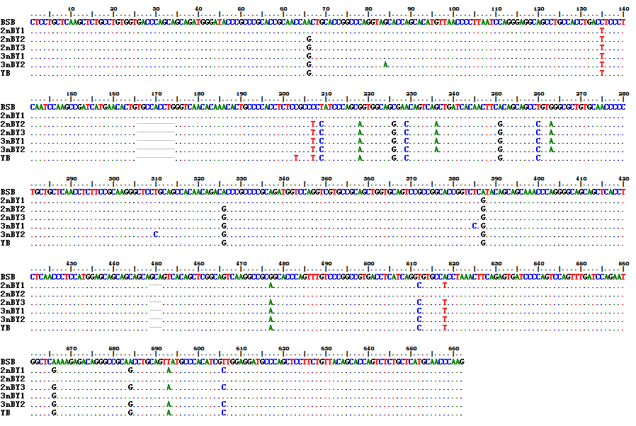

- Fitm (partial genome DNA sequence)
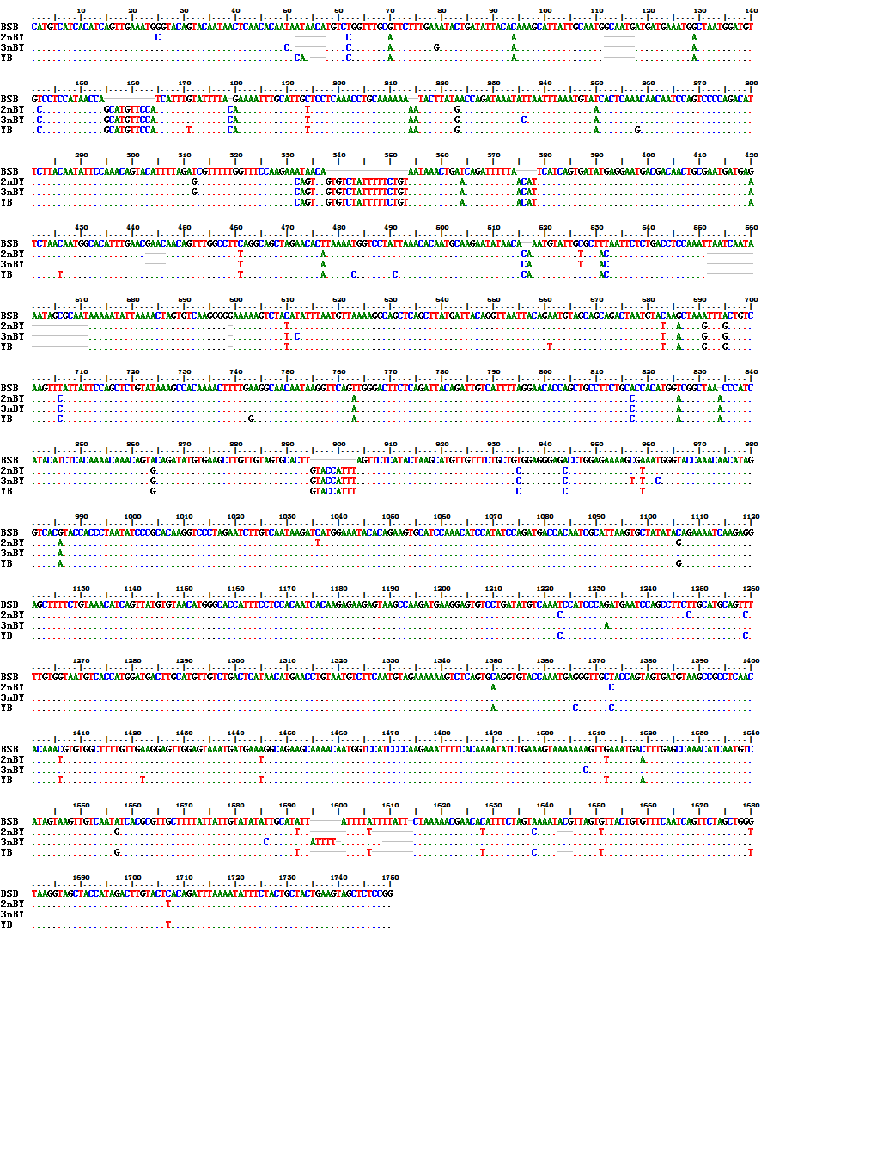

- Ptpn (partial genome DNA sequence)
