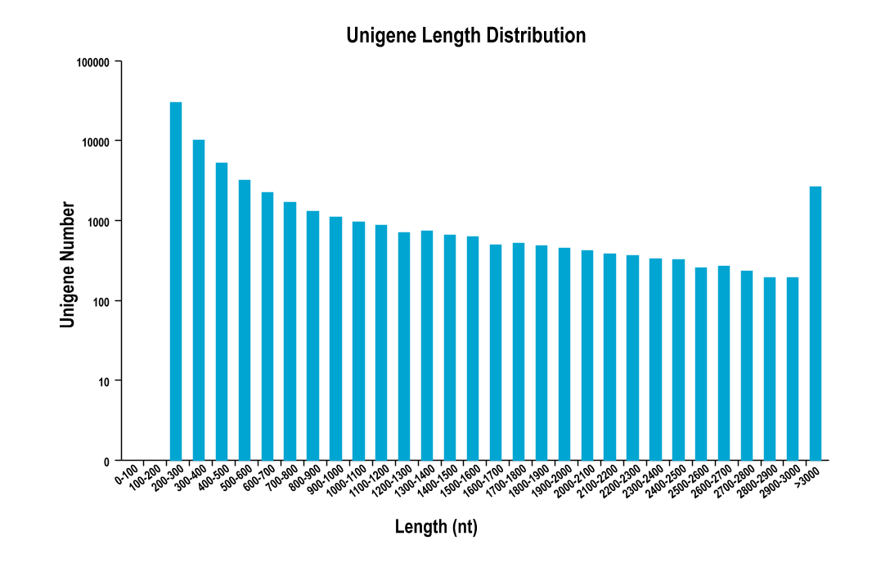
Figure. S1 The length distribution of the assembled unigenes in the C. sasakii antennal transcriptome
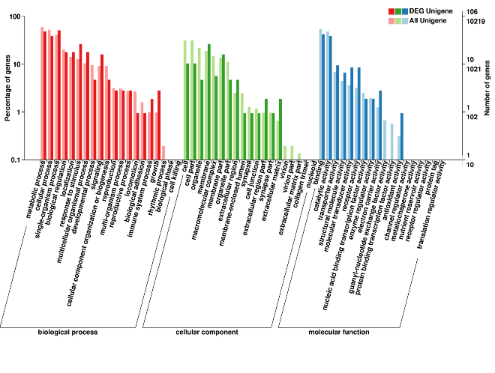
Figure. S2 Gene Ontology (GO) classifications of the differential unigenes and all of the unigenes in C. sasakii
According to the biological processes, the functional annotations were classified into three categories (molecular function, cellular component, and biological process). The light colors and the dark colors represent all unigenes and differentially expressed unigenes, respectively.

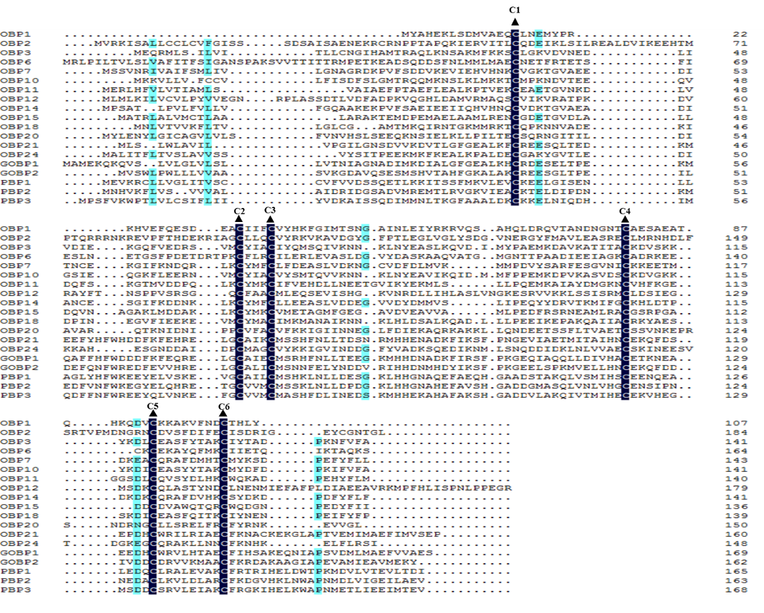
Figure S3. Alignment of candidate C.sasakii OBPs. The highly conserved cysteine residues are marked by dark triangle above.

