Additional file 2 – Gel electrophoresis of long RT-PCR amplicons used for In-Fusion and Topo XL-2 cloning.

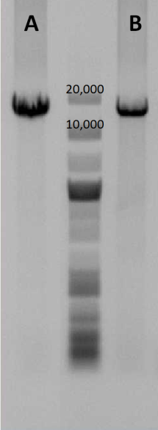
Full-genome amplification of CSFV RNA from serum sample by long RT-PCR and analyzed by agarose gel electrophoresis prior to In-Fusion (A) and TOPO-XL-2 (B) cloning.

