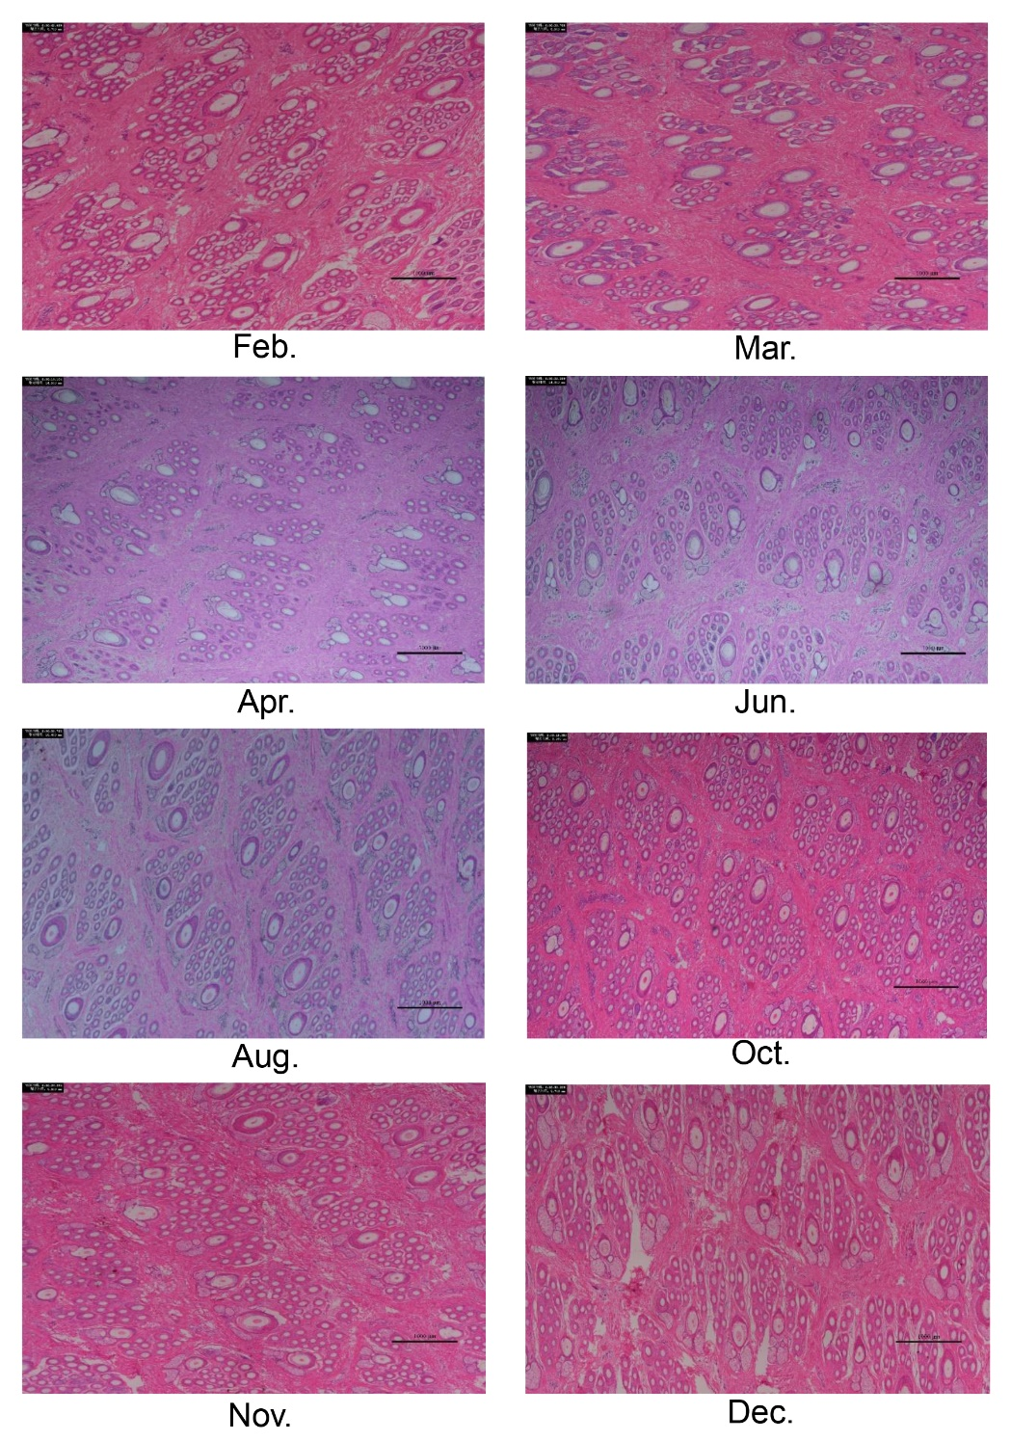
Figure S1. H&E staining of goat skins at different stage.
Figure S2. The correlation between methylation levels and chromosome length, CpG content, the ratio between the observed and expected numbers of CpG sites (CpG_{o/e}), gene number and repeat number.

Table S1 Methylated cytosines in the skins at anagen and telogen stages.
Sample | Total mC | mCG | mCHH | mCHG
anagen_1 | 52,980,374 | 34,733,194 | 13,792,732 | 4,454,448
anagen_2 | 52,565,426 | 34,193,590 | 13,908,280 | 4,463,556
anagen_3 | 45,000,380 | 29,481,714 | 11,715,165 | 3,803,501
telogen_1 | 46,120,521 | 30,444,989 | 11,821,368 | 3,854,164
telogen_2 | 54,653,240 | 35,193,806 | 14,722,724 | 4,736,710
telogen_3 | 43,555,660 | 30,736,724 | 9,748,378 | 3,070,558

Table S2 The proportion of methylated cytosines in goat skins at anagen and telogen stages.
Samples | mC (%) | mCpG (%) | mCHG (%) | mCHH (%)
anagen_1 | 4.63% | 59.3% | 1.76% | 1.66%
anagen_2 | 4.6% | 58.38% | 1.77% | 1.67%
anagen_3 | 3.94% | 50.33% | 1.51% | 1.41%
telogen_1 | 4.03% | 51.98% | 1.53% | 1.42%
telogen_2 | 4.78% | 60.09% | 1.88% | 1.77%
telogen_3 | 3.81% | 52.48% | 1.22% | 1.17%

