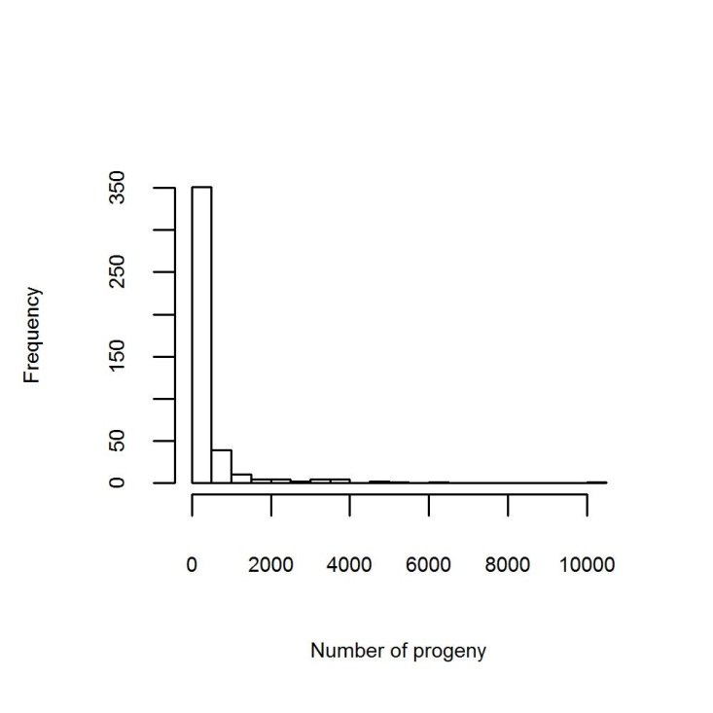
Figure 3a. Distribution of number of progeny per sire.

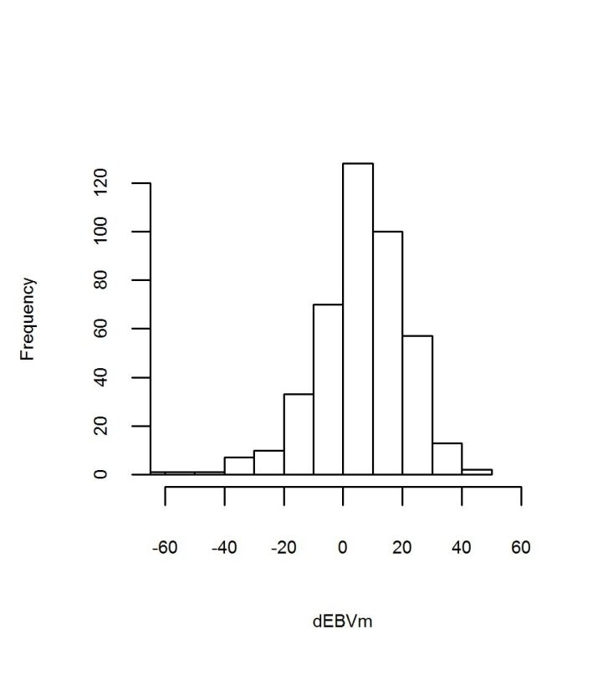 | 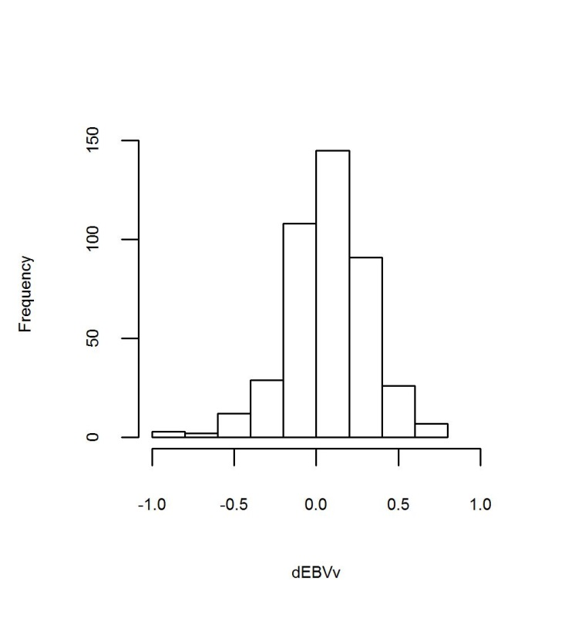
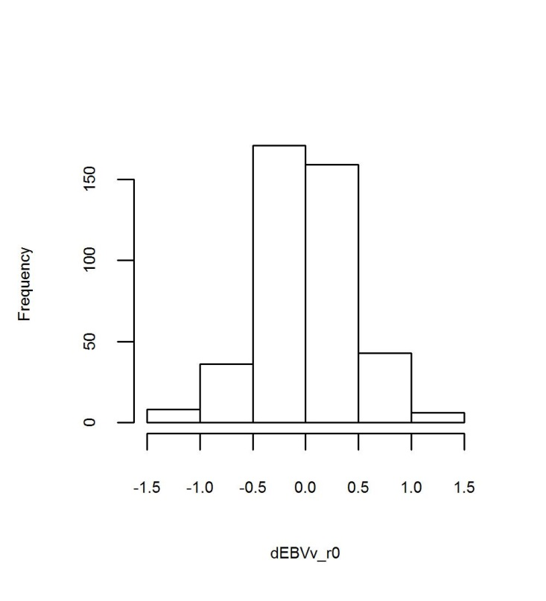 | 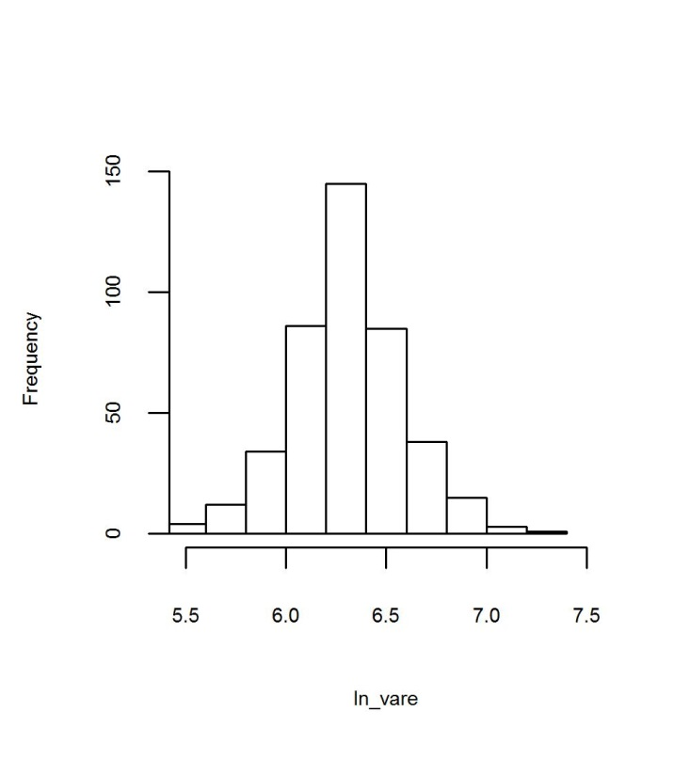
Figure 3b. Distribution of the four responses variables (dEBV_{m,} dEBV_{v,} dEBV_{v_r0} and ln_${\text{σ}}_{\text{ê}}^{\text{2}}$) used in this study.

