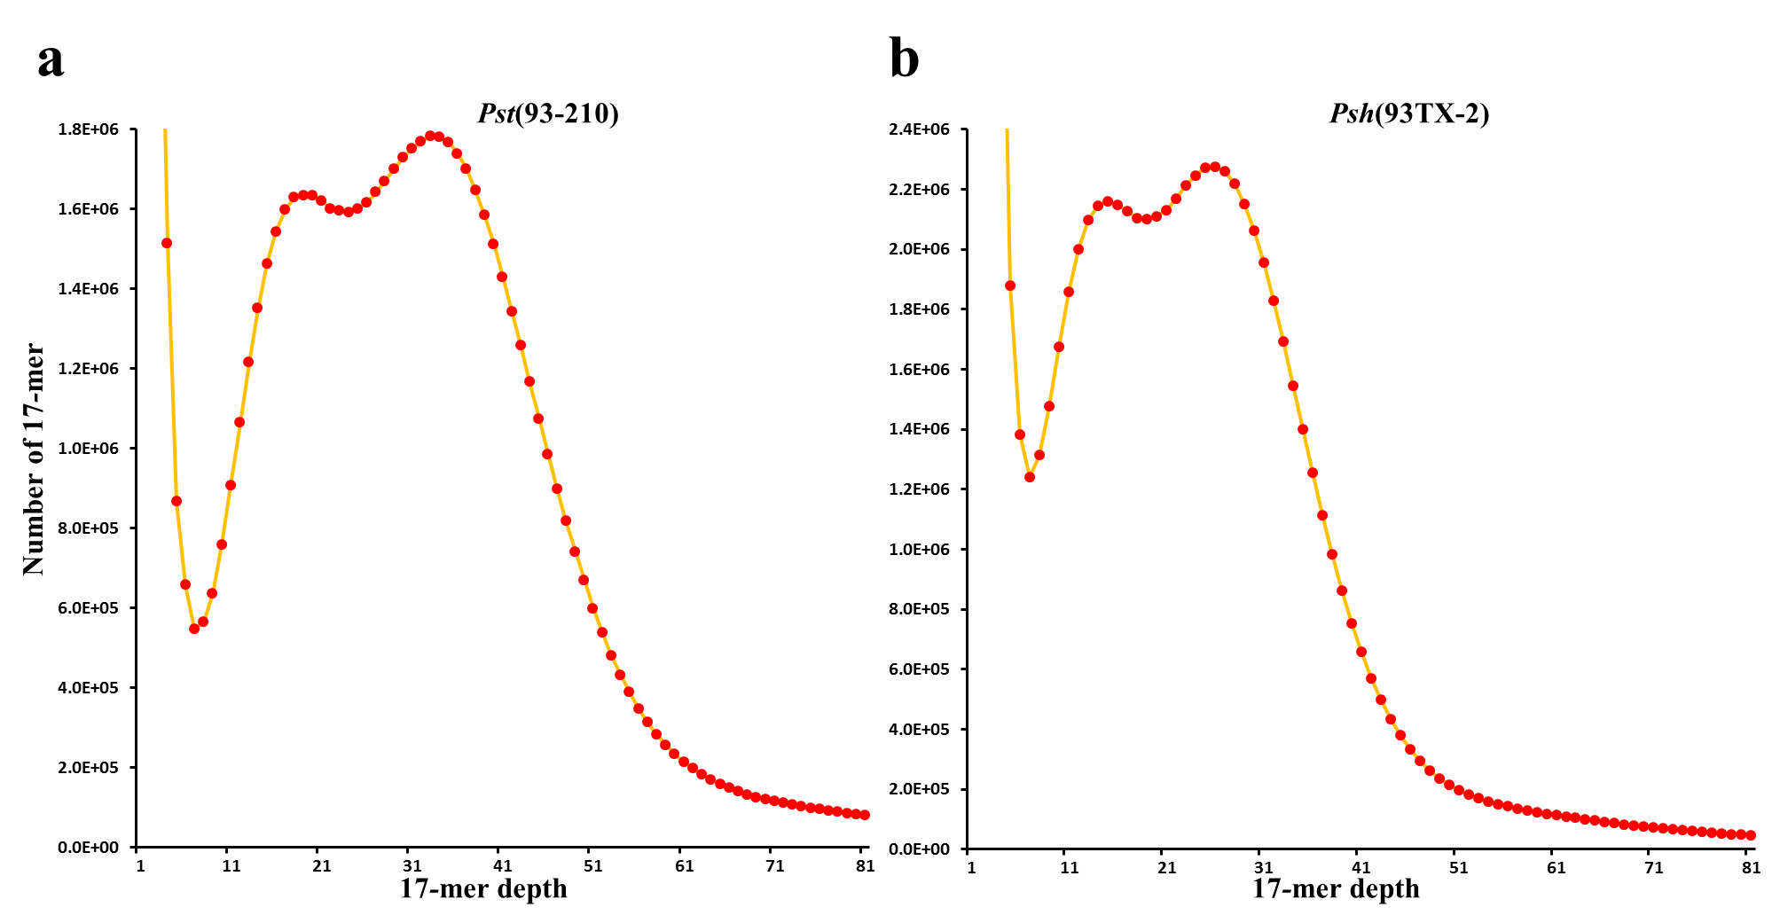
Fig. S1 The 17-mer depth distributions of the Illumina reads used to estimate the genome sizes of Pst (93-210) and Psh (93TX-2) isolates of Puccinia striiformis used in this study. a A total of 103,885,344 17-mer were obtained and two peaks at 19 and 33 were observed for the Pst isolate. The estimated genome size was 89,743,503 bp, of which 20,535,944 bp and 69,207,559 bp were estimated to be in heterozygous and homozygous regions, respectively. b A total of 166,640,626 17-mer were obtained and two peaks at 15 and 26 were observed for the Psh isolate. The estimated genome size was 89,709,453 bp, of which 18,880,342 bp and 70,829,111 bp were estimated to be in heterozygous and homozygous regions, respectively.

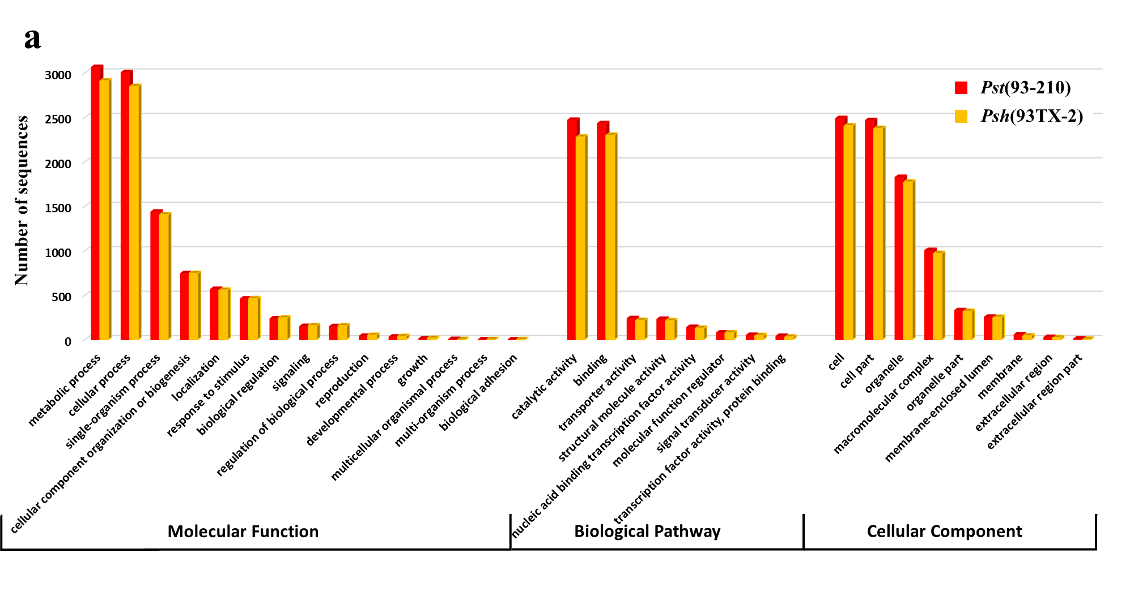
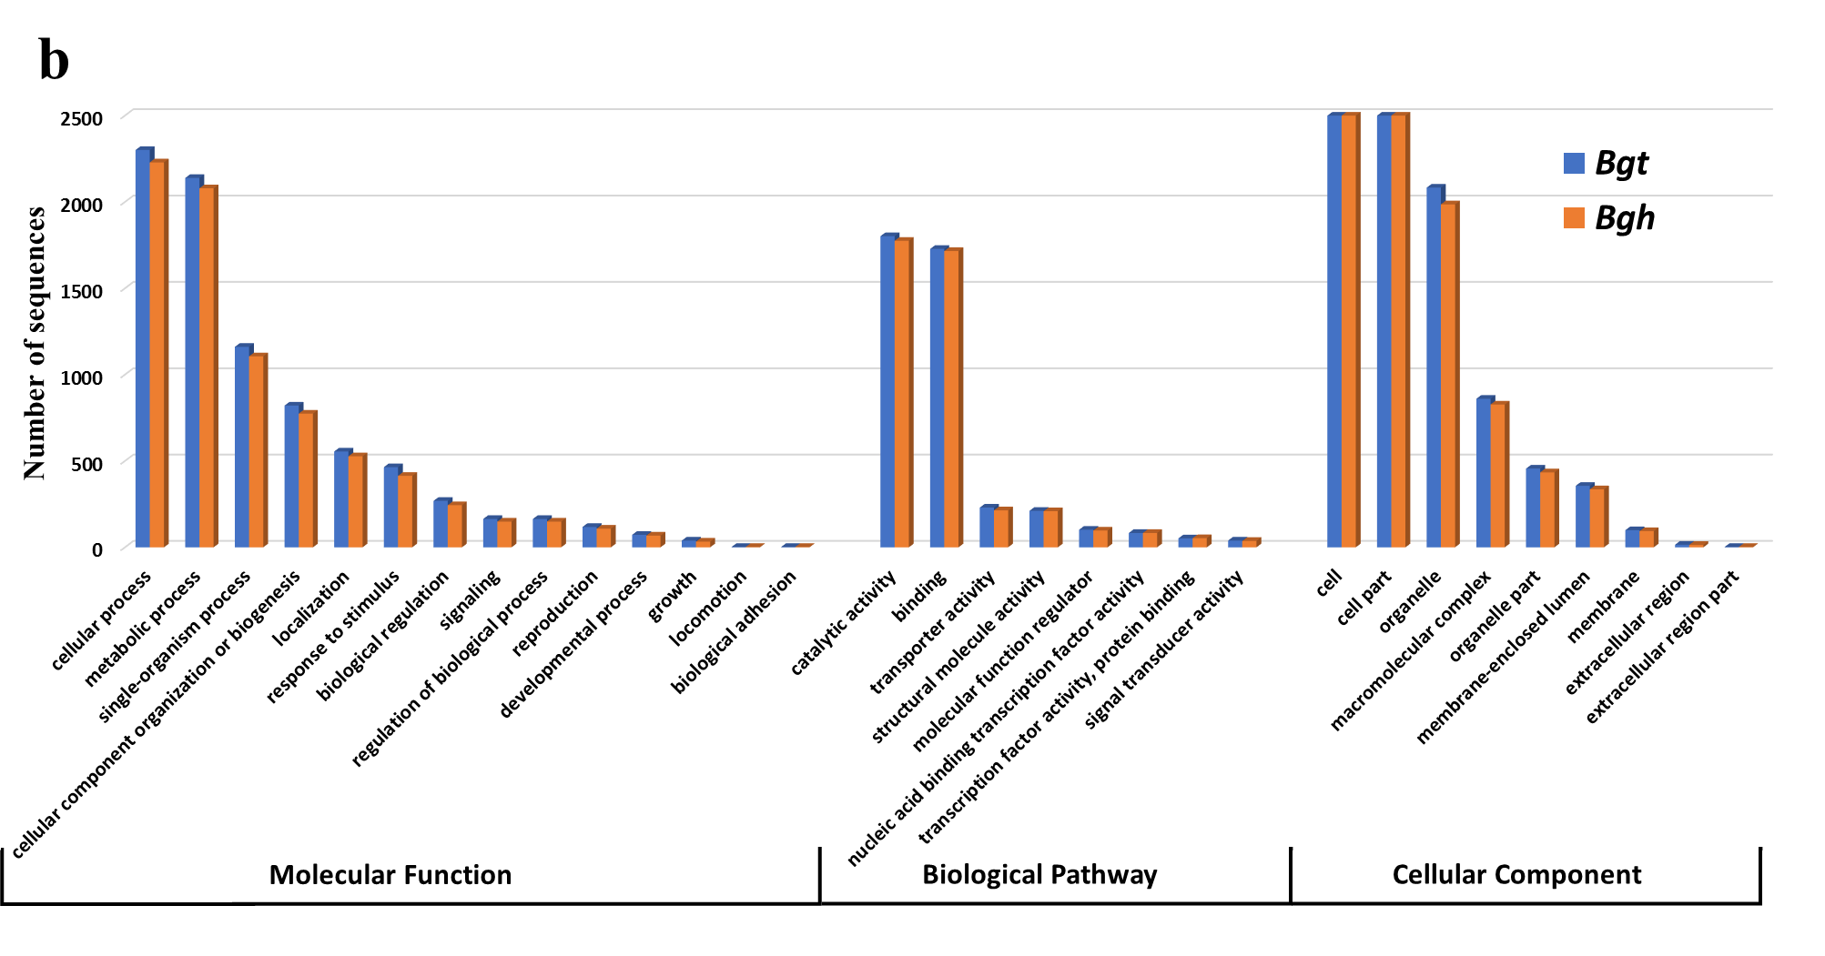
Fig. S2 Comparisons of functional annotations between wheat-hosted and barley-hosted stripe rust and powdery mildew fungi. a Comparison between wheat-hosted Pst (93-210) and barley-hosted Psh (93TX-2) isolates. b Comparison between wheat-hosted Bgt and barley-hosted Bgh isolates. The Pst and Psh data were from this study and the Bgt and Bgh data were from Wicker et al. 2013 and Spanu et al. 2010. Functional annotations were summarized using program BLAST2GO v4.1.9. Pst, Puccinia striiformis f. sp. tritici; Psh, P. striiformis f. sp. hordei; Bgt, Blumeria graminis f. sp. tritici; and Bgh, B. graminis f. sp. hordei.

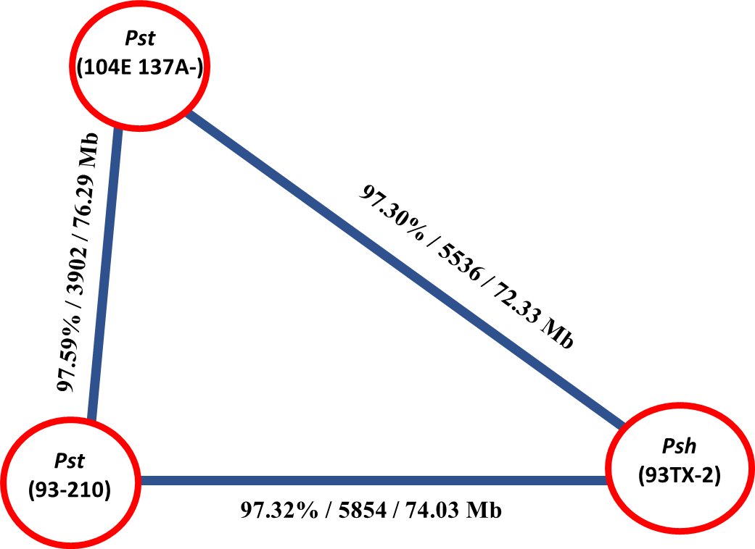
Fig. S3 Collinearity analysis of syntenic blocks among three Puccinia striiformis isolates. Three numbers along each triangle edge are average identity / total number / total size of syntenic blocks. The identity between two Pst isolates is higher than identities between Pst and Psh isolates. Syntenic blocks were identified using MUMmer v3.23.

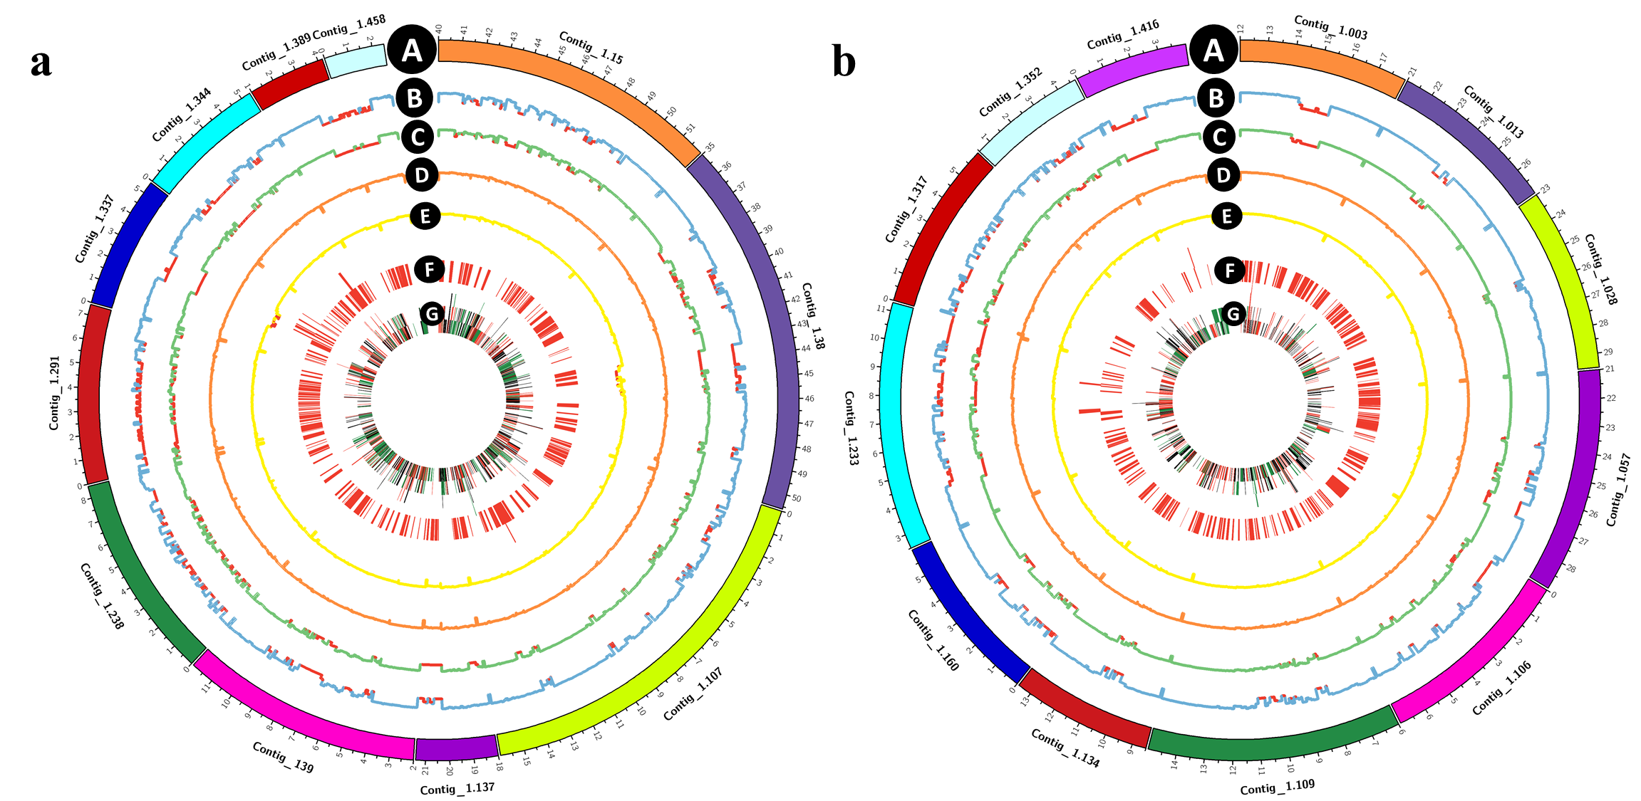

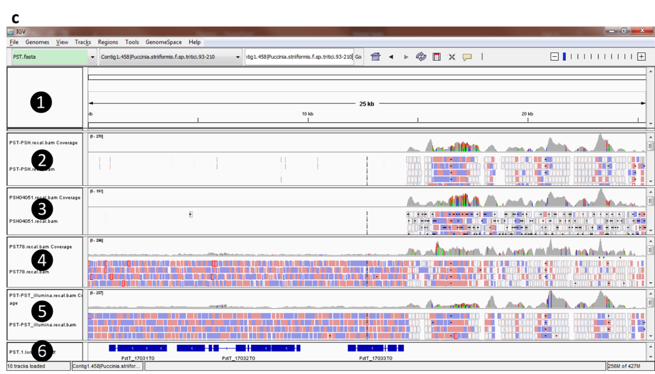
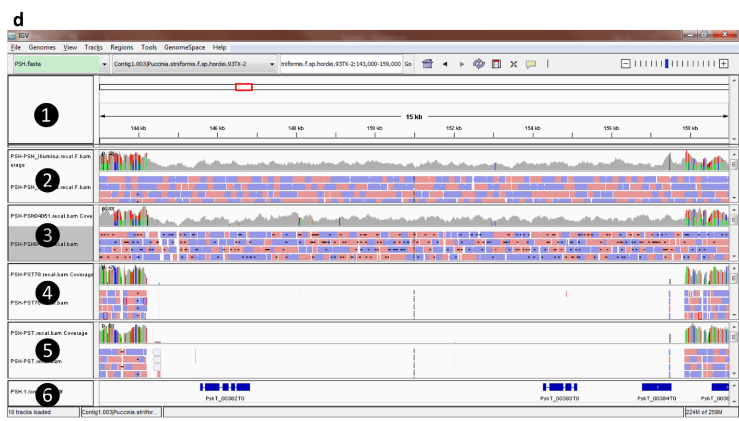
Fig. S4 Examples of missing genomic regions by reciprocal mapping of Illumina sequence reads. a Examples of Puccinia striiformis f. sp. tritici (Pst) regions that are present in two Pst isolates but absent in two Psh isolates. In these circles, A denotes contigs of the reference genome Pst (93-210); B-E histograms of mapping coverage when genomic sequencing reads of Psh (93TX-2), Psh (04-051), Pst (93-210), and 2K-41-Yr9 were mapped; F each red bar represents one gene; and G each bar represents one transposable element. b Examples of P. striiformis f. sp. hordei (Psh) regions that are present in two Psh isolates but absent in two Pst isolates. A Denotes contigs of the reference genome Psh (93TX-2); B-E histograms of mapping coverage when genomic sequencing reads of Pst (93-210), 2K-41-Yr9, Psh (93TX-2), and Psh (04-051) were mapped; and F and G are the same as in a. A 1000bp window size was used for coverage. c and d IGV screenshot of reciprocal mapping of Illumina reads showing the missing regions and genes in one isolate but present in the other. Track❶, the reference genome. Track❷, mapping of Psh (93TX-2) sequence reads. Track❸, mapping of Psh (04-051) reads. Track❹, mapping of Pst (93-210) reads. Track❺, mapping of 2K-41-Yr9 reads. Track❻, gene structure.

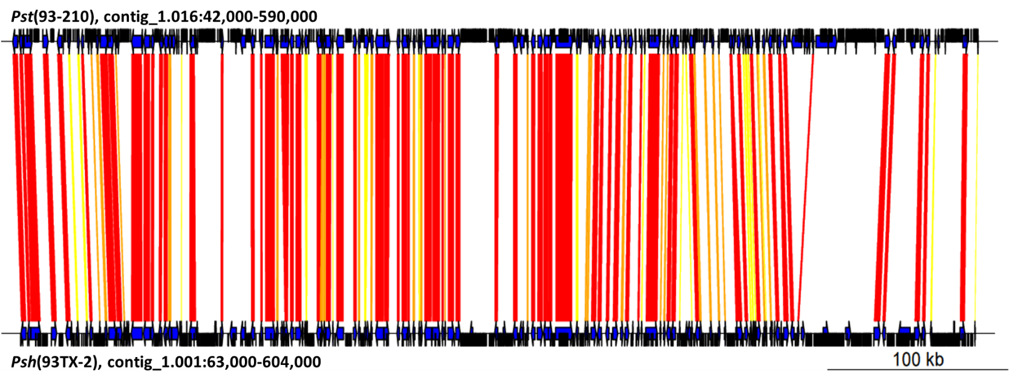
Fig. S5 An overview of a large syntenic region between isolates Pst (93-210) and Psh (93TX-2) of Puccinia striiformis. See the legends in Fig. 4.

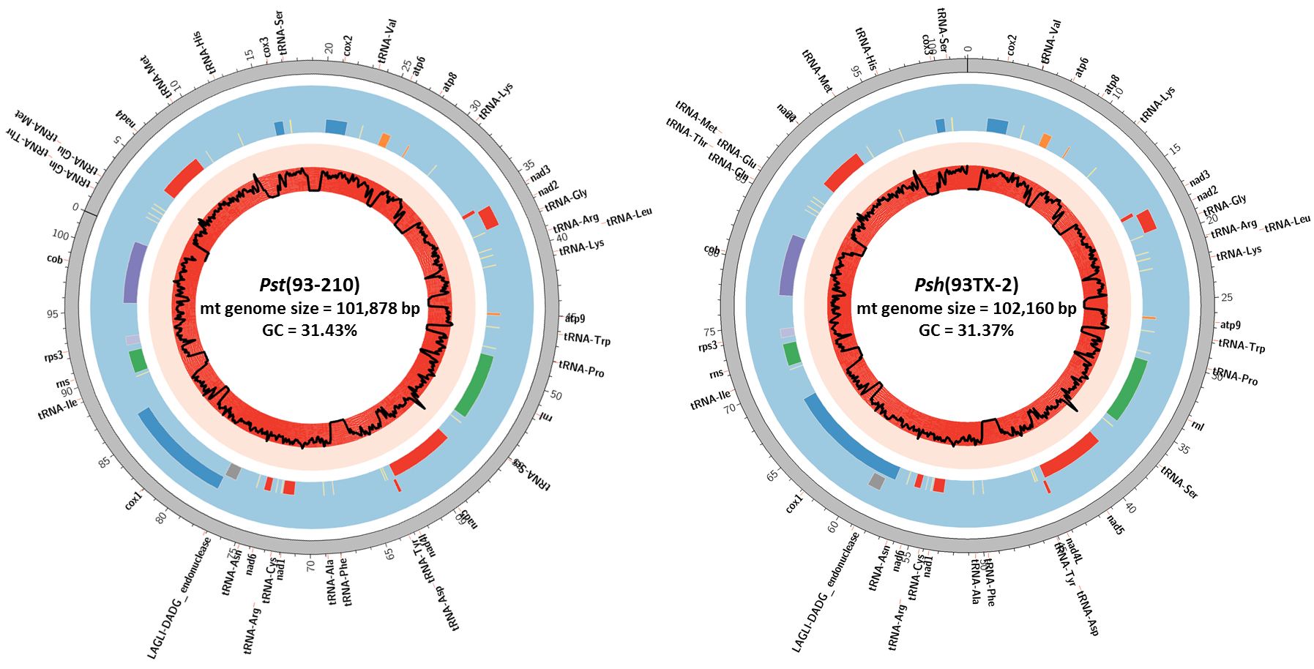
Fig. S6 An overview of the mitochondrial (mt) genomes of isolates Pst (93-210) and Psh (93Tx-2) representing Puccinia striiformis f. sp. tritici (Pst) and P. striiformis f. sp. hordei (Psh), respectively. The outer layer ideogram represents physical position of the mt chromosome, with a unit of 1 kb. Tiles in the middle layer represent genes. Yellow: tRNA-coding genes; red: NADH dehydrogenase-coding gene family; orange: ATP synthase-coding gene family; blue: cytochrome c oxidase-coding gene family; green: subunit ribosomal RNA (rnl and rns); purple: cytochrome b gene. The black line in the inner layer shows the distribution of GC content, with the inner boundary of red background 0% GC content, middle boundary 50%, and outer boundary of pink background 100% GC content.

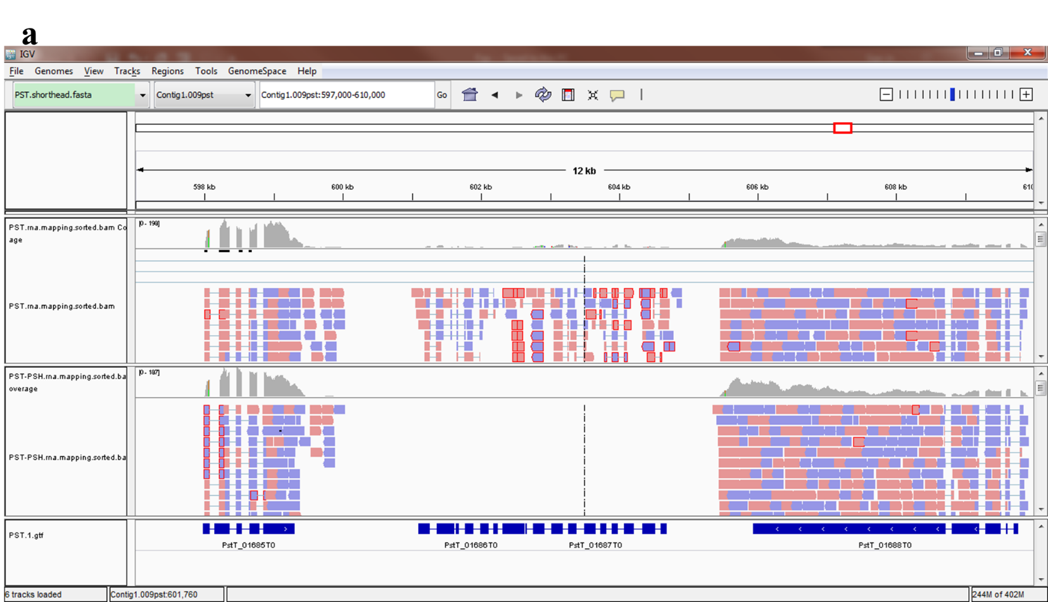
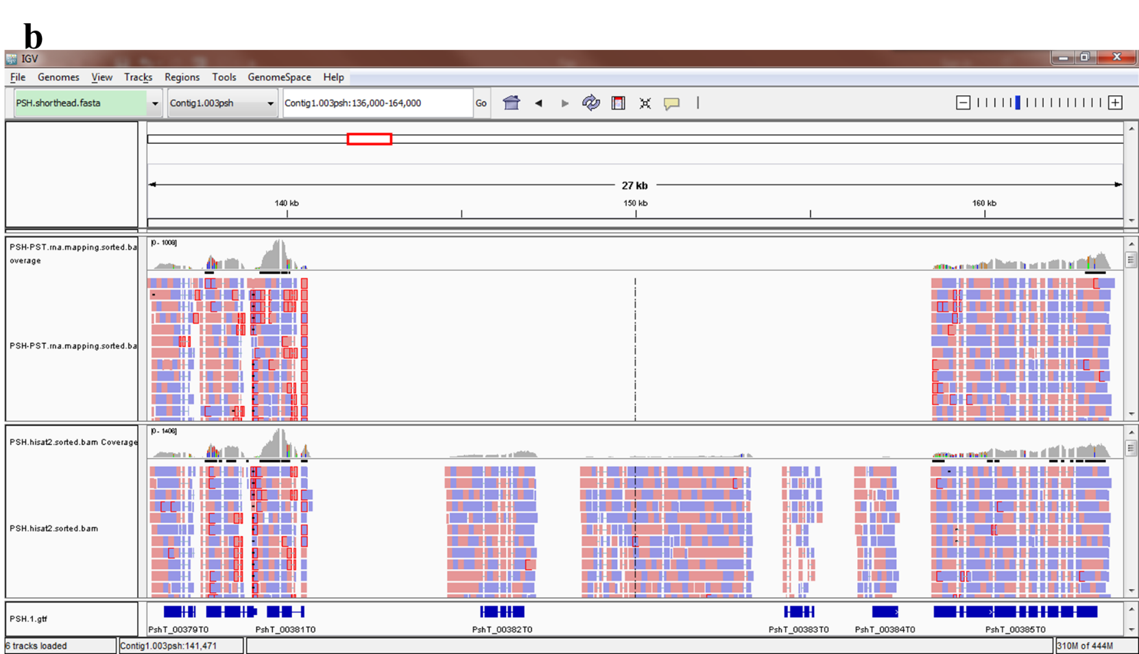
Fig. S7 IGV screenshot showing examples of exclusively expressed genes revealed by reciprocal mapping of Illumina RNA-Seq reads. a Two Pst (93-210) genes (PstG_01686T0 and PstG_01687T0) are expressed in Pst (93-210), but not expressed in Psh (93TX-2). b Three Psh (93TX-2) genes (PshG_00382T0, PshG_00383T0 and PshG_00384T0) are expressed in Psh (93TX-2) but not expressed in Pst (93-210). See legends of Fig. S4, except that the sequencing reads are RNA-Seq reads.
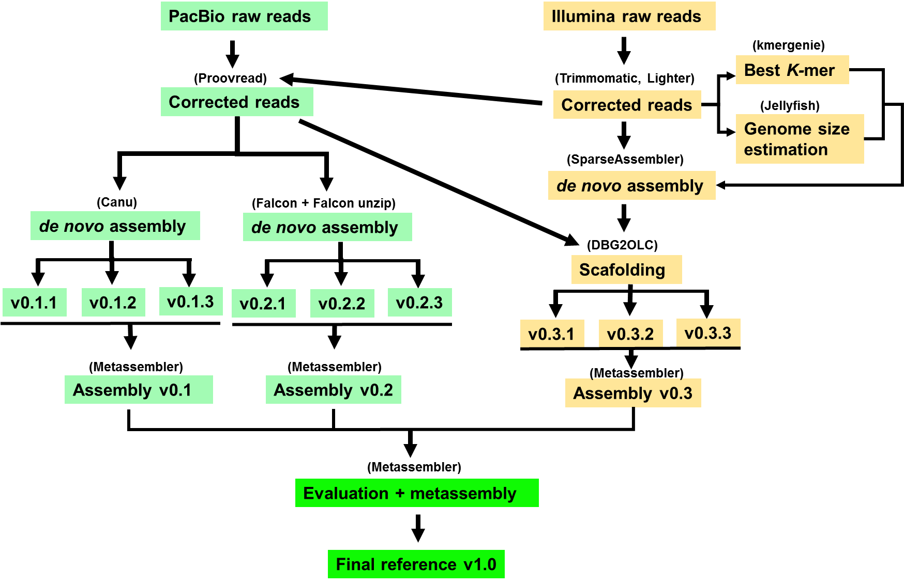
Fig. S8 Pipeline used for genome assembly in this study.

