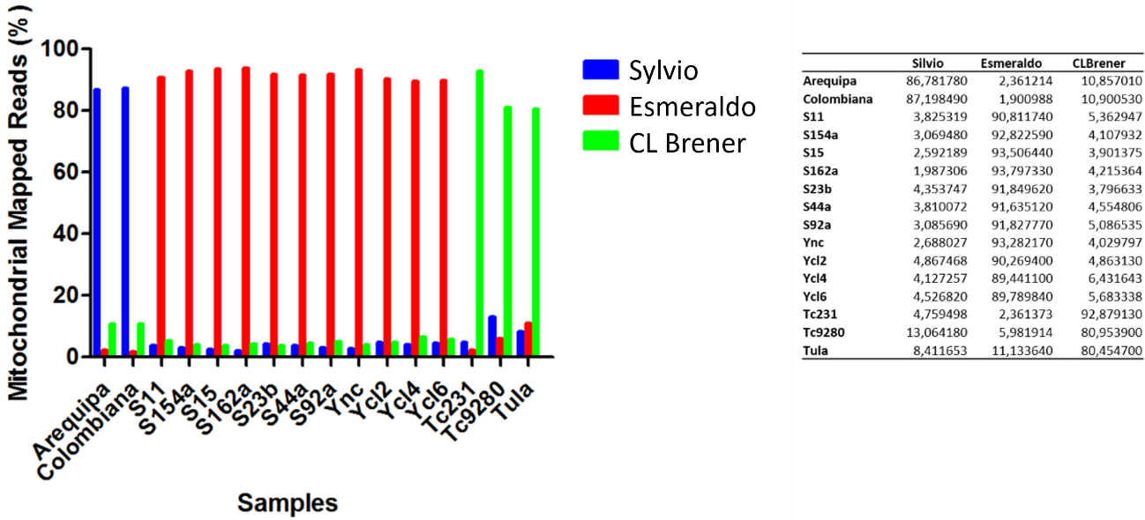
Supplementary Figure 4: Competitive mapping of the mitochondrial reads to the three available maxicircle templates. The percentage of mitochondrial genome reads from the 16 T. cruzi read libraries that mapped preferentially with each of the maxicircle sequence templates, Sylvio (TcI), Esmeraldo (TcII) and CL Brener (TcVI with mitochondria sequence derived from TcIII) is shown. The TcI strains mapped preferentially with the Sylvio template, while TcII strains mapped preferentially with the Y strain and the TcIII, V and VI strains mapped preferentially with the CL Brener maxicircle sequence.

