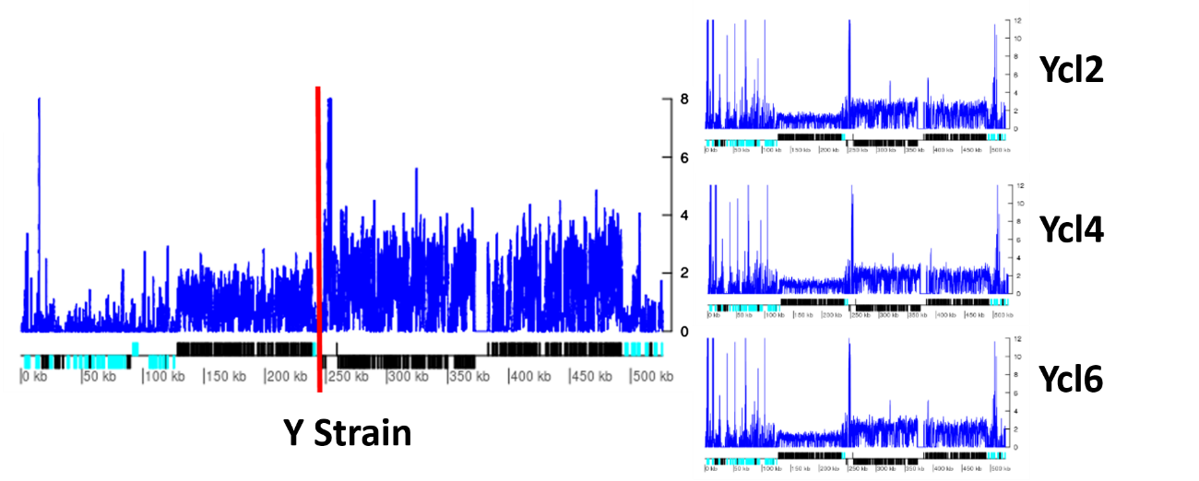
Supplementary Figure 3: Read Depth Coverage of the chromosome 11 in the Y strain and clones. In this picture, the blue lines correspond to the normalized RDC of each position of the chromosome 11, estimated by the ratio between the RDC and the genome coverage. The red line corresponds to the 248kb position in the chromosome. Below, the protein-coding genes are depicted as rectangles drawn as proportional to their length, and their coding strand is indicated by their position above (top strand) or below (bottom strand) the central line. Cyan and black rectangles represent multigene families and hypothetical/housekeeping genes, respectively. The initial 248-kb in this chromosome had a smaller RDC when compared to remaining sequence in the Y strain as well as in all three Y clones evaluated.

