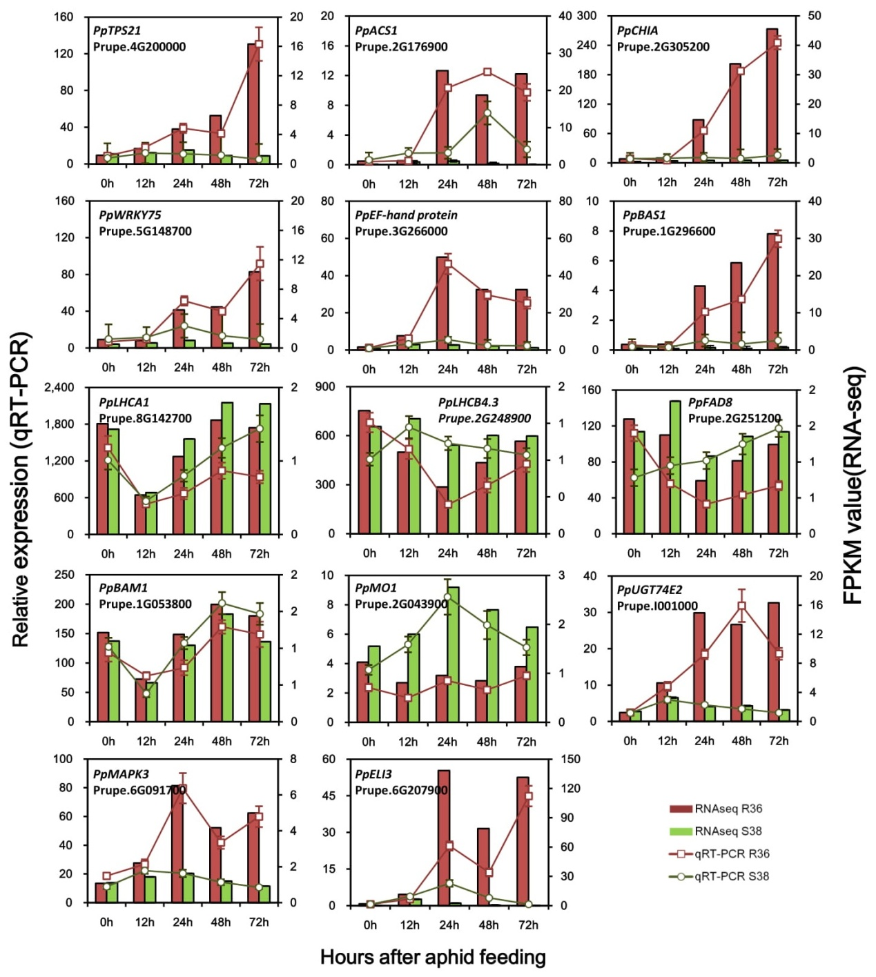
Additional file 4. Comparison of RNA-seq and qPCR gene expression data. The fourteen genes are assigned to the resistance signaling pathway, including photosynthesis, kinases and transcription factors and other uncharacterized genes. Columns represent expression by RNA-seq in FPKM values (left y-axis), while lines represent expression determined by qRT-PCR (right y-axis). The x-axis in each chart represents the five time points (0, 12, 24, 48 and 72h). For qRT-PCR, normalization was made to expression of the actin gene, and values are means of three technical replicates. For qRT-PCR, normalization was made to expression of the actin gene, and values are means of three biological replicates.

