Additional file 4. Clusters of nucleotide alignments used for forward primer design. The name of each nucleotide set which was used for primer design is equivalent to the name of the corresponding primer.

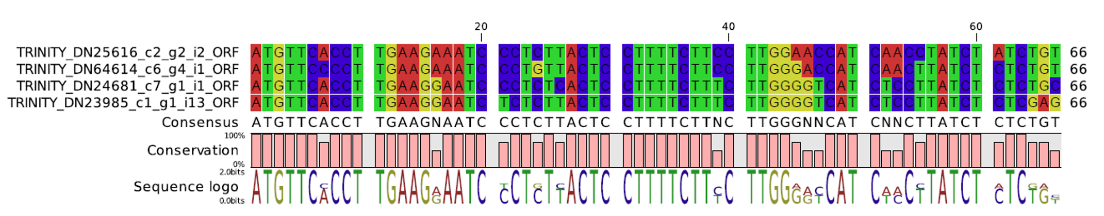
TP1

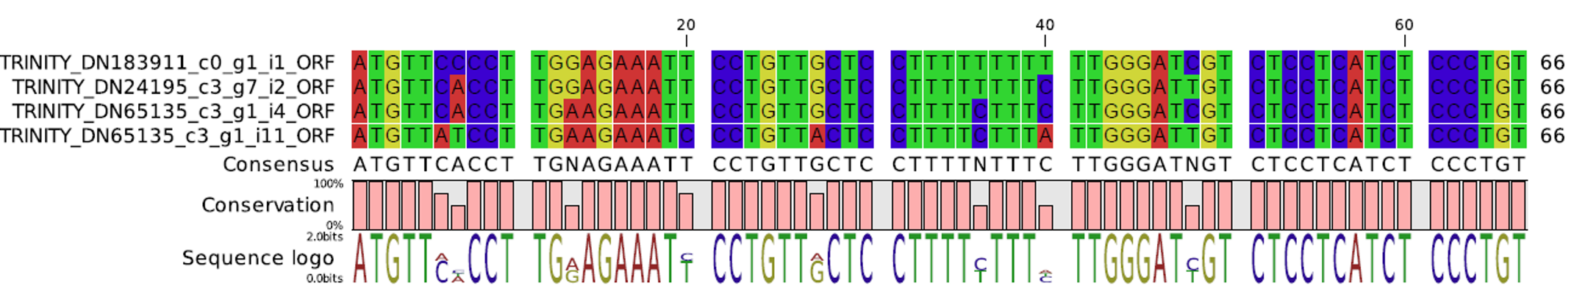
TP2

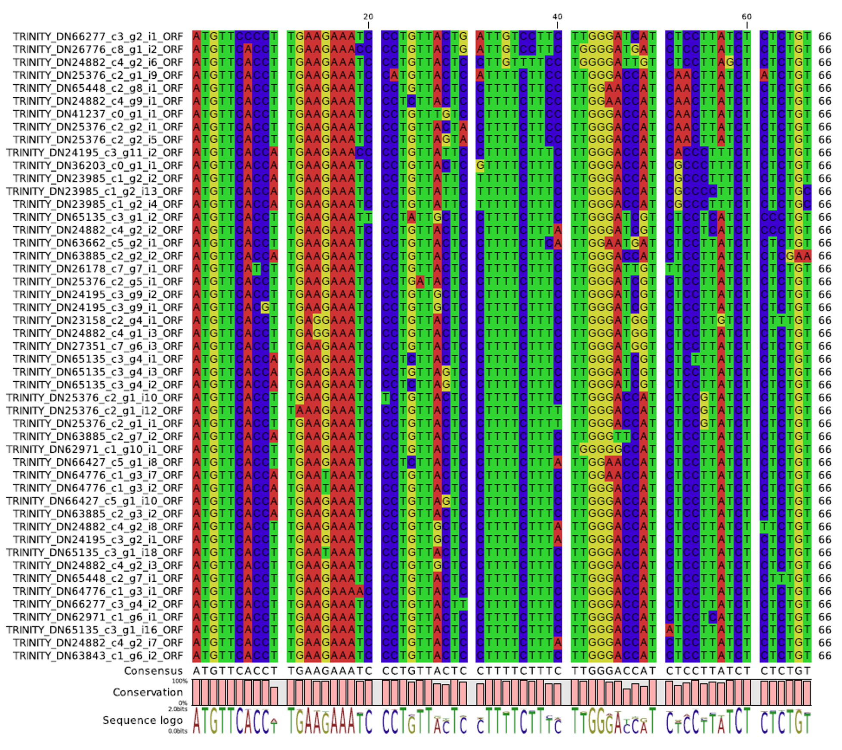
TP3

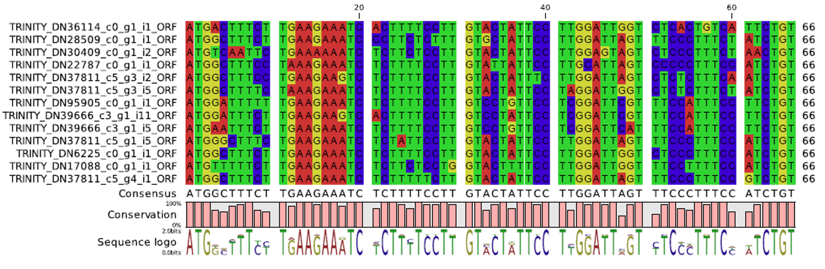
TP4

TP5
