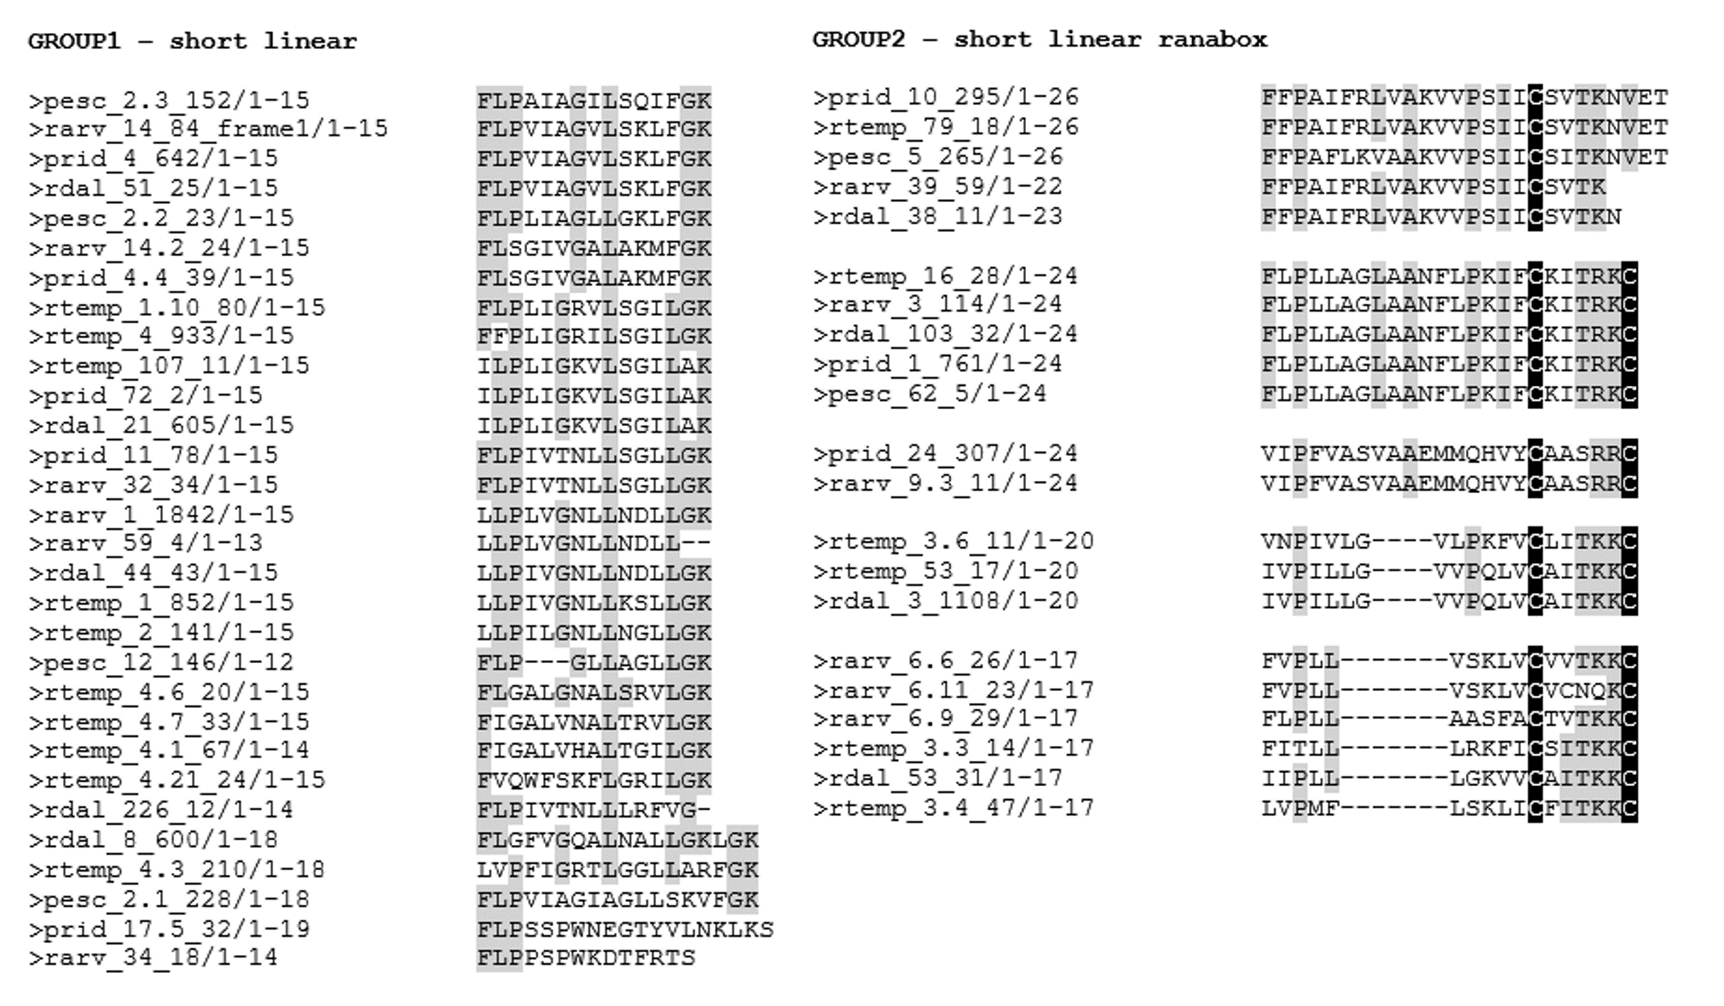
Additional file 6. Classification of peptides based on primary sequence properties and/or similarity to known protein sequences. Peptide name consists of the first letter of the frog genus where the peptide was identified, followed by 3 or 4 letters pertaining to the species name. First number refers to the contig where the peptide was found, and the second one to the number of reads supporting it. If the contig was re-assembled, it is indicated in the contig number (e.g. 4.3).
