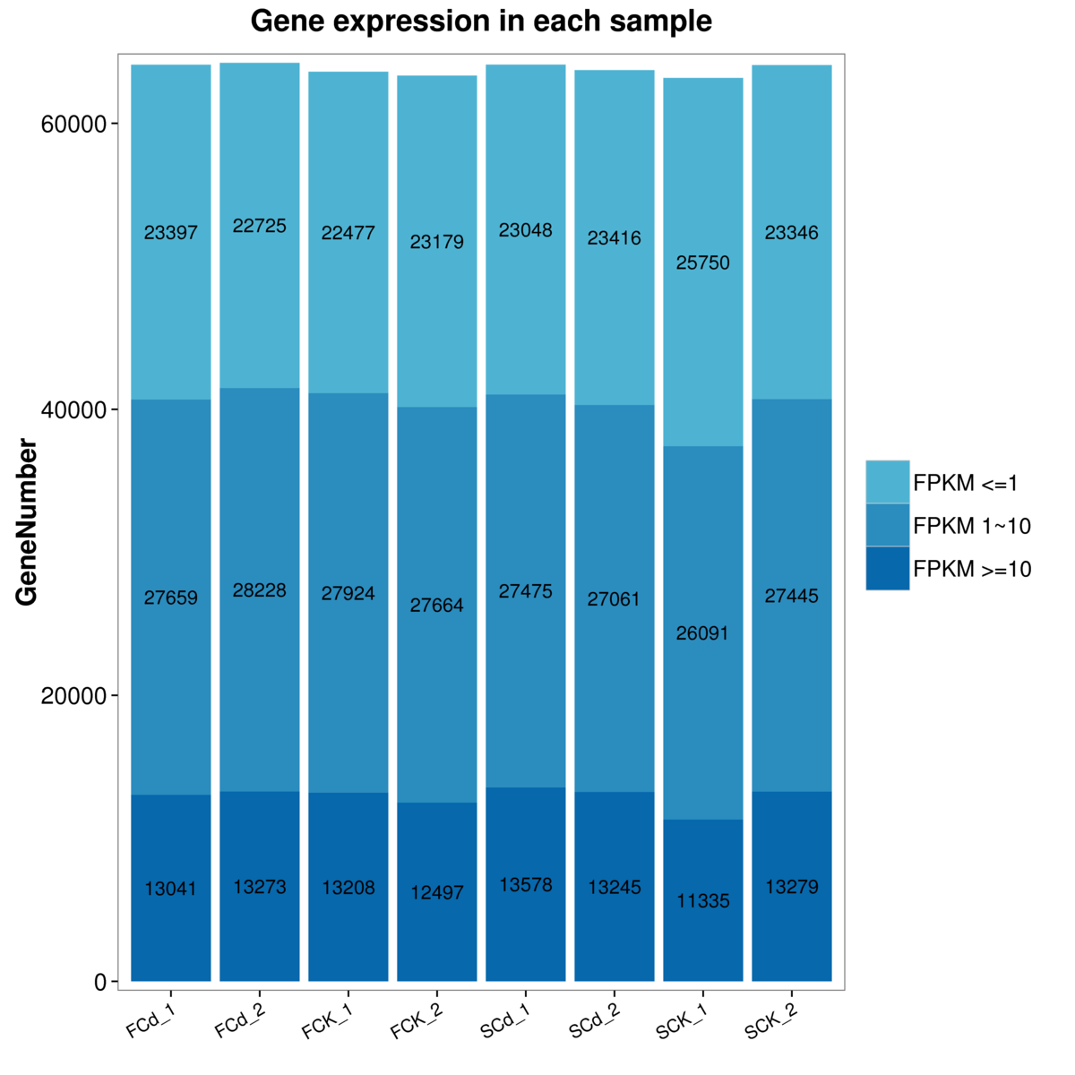
Additional file 5: Figure S1. The gene expression distribution (FPKM) in eight samples. X axis represents the sample name. Y axis represents the gene amount. The dark color means the moderate and high expression level which FPKM value ≥ 10, while the light color means the low expression level which FPKM value <10.

