Supplementary tables

Identifier | GeneID | IDS | E-value | Identity | Similarity | FLEX_score
O00311 | CDC7 | 13.763 | 0 | 1.000 | 1.000 | 0.931
Q9Z0H0 | Cdc7 | 17.021 | 0 | 0.809 | 0.874 | 0.915
P06243 | CDC7 | 8.679 | 1.10E-29 | 0.134 | 0.191 | 0.956
Q8SR83 | CDC7-2 | 3.704 | 1.54E-28 | 0.174 | 0.268 | 0.981
Q8SR85 | CDC7-1 | 3.704 | 1.71E-28 | 0.174 | 0.268 | 0.981
Q54DK3 | cdc7 | 70.028 | 3.80E-28 | 0.057 | 0.083 | 0.650
P50582 | hsk1 | 14.596 | 3.31E-24 | 0.128 | 0.195 | 0.925
Q9UQY9 | spo4 | 2.564 | 1.57E-21 | 0.147 | 0.235 | 0.981
Q9CAI5 | CKL2 | 27.097 | 1.67E-12 | 0.110 | 0.176 | 0.740
Q54P47 | ndrC | 52.509 | 5.14E-12 | 0.050 | 0.079 | 0.599
P43565 | RIM15 | 39.774 | 6.40E-12 | 0.050 | 0.089 | 0.659
Q5A3P6 | PKH2 | 52.059 | 1.61E-11 | 0.052 | 0.102 | 0.585
Q6Z8C8 | CDKF-4 | 35.512 | 1.73E-11 | 0.105 | 0.174 | 0.666
Q1ZXI5 | DDB_G0278845 | 71.556 | 2.13E-11 | 0.037 | 0.057 | 0.483
Q9ZUP4 | CKL5 | 31.871 | 2.97E-11 | 0.113 | 0.189 | 0.677
P42158 | CKL1 | 31.778 | 3.06E-11 | 0.109 | 0.178 | 0.676
Q8SRU0 | CKA1 | 0.000 | 5.20E-11 | 0.125 | 0.226 | 0.827
Q03407 | PKH1 | 34.334 | 9.37E-11 | 0.059 | 0.097 | 0.646

Table S1. Summary of BASILIScan results for homologues of human CDC7 kinase (Uniprot/Swissprot identifier O00311). Search parameters and the scoring system are described in “Results”. Calculations of the IDS and FLEX score parameters are described in the “Design and Implementation” section.

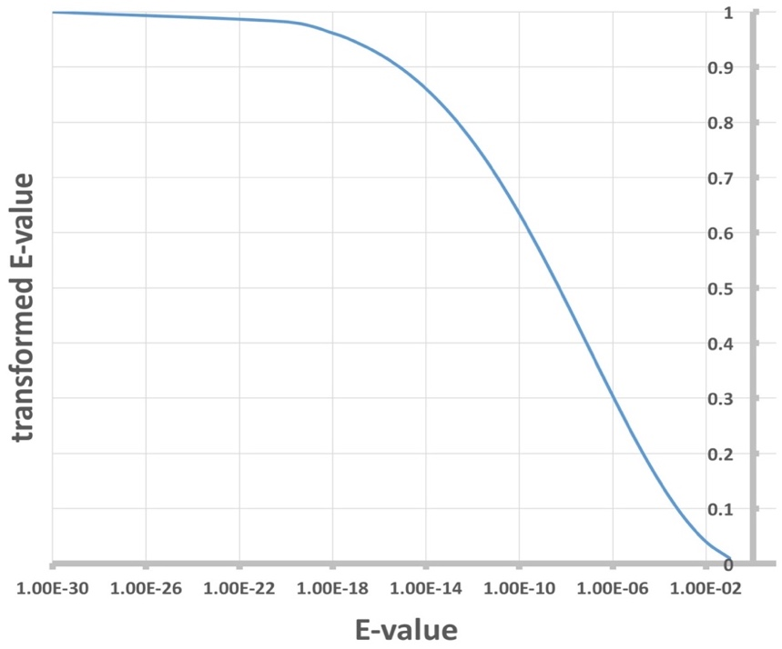
Supplementary figures

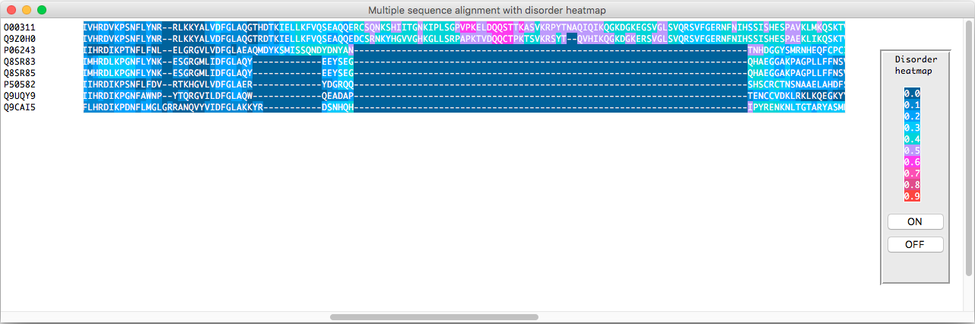
Supplementary figure S1. For more accurate scoring purposes, a hyperbolic transform is applied to the BLAST-derived E parameter, resulting in a value bound from 0 to 1 for E-values of below 1. The function is near-linear for E-values of between 10⁻¹⁴ and 10⁻³, while both far ends reach a plateau. The transformed E-value is then used for calculation of the FLEX score.

Supplementary figure S2. Eight highest-scoring hits from a BASILIScan search against hCDC7 kinase (Uniprot/Swissprot identifier O00311) aligned with the “Align” module and with the calculated intrinsic disorder overlayed on the alignment as a heatmap. In this case, the absence of an extended, highly-disordered fragment in the bottom five sequences is apparent.

