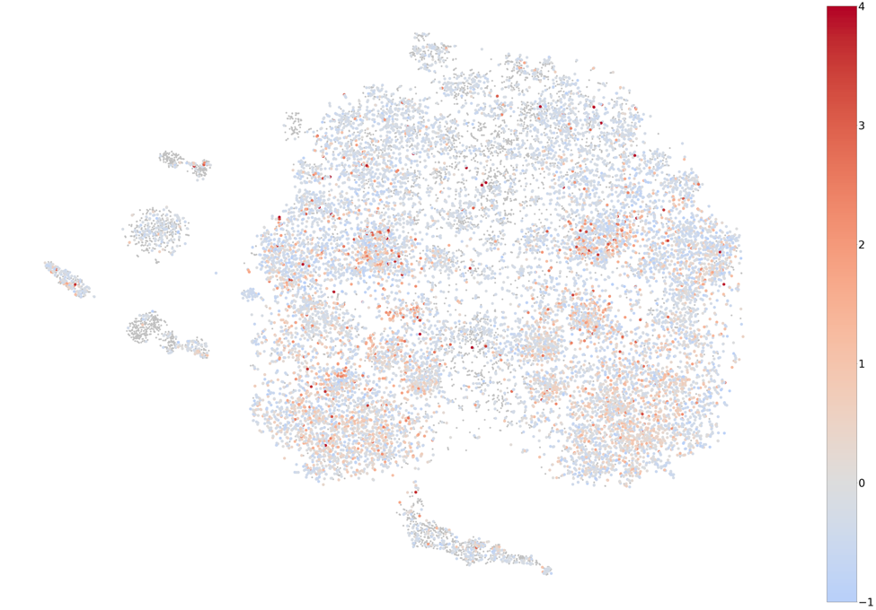
Adipose
Figure S1: Gene co-expression map with genes colored by z-scores obtained using GTEx adipose expression data.

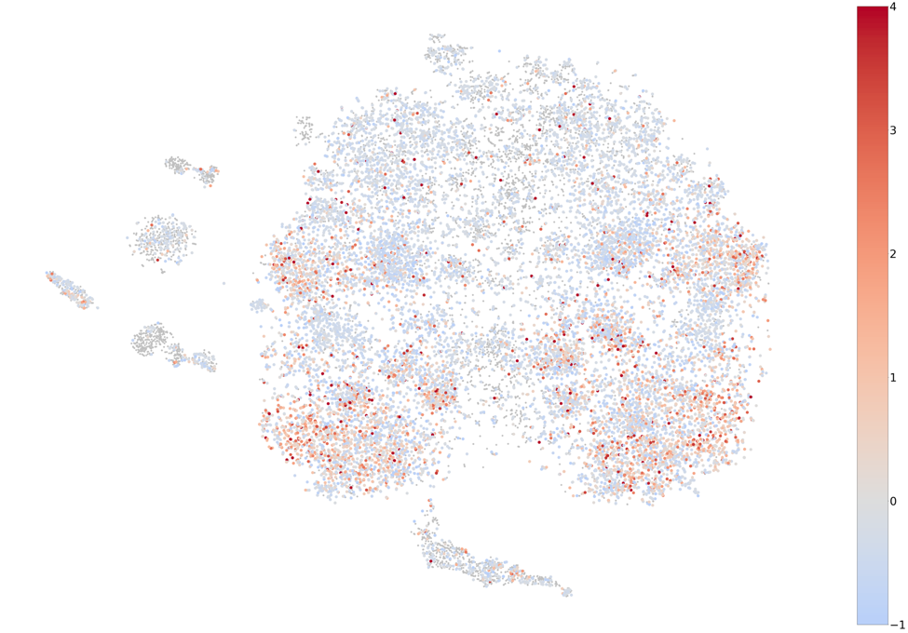
Adrenal gland
Figure S2: Gene co-expression map with genes colored by z-scores obtained using GTEx adrenal gland expression data.

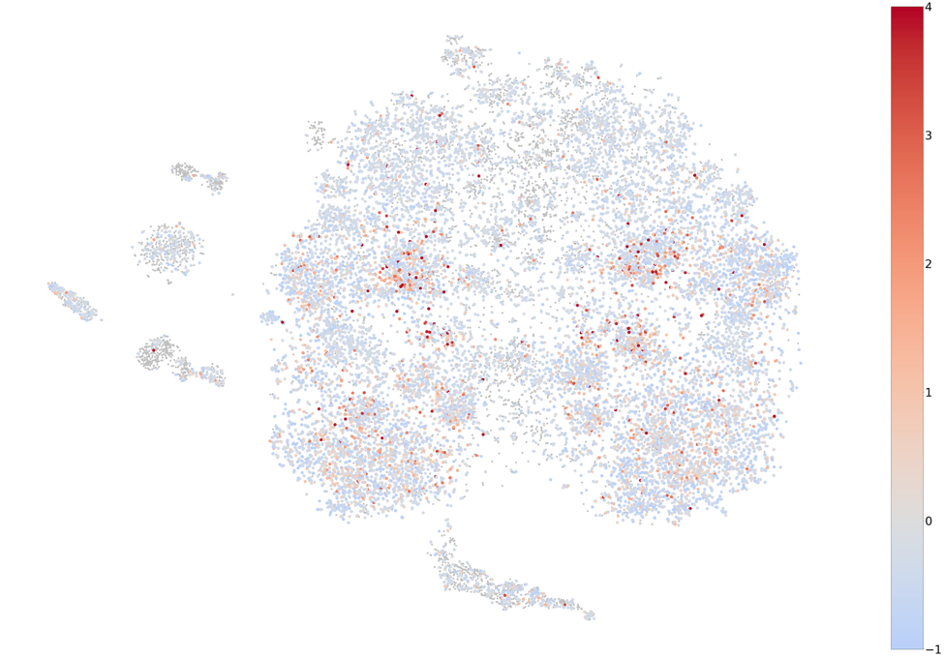
Blood vessel
Figure S3: Gene co-expression map with genes colored by z-scores obtained using GTEx blood vessel expression data.

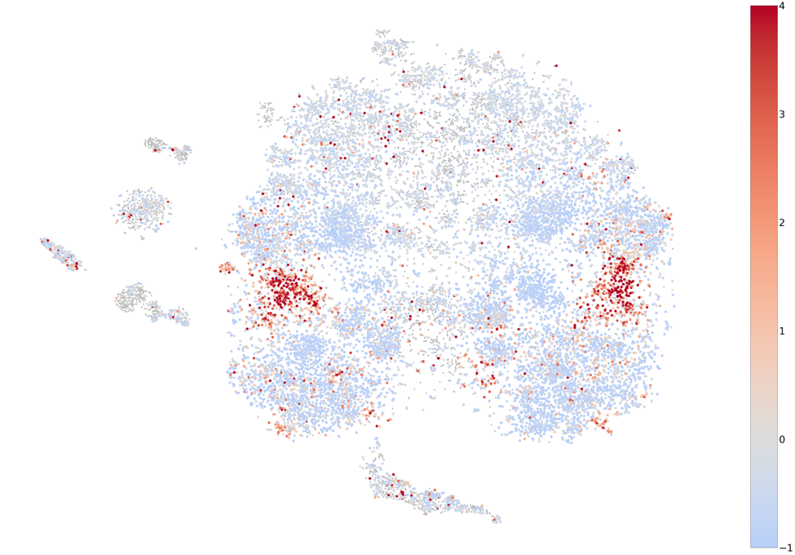
Blood
Figure S4: Gene co-expression map with genes colored by z-scores obtained using GTEx blood expression data.
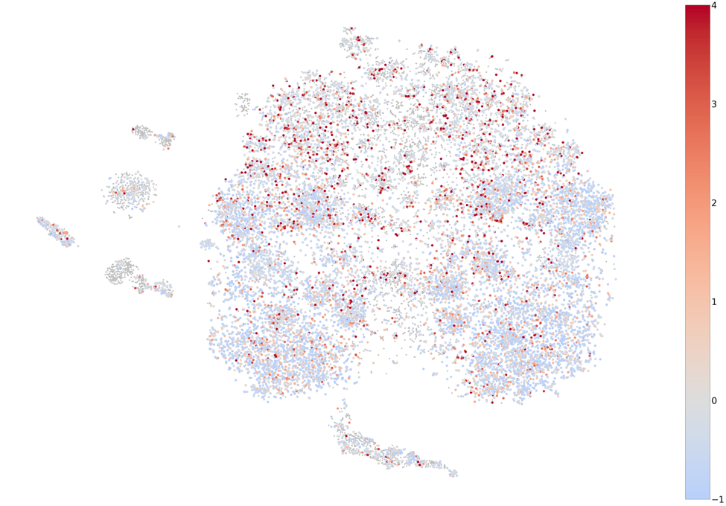
Brain
Figure S5: Gene co-expression map with genes colored by z-scores obtained using GTEx brain expression data.

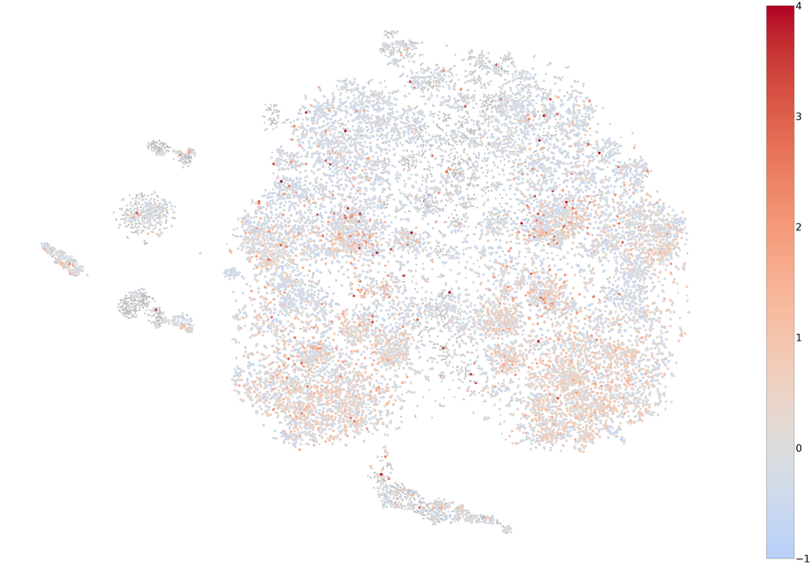
Breast
Figure S6: Gene co-expression map with genes colored by z-scores obtained using GTEx breast expression data.

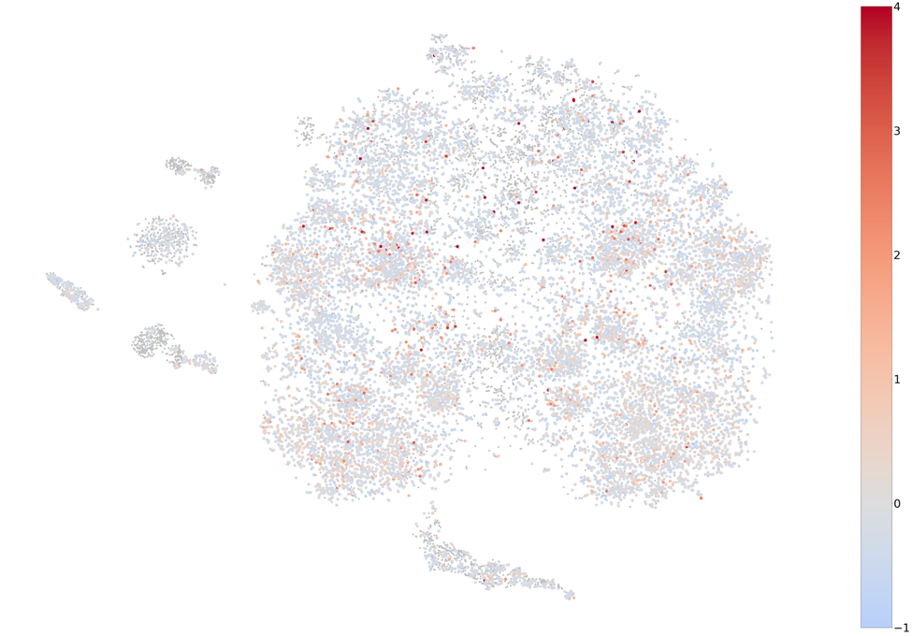
Colon
Figure S7: Gene co-expression map with genes colored by z-scores obtained using GTEx colon expression data.

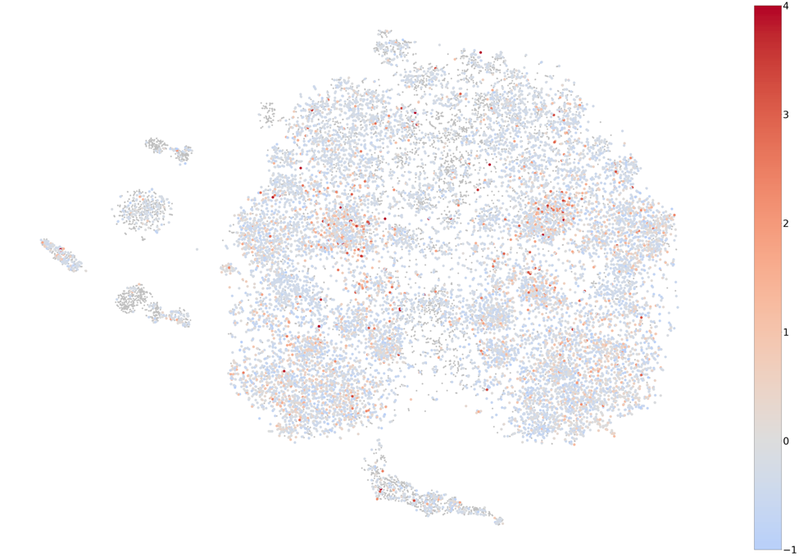
Esophagus
Figure S8: Gene co-expression map with genes colored by z-scores obtained using GTEx esophagus expression data.

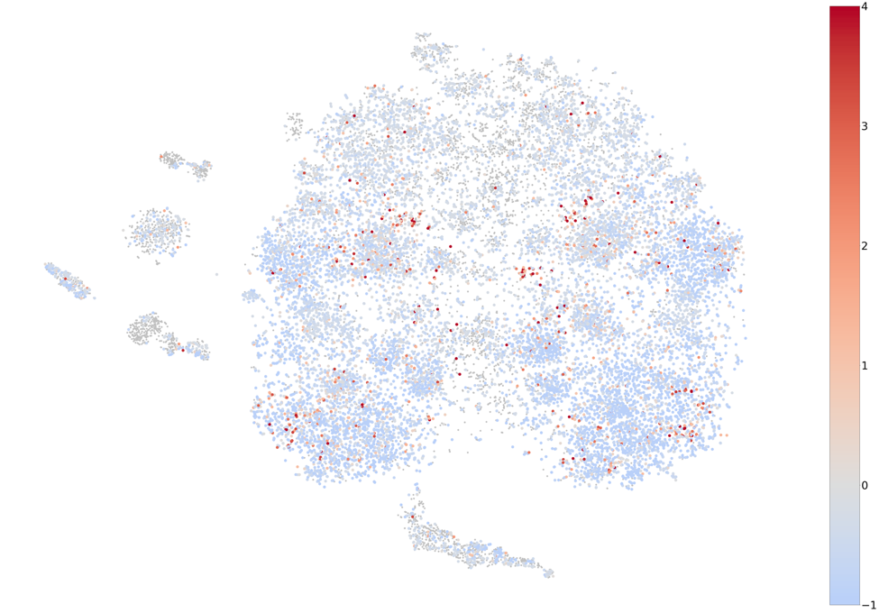
Heart
Figure S9: Gene co-expression map with genes colored by z-scores obtained using GTEx heart expression data.

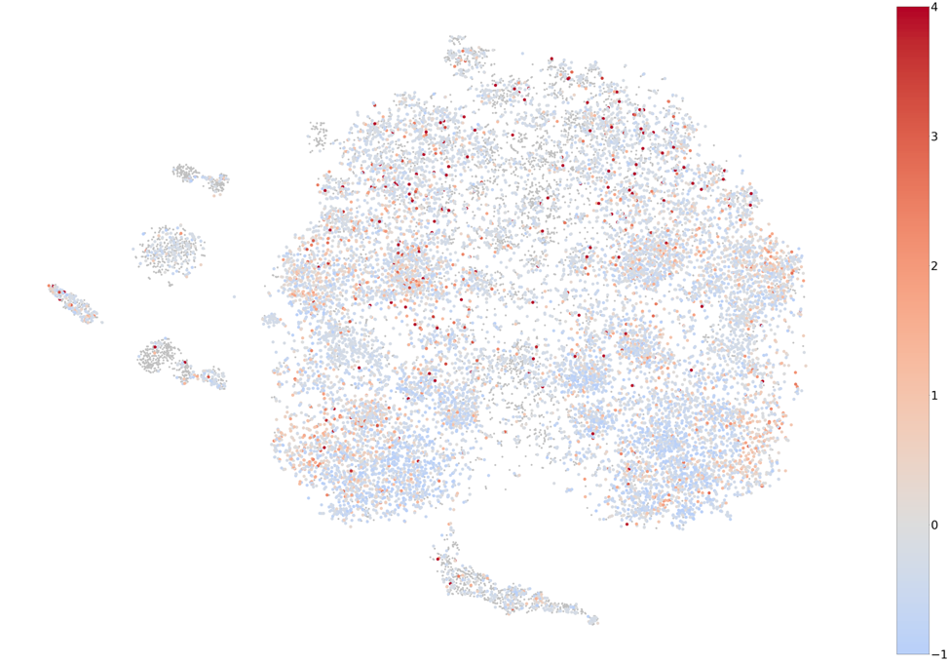
Kidney
Figure S10: Gene co-expression map with genes colored by z-scores obtained using GTEx kidney expression data.

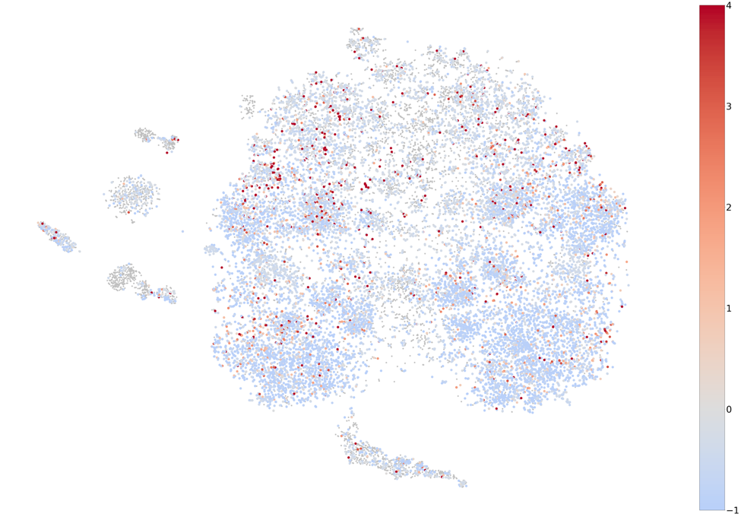
Liver
Figure S11: Gene co-expression map with genes colored by z-scores obtained using GTEx liver expression data.

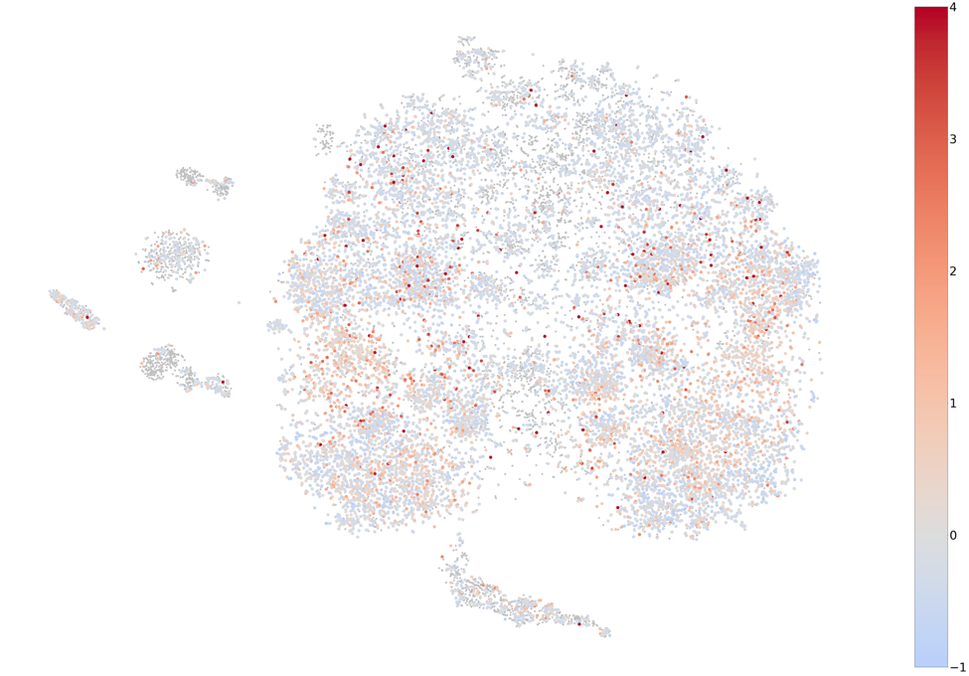
Lung
Figure S12: Gene co-expression map with genes colored by z-scores obtained using GTEx lung expression data.

Muscle
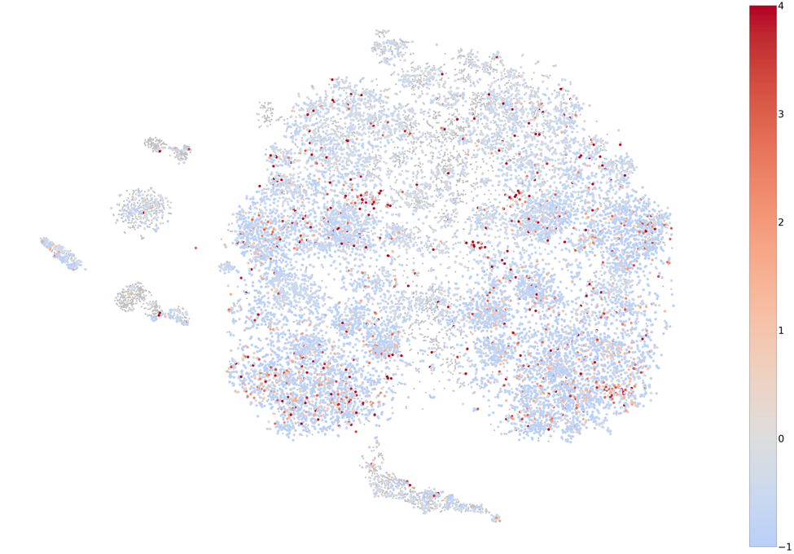
Figure S13: Gene co-expression map with genes colored by z-scores obtained using GTEx muscle expression data.

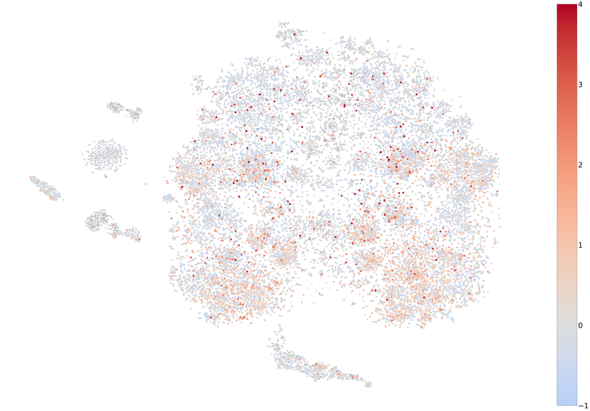
Nerve
Figure S14: Gene co-expression map with genes colored by z-scores obtained using GTEx nerve expression data.

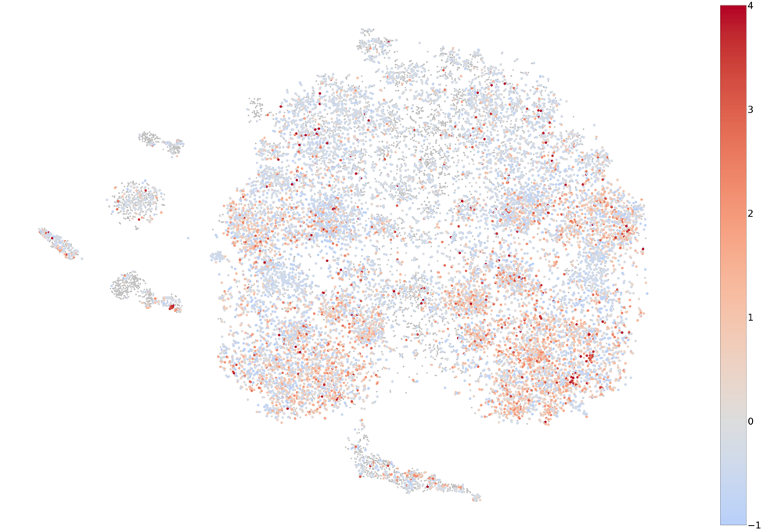
Ovary
Figure S15: Gene co-expression map with genes colored by z-scores obtained using GTEx ovary expression data.

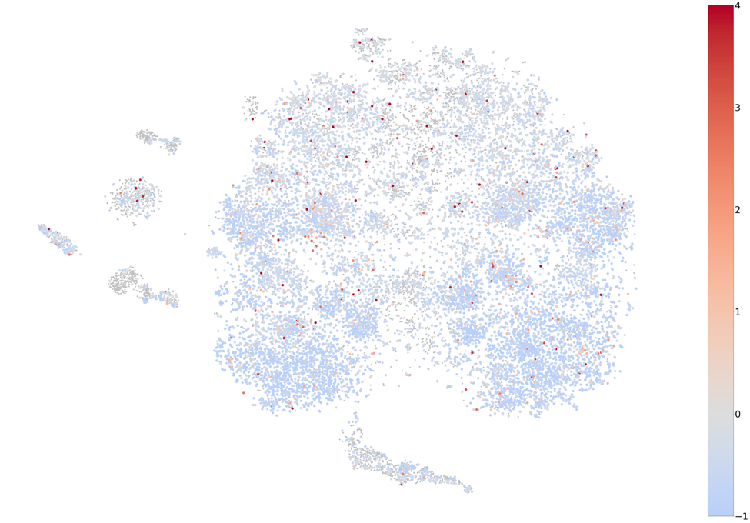
Pancreas
Figure S16: Gene co-expression map with genes colored by z-scores obtained using GTEx pancreas expression data.

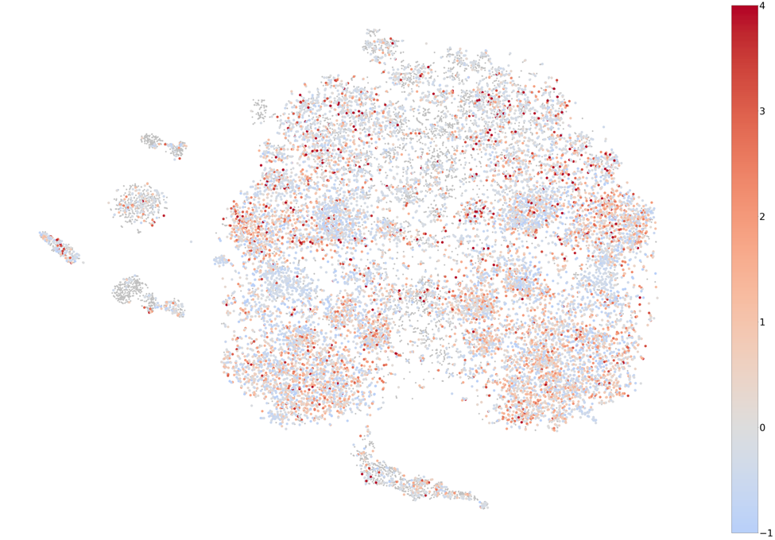
Pituitary
Figure S17: Gene co-expression map with genes colored by z-scores obtained using GTEx pituitary expression data.

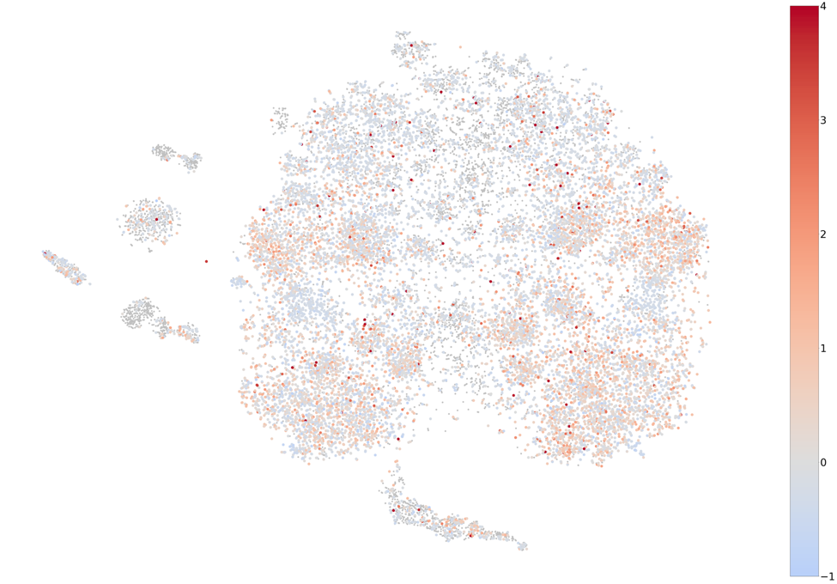
Prostate
Figure S18: Gene co-expression map with genes colored by z-scores obtained using GTEx prostate expression data.

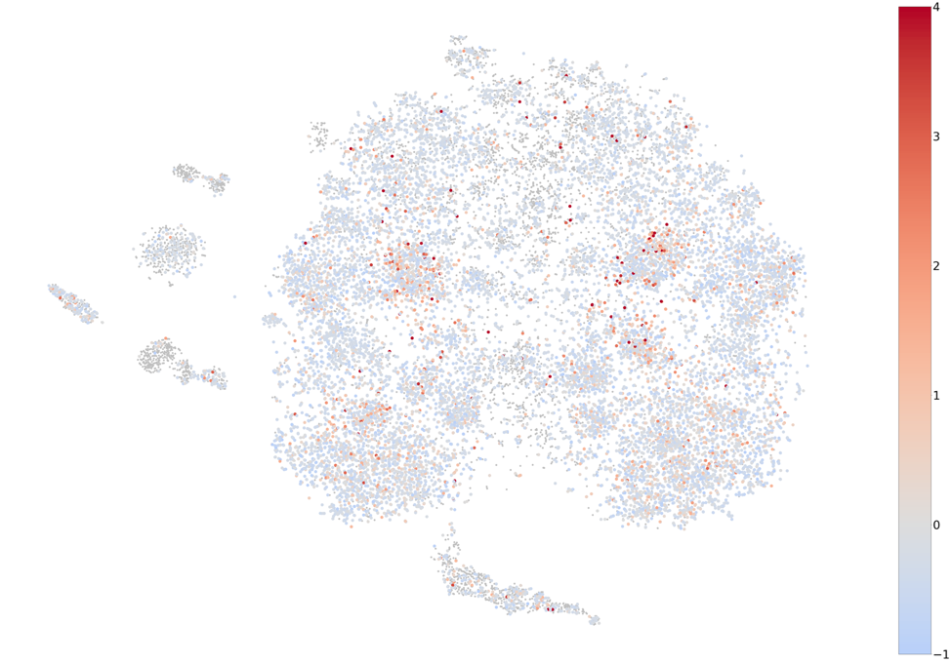
Salivary
Figure S19: Gene co-expression map with genes colored by z-scores obtained using GTEx salivary gland expression data.

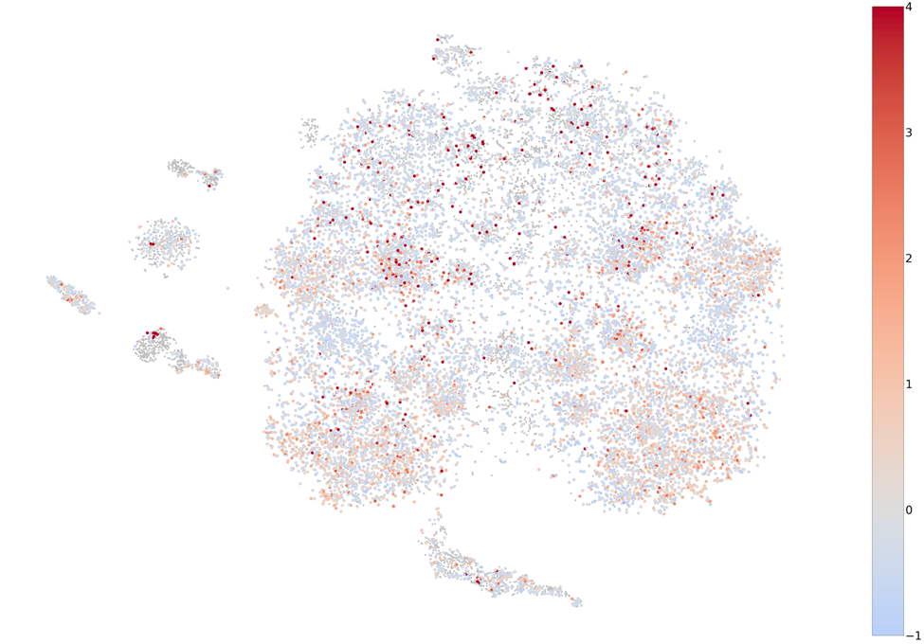
Skin
Figure S20: Gene co-expression map with genes colored by z-scores obtained using GTEx skin expression data.

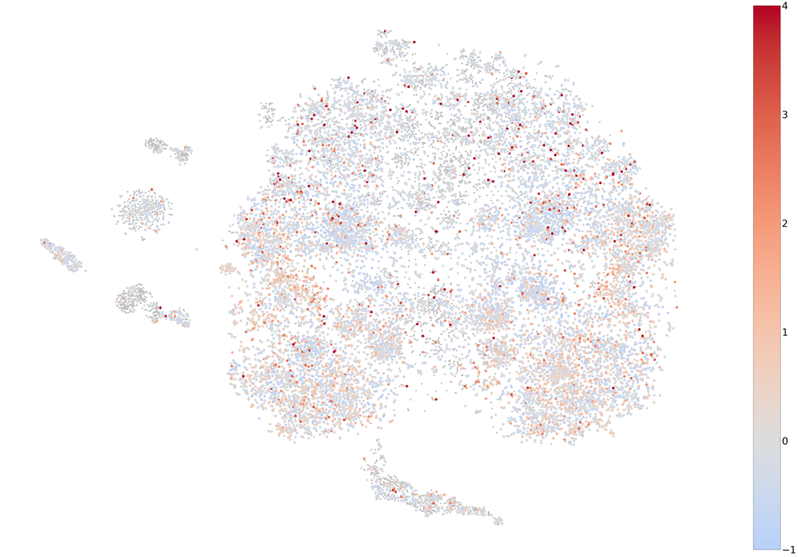
Small intestine
Figure S21: Gene co-expression map with genes colored by z-scores obtained using GTEx small intestine expression data.

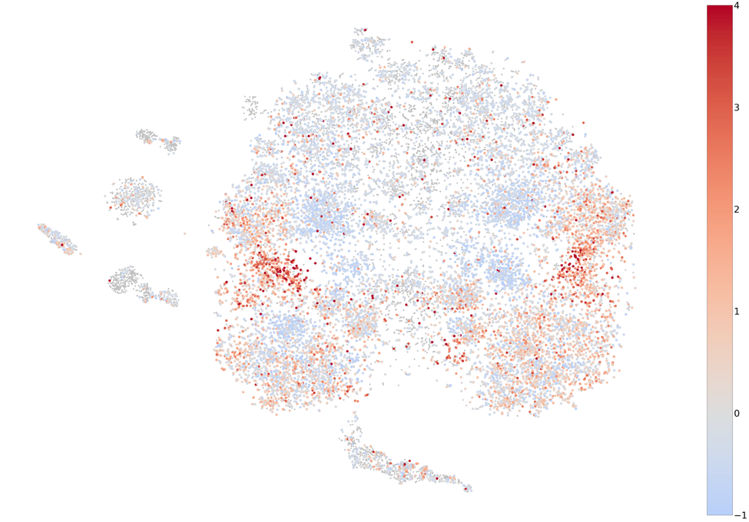
Spleen
Figure S22: Gene co-expression map with genes colored by z-scores obtained using GTEx spleen expression data.

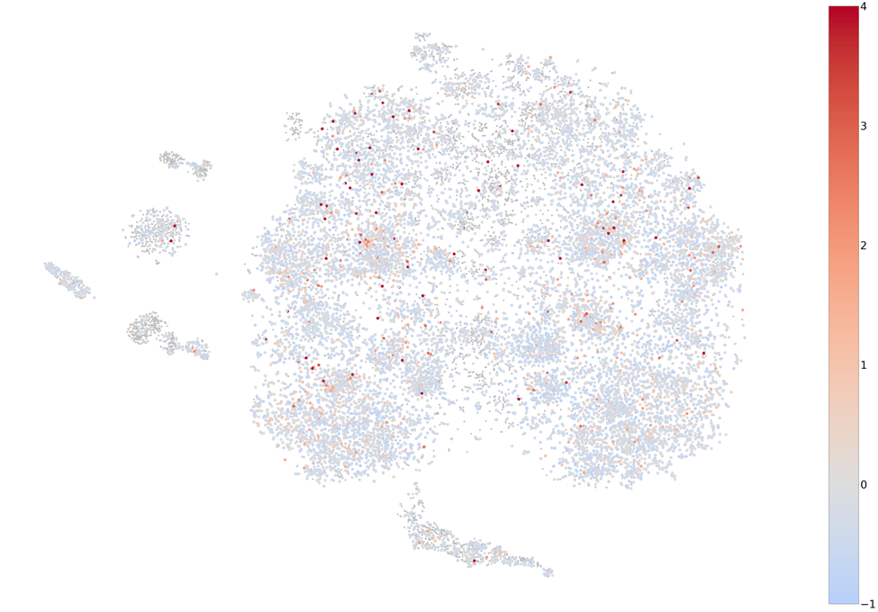
Stomach
Figure S23: Gene co-expression map with genes colored by z-scores obtained using GTEx stomach expression data.

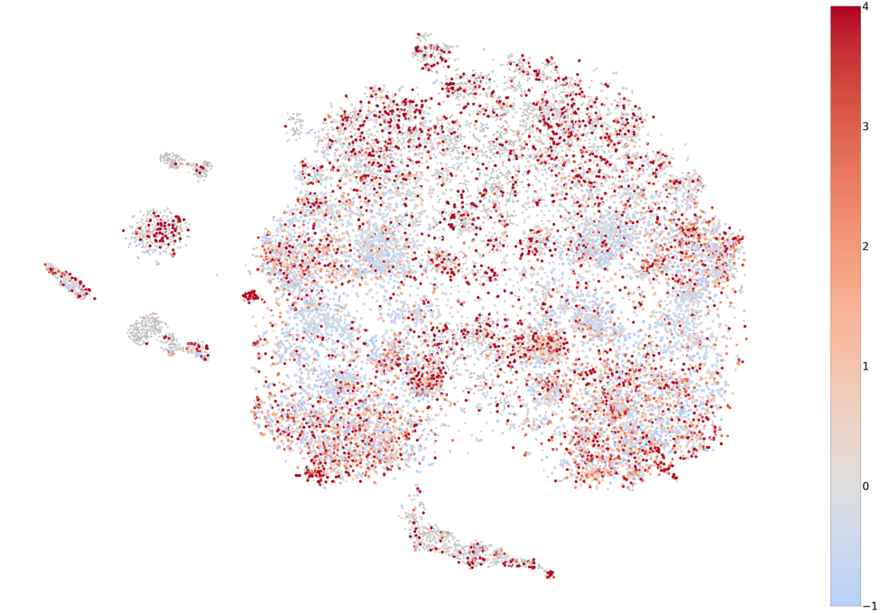
Testis
Figure S24: Gene co-expression map with genes colored by z-scores obtained using GTEx testis expression data.

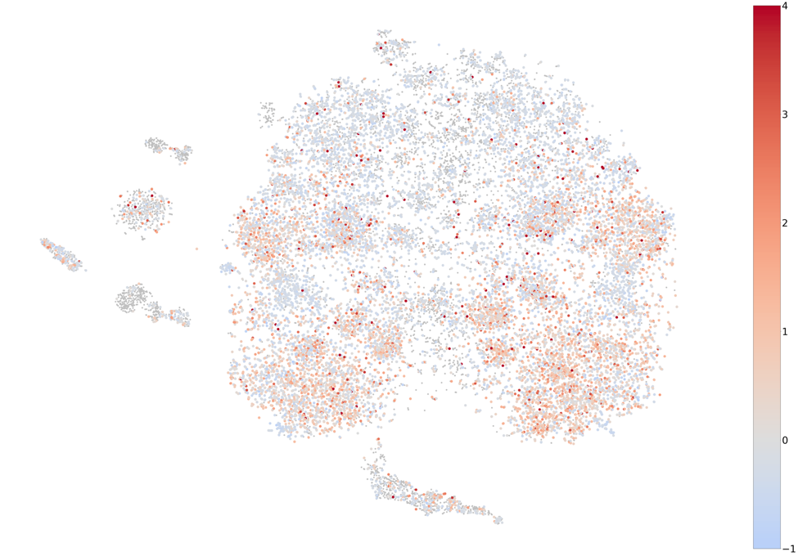
Thyroid
Figure S25: Gene co-expression map with genes colored by z-scores obtained using GTEx thyroid expression data.

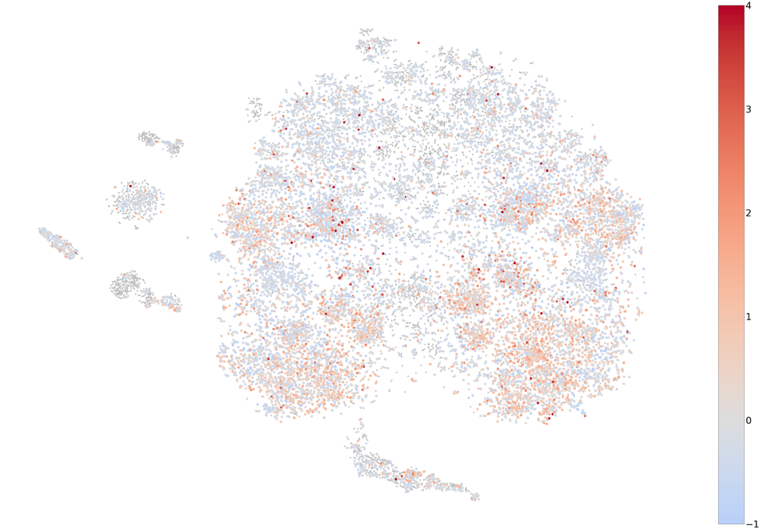
Uterus
Figure S26: Gene co-expression map with genes colored by z-scores obtained using GTEx uterus expression data.

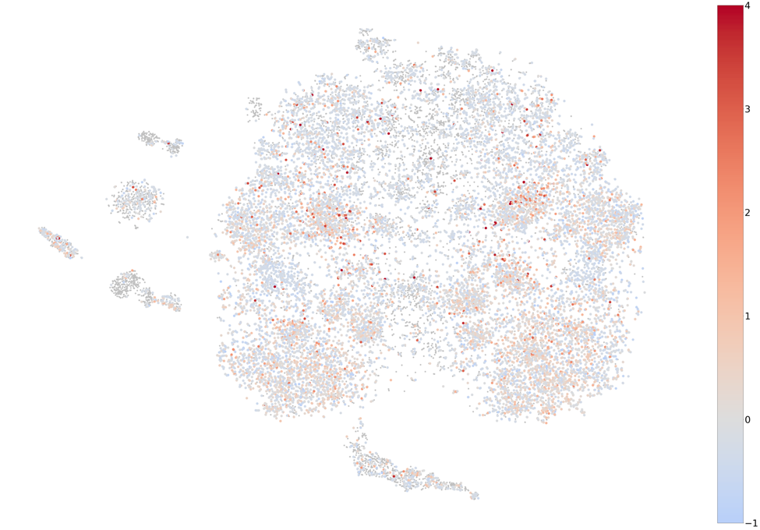
Vagina
Figure S27: Gene co-expression map with genes colored by z-scores obtained using GTEx vagina expression data.

