Supplementary Table 2. Parameter list in data mining of AoXlnR binding sequence.
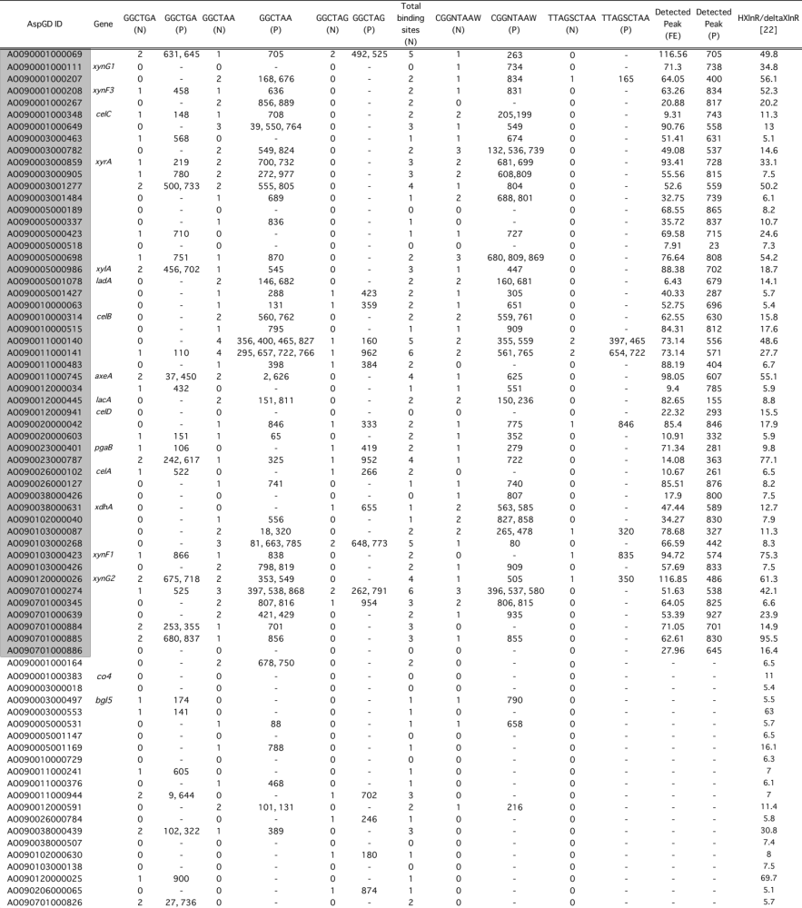
(N), the number of the site; (P), the posion of the site; (FE), fold enrichment. The Gene ID in gray column indicates that the peak was detected in the promoter in gSELEX-Seq analysis.

