Figure S1: Phylogenetic tree of phosphoenolpyruvate carboxylases. Sequence identifiers follow by species label. Node in red indicated “non-regulated” type and node in green indicated “regulated” type of ppc. Sequences were aligned and tree was created with ClustalX2 2.1 [1] and rendered with iTOL [2]

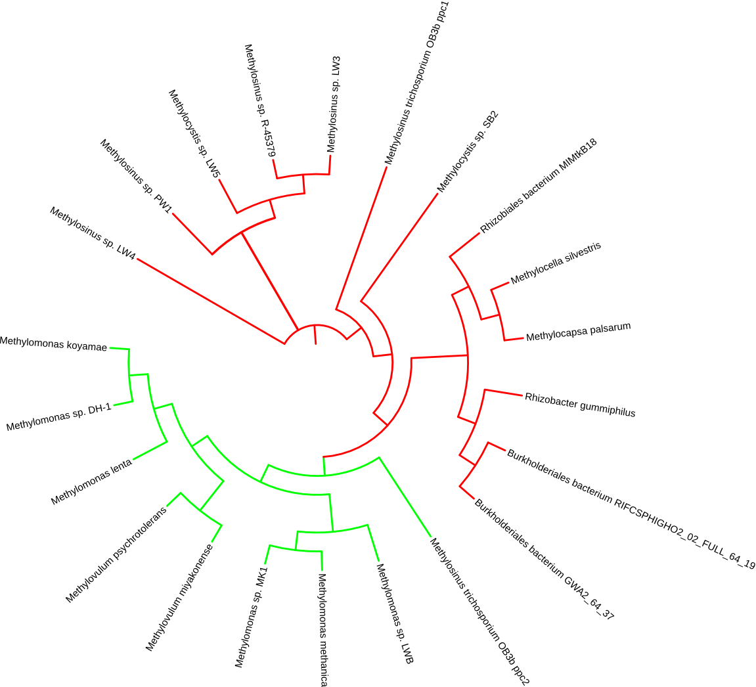
- Larkin MA, Blackshields G, Brown NP, Chenna R, McGettigan PA, McWilliam H, et al. Clustal W and Clustal X version 2.0. Bioinformatics. 2007;23:2947-8
- Letunic I and Bork P. Interactive Tree Of Life (iTOL): an online tool for phylogenetic tree display and annotation. Bioinformatics. 2007;23:127-8.

