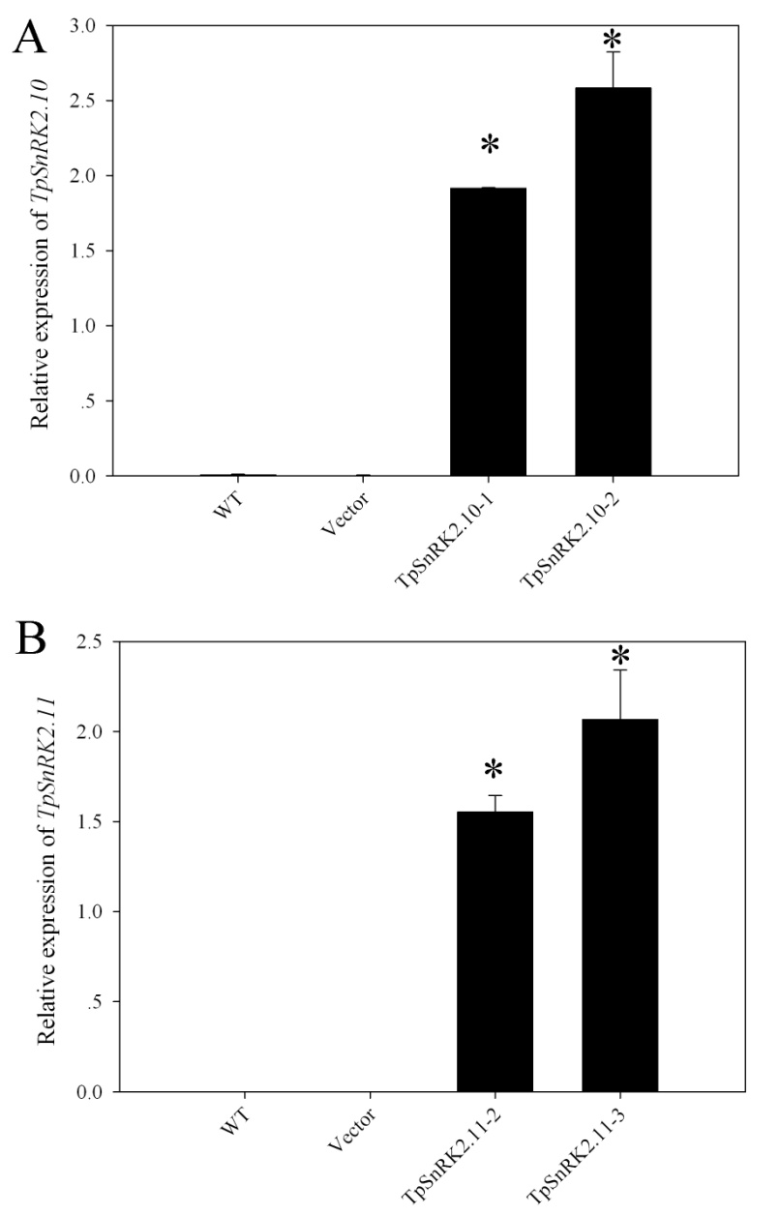
Additional file 1: Figure S1. Relative expression of TpSnRK2.10 (A) and TpSnRK2.11 (B) in transgenic Arabidopsis. Asterisk indicated significant different when compared with WT at P < 0.05; value was mean ± standard deviation (three biological replicates).

