Additional File 1A. Correlations between local GEBV for milk yield and gene expression. Top = milk cells, bottom = white blood cells, correlations were estimated between 250kb intervals and all genes within 1 Mb of the intervals, y-axis = -log10(p-value of the correlation between local GEBV and gene expression).
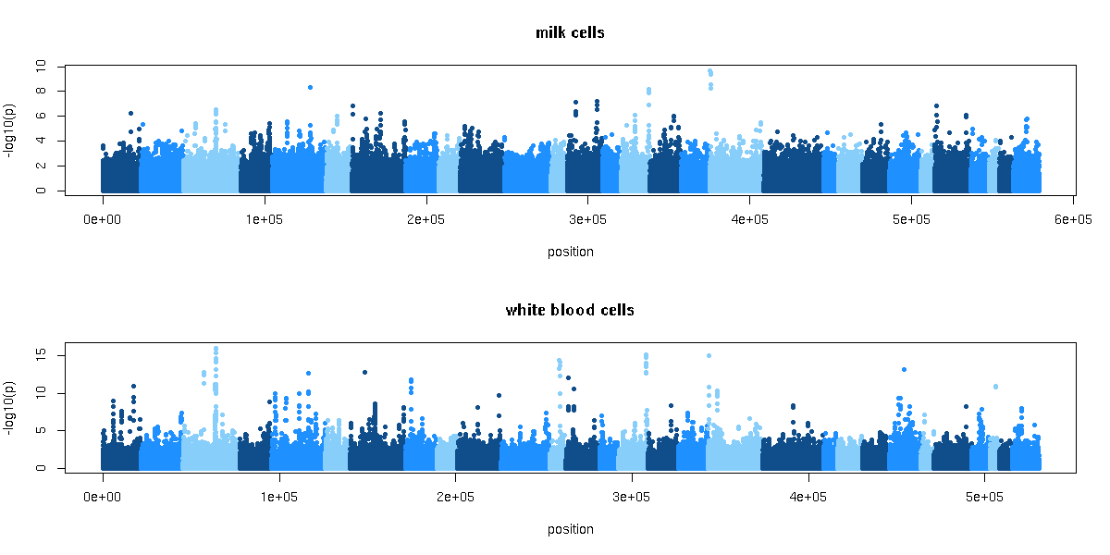
Additional File 1B. Correlations between local GEBV for protein yield and gene expression. Top = milk cells, bottom = white blood cells, correlations were estimated between 250kb intervals and all genes within 1 Mb of the intervals, y-axis = -log10(p-value of the correlation between local GEBV and gene expression).
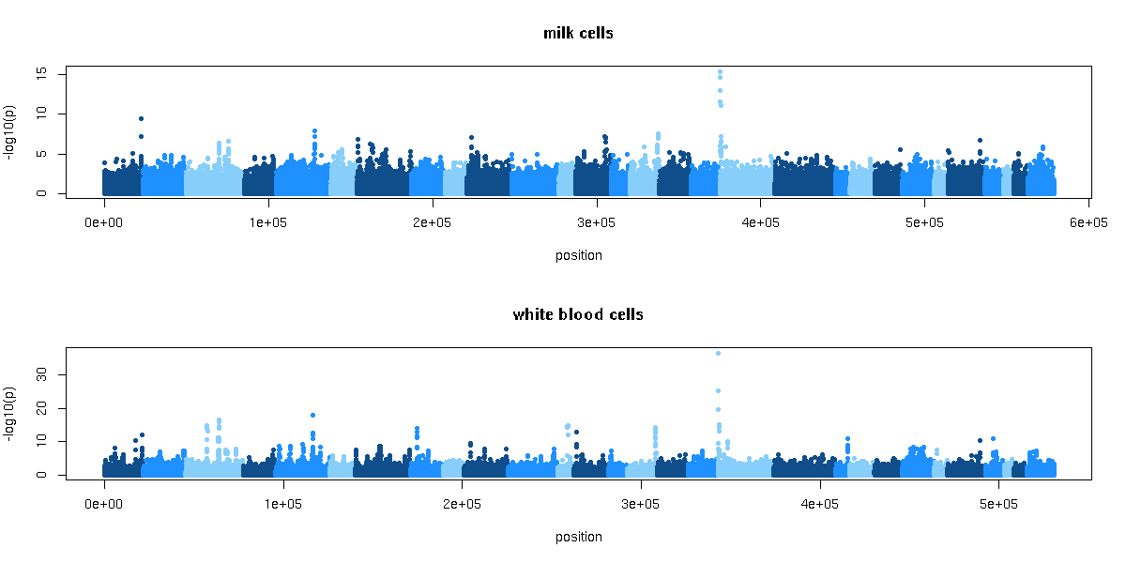
Additional File 1C. Correlations between local GEBV for fat percentage and gene expression. Top = milk cells, bottom = white blood cells, correlations were estimated between 250kb intervals and all genes within 1 Mb of the intervals, y-axis = -log10(p-value of the correlation between local GEBV and gene expression).
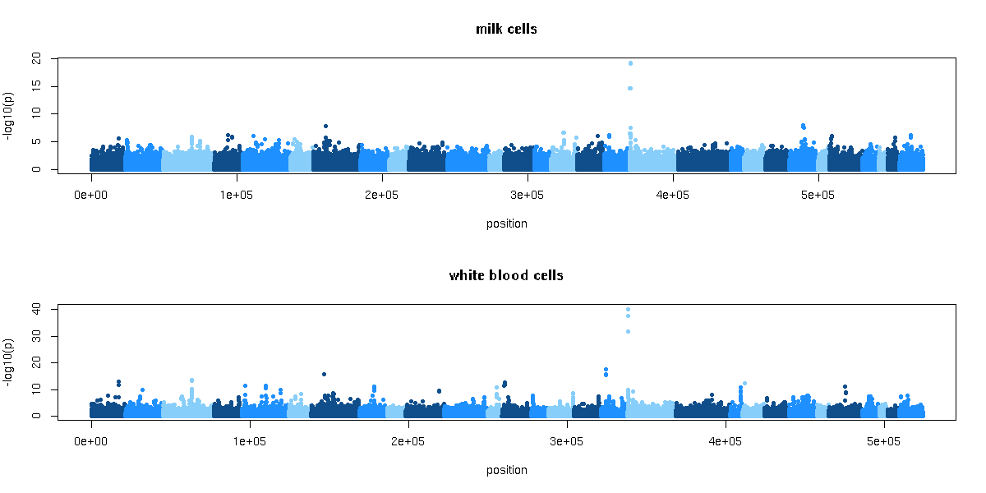
Additional File 1D. Correlations between local GEBV for protein percentage and gene expression. Top = milk cells, bottom = white blood cells, correlations were estimated between 250kb intervals and all genes within 1 Mb of the intervals, y-axis = -log10(p-value of the correlation between local GEBV and gene expression).
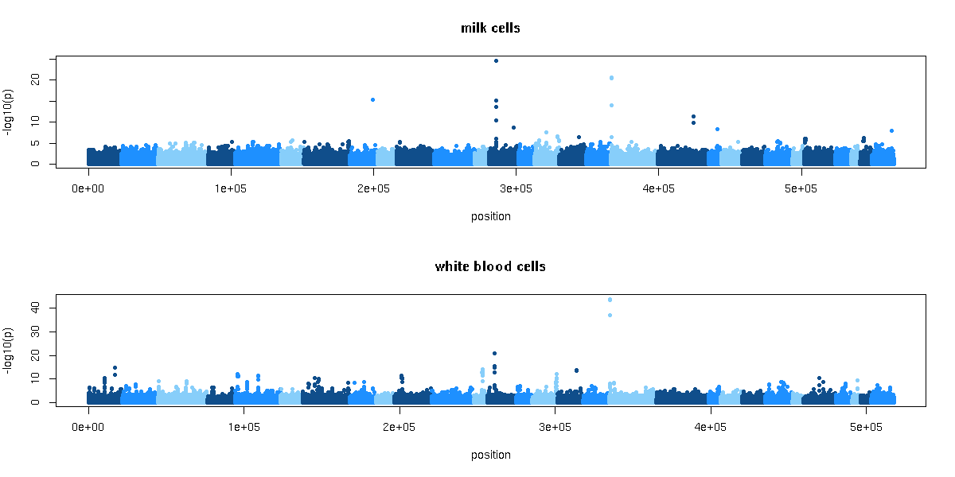
Additional File 1E. Correlations between local GEBV for fertility and gene expression. Top = milk cells, bottom = white blood cells, correlations were estimated between 250kb intervals and all genes within 1 Mb of the intervals, y-axis = -log10(p-value of the correlation between local GEBV and gene expression).
