Supplementary materials
Supplementary Table 1. Samples for clinical validation of Variantyx Unity test.
Patient ID | Type of Variant | Patient Phenotype
Synthetic panel | 24 variants including 2 SVs | N/A
Trisomy1 | Trisomy Chr 21 | N/A
Trisomy2 | Trisomy Chr 18 | N/A
Trisomy3 | Trisomy Chr 13 | N/A
Validation_test_100P | SNV + gross deletion | Neonatal hypotonia, Cardiomegaly, Hepatosplenomegaly, Neurodevelopmental delay, vacuolar myopathy, absence of acid alpha-glucosidase activity in muscle
Validation_test_101P | No SV | Vomiting, Diarrhea, Hypoketotic hypoglycemia, Coma, Decreased plasma carnitine
Validation_test_102P | No SV | Short stature, Opacification of the corneal stroma, Kyphosis, Grayish enamel, Widely spaced teeth, Platyspondyly
Validation_test_103P | No SV | Proximal muscle weakness, Muscular hypotonia, Dyspnea
Validation_test_104P | No SV | Decreased beta-galactosidase activity, Normal N-acetylgalactosamine 6-sulfate sulfatase activity
Validation_test_105P | No SV | Renal insufficiency, Abnormality of the endocardium, Opacification of the corneal stroma, Sensorineural hearing impairment, Nephrotic syndrome, Abdominal pain
Validation_test_106P | Compound het point mutation with large deletion, KRABBE DISEASE, GALC | Decreased nerve conduction velocity, Failure to thrive, Vomiting, Neurodegeneration
Validation_test_107P | No SV | Hyperammonemia, Metabolic acidosis, Feeding difficulties in infancy, Muscular hypotonia
Validation_test_110P | Alt del in ARSB, MPS VI | parents are related through their grandfather, Limitation of joint mobility, Lumbar hyperlordosis, Depressed nasal bridge, Opacification of the corneal stroma, widely-spaced peg-like teeth, prominent eyes, forehead, and tongue
Validation_test_112P | 8k deletion chrX male | MRI of the brain at age 30 was normal; began using a cane at age 28 and was wheel chair bound by age 30, Primary adrenal insufficiency, Spastic paraplegia, loss of vibration sense
Validation_test_113P | 8k het deletion GGA compound with splicing poin mutation | Generalized hypotonia, Hepatomegaly, Macroglossia, Cardiomegaly, Increased muscle glycogen content
Validation_test_115P | arr Xp11.22(53,581,675-53,692,731)x2,22q11.22q11.23(21,390,449-21,978,719)x1 | Family history suggests X-linked inheritance, Intellectual disability, Macrocephaly
Validation_test_116P | arr 2q37.2q37.3(236,218,793-242,654,701)x3,11q25(131,542,057-134,434,130)x1 | Schizophrenia
Validation_test_117P | arr[hg19] 5q33.1q35.3(152,281,639-180,686,444)x3,7q36.2q36.3(155,040,999-159,123,167)x1 | Anterior sacral meningocele, Aplasia/Hypoplasia of the sacrum, Presacral teratoma, Holoprosencephaly, Intellectual disability, Mild microcephaly, Short stature
Validation_test_118P | Deletion DMD exon 44 | Muscular dystrophy, Calf muscle pseudohypertrophy
Validation_test_119P | No SV | Progressive cerebellar ataxia, Dysarthria, Bulbar palsy
Validation_test_120P | No SV | Microcephaly, Intellectual disability, severe, Aplasia/Hypoplasia involving the central nervous system
Validation_test_121P | No SV | Dementia
Validation_test_122P | No SV | Dilated cardiomyopathy
Validation_test_123P | No SV | Autism
Validation_test_124P | No SV | High nonceruloplasmin-bound serum copper, Cirrhosis, Proteinuria, Kayser-Fleischer ring
Validation_test_125P | No SV | Flat face, Protruding tongue, Brachycephaly, Thickened nuchal skin fold, Intellectual disability, Muscular hypotonia, Brushfield spots, Broad palm
Validation_test_126P | No SV | Ataxia, Muscular hypotonia, retinitis pigmentosa
Validation_test_127P | No SV | Intrauterine growth retardation, Abnormality of cardiovascular system morphology, Micrognathia, clenched fists with overlapping fingers
Validation_test_128P | No SV | Global developmental delay
Validation_test_129P | No SV | Anencephaly, Spina bifida, Primary adrenal insufficiency
Validation_test_201P | Gross deletion | Autism, Speech and developmental delay
Validation_test_201R1 | No SV | Non-symptomatic
Validation_test_201R2 | No SV | Non-symptomatic
Validation_test_204P | Gross deletion | Calf muscle pseudohypertrophy, Elevated serum creatine phosphokinase, Dilated cardiomyopathy, Progressive muscle weakness
Validation_test_205P | 53 bp deletion | Hypertension, Impaired platelet aggregation, Thrombocytosis, Splenomegaly
Validation_test_206P | No SV | Has done liver biopsy - Hepatocellular cholestasis with balooning degeneration and microvesicular steatosis, Prolonged neonatal jaundice
Validation_test_207P | Gross duplication | Age of onset 45, Dementia, Tremor, Glomerulonephritis, Ischemic stroke, Obesity
Validation_test_207R1 | No SV | Non-symptomatic
Validation_test_207R2 | No SV | Non-symptomatic
Validation_test_207R3 | No SV | Non-symptomatic
Validation_test_211P | No SV | Cataract, Muscular hypotonia, Myotonia, Skeletal muscle atrophy
Validation_test_212P | No SV | Myotonia, Skeletal muscle atrophy
Validation_test_214P | No SV | Short stature, Pigmentary retinopathy, Reduced tendon reflexes, Sensorineural hearing impairment, Ptosis
Validation_test_215P | CHROMOSOME DELETION | Craniofacial dysmorphia
Validation_test_216P | DUPLICATED CHROMOSOME COPY NUMBER VARIATION (CNV) REFERENCE PANEL | Generalized hypotonia, Global developmental delay, dysmorphic facies, incontinentia pigmenti type of skin lesions
Validation_test_218P | TRANSLOCATED CHROMOSOME | Abortus fibroblast culture
Validation_test_220P | RECOMBINANT CHROMOSOME COPY NUMBER VARIATION (CNV) REFERENCE PANEL 02 | Global developmental delay, Failure to thrive, Congenital heart disease
Validation_test_221P | No SV | Dysarthria, Dysmetria, Hyperreflexia, Cone/cone-rod dystrophy, Dysphagia, Babinski sign
Validation_test_222P | No SV | Dementia, Behavioral abnormality, Personality changes, Abnormality of the voice, EEG abnormality, Spasticity
Validation_test_223P | No SV | Intellectual diability, mild
Validation_test_224P | No SV | Intellectual diability, moderate
Validation_test_225P | No SV | Premature ovarian failure
Validation_test_226P | No SV | One affected son, moderate intellectual disability, Premature ovarian failure
Validation_test_227P | No SV | Intellectual diability, mild
Validation_test_228P | No SV | Intention tremor
Validation_test_229P | No SV | Intention tremor
Validation_test_230P | No SV | Intention tremor, MRI findings: white matter lesions involving middle cerebellar peduncles, Gait ataxia
Validation_test_231P | No SV | Non-symptomatic
Validation_test_232P | No SV | Intention tremor, Orthostatic hypotension, Deficit in phonologic short-term memory, MRI findings: lesions of cerebral white matter
Validation_test_241P | No SV | Muscle weakness, Limb girdle and distal inclusion body myopathy
Validation_test_241R1 | No SV | Non-symptomatic
Validation_test_241R2 | No SV | Non-symptomatic
Validation_test_244P | No SV | Distal amyotrophy, Myotonia, Reduced tendon reflexes, difficulty swallowing
Validation_test_245P | No SV | Bilateral ptosis, Lower limb muscle weakness, poor ability to swallow cold liquids, difficulty walking on heels, Mother, maternal aunt, two maternal cousins; maternal grandmother (and many of maternal grandmother’s siblings) are also affected.

Supplementary Table 2. Variantyx Unity test thresholds.
Source | Name | Threshold
DNA Extraction and Quality Control | NanoDrop concentration | 30ng/ul
DNA Extraction and Quality Control | NanoDrop 260/280 | 1.8
DNA Extraction and Quality Control | NanoDrop 260/230 | 1.8
DNA Extraction and Quality Control | DIN | 7
DNA Extraction and Quality Control | Electrophoresis gel test success | Pass
DNA Extraction and Quality Control | Volume sent to sequencer | 60ul
DNA Extraction and Quality Control | Concentration sent to sequencer | 30ng/ul
DNA Extraction and Quality Control | Qubit | Yes
Alignment Quality Metrics | Mapped Reads | 97%
Alignment Quality Metrics | Properly Paired Reads Over Total | 93%
Alignment Quality Metrics | Properly Paired Reads Over Mapped | 93%
Alignment Quality Metrics | QC Failed Reads | 0%
Alignment Quality Metrics | Duplicate Reads | 28%
Aneuploidy Analysis | Normalized Ploidy | >2.5 or <1.5 autosomes, >1.5 or <0.5 sex chr
Aneuploidy Analysis | Predicted Gender | Matches reported gender
Aligner | Min Average On-Target Depth | 90% of requested (30X)
Aligner | Min On-Target >8x Coverage | 98%
Aligner | Min On-Target >0x Coverage | 99%
Aligner | Average Template Length | 350 - 850
Aligner | Duplicate Max | 28%
Aligner | Global Het VAF Min | 44%
Aligner | % Bases with Variants | 0.03% - 0.3%
Aligner | Coding Region with Coverage Min | 98%
Aligner | Clinically Relevant with Coverage Min | 99%

Supplemental Figure 1. Causative heterozygous deletion of 45 bp detected and reported by Variantyx Unity test.
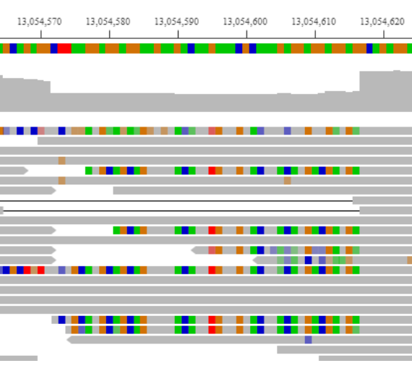

Supplementary Figure 2. Analytical validation statistics of small sequence changes by Variantyx Unity test basing on combination of 3 different Genome in the Bottle samples.
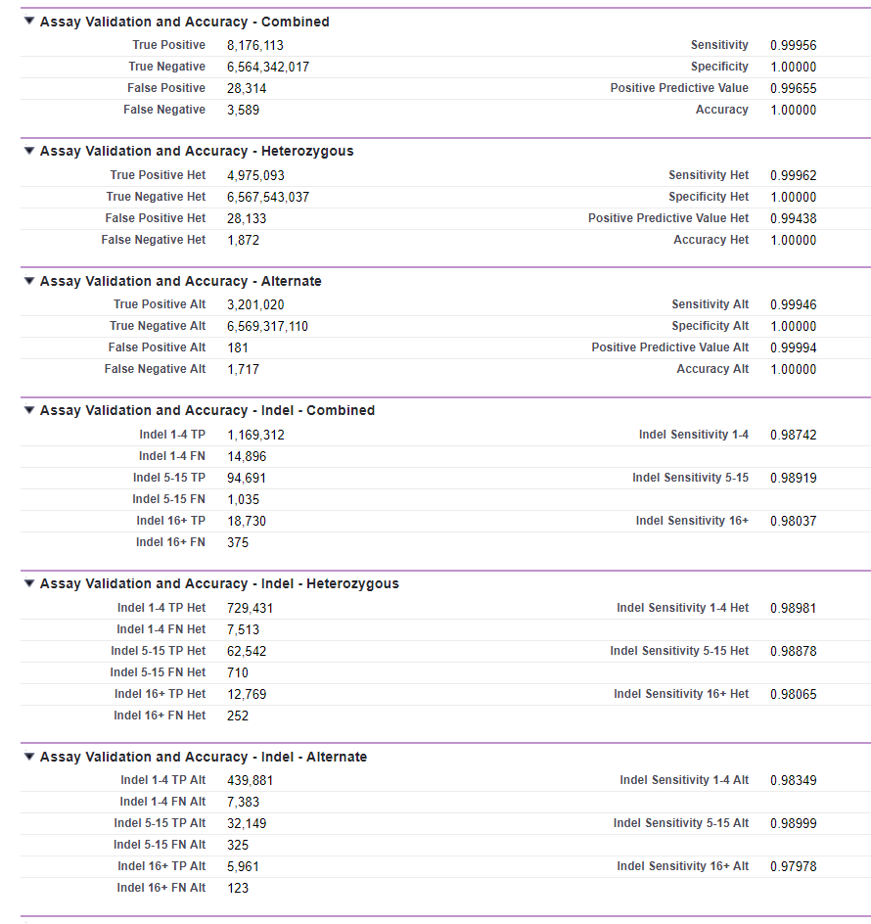
Supplementary Method 1. Variantyx diagnostic procedure for reporting pathogenic structural variants.

    - Structural variants (Applicable for Whole Genome Sequencing only)
      - At the top of the page, click the top left most selector and select “structural variants”
      - Review and annotate the structural variants:
      - Review all variants for size; if > than 3 Mb
        - Note if variant includes any genes or parts of genes
        - Note if the genes have known function
        - Map the variant in the Database of Genomic Variants
          - http://dgv.tcag.ca/dgv/app/home?ref=GRCh38/hg38
          - Make sure you map in Hg38
          - Copy the CNV location into the search bar in the format: Chr1:123456-125678
          - Review the genome map to determine if their are any overlapping reported deletions (red) or duplications (blue)
          - Review in IGV to look for:
            - Split Reads
            - Depth Calls
            - Non-uniquely mapped reads
            - Poor Quality Reads
      - Report all variants > 3 Mb even without associated phenotype if
        - It is not reported in DGV AND
        - Looks reliable in IGV
      - Review all variants for size, if < than 3 Mb
        - Note reported phenotype and gender of the proband
        - Select structural variants including genes with a
          - Matching phenotype - gene(s) involved appears to be an explanation for the with reported phenotype (mark as primary)
          - Overlapping phenotype - gene (s) involved appear to overlap with at least one phentoype or be in the same organ system (mark as secondary)
        - Note if allele frequency makes sense with phenotype, age, suspected inheritance and gender of proband
          - i.e Severe multiple congenital anomalies likely represent a more fully penetrant condition and autosomal dominant and therefore an allele frequency of 1/1000 in healthy populations (DGV)is too high.
          - I.e. If phenotype is adult onset and more mild or variably penetrant, an allele frequency of 1/1000 in healthy adults in DGV may be plausible due to lack of symptoms at that age or mild symptoms.
          - I.e. If condition associated with CNV is Autosomal Recessive, check if a second SNV is present; if not, the individual will be a carrier and the CNV not reported
        - Note if variant includes any genes or parts of genes
        - Note if the genes have known function
        - Map the variant in the Database of Genomic Variants
          - http://dgv.tcag.ca/dgv/app/home?ref=GRCh38/hg38
          - Make sure you map in Hg38
          - Copy the CNV location into the search bar in the format: Chr1:12345678-12567890
          - Review the genome map to determine if their are any overlapping reported deletions (red) or duplications (blue)
        - Some structural variants are split into multiple variants so sort by chromosome and check coordinates to identify those in tandem to identify the larger variant
        - Even if have identified a causative structural variant, continue to review the remaining variants to ensure there are not two or more structural variants.
        - Classify each selected variant as described in the following two guidelines:
          - http://www.nature.com.proxy.hsl.ucdenver.edu/articles/gim92011110.pdf
          - https://www.ncbi.nlm.nih.gov/pmc/articles/PMC5655614/pdf/13353_2017_Article_407.pdf
          - Pathogenic
          - Variant of Uncertain Significance - Likely Pathogenic
          - Variant of Uncertain Significance
          - Variant of Uncertain Significance - Benign
          - Benign
        - Report only variants that are in Primary or Secondary AND are classified as Pathogenic, Variant of Uncertain Significance-Likely Pathogenic AND Variant of Uncertain Significance
        - Do Not Report
          - Carrier variants
          - Pathogenic or Likely Pathogenic variants that are UNRELATED to the phenotype other than those that involve the ACMG 59 incidental finding genes < 3 MB
      - If there are any variants that look relevant but are questionable after reviewing IGV; recommend confirmation with an orthogonal technology on the report
    - Report generation
Press the ‘report generation’ button to create a report in docx format. This report will include all of the genetic findings along with any comments and follow up recommendations, disclaimers and variant information. This report is also attached to the bioinformatic analysis.
      - The Word Document generated should be reviewed for:
        - Typographical errors
        - Comparison with TRF data to ensure identifiers are entered accurately
        - Editing for aesthetics and ease of reading (delete extra spaces, non-grammatically correct imported language etc.)
        - Inclusion of any pertinent aspects of testing that may not be accounted for i.e. sample of poor quality or other factors that might impact interpretation

