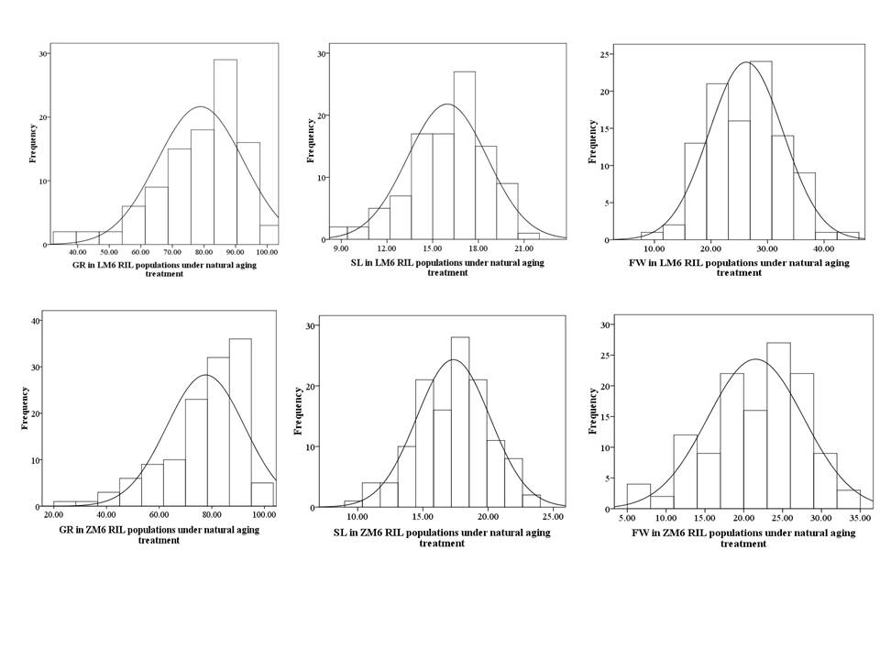
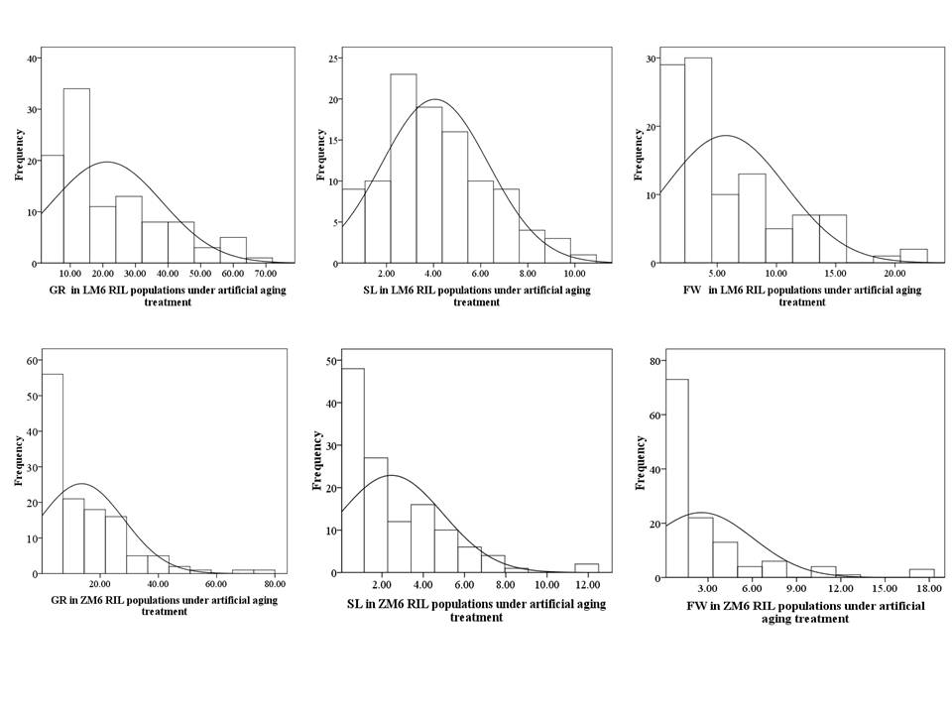
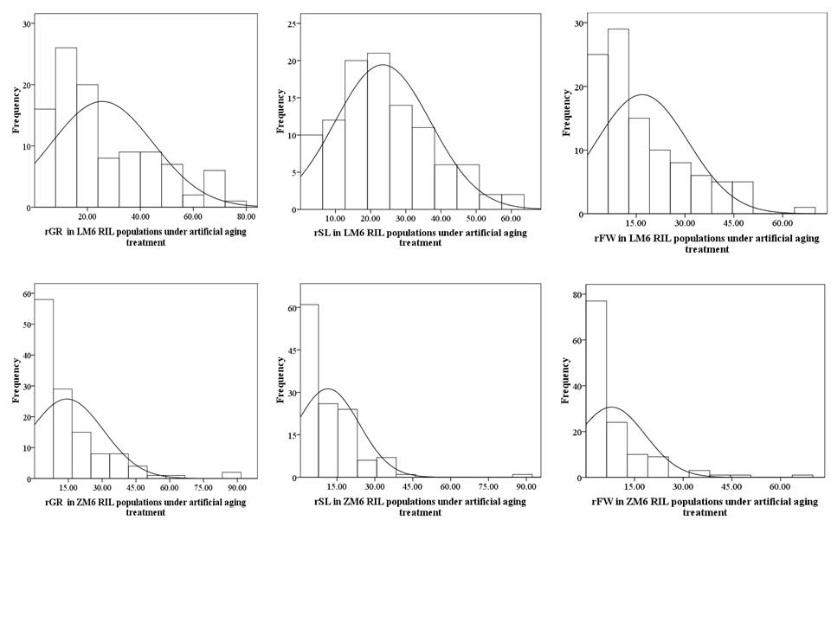
Supplementary Fig. S1: Frequency distribution of germination rate (GR), normal seedling length (SL) and normal seedling fresh weight (FW) of LM6 and ZM6 RIL populations under natural and artificial aging conditions.
For natural aging only treatment trait were used for analysis, whereas for artificial aging both treatment and relative trait value have been used for analysis. Relative germination rate (rGR); Relative normal seedling length (rSL); Relative normal seedling fresh weight (rFW).

