Confusion matrix for training data
Fold10 |  | Fold9 |  | Fold8 |  | Fold7 |  | Fold6 |  | Fold5 |  | Fold4 |  | Fold3 |  | Fold2 |  | Fold1
- | + | - | + | - | + | - | + | - | + | - | + | - | + | - | + | - | + | - | +
69 | 227 | 67 | 228 | 68 | 227 | 70 | 225 | 69 | 226 | 64 | 231 | 63 | 232 | 68 | 227 | 65 | 230 | 68 | 228 | +
215 | 57 | 217 | 56 | 215 | 58 | 212 | 61 | 215 | 58 | 219 | 54 | 216 | 57 | 219 | 54 | 213 | 59 | 211 | 61 | -

Performance evaluation for training data
AUC % | Accuracy % | F_measure % | Recall % | Precision % | Fold#
82.38 | 77.29 | 77.94 | 77.02 | 78.90 | 1
82.93 | 78.13 | 78.76 | 77.97 | 79.59 | 2
83.81 | 78.52 | 78.81 | 76.95 | 80.78 | 3
84.00 | 78.87 | 79.45 | 78.64 | 80.28 | 4
83.61 | 79.22 | 79.65 | 78.30 | 81.05 | 5
83.08 | 77.64 | 78.06 | 76.61 | 79.58 | 6
82.57 | 76.94 | 77.45 | 76.27 | 78.67 | 7
82.84 | 77.81 | 78.28 | 76.95 | 79.65 | 8
83.28 | 78.34 | 78.76 | 77.29 | 80.28 | 9
83.27 | 77.82 | 78.27 | 76.69 | 79.93 | 10

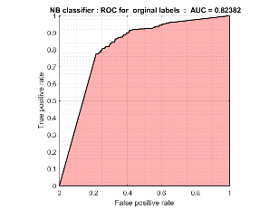 | 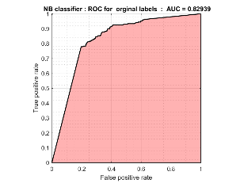 | 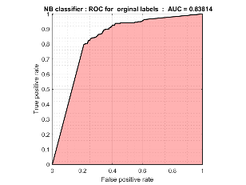 | 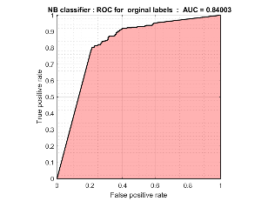 | 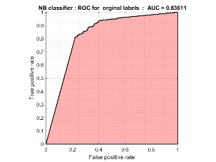
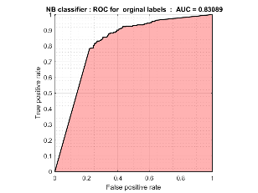 | 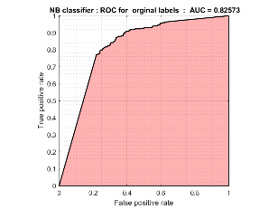 | 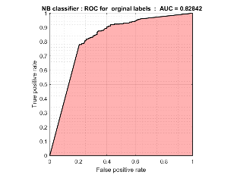 | 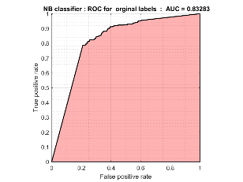 | 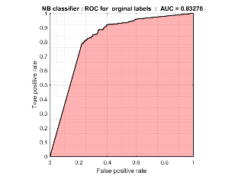

Confusion matrix for test data
Fold10 |  | Fold9 |  | Fold8 |  | Fold7 |  | Fold6 |  | Fold5 |  | Fold4 |  | Fold3 |  | Fold2 |  | Fold1
- | + | - | + | - | + | - | + | - | + | - | + | - | + | - | + | - | + | - | +
7 | 25 | 6 | 27 | 6 | 27 | 6 | 27 | 4 | 29 | 12 | 21 | 15 | 18 | 7 | 26 | 9 | 24 | 6 | 26 | +
23 | 8 | 22 | 8 | 24 | 6 | 26 | 4 | 23 | 7 | 22 | 8 | 26 | 4 | 19 | 11 | 25 | 6 | 27 | 4 | -

Performance evaluation for test data
AUC % | Accuracy % | F_measure % | Recall % | Precision % | Fold#
90.97 | 84.13 | 83.87 | 81.25 | 86.67 | 1
84.31 | 76.56 | 76.19 | 72.72 | 80.00 | 2
75.30 | 71.43 | 74.29 | 78.79 | 70.27 | 3
72.52 | 69.84 | 65.45 | 54.54 | 81.81 | 4
74.59 | 68.25 | 67.74 | 63.64 | 72.41 | 5
83.83 | 82.53 | 84.05 | 87.88 | 80.55 | 6
88.99 | 84.13 | 84.37 | 81.82 | 87.09 | 7
83.73 | 80.95 | 81.82 | 81.82 | 81.82 | 8
80.70 | 77.78 | 79.41 | 81.82 | 77.14 | 9
78.83 | 76.19 | 76.92 | 78.12 | 75.76 | 10

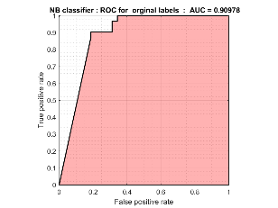 | 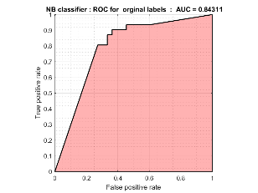 | 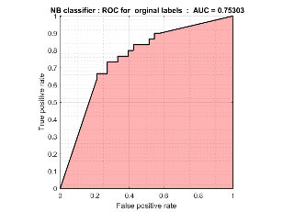 | 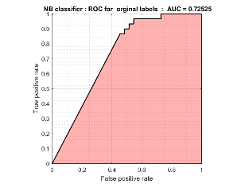 | 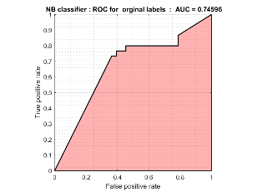
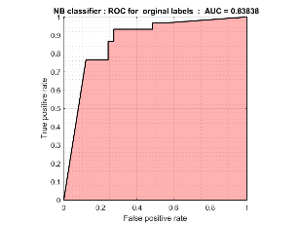 | 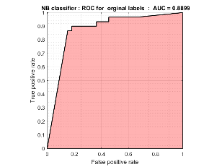 | 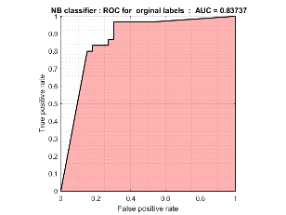 | 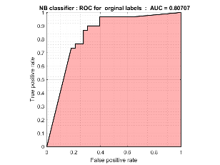 | 