Additional file 1:
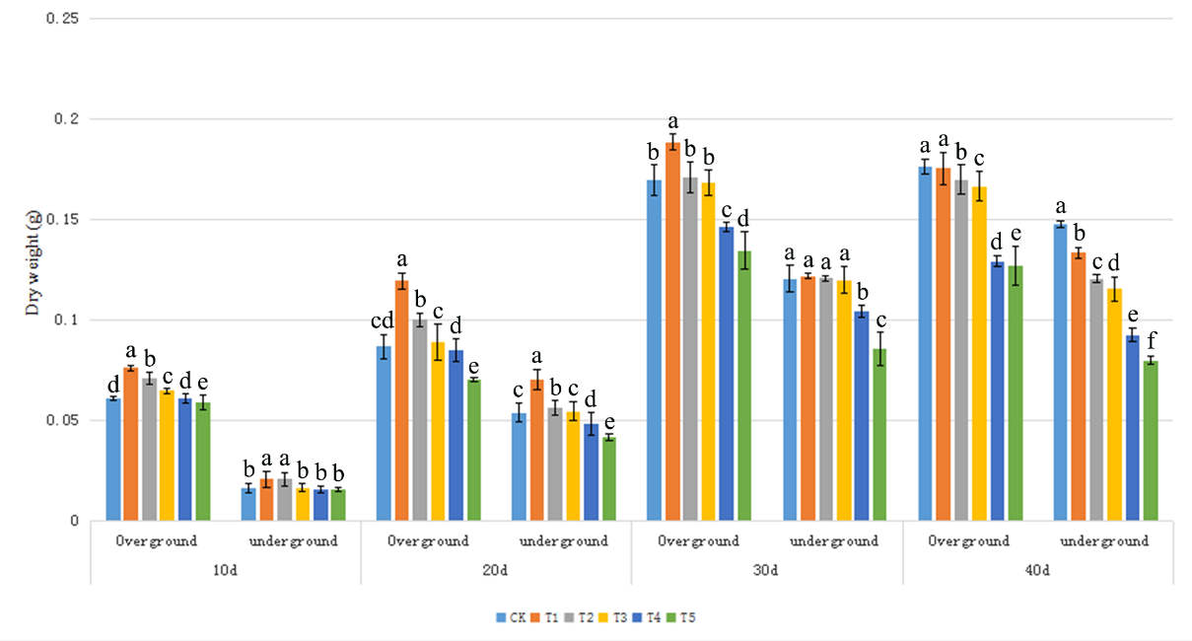
Figure S1 Changes of Verbena bonariensis biomass under Cd different concentration stress.

