Additional file 2:
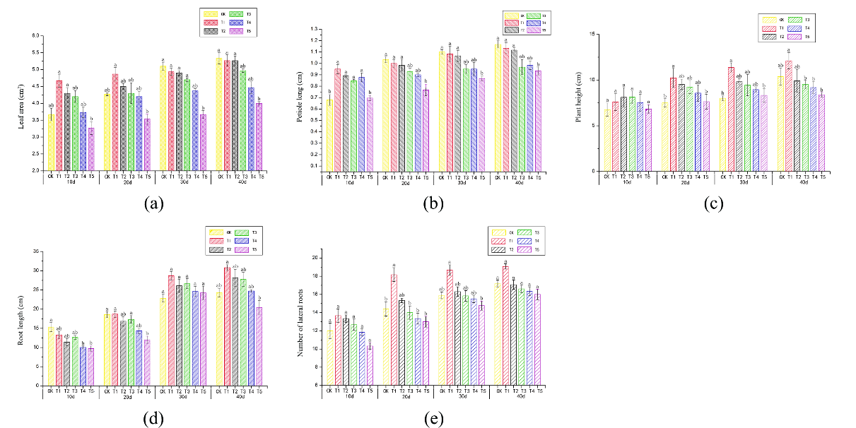
Figure S2 Changes of Verbena bonariensis morphological indexes under Cd different concentration stress. (a) Leaf area; (b) petiole long; (c) Plant height; (d) Root length; (e) Number of lateral roots.

