Additional file 3:
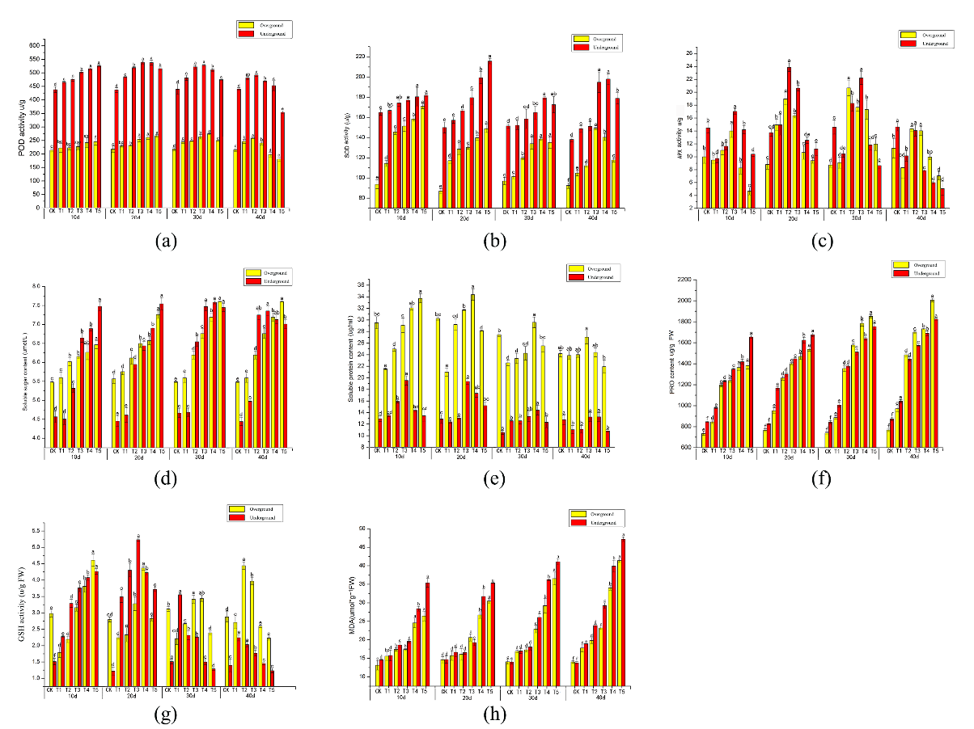
Figure S3 Changes of Verbena bonariensis physiological indexes under Cd different concentration stress. (a) POD activity; (b) SOD activity; (c) APX activity；(d) Soluble sugar content; (e) Soluble protein content; (f) PRO content; (g) GSH activity; (h) MDA activity.

