Additional file 4:
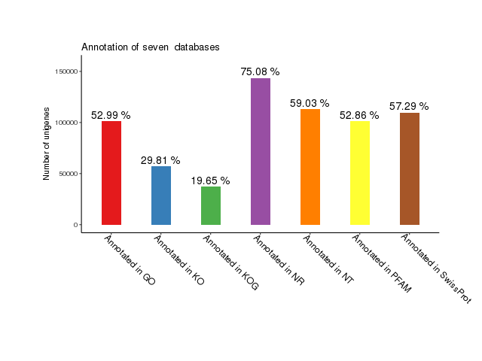
Figure S4 Unigenes notes success statistics in each database.

