Additional file 5:
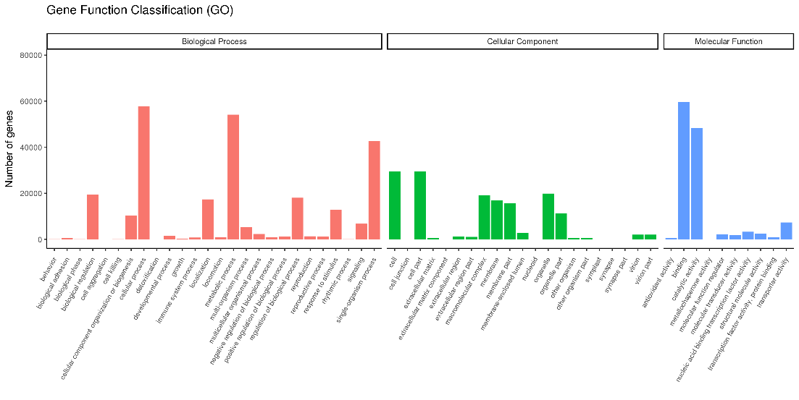
Figure S5 Unigenes classified statistics based on GO annotations.

