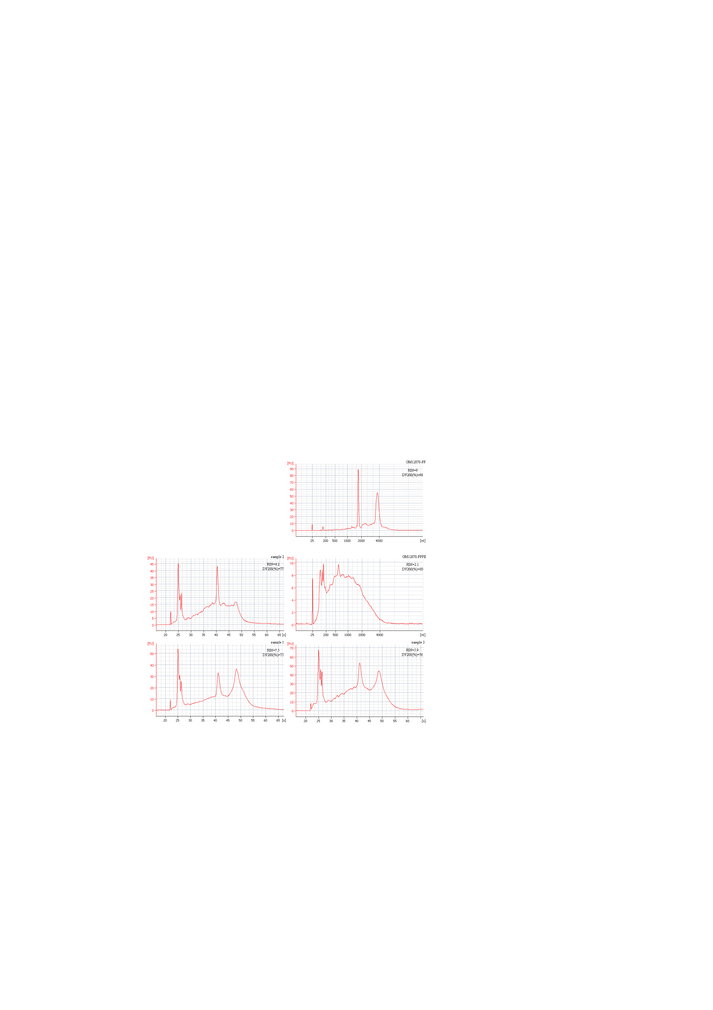
Additional file 1: Figure S1 The quality of the RNA samples from GM12878 fresh cells and paired FFPE sample.

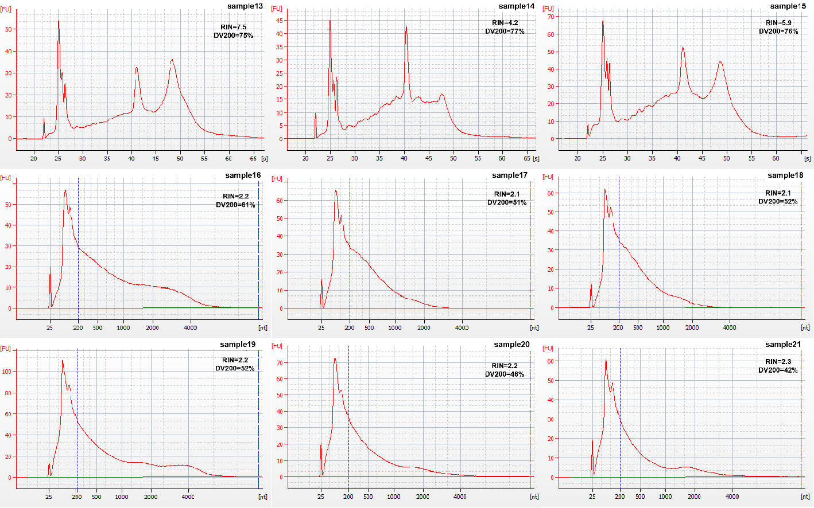
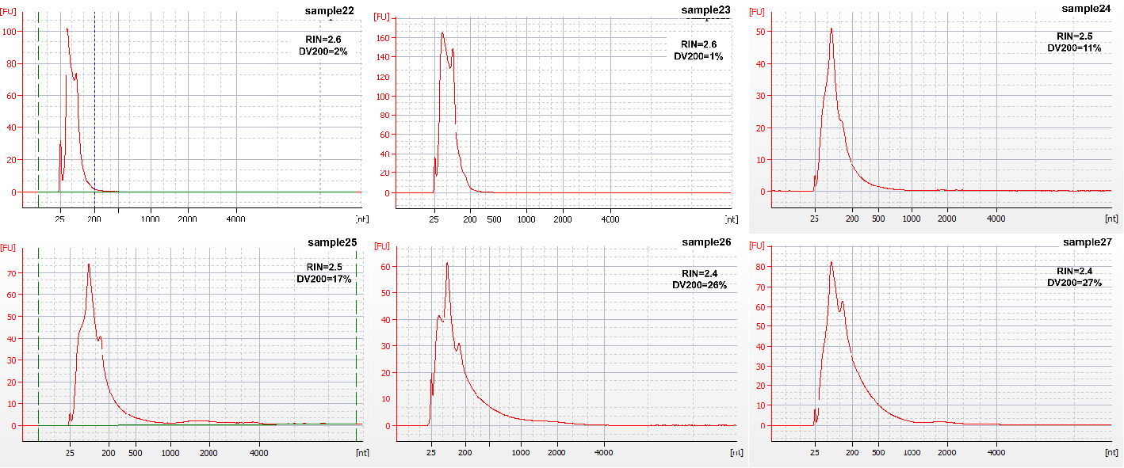
Additional file 1: Figure S2 The quality of the RNA samples from the fifteen clinical samples

Additional file 1: Table S1 Comparison of four RNA library preparation kits for FFPE samples
Kits | KAPA |  |  | TaKaRa |  |  | Vazyme |  |  | QIAGEN
Sample | sample 13 | sample 14 | sample 15 | sample 13 | sample 14 | sample 15 | sample 13 | sample 14 | sample 15 | sample 13 | sample 14 | sample 15
Input total RNA (ng) | 100 |  |  | 50 |  |  | 100 |  |  | 100
PCR cycles | 15 |  |  | 13 |  |  | 15 |  |  | 15
Library (ng) | 48.8 | 31.2 | 17.2 | 115.6 | 448 | 242 | 124.0 | 377.5 | 200.5 | 92.4 | 118.4 | 45.2
Total raw data (G) | 43.7 | 37.3 | 28.3 | 18.1 | 19.2 | 21.8 | 34.6 | 36.1 | 38.8 | 38.3 | 37.3 | 38.6
Downsampled data (G) | 18.0 | 18.0 | 18.0 | 18.0 | 18.0 | 18.0 | 18.0 | 18.0 | 18.0 | 18.0 | 18.0 | 18.0
Clean_bases (G) | 15.9 | 16.3 | 16.1 | 15.7 | 15.3 | 15.2 | 16.5 | 16.5 | 16.5 | 15.3 | 15.9 | 15.6
rRNA (%) | 5.27 | 2.07 | 5.31 | 5.28 | 4.80 | 10.11 | 2.12 | 1.46 | 2.95 | 5.42 | 1.40 | 4.01
Q30 (%) | 91.86 | 92.11 | 92.19 | 94.13 | 94.58 | 93.98 | 92.19 | 92.92 | 93.11 | 91.42 | 91.65 | 91.50
GC (%) | 49.86 | 49.16 | 49.70 | 45.27 | 47.05 | 48.40 | 47.62 | 47.86 | 48.76 | 45.32 | 45.52 | 46.41
Total mapping rate (%) | 93.94 | 94.09 | 95.16 | 84.03 | 89.3 | 82.97 | 93.55 | 94.15 | 94.81 | 92.82 | 93.29 | 93.59
Uniquely mapping rate (%) | 84.63 | 84.82 | 84.2 | 71.05 | 78.43 | 67.64 | 84.61 | 85.72 | 83.87 | 84.78 | 85.32 | 84.64
Multiple mapping rate (%) | 9.31 | 9.27 | 10.96 | 12.98 | 10.87 | 15.33 | 8.94 | 8.43 | 10.94 | 8.04 | 7.97 | 8.95
Exon (%) | 66.59 | 57.39 | 71.48 | 59.52 | 60.61 | 67.71 | 62.53 | 54.08 | 69.38 | 59.23 | 51.39 | 66.08
Intron (%) | 31.86 | 40.92 | 27.40 | 38.31 | 37.68 | 30.50 | 35.82 | 44.04 | 29.23 | 38.91 | 46.83 | 32.65
Intergenic (%) | 1.55 | 1.68 | 1.12 | 2.17 | 1.71 | 1.79 | 1.65 | 1.88 | 1.40 | 1.87 | 1.78 | 1.27
Transcript (FPKM >= 0.3) | 21710 | 22139 | 18140 | 22953 | 24925 | 21697 | 22609 | 25445 | 21376 | 23377 | 25683 | 21596
Transcript (FPKM >= 1) | 16990 | 18411 | 15023 | 17318 | 18872 | 15911 | 17398 | 19784 | 15979 | 17746 | 20147 | 16255

Additional file 1: Table S2 The consistency of transcript quantification of four RNA library preparation kits with FFPE samples
sample 13 |  |  |  | sample 14 |  |  |  | sample 15
Pearson R | KAPA | TaKaRa | Vazyme | Pearson R | KAPA | TaKaRa | Vazyme | Pearson R | KAPA | TaKaRa | Vazyme
KAPA |  |  |  | KAPA |  |  |  | KAPA
TaKaRa | 0.866 |  |  | TaKaRa | 0.919 |  |  | TaKaRa | 0.943
Vazyme | 0.977 | 0.869 |  | Vazyme | 0.959 | 0.901 |  | Vazyme | 0.964 | 0.898
QIAGEN | 0.938 | 0.897 | 0.932 | QIAGEN | 0.95 | 0.912 | 0.928 | QIAGEN | 0.973 | 0.938 | 0.939

Additional file 1: Table S3 The list of differentially expressed transcripts between TaKaRa and other three kits.
37 differential transcripts 50 folds in FF
Ensembl Gene ID | Gene Name | Ensembl Gene ID | Gene Name
ENSG00000121851.8 | POLR3GL | ENSG00000205609.8 | EIF3CL
ENSG00000169627.7 | BOLA2B | ENSG00000206596.1 | RNU1-27P
ENSG00000177144.5 | NUDT4P1 | ENSG00000207205.1 | RNVU1-15
ENSG00000185467.7 | KPNA7 | ENSG00000207445.1 | SNORD15B
ENSG00000185847.3 | RP1-46F2.2 | ENSG00000208892.1 | SNORA49
ENSG00000186141.4 | POLR3C | ENSG00000209082.1 | MT-TL1
ENSG00000198406.6 | BZW1P2 | ENSG00000210049.1 | MT-TF
ENSG00000201098.1 | RNY1 | ENSG00000210077.1 | MT-TV
ENSG00000202354.1 | RNY3 | ENSG00000210082.2 | MT-RNR2
ENSG00000202515.1 | VTRNA1-3 | ENSG00000210127.1 | MT-TA
ENSG00000211459.2 | MT-RNR1 | ENSG00000228519.3 | RP11-298C3.2
ENSG00000214832.4 | UPF3AP2 | ENSG00000231043.2 | AC007238.1
ENSG00000224722.3 | PRNCR1 | ENSG00000234589.3 | RP11-253E3.1
ENSG00000224865.3 | AC009518.4 | ENSG00000235065.1 | RPL24P2
ENSG00000225813.1 | AC009299.4 | ENSG00000236439.3 | RP11-175B9.3
ENSG00000237649.3 | KIFC1 | ENSG00000264940.2 | SNORD3C
ENSG00000249784.1 | SCARNA22 | ENSG00000269028.2 | MTRNR2L12
ENSG00000258628.1 | RP11-492D6.3 | ENSG00000271043.1 | MTRNR2L2
ENSG00000260035.1 | CTD-2651B20.6
58 differential transcripts 50 folds in FFPE
Ensembl Gene ID | Gene Name | Ensembl Gene ID | Gene Name
ENSG00000102390.6 | PBDC1 | ENSG00000202515.1 | VTRNA1-3
ENSG00000121851.8 | POLR3GL | ENSG00000202538.1 | RNU4-2
ENSG00000177144.5 | NUDT4P1 | ENSG00000206588.1 | RNU1-28P
ENSG00000185825.11 | BCAP31 | ENSG00000206596.1 | RNU1-27P
ENSG00000196533.6 | C1orf186 | ENSG00000206630.1 | SNORD60
ENSG00000198406.6 | BZW1P2 | ENSG00000206903.1 | SNORA24
ENSG00000199415.1 | RNA5SP370 | ENSG00000207093.1 | SNORD116-8
ENSG00000199994.1 | RNA5SP145 | ENSG00000207174.1 | SNORD116-15
ENSG00000200558.1 | RNA5SP429 | ENSG00000207263.1 | SNORD116-16
ENSG00000200741.1 | RNA5SP161 | ENSG00000207279.1 | SNORD116-24
ENSG00000200785.1 | SNORD8 | ENSG00000207344.1 | SNORA22
ENSG00000200795.1 | RNU4-1 | ENSG00000207392.1 | SNORA20
ENSG00000201098.1 | RNY1 | ENSG00000207418.1 | RNVU1-7
ENSG00000201321.1 | RNA5S9 | ENSG00000207445.1 | SNORD15B
ENSG00000201998.1 | SNORA23 | ENSG00000208892.1 | SNORA49
ENSG00000202354.1 | RNY3 | ENSG00000209082.1 | MT-TL1
ENSG00000210082.2 | MT-RNR2 | ENSG00000236618.2 | PITPNA-AS1
ENSG00000211459.2 | MT-RNR1 | ENSG00000239776.2 | AC079949.1
ENSG00000224722.3 | PRNCR1 | ENSG00000241781.2 | AL161626.1
ENSG00000228519.3 | RP11-298C3.2 | ENSG00000249784.1 | SCARNA22
ENSG00000232702.2 | RP3-437C15.1 | ENSG00000251869.1 | SCARNA23
ENSG00000232838.3 | PET117 | ENSG00000252316.1 | RNY4
ENSG00000233891.3 | AC007131.2 | ENSG00000252947.1 | SCARNA1
ENSG00000234589.3 | RP11-253E3.1 | ENSG00000260035.1 | CTD-2651B20.6
ENSG00000234964.3 | FABP5P7 | ENSG00000263563.1 | UBBP4
ENSG00000253007.2 | SNORA76 | ENSG00000264940.2 | SNORD3C
ENSG00000253190.2 | AC084082.3 | ENSG00000266019.1 | MIR3609
ENSG00000259020.2 | RP11-529H20.3 | ENSG00000266638.1 | AC129492.1
ENSG00000259781.1 | RP11-673C5.1 | ENSG00000270123.2 | VTRNA2-1

Additional file 1: Table S4 Comparison of mapping data using HISAT and STAR in FF and FFPE samples.
samples |  | RIN |  | DV200% | Total mapping rate |  | Unique mapping rate |  | Multiple mapping rate |  | exon% |  | FPKM>=0.3 |  | FPKM>=1
 |  |  |  | DV200% | HISAT | STAR | HISAT | STAR | HISAT | STAR | HISAT | STAR | HISAT | STAR | HISAT | STAR
FFPE-  GM12878 | GM-Kapa |  | 2.1 | 80% | 96.3% | 84.7% | 80.9% | 67.6% | 15.4% | 17.1% | 53.4 | 52.7 | 23749 | 23370 | 18667 | 18434
FFPE-  GM12878 | GM-Takara |  | 2.1 | 80% | 91.6% | 82.2% | 79.3% | 69.9% | 12.3% | 12.3% | 64.8 | 63.3 | 22046 | 21981 | 16782 | 16845
FFPE-  GM12878 | GM-Vaths |  | 2.1 | 80% | 97.4% | 84.3% | 85.5% | 72.6% | 11.8% | 11.8% | 48.5 | 47.7 | 23788 | 23300 | 18892 | 18598
FFPE-  GM12878 | GM-Qiagen |  | 2.1 | 80% | 95.4% | 84.2% | 84.6% | 72.1% | 10.8% | 12.2% | 45.0 | 43.5 | 24420 | 23976 | 19501 | 19174
FF-  GM12878 | GM-Kapa |  | 9 | 98% | 96.4% | 84.7% | 79.1% | 64.4% | 17.3% | 20.3% | 75.1 | 74.1 | 22099 | 21642 | 16255 | 15884
FF-  GM12878 | GM-Takara |  | 9 | 98% | 93.9% | 83.4% | 80.6% | 68.6% | 13.3% | 14.8% | 70.3 | 69.0 | 32221 | 31652 | 18079 | 18015
FF-  GM12878 | GM-Vaths |  | 9 | 98% | 97.5% | 84.4% | 84.5% | 71.5% | 13.0% | 13.0% | 70.4 | 69.6 | 22397 | 21953 | 16712 | 16380
FF-  GM12878 | GM-Qiagen |  | 9 | 98% | 94.8% | 83.8% | 81.7% | 68.4% | 13.2% | 15.4% | 67.3 | 66.2 | 22718 | 22350 | 17247 | 16922
FF | Sample1 | 2.4 |  | 64 | 95.9% | 82.4% | 77.7% | 66.0% | 18.3% | 16.4% | 64.7 | 63.3 | 24463 | 25108 | 18532 | 19323
FF | Sample2 | 4.7 |  | 75 | 97.4% | 87.4% | 82.8% | 73.2% | 14.6% | 14.2% | 74.9 | 74.2 | 22728 | 23115 | 16266 | 16897
FF | Sample3 | 2.3 |  | 29 | 93.4% | 91.9% | 78.8% | 74.2% | 14.6% | 17.7% | 62.3 | 61.5 | 24889 | 25319 | 18123 | 18809
FF | Sample4 | 2 |  | 49 | 88.2% | 88.7% | 72.9% | 73.3% | 15.3% | 15.4% | 67.6 | 67.7 | 21943 | 22749 | 16738 | 17655
FF | Sample5 | 2 |  | 59 | 93.0% | 79.9% | 77.1% | 67.0% | 16.0% | 12.9% | 54.7 | 54.1 | 28596 | 26007 | 19806 | 21122
FFPE | Sample6 | 1.2 |  | 45 | 75.5% | 77.8% | 60.4% | 64.9% | 15.1% | 12.9% | 35.0 | 33.2 | 23911 | 25082 | 19161 | 20400
FFPE | Sample7 | 2.2 |  | 50 | 89.4% | 89.1% | 76.8% | 77.0% | 12.7% | 12.1% | 47.6 | 47.6 | 25954 | 26567 | 19654 | 20522
FFPE | Sample8 | 2 |  | 56 | 89.6% | 82.9% | 72.0% | 66.1% | 17.7% | 16.9% | 45.3 | 43.9 | 25983 | 26317 | 20371 | 21081
FFPE | Sample9 | 2.1 |  | 44 | 90.6% | 89.0% | 76.9% | 75.6% | 13.7% | 13.4% | 50.0 | 50.0 | 29131 | 29748 | 20812 | 21734
FFPE | Sample10 | 2 |  | 47 | 94.0% | 93.4% | 83.4% | 83.2% | 10.6% | 10.2% | 41.4 | 41.4 | 27342 | 27853 | 20349 | 21163
FFPE | Sample11 | 2.3 |  | 57 | 83.2% | 83.6% | 72.0% | 73.5% | 11.1% | 10.1% | 42.6 | 42.9 | 25902 | 26462 | 19861 | 20719
FFPE | Sample12 | 2.5 |  | 61 | 85.1% | 80.7% | 66.7% | 62.6% | 18.4% | 18.0% | 52.2 | 51.7 | 23050 | 23931 | 17982 | 18939

Additional file 1: Table S5 Clinical information of samples
Sample types | Sample name |  | Gender | Age | Cancer
FF | Sample1 | Female |  | 61 | colon cancer
FF | Sample2 | Female |  | 54 | ovarian cancer
FF | Sample3 | Male |  | 63 | prostate cancer
FF | Sample4 | Female |  | 71 | lung cancer
FF | Sample5 | Female |  | 46 | cervical cancer
FFPE | Sample6 | Male |  | 40 | lung cancer
FFPE | Sample7 | Male |  | 49 | lung cancer
FFPE | Sample8 | Male |  | 47 | lung cancer
FFPE | Sample9 | Female |  | 43 | gastric carcinoma
FFPE | Sample10 | Female |  | 47 | thymic carcinoma
FFPE | Sample11 | Female |  | 63 | lung cancer
FFPE | Sample12 | Male |  | 61 | renal carcinoma
FFPE | Sample13* | — |  | — | —
FFPE | Sample14* | — |  | — | —
FFPE | Sample15* | — |  | — | —
FFPE | Sample16 | Female |  | 69 | liver cancer
FFPE | Sample17 | Male |  | — | liver cancer
FFPE | Sample18 | Female |  | — | liver cancer
FFPE | Sample19 | Male |  | 42 | liver cancer
FFPE | Sample20 | Male |  | 51 | liver cancer
FFPE | Sample21 | Female |  | 38 | liver cancer
FFPE | Sample22 | Female |  | 48 | colon cancer
FFPE | Sample23 | Male |  | 38 | liver cancer
FFPE | Sample24 | Male |  | 49 | esophageal carcinoma
FFPE | Sample25 | Male |  | 60 | liver cancer
FFPE | Sample26 | Female |  | 33 | liver cancer
FFPE | Sample27 | Male |  | 26 | rectal cancer
* samples from native external quality assessment

