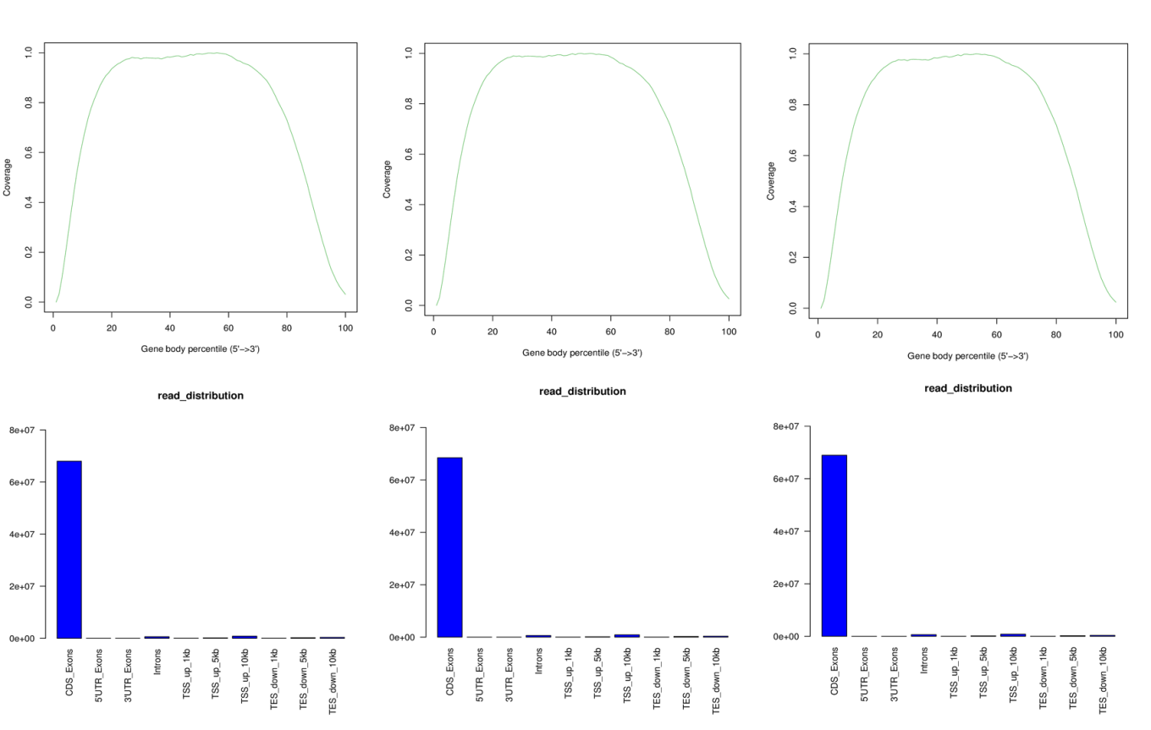
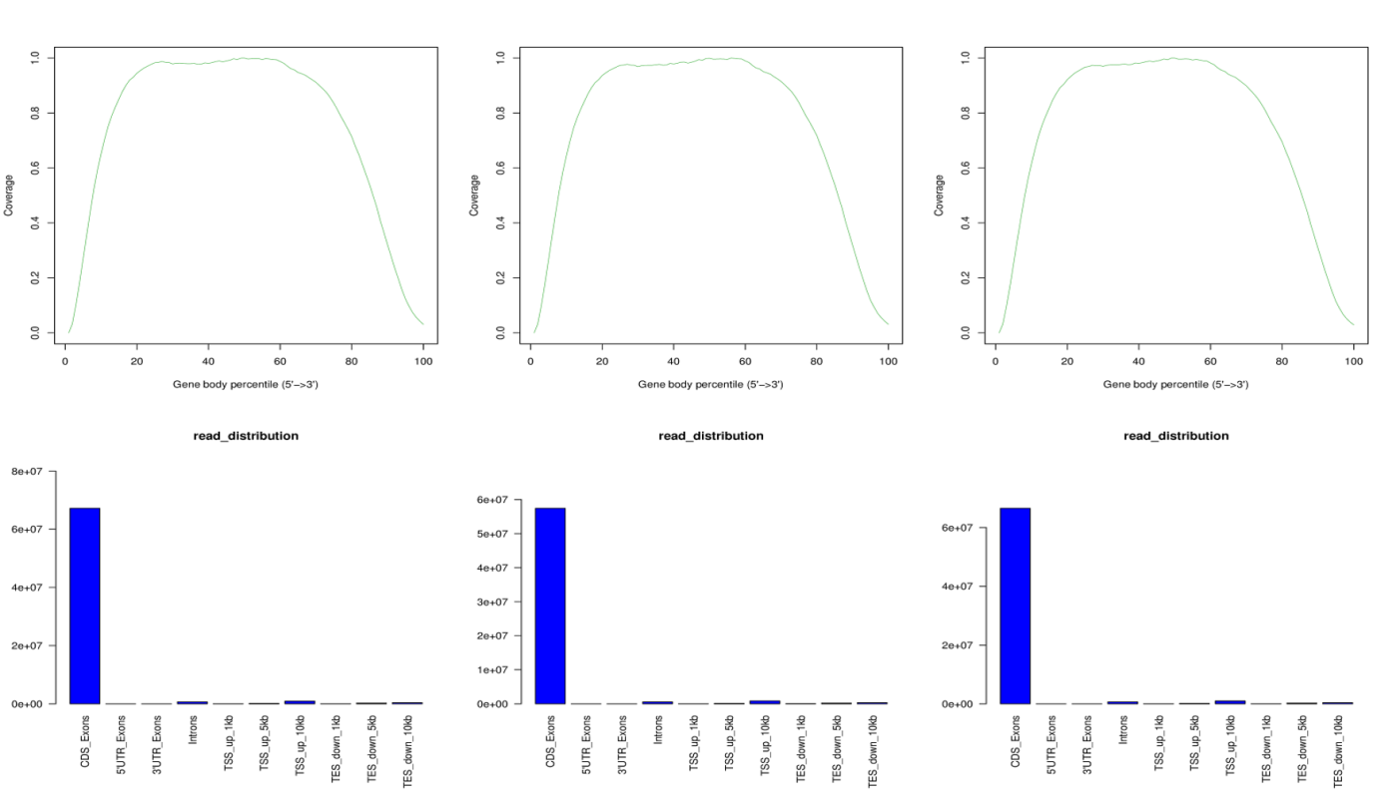
Fig. S2 The reads mapping of six samples. A-F represent LT-1, LT-2, LT-3, LT+EBR-1, LT+EBR-2, and LT+EBR-3, respectively.

