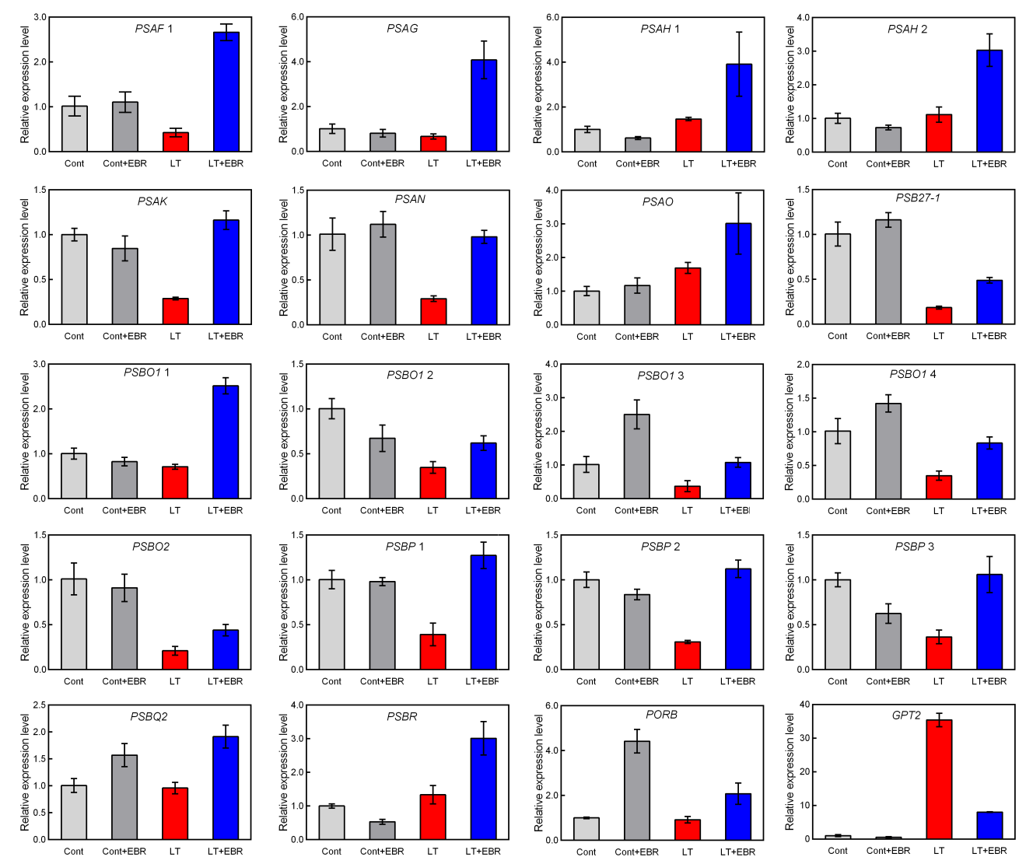
Fig. S3 The 20 DEGs we randomly selected for qRT-PCR assay in EBR-mediated LT stress. Cont, suitable environment control plants without 0.1 µM EBR pretreatment; Cont+EBR, suitable environment plants with 0.1 µM EBR pretreatment; LT, low temperature control plants without 0.1 µM EBR pretreatment; LT+EBR, low temperature-stressed plants with 0.1 µM EBR pretreatment.

