Additional file 1:
Table S1 The summary of the Illumina sequencing data.
Samples-ID | Clean Read Number | Bases (G) | Clean Read GC Content | Clean Read %≥Q30 | Mapped Reads | Mapped Ratio
FA1 | 21,118,175 | 6.30 | 47.53% | 95.05% | 14,294,845 | 67.69%
FA2 | 24,753,666 | 7.37 | 46.53% | 94.00% | 17,665,015 | 71.36%
FA3 | 23,339,236 | 6.94 | 47.10% | 95.23% | 16,151,326 | 69.20%
MA1 | 24,383,396 | 7.27 | 46.51% | 94.56% | 16,652,202 | 68.29%
MA2 | 26,325,218 | 7.84 | 45.67% | 95.03% | 17,407,765 | 66.13%
MA3 | 25,063,733 | 7.48 | 45.65% | 94.57% | 16,242,076 | 64.80%
FH1 | 23,660,498 | 7.07 | 52.43% | 95.99% | 20,640,788 | 87.24%
FH2 | 25,439,127 | 7.60 | 52.44% | 95.74% | 22,050,801 | 86.68%
FH3 | 25,183,824 | 7.52 | 52.03% | 95.43% | 21,269,888 | 84.46%
MH1 | 22,530,117 | 6.73 | 49.05% | 94.98% | 17,997,125 | 79.88%
MH2 | 25,046,088 | 7.47 | 48.14% | 95.14% | 19,612,927 | 78.31%
MH3 | 24,110,430 | 7.20 | 49.03% | 95.28% | 18,998,316 | 78.80%
FL1 | 23,144,252 | 6.89 | 48.84% | 95.31% | 17,327,083 | 74.87%
FL2 | 23,570,823 | 7.03 | 49.17% | 95.24% | 16,614,447 | 70.49%
FL3 | 26,391,135 | 7.88 | 50.60% | 95.60% | 20,304,159 | 76.94%
ML1 | 25,358,914 | 7.57 | 48.90% | 95.11% | 17,514,079 | 69.06%
ML2 | 21,867,088 | 6.51 | 48.64% | 94.98% | 15,787,688 | 72.20%
ML3 | 24,848,629 | 7.41 | 49.53% | 95.06% | 18,861,968 | 75.91%
FW1 | 23,890,086 | 7.12 | 49.50% | 94.88% | 18,048,160 | 75.55%
FW2 | 27,123,308 | 8.11 | 50.58% | 95.00% | 23,008,613 | 84.83%
FW3 | 25,331,447 | 7.56 | 50.33% | 94.91% | 20,801,568 | 82.12%
MW1 | 22,431,447 | 6.69 | 48.14% | 94.00% | 15,294,311 | 68.18%
MW2 | 21,673,785 | 6.47 | 48.39% | 94.29% | 15,736,910 | 72.61%
MW3 | 24,446,829 | 7.30 | 48.02% | 94.27% | 16,025,604 | 65.55%
FT1 | 29,291,631 | 8.76 | 52.26% | 94.62% | 23,947,622 | 81.76%
FT2 | 29,117,366 | 8.71 | 52.78% | 94.35% | 21,078,012 | 72.39%
FT3 | 29,089,098 | 8.71 | 51.03% | 94.67% | 24,275,870 | 83.45%
MT1 | 27,791,182 | 8.30 | 49.73% | 95.02% | 20,761,137 | 74.70%
MT2 | 29,045,148 | 8.68 | 49.97% | 95.11% | 22,704,182 | 78.17%
MT3 | 24,311,213 | 7.26 | 50.06% | 94.75% | 18,554,764 | 76.32%
Average | 24,989,230 | 7.46 | 49.29% | 94.94% | 18,854,308 | 75.26%
Note: FA: female antennae; MA: male antennae; FH: female head (antennae were cut off); MH: male head (antennae were cut off); FL: female leg; ML: male leg; FW: female wing; MW: male wing; FT: female abdomen-thorax; MT: male abdomen-thorax. Representation of three biological repeats with Arabic numbers 1, 2 and 3.

Table S2 Length distribution and quality metrics of the C. nigricornis transcripts and unigenes.
Length Range | Transcript | Unigene
300-500 | 14,244(20.18%) | 10,635(24.39%)
500-1000 | 19,190(27.19%) | 12,054(27.64%)
1000-2000 | 18,813(26.65%) | 11,142(25.55%)
2000+ | 18,334(25.98%) | 9,772(22.41%)
Total Number | 70,581 | 43,603
Total Length | 112,816,350 | 63,769,326
N50 Length | 2,434 | 2,235
Mean Length | 1598.4 | 1462.5

Table S3 BUSCO analysis of assembly completeness in C. nigricornis.
Complete (C) | 89.1% (1477/1658)
Complete and single-copy (S) | 85.2% (1412/1658)
Complete and duplicated (D) | 3.9% (65/1658)
Fragmented (F) | 2.5% (41/1658)
Missing (M) | 8.4% (140/1658)

Table S4 The summary of functional annotation of C. nigricornis transcriptomes.
Anno Database | Number | Percentage
total | 43603 | 100.00%
Nr Annotation | 24832 | 56.95%
Swissprot Annotation | 15750 | 36.12%
KEGG Annotation | 13150 | 30.16%
COG Annotation | 11503 | 26.38%
KOG Annotation | 18100 | 41.51%
EggNOG Annotation | 26933 | 61.77%
Pfam Annotation | 22295 | 51.13%
GO Annotation | 12102 | 27.75%
All Annotated | 29122 | 66.79%

Table S5 Conserved domains of odorant binding proteins in C. nigricornis.
Proteins | Domains | Domain definition | Position (AA) | E-value | Interpro family | GO function
CnigOBP1 | 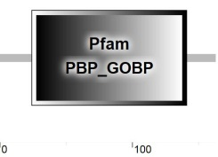 | PBP/GOBP family domain | 24 to 141 | 2.50E-08 | PBP_GOBP (IPR006170) | odorant binding (GO:0005549)
CnigOBP2 | 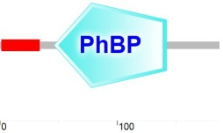 | Insect pheromone/odorant binding protein domains | 46 to 142 | 1.13E-21 | PBP_GOBP (IPR006170) | odorant binding (GO:0005549)
CnigOBP3 | 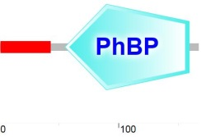 | Insect pheromone/odorant binding protein domains | 58 to 159 | 9.00E-26 | PBP_GOBP (IPR006170) | odorant binding (GO:0005549)
CnigOBP4 | 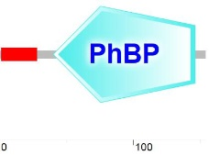 | Insect pheromone/odorant binding protein domains | 43 to 145 | 5.00E-16 | PBP_GOBP (IPR006170) | odorant binding (GO:0005549)
CnigOBP5 | 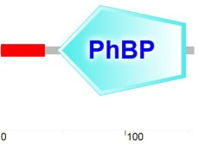 | Insect pheromone/odorant binding protein domains | 46 to 148 | 5.00E-61 | PBP_GOBP (IPR006170) | odorant binding (GO:0005549)
CnigOBP6 | 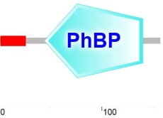 | Insect pheromone/odorant binding protein domains | 44 to 140 | 3.00E-43 | PBP_GOBP (IPR006170) | odorant binding (GO:0005549)
CnigOBP7 | 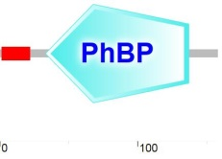 | Insect pheromone/odorant binding protein domains | 33 to 137 | 5.02E-01 | IPR006170 PBP_GOBP (IPR006170) | odorant binding (GO:0005549)
CnigOBP8 | 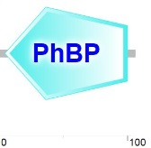 | Insect pheromone/odorant binding protein domains | 4 to 100 | 1.00E-45 | PBP_GOBP (IPR006170) | odorant binding (GO:0005549)
CnigOBP9 | 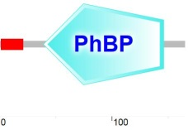 | Insect pheromone/odorant binding protein domains | 52 to 144 | 6.00E-07 | PBP_GOBP (IPR006170) | odorant binding (GO:0005549)
CnigOBP10 | 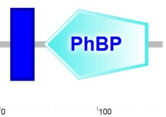 | Insect pheromone/odorant binding protein domains | 49 to 147 | 4.00E-07 | PBP_GOBP (IPR006170) | odorant binding (GO:0005549)
CnigOBP11 | 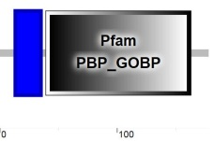 | PBP/GOBP family domain | 39 to 163 | 1.50E-13 | PBP_GOBP (IPR006170) | odorant binding (GO:0005549)
CnigOBP12 | 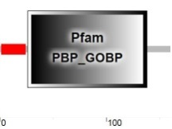 | PBP/GOBP family domain | 26 to 138 | 1.80E-10 | PBP_GOBP (IPR006170) | odorant binding (GO:0005549)
CnigOBP13 | 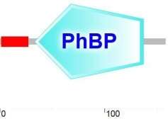 | Insect pheromone/odorant binding protein domains | 33 to 137 | 4.13E-01 | PBP_GOBP (IPR006170) | Odorant binding (GO:0005549)
CnigOBP14 | 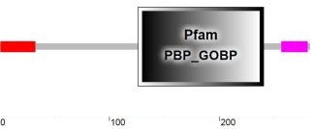 | PBP/GOBP family domain | 126 to 240 | 8.30E-07 | PBP_GOBP (IPR006170) | odorant binding (GO:0005549)
CnigOBP15 | 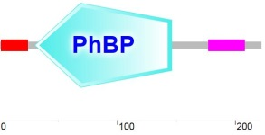 | Insect pheromone/odorant binding protein domains | 30 to 146 | 2.45E-01 | PBP_GOBP (IPR006170) | odorant binding (GO:0005549)
CnigOBP16 | 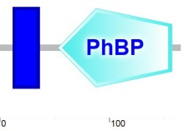 | Insect pheromone/odorant binding protein domains | 53 to 157 | 2.00E-65 | PBP_GOBP (IPR006170) | odorant binding (GO:0005549)
CnigOBP17 | 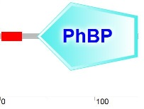 | Insect pheromone/odorant binding protein domains | 42 to 143 | 1.00E-08 | PBP_GOBP (IPR006170) | odorant binding (GO:0005549)
CnigOBP18 | 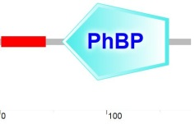 | Insect pheromone/odorant binding protein domains | 58 to 158 | 4.00E-69 | PBP_GOBP (IPR006170) | odorant binding (GO:0005549)
CnigOBP19 | 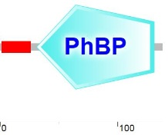 | Insect pheromone/odorant binding protein domains | 34 to 95 | 3.00E-06 | PBP_GOBP (IPR006170) | odorant binding (GO:0005549)
CnigOBP20 | 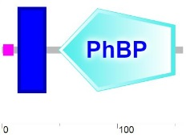 | Insect pheromone/odorant binding protein domains | 49 to 150 | 3.00E-65 | PBP_GOBP (IPR006170) | odorant binding (GO:0005549)

Table S6 Conserved domains of chemosensory proteins in C. nigricornis.
Proteins | Domains | Domain definition | Position (AA) | E-value | Interpro family
CnigCSP1 | 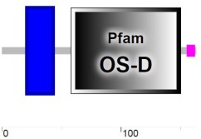 | Insect pheromone-binding family, A10/OS-D | 58 to 150 | 5.90E-34 | IPR005055 OS_D_A10/PebIII
CnigCSP2 | 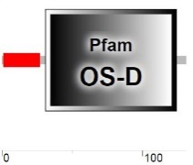 | Insect pheromone-binding family, A10/OS-D | 31 to 124 | 1.60E-24 | IPR005055 OS_D_A10/PebIII
CnigCSP3 | 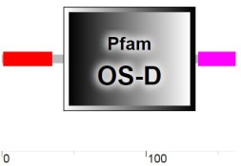 | Insect pheromone-binding family, A10/OS-D | 43 to 134 | 4.50E-32 | IPR005055 OS_D_A10/PebIII
CnigCSP4 | 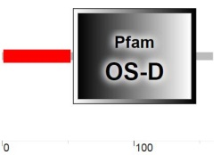 | Insect pheromone-binding family, A10/OS-D | 54 to 147 | 2.10E-25 | IPR005055 OS_D_A10/PebIII
CnigCSP5 | 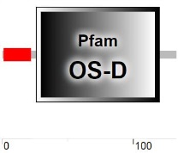 | Insect pheromone-binding family, A10/OS-D | 26 to 120 | 1.40E-22 | IPR005055 OS_D_A10/PebIII
CnigCSP6 | 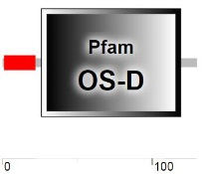 | Insect pheromone-binding family, A10/OS-D | 26 to 119 | 1.10E-32 | IPR005055 OS_D_A10/PebIII
CnigCSP7 | 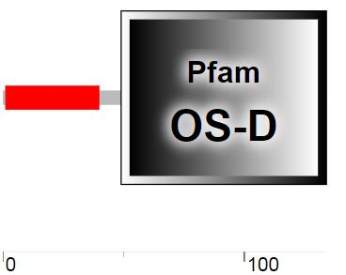 | Insect pheromone-binding family, A10/OS-D | 49 to 134 | 3.90E-16 | IPR005055 OS_D_A10/PebIII
CnigCSP8 | 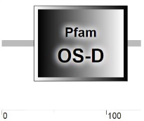 | Insect pheromone-binding family, A10/OS-D | 31 to 120 | 3.70E-21 | IPR005055 OS_D_A10/PebIII
CnigCSP9 | 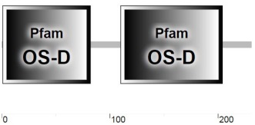 | Insect pheromone-binding family, A10/OS-D | 1 to 82 and 110 to 204 | 2.3E-24 and 4.8E-33 | IPR005055 OS_D_A10/PebIII
CnigCSP10 | 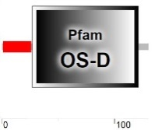 | Insect pheromone-binding family, A10/OS-D | 27 to 121 | 1.60E-34 | IPR005055 OS_D_A10/PebIII

Table S7 Primers used for qRT-PCR.
Genes | Forward primers (5’-3’) | Reverse primers (5’-3’)
CnigOBP1 | GGAAGGCAGACACCCTCCT | TCGAAGCCAGTCGTATATTGTCT
CnigOBP3 | TACTGTCTCCCAGCGAACC | TCGTCACCCTTCGTCGGAT
CnigOBP4 | GCTACCATGACGTTTGCTTCC | GTACGTGTCGTTGCATTCGT
CnigOBP6 | CACGATACGACATGTGGGC | AGATGCACGGCACTTGGTAT
CnigOBP11 | TATACTCGACGCAGCACCTC | ACCTTTGCTGGGATGAGCC
CnigOBP12 | TTTCCTACCTGTCGCCGTGA | GTTTTGAGCCCACCGAGACTA
CnigOBP13 | GCAGCACCCACCAGACG | GGGTGCCTTGCCAGTCTTG
CnigOBP14 | AATTCCTGCAGCCATGAACTGG | TTCATCGGTATGACATTTTAGCCCT
CnigOBP15 | ACCTCTACCACCACTCCGTC | TTTGTCCATGTCACTCCCCG
CnigOBP16 | TTCATACACTGCCTGACGGAC | TCTAGCAGCGACGCAATCG
CnigOBP19 | AACGGCGAGGTGTTTCACT | ATCATCACTGGGGTCGTGCT
CnigOBP20 | TGGAAGGACTCCAGGAAGGG | CTTCGCAGCATTCACGTTGT
CnigCSP1 | TCCCACCGGCCTTCCAG | CGATACTGTCGTAGCGTGTAGT
CnigCSP2 | CGACTTATGTGACCCCGGAA | TTGAAGAGGTCGGGGTGTTTC
CnigCSP3 | TCCTTCCTGACGCCCTGA | TTGGCCTCCAGGCGTTT
CnigCSP4 | CAGTCTGACGCAACAGCCAT | AAGACTTGAGGAGGCGTTCG
CnigCSP5 | CGTTTGCACTTTCGCTGCTC | TCAATGCGGTCCTTGTTGGC
CnigCSP6 | GGCAGTCGTAGCATTTCTCG | CATCAGGCGCTCGTTGTGTA
CnigCSP7 | ACAAGATGCCCTGCGATGAG | CTGTCTCACTGTCTCAGCGTT
CnigCSP8 | GCCACCTGACAACCAAAAGAAA | CTGCTCCCAGTGCTTGCG
CnigCSP9 | CAGCGACCGGCTACTCA | AGAGCGTCTGGGATGACTTC
CnigCSP10 | GACCCTGACCCTCGTTCTCG | CAGGCGCTCATTGTTGAGGAT
CnigOR6 | CGTGCCCATCTGTGTGGTTA | CGTCTGCCTCATCGTCTCC
CnigOR10 | CCGCTGGTGAAGACAGATCA | GAGATGTAACCAGGGAGGCG
CnigOR13 | GCTACAGGACATTAGGGGGC | GGAGGTGTCGAGCAGTATGG
CnigOR18 | CGCTTTTCTTCGTGCGTGAC | AAGGCGGAATACACGTCTGC
CnigOR20 | GAAGCTCAACATTCGCCACC | TGGTCAGCAAGCACTCTGTT
CnigOR32 | TGTGCCTCGACCTGTTCTTC | CGACCTTGGTATCCTCTCGC
CnigOR35 | CTACTACGGTCAGATGGTGGC | CGAATGGAAACCAGACGGGA
CnigOR37 | GCATCGCCTCTCTAGGACAC | TGCACGAACGTAACTCTGCT
CnigOR55 | GGCCTTCGTCTCGCAAATAA | CGTCTTACTGGTTTTATGCGGT
CnigOR60 | CCTCACATGGGGACTCAGGA | CGCGCCTGTGGTACTTCTTA
CnigOR65 | AATGCACGCCTATCGAGCTT | TACACGTCTCTCGTTCGTCC
CnigOR70 | TCGAGTGTTCTCATGCTGGC | TAACATACGCCGGGAAGGTG
β-actin | CTAAGCAAAGCCAAGACCGT | ATACCCACCATCACACCCTG

