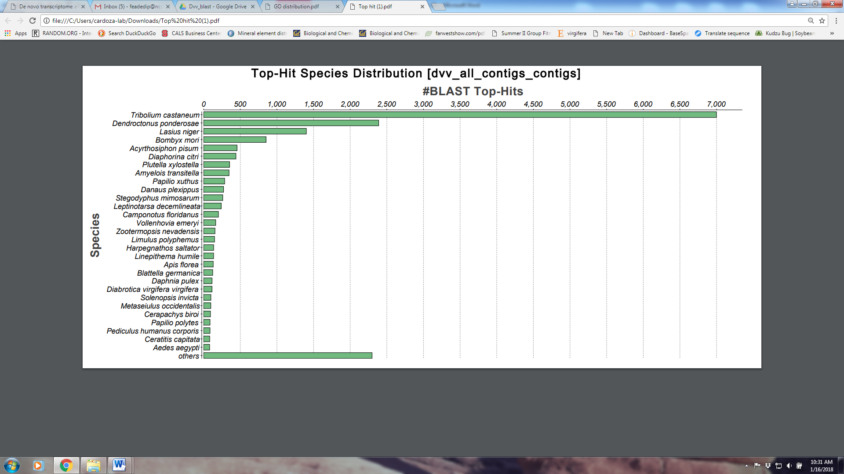
Figure S2: Top-Hits species distribution from Blast2GO. The most represented species in the top scoring BLASTx-matches the D. v. virgifera contigs when compared to an arthropod-specific database.

