Supplemental Information

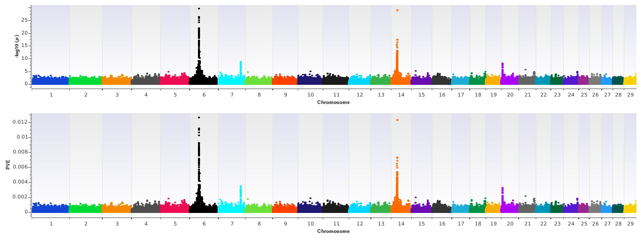
Figure S1. EMMAX birth weight (BW) analysis. The top pane reveals a Manhattan plot of –log₁₀ P-values from EMMAX analysis, whereas the bottom pane reflects the estimated proportion of variance explained (PVE) by marker effects for n = 10,837 Gelbvieh cattle. A summary of all markers passing the nominal significance threshold [31] are presented in Table S1.

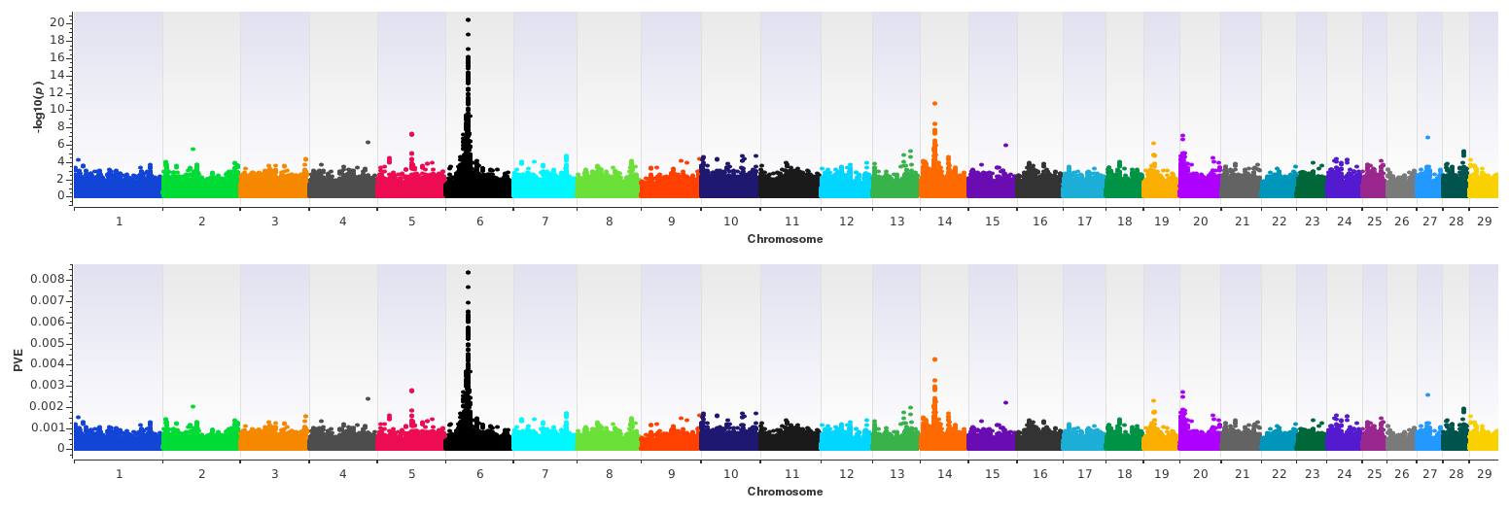
Figure S2. EMMAX weaning weight (WW) analysis. The top pane reveals a Manhattan plot of –log₁₀ P-values from EMMAX analysis, whereas the bottom pane reflects the estimated proportion of variance explained (PVE) by marker effects for n = 10,837 Gelbvieh cattle. A summary of all markers passing the nominal significance threshold [31] are presented in Table S4.

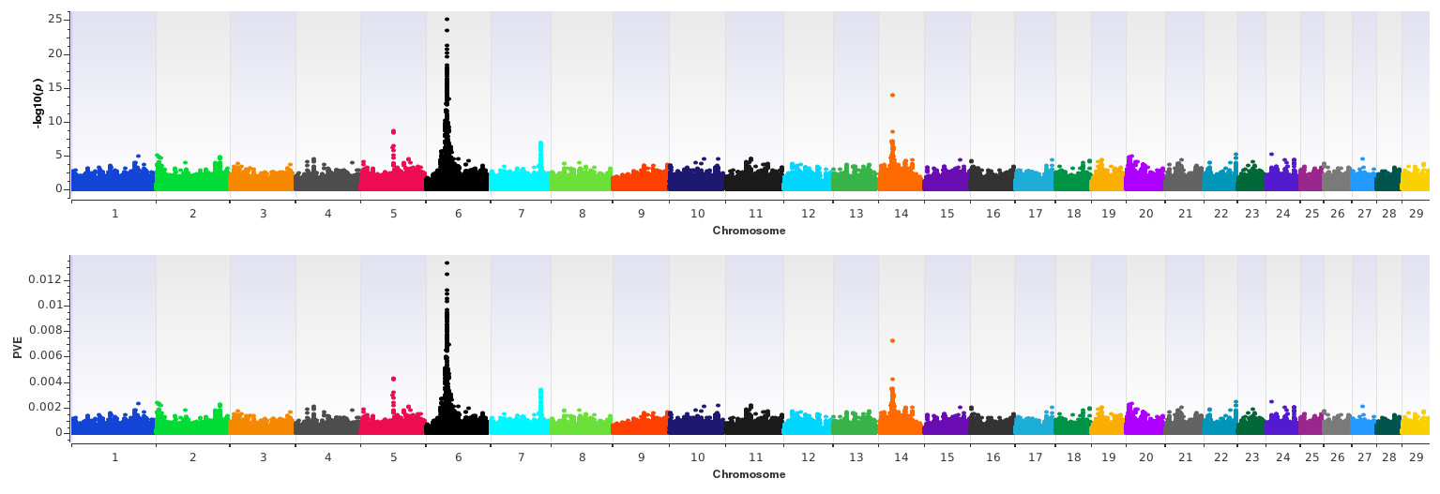
Figure S3. EMMAX yearling weight (YW) analysis. The top pane reveals a Manhattan plot of –log₁₀ P-values from EMMAX analysis, whereas the bottom pane reflects the estimated proportion of variance explained (PVE) by marker effects for n = 10,837 Gelbvieh cattle. A summary of all markers passing the nominal significance threshold [31] are presented in Table S5.

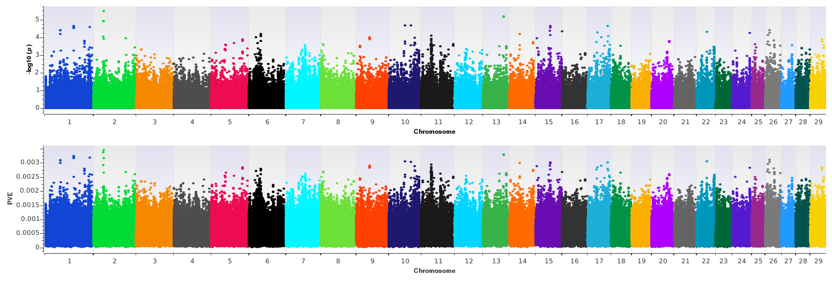
Figure S4. EMMAX birth weight (BW) genotype-by-environment (GxE) analysis. The top pane reveals a Manhattan plot of –log₁₀ P-values from EMMAX analysis, whereas the bottom pane reflects the estimated proportion of variance explained (PVE) by marker effects for n = 10,837 Gelbvieh cattle. A summary of all markers passing the nominal significance threshold [31] are presented in Table S6.

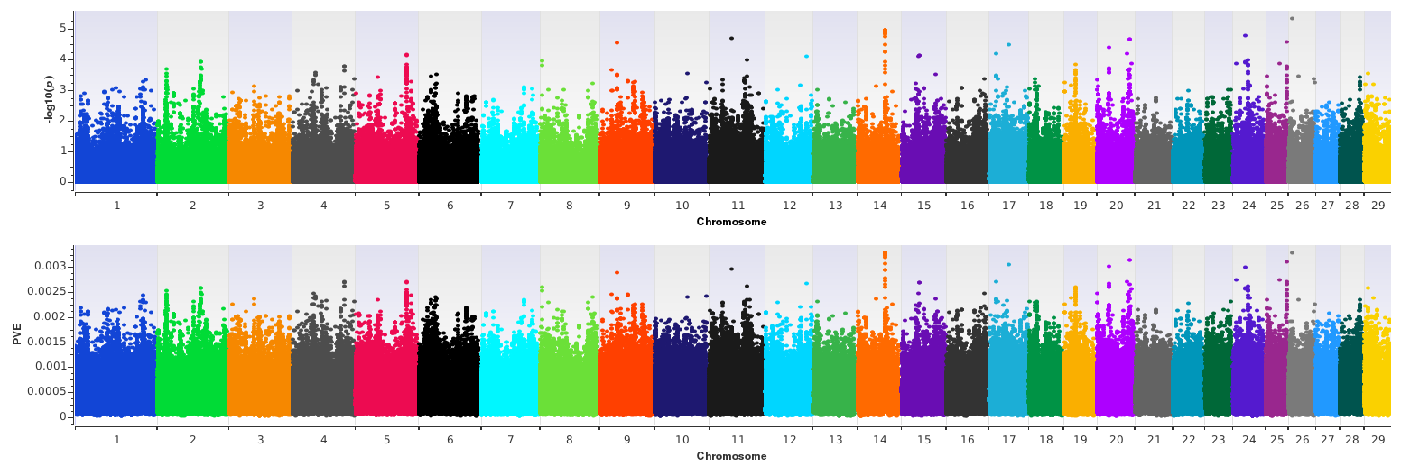
Figure S5. EMMAX weaning weight (WW) genotype-by-environment (GxE). The top pane reveals a Manhattan plot of –log₁₀ P-values from EMMAX analysis, whereas the bottom pane reflects the estimated proportion of variance explained (PVE) by marker effects for n = 10,837 Gelbvieh cattle. No QTL signals met our criteria for reporting (see Methods).

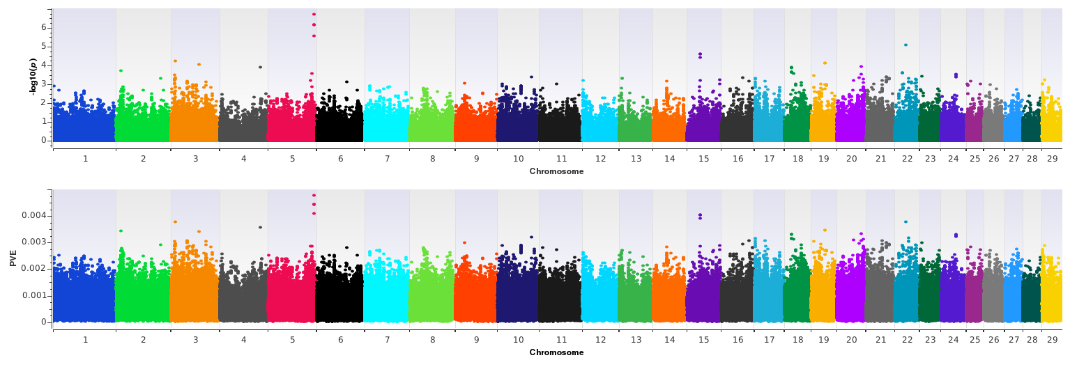
Figure S6. EMMAX yearling weight (YW) genotype-by-environment (GxE) analysis. The top pane reveals a Manhattan plot of –log₁₀ P-values from EMMAX analysis, whereas the bottom pane reflects the estimated proportion of variance explained (PVE) by marker effects for n = 10,837 Gelbvieh cattle. A summary of all markers passing the nominal significance threshold [31] are presented in Table S7.

Table S1. Summary of QTL detected by EMMAX for BW in U.S. Gelbvieh cattle.
Chr_Mb | EMMAX  -log₁₀  P-value | Regression  Beta | PVE | Supporting  SNPs | Positional  Candidate  Genes | Lead SNP  Location | Scientific Precedence [reference]; organism; trait
6_39 | 29.66 | -1.795 | 0.013 | 152 | NCAPG | Exonª | [18, 21, 30, 35–39]; Cattle, chicken; stature, calving ease and growth traits association, SimAngus mid-test metabolic weight association, fetal growth, carcass trait association, average daily gain and daily feed intake, muscle mass
14_25 | 28.93 | -1.623 | 0.012 | 67 | PLAG1 | 3’UTR | [2, 14, 18, 21, 30, 32–34]; Cattle; SimAngus mid-test metabolic weight association, carcass weight, stature, body weight and milk
14_26 | 14.32 | -1.037 | 0.006 | 52 | IMPAD1,  FAM110B | Intergenic | [30, 32, 34, 40]; Cattle; SimAngus mid-test metabolic weight association, carcass weight association, stature and body weight association, bone and cartilage system
14_24 | 12.83 | -0.947 | 0.005 | 49 | RP1, XKR4 | Intergenic | [2, 30, 43, 44, 57]; Cattle; birth weight association, SimAngus mid-test metabolic weight association, growth trait association, feed intake and growth traits, retina development
6_42 | 12.65 | -1.266 | 0.005 | 27 | KCNIP4 | Intron | [39, 41, 42]; Chicken, cattle, human; growth and muscle mass trait association, potassium channel activity
6_38 | 10.34 | -1.096 | 0.004 | 49 | HERC6,  PPM1K | Intergenic | [49, 58, 59]; Cattle; milk, fat, and protein yield, metabolic processes, feed efficiency association
6_41 | 8.97 | 0.944 | 0.004 | 23 | LOC782905,  SLIT2 | Intergenic | [39, 49–53]; Cattle, chicken, human; milk fat and protein association, organ and muscle weight, development of central nervous system, tumor suppressor activity
7_93 | 8.65 | 0.952 | 0.003 | 31 | LOC101905238, ARRDC3 | Intergenic | [14, 22, 30, 46]; Cattle; body and carcass weight association, calving ease, average daily gain in Hereford, growth and muscularity, birth weight, weaning weight, yearling weight, and ribeye area in Angus
20_05 | 8.13 | 0.925 | 0.003 | 17 | LOC104975192,  STC2 | Intergenic | [30, 45]; Cattle, mouse; mid-test metabolic weight in Hereford and SimAngus, developing and adult tissue maintenance, body size, related to post-natal growth
6_40 | 7.49 | -0.852 | 0.003 | 7 | LCORL,  LOC782905 | Intergenic | [18, 21, 37–39, 50, 55, 56]; Cattle, sheep; stature, muscle and organ growth, feed intake and gain association, growth and carcass traits, skeletal growth and muscle mass
6_34 | 6.63 | -1.591 | 0.003 | 8 | LOC104972717, LOC526089 | Intergenic | NA
6_36 | 6.44 | -0.782 | 0.003 | 15 | CCSER1 | Intron | [14, 60]; Cattle, human; body and carcass weight association, regulator of mitosis
14_23 | 5.89 | 0.584 | 0.002 | 3 | ST18 | Intron | [54]; Human; regulation of apoptosis and inflammatory response
6_29 | 5.09 | -0.602 | 0.002 | 2 | LOC530285, LOC100296313 | Intergenic | NA
ª Indicates a predicted nonsynonymous mutation IleMet, exon 9

Table S2. Genomic inflation factors (λ) calculated using observed P-values and expected P-values.
 | GEMMA λ | GEMMA SE of λ | EMMAX λ | EMMAX SE of λ
BW | 1.16 | 1.06E-03 | 1.14 | 7.10E-04
WW | 1.09 | 6.38E-04 | 1.08 | 3.87E-04
YW | 1.11 | 7.35E-04 | 1.12 | 4.92E-04
BW GxE | 1.07 | 1.72E-05 | 0.78 | 1.12E-04
WW GxE | 1.00 | 1.60E-05 | 0.77 | 1.06E-04
YW GxE | 1.06 | 1.81E-05 | 0.62 | 1.26E-04

Table S3. Correlation coefficients for GEMMA versus EMMAX P-values.
 | Pearson Correlation | Spearman Correlation
BW | 0.95 | 0.95
WW | 0.80 | 0.80
YW | 0.95 | 0.95
BW GxE | 0.34 | 0.34
WW GxE | 0.32 | 0.31
YW GxE | 0.37 | 0.37

Table S4. Summary of QTL detected by EMMAX for WW in U.S. Gelbvieh cattle.
Chr_Mb | EMMAX  -log₁₀  P-value | Regression Beta | PVE | Supporting SNPs | Positional Candidate Genes | Lead SNP Location | Scientific Precedence [reference]; organism; trait
6_39 | 20.43 | -11.205 | 0.008 | 112 | NCAPG | Exonª | [18, 21, 30, 35–39]; Cattle, chicken; stature, calving ease and growth traits association, SimAngus mid-test metabolic weight association, fetal growth, carcass trait association, average daily gain and daily feed intake, muscle mass
14_25 | 10.77 | -7.299 | 0.004 | 8 | PLAG1 | 3’UTR | [2, 14, 18, 21, 30, 32–34]; Cattle; SimAngus mid-test metabolic weight association, carcass weight, stature, body weight and milk
6_36 | 9.32 | -7.686 | 0.004 | 32 | CCSER1 | Intron | [14, 60]; Cattle, human; body and carcass weight association, regulator of mitosis
6_42 | 9.31 | -7.191 | 0.004 | 5 | KCNIP4 | Intron | [39, 41, 42]; Chicken, cattle, human; growth and muscle mass trait association, potassium channel activity
6_38 | 8.66 | -7.574 | 0.003 | 14 | HERC6, PPM1K | Intergenic | [49, 58, 59]; Cattle; milk, fat, and protein yield, metabolic processes, feed efficiency association
14_26 | 8.37 | -5.655 | 0.003 | 16 | IMPAD1, FAM110B | Intergenic | [30, 32, 34, 40]; Cattle; SimAngus mid-test metabolic weight association, carcass weight association, stature and body weight association, bone and cartilage system
6_37 | 7.74 | -6.556 | 0.003 | 6 | SNCA, GPRIN3 | Intergenic | [61–64]; Human, goat, equine; neurological regulation, milk and meat associations, tendon tissue association
5_60 | 7.27 | 9.486 | 0.003 | 5 | LOC511753, LOC527216 | Intergenic | NA
6_41 | 7.23 | -6.294 | 0.003 | 6 | LOC782905, SLIT2 | Intergenic | [39, 49–53]; Cattle, chicken, human; milk fat and protein association, organ and muscle weight, development of central nervous system, tumor suppressor activity
6_31 | 7.08 | -6.583 | 0.003 | 7 | UNC5C | 3’UTR | [65, 66]; Cattle; axon migration and embryonic development
20_05 | 6.98 | 5.211 | 0.003 | 3 | ERGIC1 | Intron | [14, 30]; Cattle; transport between endoplasmic reticulum and golgi, SimAngus and Hereford mid-test metabolic weight test association
6_34 | 6.53 | 5.690 | 0.002 | 6 | LOC100336621, LOC104972717 | Intergenic | NA
14_24 | 5.52 | -5.237 | 0.002 | 4 | XKR4 | Intron | [2, 30, 43, 44]; Cattle; birth weight association, SimAngus mid-test metabolic weight association, growth trait association, feed intake and growth traits
28_37 | 5.16 | 4.348 | 0.002 | 2 | SH2D4B, LOC787215 | Intergenic | [67]; Mouse; immunological response
ª Indicates a predicted nonsynonymous mutation IleMet, exon 9

Table S5. Summary of QTL detected by EMMAX for YW in U.S. Gelbvieh cattle.
Chr_Mb | EMMAX  -log₁₀  P-value | Regression Beta | PVE | Supporting SNPs | Positional Candidate Genes | Lead SNP Location | Scientific Precedence [reference]; organism; trait
6_39 | 25.13 | -24.287 | 0.013 | 108 | LCORL | Intron | [18, 21, 30, 37–39, 55, 56]; Cattle, sheep; stature, SimAngus mid-test metabolic weight association, muscle and organ growth, feed intake and gain association, growth and carcass traits, skeletal growth and muscle mass
14_25 | 13.91 | -15.418 | 0.007 | 3 | PLAG1 | 3’UTR | [2, 14, 18, 21, 30, 32–34]; Cattle; SimAngus mid-test metabolic weight association, carcass weight, stature, body weight and milk
6_38 | 13.43 | -17.747 | 0.007 | 53 | HERC6, PPM1K | Intergenic | [49, 58, 59]; Cattle; milk, fat, and protein yield, metabolic processes, feed efficiency association
6_42 | 13.38 | -16.123 | 0.007 | 26 | KCNIP4 | Intron | [39, 41, 42]; Chicken, cattle, human; growth and muscle mass trait association, potassium channel activity
6_37 | 12.66 | -15.728 | 0.007 | 34 | SNCA, GPRIN3 | Intergenic | [61–64]; Human, goat, equine; neurological regulation, milk and meat associations, tendon tissue association
6_36 | 10.10 | -14.441 | 0.005 | 32 | CCSER1 | Intron | [14, 60]; Cattle, human; body and carcass weight association, regulator of mitosis
6_41 | 9.86 | -13.955 | 0.005 | 26 | SLIT2 | Intron | [39, 49–53]; Cattle, chicken, human; milk fat and protein association, organ and muscle weight, development of central nervous system, tumor suppressor activity
5_60 | 8.57 | 19.910 | 0.004 | 8 | LOC511753, LOC527216 | Intergenic | NA
14_26 | 8.45 | -11.412 | 0.004 | 20 | IMPAD1, FAM110B | Intergenic | [30, 32, 34, 40]; Cattle; SimAngus mid-test metabolic weight association, carcass weight association, stature and body weight association, bone and cartilage system
6_40 | 7.12 | -15.870 | 0.004 | 18 | LOC782905, SLIT2 | Intergenic | [39, 49–53]; Cattle, chicken, human; milk fat and protein association, organ and muscle weight, development of central nervous system, tumor suppressor activity
14_24 | 7.12 | 9.920 | 0.003 | 2 | RP1, XKR4 | Intergenic | [2, 30, 43, 44, 57]; Cattle; birth weight association, SimAngus mid-test metabolic weight association, growth trait association, feed intake and growth traits, retina development
14_27 | 6.90 | 10.122 | 0.003 | 7 | NSMAF | Intron | [30, 68]; Cattle, human; Angus residual feed intake, immune system response
7_93 | 6.88 | 11.644 | 0.003 | 15 | LOC101905238, ARRDC3 | Intergenic | [14, 22, 30, 46]; Cattle; body and carcass weight association, calving ease, average daily gain in Hereford, growth and muscularity, birth weight, weaning weight, yearling weight, and ribeye area in Angus
6_45 | 6.26 | -9.356 | 0.003 | 4 | PPARGC1A | Intron | [70, 71]; Cattle; milk composition, milk fat synthesis, and yield
6_29 | 5.60 | -10.847 | 0.003 | 5 | LOC782977, LOC530285 | Intergenic | NA

Table S6. Summary of GxE QTL detected by EMMAX for BW in U.S. Gelbvieh cattle.
Chr_Mb | EMMAX  -log₁₀  P-value | Regression Beta | PVE | Supporting SNPs | Positional Candidate Genes | Lead SNP Location | Scientific Precedence [reference]; organism; trait
13_67 | 5.17 | 0.641 | 0.003 | 2 | CTNNBL1 | 5’UTR | [76]; Human; obesity association

Table S7. Summary of GxE QTL detected by EMMAX for YW in U.S. Gelbvieh cattle.
Chr_Mb | EMMAX  -log₁₀  P-value | Regression Beta | PVE | Supporting SNPs | Positional Candidate Genes | Lead SNP Location | Scientific Precedence [reference]; organism; trait
5_116 | 6.71 | 3.635 | 0.005 | 4 | PHF21B | Intron | [86, 87]; Human, rat; modulates stress response, cell division regulation

