Supplemental Figures and Tables
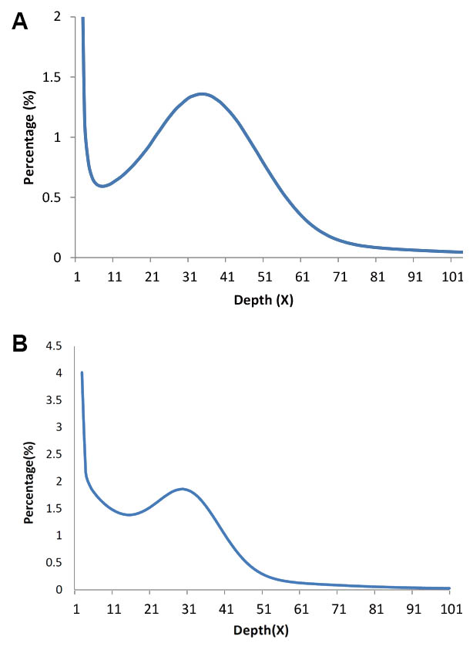
Figure S1. Seventeen-k-mer estimation of C. vestalis and D. collaris genome size. (A) The genome size of C. vestalis was estimated to be 203 Mb based on reads from 170 bp and 500 bp insert size libraries. (B) The genome size of D. collaris was estimated to be 408 Mb based on reads from 170 bp and 500 bp insert size libraries.
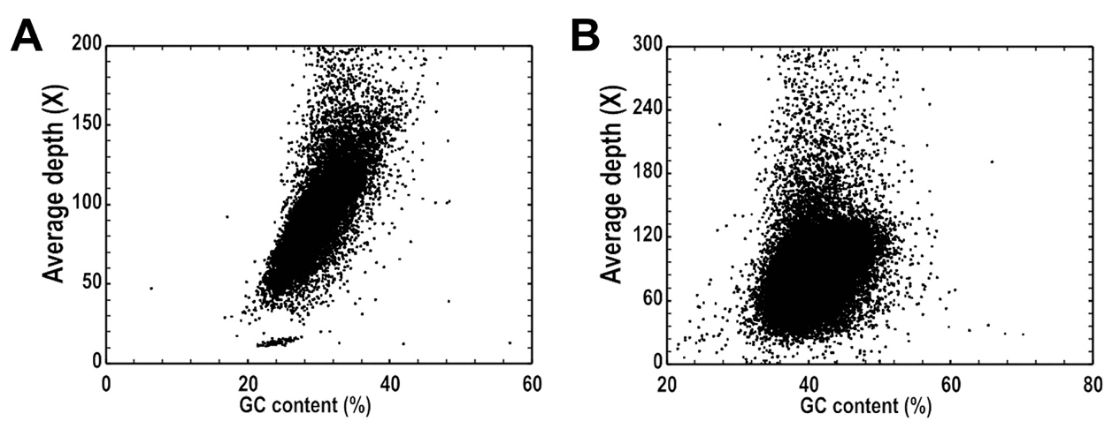Figure S2. GC content and sequencing depth of C. vestalis (A) and D. collaris (B). 10 Kb non-overlapping sliding windows for C. vestalis, and 20 Kb non-overlapping sliding windows for D. collaris were used to calculate the GC content and average depth among the windows.

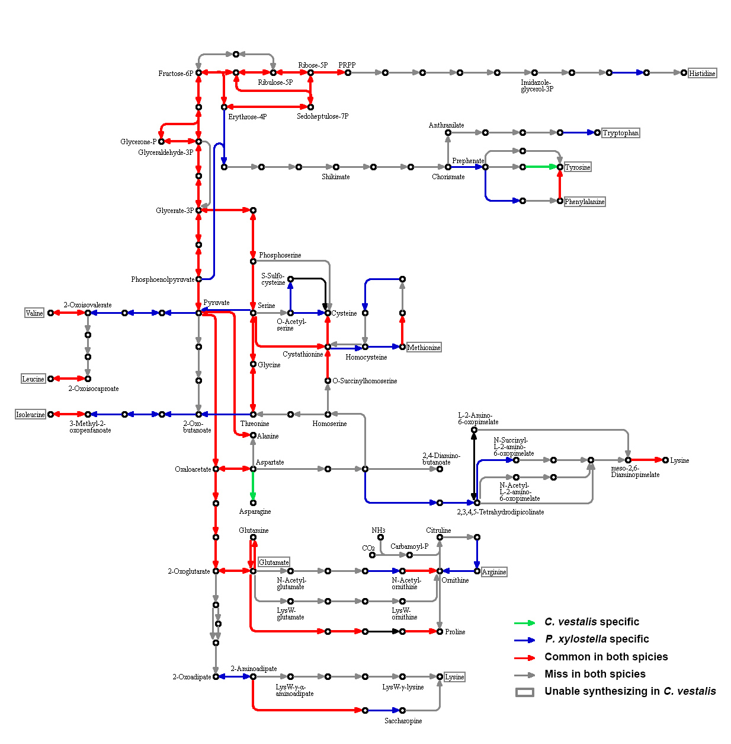
Figure S3. Comparison of amino acids biosynthesis between C. vestalis and P. xylostella. Three colors were used to show the difference between the two species on the KEGG pathway map of biosynthesis of amino acids (ko01230). Permission to use this pathway map image was kindly granted by the KEGG curators [61].

Table S1. Summary statistics of whole-genome sequencing data of C. vestalis and D. collaris
Species |  | Library Insert Size | Reads Length(bp) | Total Data(Gb) | Sequence Depth (X)
C. vestalis | Solexa | 170bp | 100 | 5.20 | 26.02
C. vestalis | Solexa | 500bp | 100 | 3.57 | 17.87
C. vestalis | Solexa | 2kb | 49 | 7.46 | 37.28
C. vestalis | Solexa | 5kb | 49 | 7.26 | 36.28
C. vestalis | Solexa | 10kb | 49 | 3.97 | 19.83
C. vestalis | Solexa | 20kb | 49 | 4.60 | 22.99
C. vestalis | Solexa Total |  |  | 32.05 | 160.27
C. vestalis | Pacbio | 20kb |  | 4.05 | 20.23
C. vestalis | Total |  |  | 36.10 | 180.50
D. collaris | Solexa | 200bp | 100 | 11.63 | 28.57
D. collaris | Solexa | 500bp | 100 | 9.38 | 23.05
D. collaris | Solexa | 800bp | 100 | 8.59 | 21.11
D. collaris | Solexa | 2kb | 49 | 15.64 | 38.43
D. collaris | Solexa | 5kb | 49 | 7.56 | 18.57
D. collaris | Solexa | 10kb | 40 | 4.96 | 12.19
D. collaris | Solexa | 20kb | 49 | 3.29 | 8.08
D. collaris | Solexa Total |  |  | 61.05 | 150.0
D. collaris | Pacbio | 20kb |  | 4.86 | 11.94
D. collaris | Total |  |  | 65.91 | 161.94

Table S2. Summary statistics of filtered data of C. vestalis and D. collaris
 |  | Library Insert Size | Reads Length(bp) | Total Data(Gb) | Sequence Depth (X)
C. vestalis | Solexa | 170bp | 100 | 4.93 | 24.64
C. vestalis | Solexa | 500bp | 100 | 3.31 | 16.56
C. vestalis | Solexa | 2kb | 49 | 5.57 | 27.85
C. vestalis | Solexa | 5kb | 49 | 3.45 | 17.23
C. vestalis | Solexa | 10kb | 49 | 2.35 | 11.74
C. vestalis | Solexa | 20kb | 49 | 2.33 | 11.66
C. vestalis | Solexa Total |  |  | 21.93 | 109.67
C. vestalis | Pacbio | 20kb |  | 3.62 | 18.11
C. vestalis | Total |  |  | 25.55 | 127.78
D. collaris | Solexa | 200bp | 100 | 11.03 | 27.10
D. collaris | Solexa | 500bp | 100 | 8.23 | 20.22
D. collaris | Solexa | 800bp | 100 | 6.87 | 16.88
D. collaris | Solexa | 2kb | 49 | 11.89 | 29.21
D. collaris | Solexa | 5kb | 49 | 4.73 | 11.62
D. collaris | Solexa | 10kb | 40 | 2.70 | 6.63
D. collaris | Solexa | 20kb | 49 | 1.54 | 3.78
D. collaris | Solexa Total |  |  | 46.99 | 115.45
D. collaris | Pacbio | 20kb |  | 2.20 | 5.41
D. collaris | Total |  |  | 49.19 | 120.86

Table S3. Statistics of the genome assembly of C. vestalis and D. collaris
Species |  | Contig |  | Scaffold
Species |  | Size (bp) | Number | Size (bp) | Number
C. vestalis | N90 | 5,991 | 4,490 | 59,784 | 249
C. vestalis | N50 | 51,333 | 818 | 2,609,601 | 16
C. vestalis | Longest | 542,561 |  | 11,695,239
C. vestalis | Total Size | 171,707,290 |  | 178,546,584
C. vestalis | Total Number (>100 bp) |  | 39,668 |  | 32,746
C. vestalis | Total Number (>2 kb) |  | 6,820 |  | 1,437
D. collaris | N90 | 5,431 | 15,290 | 57,877 | 688
D. collaris | N50 | 25,941 | 4,123 | 1,030,362 | 107
D. collaris | Longest | 205,319 |  | 5,788,798 | -
D. collaris | Total Size | 367,771,060 |  | 399,170,654 | -
D. collaris | Total Number (>100 bp) |  | 84,658 |  | 63,392
D. collaris | Total Number (>2 kb) |  | 20,676 |  | 2,732

Table S4. Transcriptome sequence map to the genome assemblies of C. vestalis and D. collaris
Specie | Dataset | Number | Total Length  (bp) | Sequences  Covered by  Assembly | With >90% Sequence in  one Scaffold |  | With >50% Sequence in  one Scaffold
 |  |  |  |  | Number | Percent | Number | Percent
C. vestalis | All | 16,734 | 8,998,285 | 91.70% | 14,797 | 88.42% | 15,218 | 90.94%
C. vestalis | >200bp | 14,446 | 8,603,601 | 93.51% | 13,050 | 90.34% | 13,390 | 92.69%
C. vestalis | >500bp | 5,998 | 5,932,831 | 98.25% | 5,694 | 94.93% | 5,816 | 96.97%
C. vestalis | >1000bp | 2,076 | 3,185,560 | 99.76% | 1,998 | 96.24% | 2,038 | 98.17%
D. collaris | All | 38,330 | 17,698,102 | 98.11% | 33,961 | 88.60% | 37,310 | 97.33%
D. collaris | >200bp | 38,330 | 17,698,102 | 98.11% | 33,961 | 88.60% | 37,310 | 97.33%
D. collaris | >500bp | 10,353 | 9,364,184 | 99.68% | 9,892 | 95.54% | 10,270 | 99.20%
D. collaris | >1000bp | 2,864 | 4,250,196 | 99.86% | 2,782 | 97.13% | 2,849 | 99.47%

Table S5. General statistics of predicted protein-coding genes for C. vestalis
Gene set |  | Number | Average transcript length (bp) | Average CDS length (bp) | Average exon per gene | Average exon length (bp) | Average intron length (bp)
De novo | AUGUSTUS | 11,266 | 4030.90 | 1505.55 | 4.75 | 317.04 | 673.64
De novo | geneid | 12,493 | 4517.69 | 1504.74 | 5.00 | 301.18 | 753.96
Homolog | A. mellifera | 10,902 | 4444.06 | 1325.03 | 4.06 | 326.68 | 1020.61
Homolog | N. vitripennis | 14,458 | 3168.21 | 1138.93 | 3.30 | 344.75 | 880.90
Homolog | T. castaneum | 12,563 | 3152.17 | 1126.41 | 3.30 | 341.17 | 880.15
Homolog | D. melanogaster | 9,180 | 3633.09 | 1155.09 | 3.54 | 326.05 | 974.55
EST |  | 20,408 | 3473.71 | 985.71 | 2.91 | 338.59 | 1301.76
GLEAN |  | 10,815 | 4816.18 | 1592.67 | 4.83 | 329.79 | 841.78
RNA_seq |  | 11,278 | 4863.78 | 1559.94 | 4.74 | 329.35 | 830.18

Table S6. General statistics of predicted protein-coding genes for D. collaris
Gene set |  | Number | Average transcript length (bp) | Average CDS length (bp) | Average exon per gene | Average exon length (bp) | Average intron length (bp)
De novo | AUGUSTUS | 20,489 | 3689.26 | 1158.1 | 4.19 | 276.29 | 793.07
De novo | geneid | 22,480 | 4038 | 1080.75 | 3.77 | 286.39 | 1066.21
Homolog | A. mellifera | 13,407 | 6432.77 | 1245.36 | 4.52 | 275.44 | 1473.15
Homolog | N. vitripennis | 19,817 | 4375.72 | 1087.7 | 3.5 | 310.89 | 1315.94
Homolog | T. castaneum | 16,730 | 4229.92 | 1103.08 | 3.47 | 317.64 | 1264.53
Homolog | D. melanogaster | 10,642 | 5033.24 | 1070.04 | 3.99 | 268.08 | 1324.8
EST |  | 34,324 | 2075.36 | 492.73 | 1.86 | 265.57 | 1850.2
GLEAN |  | 15,414 | 5348.12 | 1294.6 | 4.39 | 294.68 | 1194.57
RNA_seq |  | 15,328 | 5449.75 | 1274.97 | 4.36 | 292.74 | 1174.03

 |  | C. vestalis |  | D. collaris
 |  | Number | Percent (%) | Number | Percent (%)
Total |  | 11,278 |  | 15,328
Annotated | InterPro | 7,898 | 70.03 | 9,420 | 61.46
Annotated | GO | 6,444 | 57.14 | 7,634 | 49.80
Annotated | KEGG | 6,725 | 59.63 | 8,279 | 54.01
Annotated | Swissprot | 7,952 | 70.51 | 9,657 | 63.00
Annotated | TrEMBL | 9,584 | 84.98 | 11,697 | 76.31
Unannotated |  | 1,577 | 13.98 | 2,906 | 18.96
Table S7. Statistics of function annotation for C. vestalis and D. collaris

Table S8. TE statistics for C. vestalis, D. collaris and other insect genomes
Species | DNA (% of genome) | LINE (%) | SINE (%) | LTR (%) | Other (%) | Unknown (%) | Total (%)
C. vestalis | 11,736,864  (6.57) | 4,732,971  (2.65) | 382,064  (0.21) | 14,234,765  (7.97) | 11,194  (0.01) | 19,805,303  (11.09) | 43,052,119  (24.11)
D. collaris | 27,127,319  (6.80) | 14,817,630  (3.71) | 1,238,331  (0.31) | 76,294,605  (19.11) | 35,401  (0.01) | 49,041,523  (12.29) | 148,111,143  (37.10)
D. semiclausum | 16,517,560  (6.32) | 5,553,267  (2.12) | 443,292  (0.17) | 38,273,272  (14.64) | 1,337  (0.00) | 8,894,627  (3.40) | 66,244,517  (25.33)
L. albipes | 46,604,764  (13.64) | 7,595,887  (2.22) | 54,414  (0.02) | 27,785,828  (8.13) | 1,645  (0.00) | 31,156,356  (9.12) | 91,180,752  (26.69)
P. xylostella | 38,095,301  (9.67) | 51,536,938  (13.08) | 15,313,451  (3.89) | 37,181,193  (9.44) | 57  (0.00) | 18,561,207  (4.71) | 130,580,857  (33.14)
N. vitripennis | 26,170,738  (8.87) | 13,698,632  (4.64) | 150,887  (0.05) | 27,606,078  (9.36) | 3,838  (0.00) | 15,364,911  (5.21) | 66,259,859  (22.45)
C. solmsi | 11,311,239  (4.07) | 2,824,099  (1.02) | 38,753  (0.01) | 7,293,952  (2.62) | 34,085  (0.01) | 3,602,732  (1.30) | 16,307,257  (5.87)
P. humanus | 7,698,964  (6.95) | 4,107,285  (3.71) | 296,167  (0.27) | 4,157,756  (3.75) | 201,506  (0.18) | 517,904  (0.47) | 8,504,594  (7.677)
D. melanogaster | 4,306,649  (2.55) | 11,592,141  (6.87) | 16,601  (0.01) | 20,136,524  (11.93) | 696,218  (0.41) | 5,204,638  (3.08) | 41,585,537  (24.65)
A. mellifera | 3,728,195  (1.63) | 746,542  (0.33) | 44,465  (0.02) | 1,820,345  (0.80) | 4,689  (0.00) | 1,896,072  (0.83) | 7,304,535  (3.20)

Table S10. Microsynteny of C. vestalis and D. collaris genomes
Organism | Species | Orthology genes | Number of blocks | Block length | Rate of genome (%) | N50 of blocks | Genes in blocks | Rate of genes (%)
Cve_Dco | Cve | 7,303 | 1,360 | 57,373,860 | 30.28 | 87,618 | 5,103 | 39.38
Cve_Dco | Dco | 7,303 | 1,360 | 133,369,065 | 33.41 | 244,898 | 6,557 | 38.90
Cve_Ame | Ame | 5554 | 1473 | 81,438,984 | 35.63 | 163,304 | 5456 | 6.89
Cve_Ame | Cve | 5554 | 752 | 91,956,255 | 51.5 | 2,838,746 | 7281 | 8.72
Ame_Dco | Ame | 6202 | 1722 | 86,627,381 | 37.9 | 140,134 | 5810 | 7.34
Ame_Dco | Dco | 6202 | 1400 | 103,808,709 | 39.7 | 209,646 | 6774 | 6.97
Cve: C. vestalis, Dco: D. collaris, Ame: A. mellifera.

Table S11. Statistics of syntonic regions of C. vestalis and D. collaris genomes compare to other insects
Subject_Query | Size | Synteny | % | Size | Synteny | %
Cve_Dco | 178,546,584 | 69,978,021 | 17.53 | 399,170,654 | 46,042,780 | 25.79
Cve_Ame | 178,546,584 | 54,845,672 | 30.72 | 228,564,734 | 52,308,421 | 22.89
Cve_Dme | 178,546,584 | 5,901,668 | 3.31 | 168,736,537 | 4,642,704 | 2.75
Dco_Ame | 399,170,654 | 79,400,175 | 19.89 | 228,564,734 | 47,539,969 | 20.80
Dco_Dme | 399,170,654 | 9,825,973 | 2.46 | 168,736,537 | 5,509,681 | 3.27
Cve: C. vestalis, Dco: D. collaris, Ame: A. mellifera, Dme: D. melanogaster.

Table S13. Comparisons of the immune-related genes among several arthropod species
Gene family | Cve | Dse | Dco | Nvi | Ame | Dme | Aga | Pxy
Recognition
PGRP | 4 | 3 | 4 | 11 | 4 | 13 | 7 | 9
GNBP/βGRP | 2 | 1 | 4 | 2 | 2 | 3 | 7 | 18
Galectins | 2 | 5 | 3 | 2 | 2 | 6 | 8 | 4
FREPs (Fibrinogen-Related Proteins) | 2 | 3 | 4 | 1 | 2 | 14 | 61 | 2
C-type lectins | 8 | 13 | 17 | 28 | 10 | 37 | 25 | 7
Scavenger receptor | 26 | 35 | 30 | 19 | 13 | 23 | 21 | 15
Signaling
Toll Pathway
Spz | 4 | 4 | 5 | 6 | 7 | 5 | 6 | 5
Toll Receptor | 7 | 7 | 5 | 6 | 5 | 9 | 10 | 9
MyD88 | 1 | 1 | 1 | 1 | 1 | 1 | 1 | 0
Tube | 0 | 1 | 1 | 1 | 1 | 1 | 1 | 1
Pelle | 2 | 1 | 1 | 1 | 1 | 1 | 1 | 3
Cactus | 1 | 2 | 1 | 2 | 3 | 1 | 1 | 1
TRAF6 | 1 | 1 | 2 | 1 | 1 | 1 | 1 | 2
IMD pathway
IMD | 1 | 1 | 1 | 1 | 1 | 1 | 1 | 1
FADD | 1 | 1 | 1 | 1 | 1 | 1 | 1 | 1
Dredd (caspase 8) | 1 | 1 | 1 | 1 | 1 | 1 | 1 | 1
TAK1 | 1 | 1 | 1 | 1 | 1 | 1 | 1 | 1
Tab2 | 1 | 1 | 1 | 1 | 1 | 1 | 1 | 2
IKK-β | 1 | 0 | 1 | 1 | 0 | 1 | 1 | 1
IKK-γ | 1 | 1 | 1 | 1 | 1 | 1 | 1 | 2
Relish | 1 | 1 | 1 | 1 | 2 | 1 | 1 | 3
JAK-STAT Pathway
Domeless | 1 | 1 | 1 | 1 | 1 | 1 | 1 | 1
Hopscotch | 2 | 1 | 1 | 1 | 1 | 1 | 1 | 1
STAT | 1 | 1 | 1 | 1 | 1 | 1 | 2 | 2
Effectors
PPO | 1 | 2 | 2 | 4 | 2 | 3 | 9 | 1
TEP | 4 | 5 | 4 | 3 | 3 | 6 | 13 | 1
LYS | 1 | 1 | 1 | 1 | 2 | 13 | 8 | 2
AMP | 15 | 15 | 11 | 44 | 7 | 22 | 10 | 7
Others
IAP(apoptosis) | 4 | 4 | 29 | 6 | 5 | 4 | 7 | 3
Catalase(Peroxisome) | 2 | 2 | 1 | 1 | 1 | 2 | 1 | 13
Peroxidase | 16 | 12 | 14 | 15 | 13 | 20 | 23 | 17
SOD(Peroxisome) | 6 | 7 | 6 | 4 | 2 | 4 | 4 | 7
Serpins | 16 | 12 | 15 | 12 | 7 | 28 | 17 | 26
CLIP-domain Serine Protease | 3 | 3 | 4 | 17 | 28 | 65 | 49 | 13
Total | 140 | 150 | 176 | 199 | 133 | 293 | 303 | 182

Table S15. Comparisons of the detoxification genes among several arthropod species
 | Dco | Cve | Dse | Cso | Nvi | Api | Tca | Ame | Dme | Bmo | Pxy | Zne
P450
cyp2 | 10 | 10 | 10 | 7 | 7 | 10 | 8 | 8 | 6 | 10 | 10 | 12
cyp3 | 38 | 25 | 25 | 11 | 48 | 32 | 72 | 28 | 36 | 36 | 26 | 27
cyp4 | 43 | 11 | 19 | 10 | 30 | 32 | 44 | 4 | 32 | 32 | 36 | 21
Mitochondrial | 6 | 5 | 7 | 6 | 7 | 8 | 9 | 6 | 11 | 8 | 13 | 9
Total | 97 | 51 | 61 | 34 | 92 | 82 | 133 | 46 | 85 | 86 | 85 | 69
GSTs
Delta |  |  |  | 4 | 5 | 10 | 3 | 1 | 11 | 4 | 5
Epsilon |  |  |  | 0 | 0 | 0 | 19 | 0 | 14 | 8 | 5
Omega |  |  |  | 2 | 2 | 0 | 3 | 1 | 5 | 4 | 5
Sigma |  |  |  | 4 | 8 | 6 | 7 | 4 | 1 | 2 | 2
Theta |  |  |  | 0 | 3 | 2 | 1 | 1 | 4 | 1 | 1
Zeta |  |  |  | 1 | 1 | 0 | 1 | 1 | 2 | 2 | 2
total | 14 | 17 | 11 | 11 | 19 | 18 | 34 | 8 | 37 | 21 | 20 | 12
CCEs
carboxylesterase | 22 | 8 | 7 | 17 | 41 | 30 | 49 | 24 | 35 | 69 | 13
Dco: D. collaris, Cve: C. vestalis, Dse: D. semiclausum, Cso: C. solmsi, Nvi: N. vitripennis, Api: A. pisum, Tca: T. castaneum, Ame: A. mellifera, Dme: D. melanogaster, Bmo: B. mori, Pxy: P. xylostella, Zne: Z. nevadensis.

