Genome-guided analyses allow the identification of novel physiological traits in Trichococcus species

Nikolaos Strepis^{1,2}, Henry D. Naranjo¹, Jan Meier-Kolthoff³, Markus Göker³, Nicole Shapiro⁴, Nikos Kyrpides⁴, Hans-Peter Klenk^{3,5}, Peter J. Schaap², Alfons j. M. Stams^{1,6}, Diana Z. Sousa^{1*}

¹ Laboratory of Microbiology, Wageningen University & Research, Stippeneng 4, 6708 WE Wageningen, The Netherlands
² Laboratory of Systems and Synthetic Biology, Wageningen University & Research, Stippeneng 4, 6708 WE Wageningen, The Netherlands
³ Leibniz Institute DSMZ German Collection of Microorganisms and Cell Cultures, Inhoffenstraße 7B, 38124 Braunschweig, Germany
⁴ DOE Joint Genome Institute, 2800 Mitchell Drive 100, CA 94598 Walnut Creek, CA USA
⁵ School of Biology, Newcastle University, Ridley Building 2, NE1 7RU Newcastle, UK
⁶ Centre of Biological Engineering, University of Minho, Campus de Gualtar, 4710-057 Braga, Portugal

*Corresponding author: Diana Z. Sousa, e-mail: diana.sousa@wur.nl

ADDITIONAL FILE 4

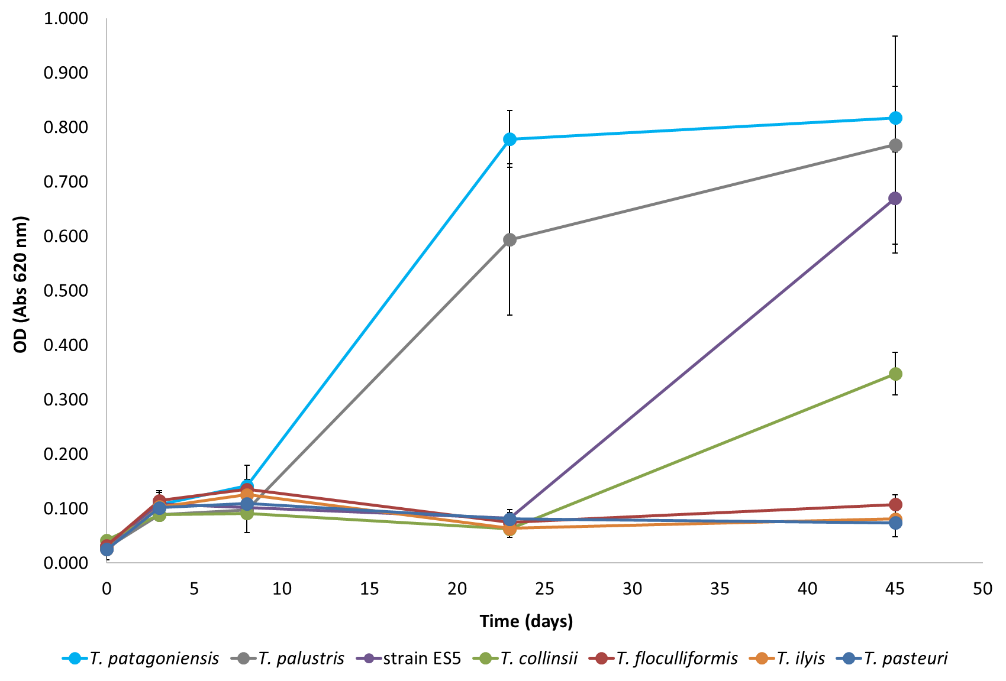
Figure S2. Growth of Trichococcus species at 0 ºC.

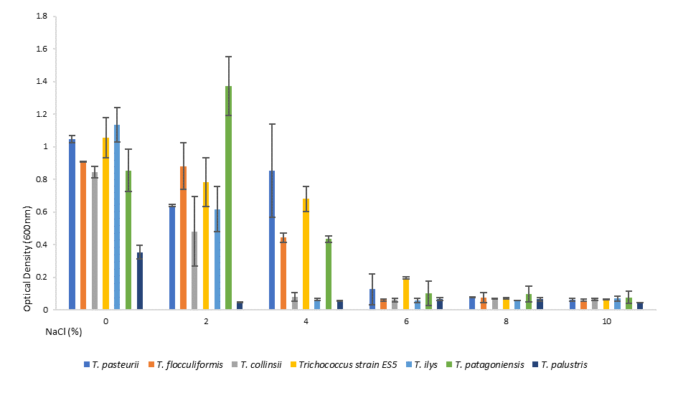
Figure S3. Growth of Trichococcus species at different salinity (% NaCl (w/v)).

