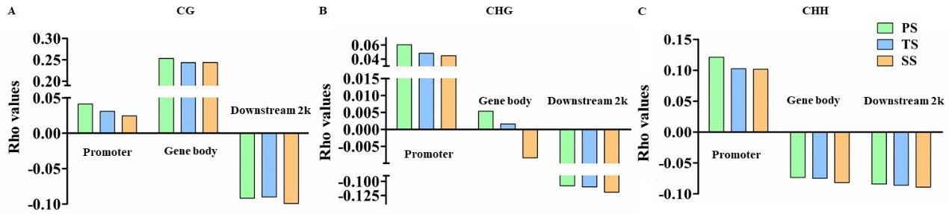
Additional file 11 Correlation between 5-methylcytosines methylation in different genic regions and gene expression in primary stems (PS), transitional stems (TS), and secondary stems (SS) of poplar. (A), (B), and (C) represent CG, CHG, and CHH DNA methylation contexts, respectively. The regions of promoter, gene body, and 2kb downstream regions were split on the x-axis to investigate the Spearman rank correlation (y-axis) between levels of methylation and expression. Rho > 0 means positive correlation, and rho < 0 means negative correlation.

