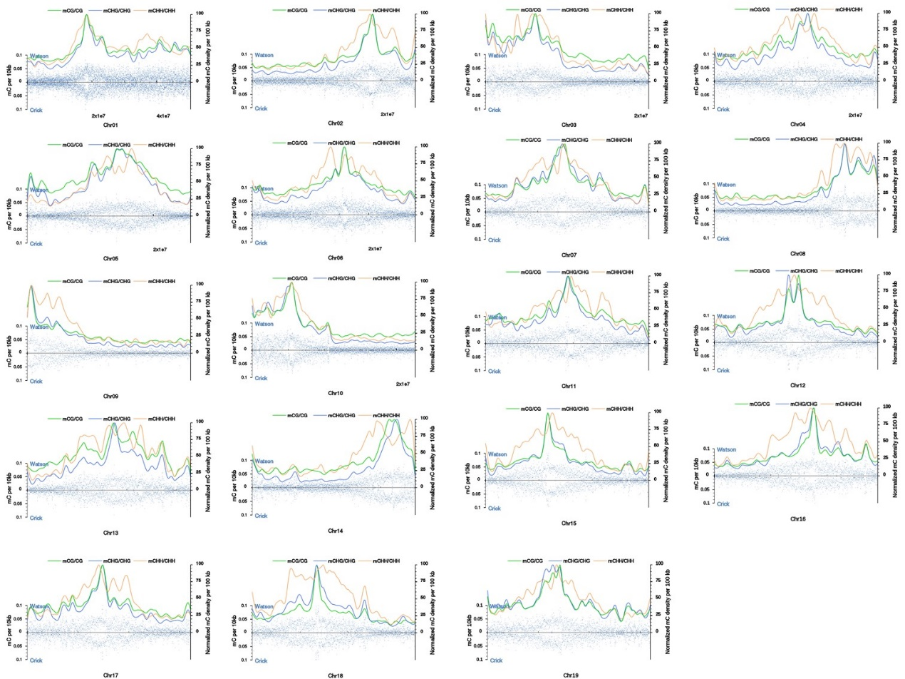
Additional file 3 Distributions of 5-methylcytosine density on chromosomes 1-19 on transitional stems (TS).

