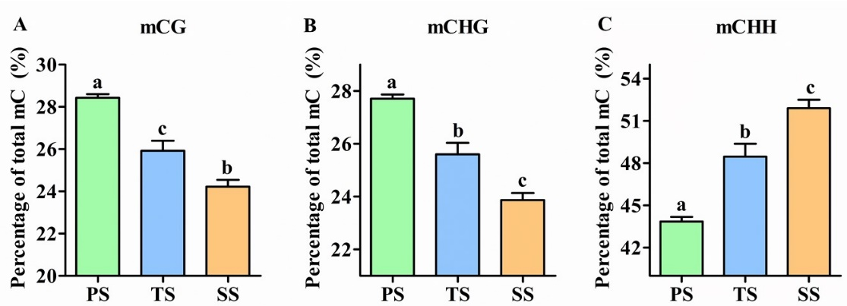
Additional file 6 Comparison of mCs in CG, CHG, and CHH sequence contexts in three developmental stages: primary stems (PS), transitional stems (TS) and secondary stems (SS). The y-axis indicates the percentage of mC (%). The different letters on the top of the error bars indicate statistically significant differences between means at p < 0.05.

