Supplemental

Supplemental mutation flow diagrams
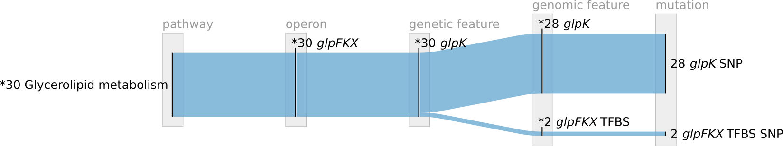
Supplemental Figure 1 The mutation convergence and significance of features associated with glpK and glycerol metabolism pathway.

start AA position | stop AA position | mut type | details | ΔΔGpred (destabilizing) | SIFT score (deleterious)
34 | 34 | SNP | I34T | 3.47091 | 0.0074979
39 | 39 | SNP | D39H | 2.49214 | 0
44 | 44 | SNP | E44V | NA | 0
48 | 48 | SNP | G48V | 18.6249 | 0
50 | 50 | SNP | G50S | 13.6354 | 0
72 | 72 | SNP | F72V | NA | 0
72 | 72 | SNP | F72V | NA | 0
93 | 93 | SNP | G93S | 7.2727 | 0
138 | 138 | SNP | P138Q | 3.46287 | 0
138 | 138 | SNP | P138Q | 3.46287 | 0
Supplemental Table 1 Table of crr mutation details.

AA position | AA change | summary
17 | S17A | uncharacterized
34 | R34H | uncharacterized
34 | R34S | uncharacterized
54 | W54L | uncharacterized
55 | A55T | uncharacterized
56 | T56A | uncharacterized
59 | S59Y | subunit interaction interface (1)
59 | S59Y | subunit interaction interface (1)
59 | S59Y | subunit interaction interface (1)
59 | S59Y | subunit interaction interface (1)
66 | A66S | associated to FBP binding (2)
73 | D73V | subunit interaction interface (3)
73 | D73V | subunit interaction interface (3)
73 | D73V | subunit interaction interface (3)
73 | D73V | subunit interaction interface (3)
73 | D73A | subunit interaction interface (3)
73 | D73A | subunit interaction interface (3)
96 | K96E | uncharacterized
96 | K96Q | uncharacterized
96 | K96Q | uncharacterized
96 | K96Q | uncharacterized
97 | P97H | Computationally predicted stability (4)
173 | K173T | Computationally predicted stability (4)
229 | N229H | uncharacterized
229 | N229K | uncharacterized
236 | T236K | FBP binding site (5)
236 | T236K | FBP binding site (5)
441 | A441V | uncharacterized
Supplemental Table 2 Table of glpK SNP details.

References
1. Bystrom CE, Pettigrew DW, Branchaud BP, O’Brien P, Remington SJ. Crystal structures of Escherichia coli glycerol kinase variant S58-->W in complex with nonhydrolyzable ATP analogues reveal a putative active conformation of the enzyme as a result of domain motion. Biochemistry. 1999 Mar 23;38(12):3508–18.
2. Feese MD, Faber HR, Bystrom CE, Pettigrew DW, Remington SJ. Glycerol kinase from Escherichia coli and an Ala65→Thr mutant: the crystal structures reveal conformational changes with implications for allosteric regulation. Structure. 1998 Nov 15;6(11):1407–18.
3. Herring CD, Raghunathan A, Honisch C, Patel T, Applebee MK, Joyce AR, et al. Comparative genome sequencing of Escherichia coli allows observation of bacterial evolution on a laboratory timescale. Nat Genet. 2006 Dec;38(12):1406–12.
4. Wagih O, Galardini M, Busby BP, Memon D, Typas A, Beltrao P. A resource of variant effect predictions of single nucleotide variants in model organisms. Mol Syst Biol. 2018 Dec 20;14(12):e8430.
5. UniProt Consortium T. UniProt: the universal protein knowledgebase. Nucleic Acids Res. 2018 Mar 16;46(5):2699.

