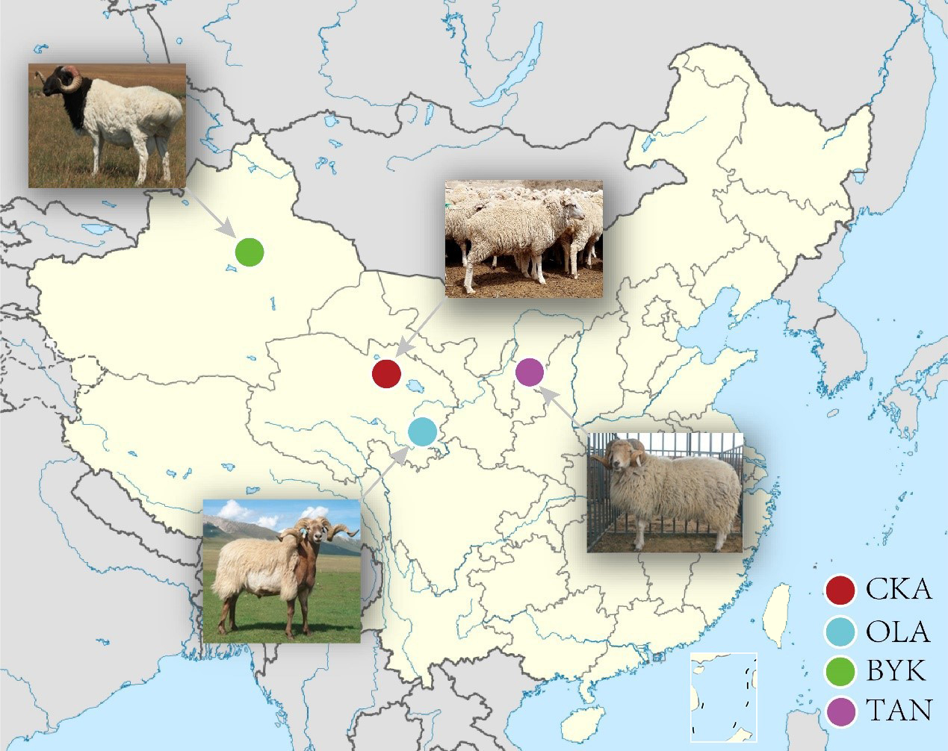
Supplementary Fig. 1. Geographic distribution of the four Chinese sheep breeds. (CKA, Chaka; TAN, Tan; BYK, Bayinbuluke and OLA, Oula sheep)

