Additional MPK domains

Clade A

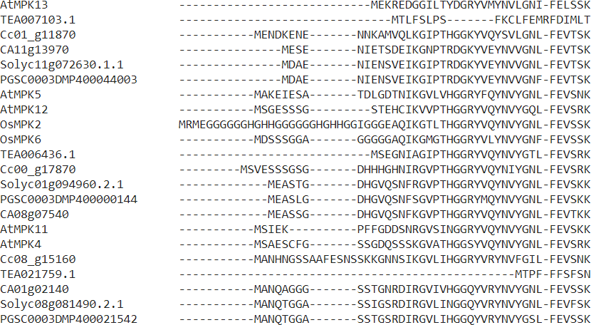
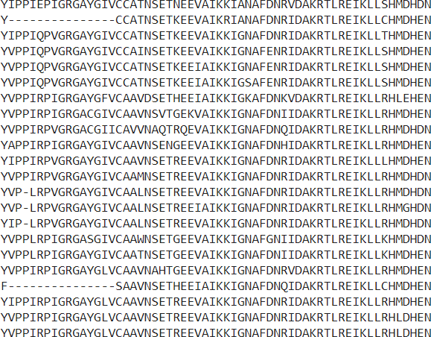
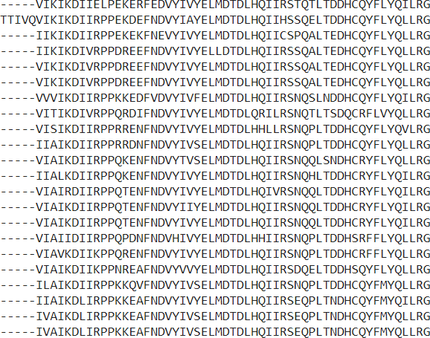
IGxGxYGxV IKKIxxxF DAxRxLRE FxDIYxxxELM DLxxVI QxLRx

LKYxH HRDLKPxN LxNxNCxLKIxDFGLAR TRWYRAPEL IDxWS^{V}IGC KMLTFDP^{K}RQKRITVE^{D}EAL

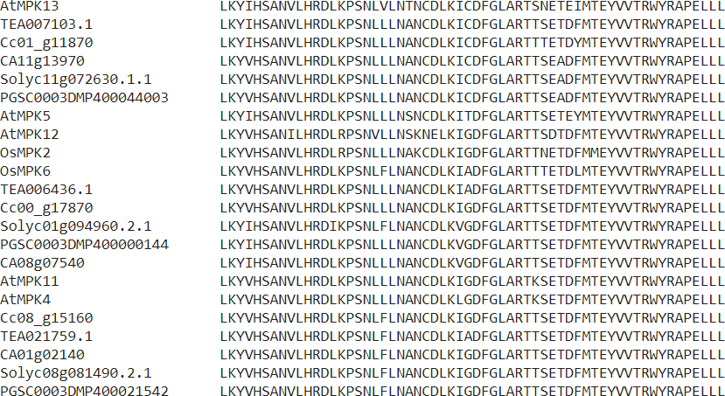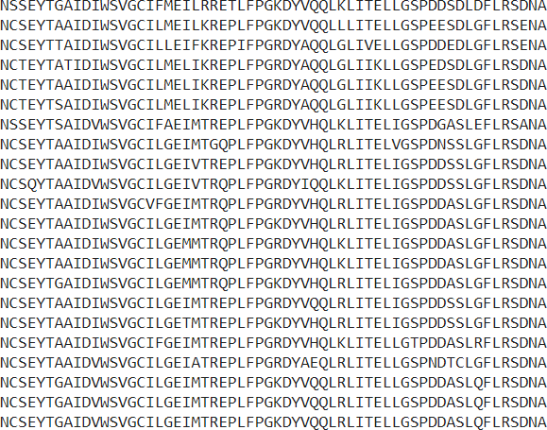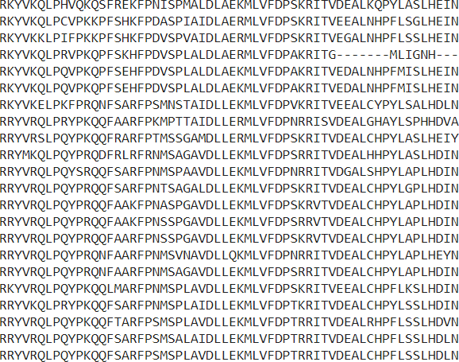

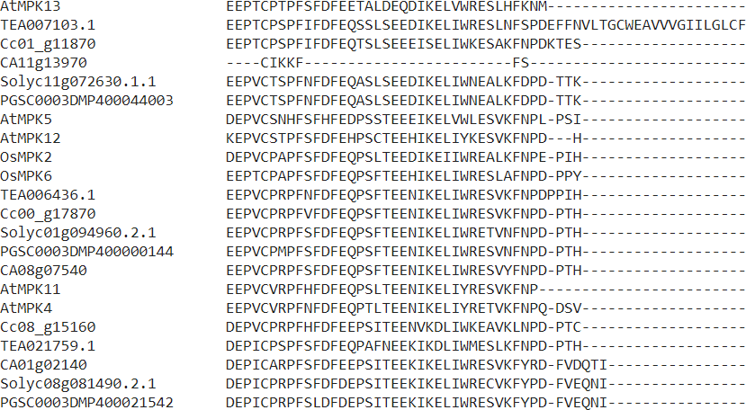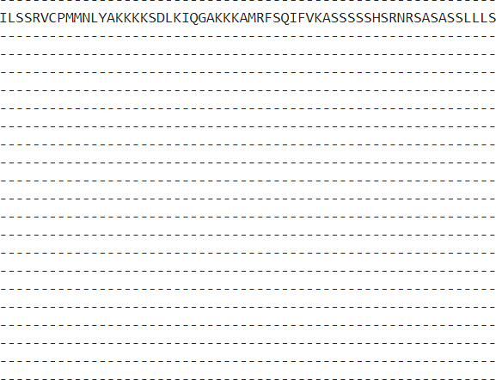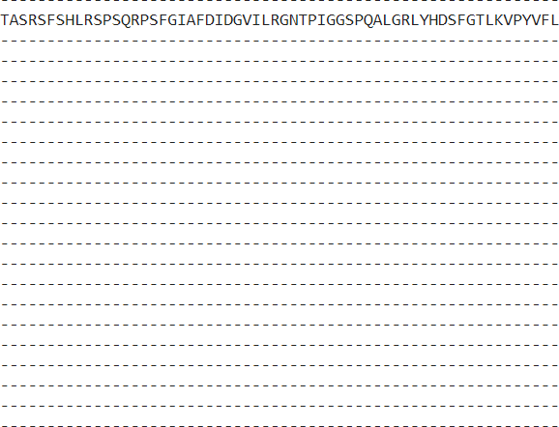

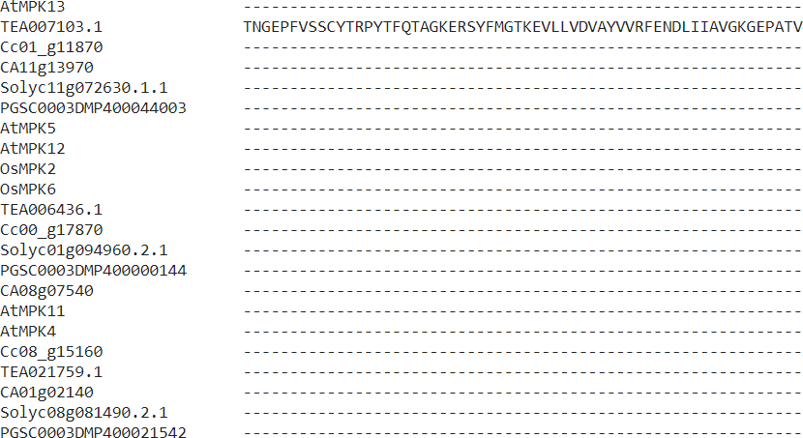
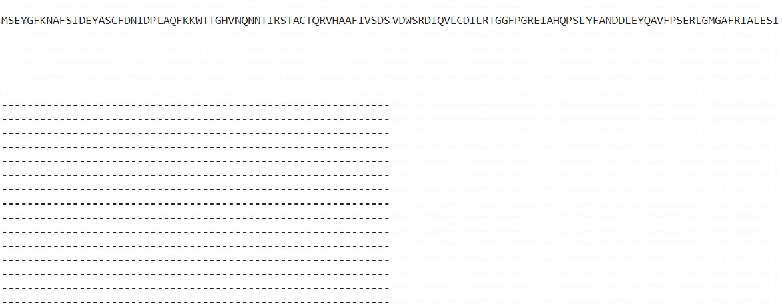

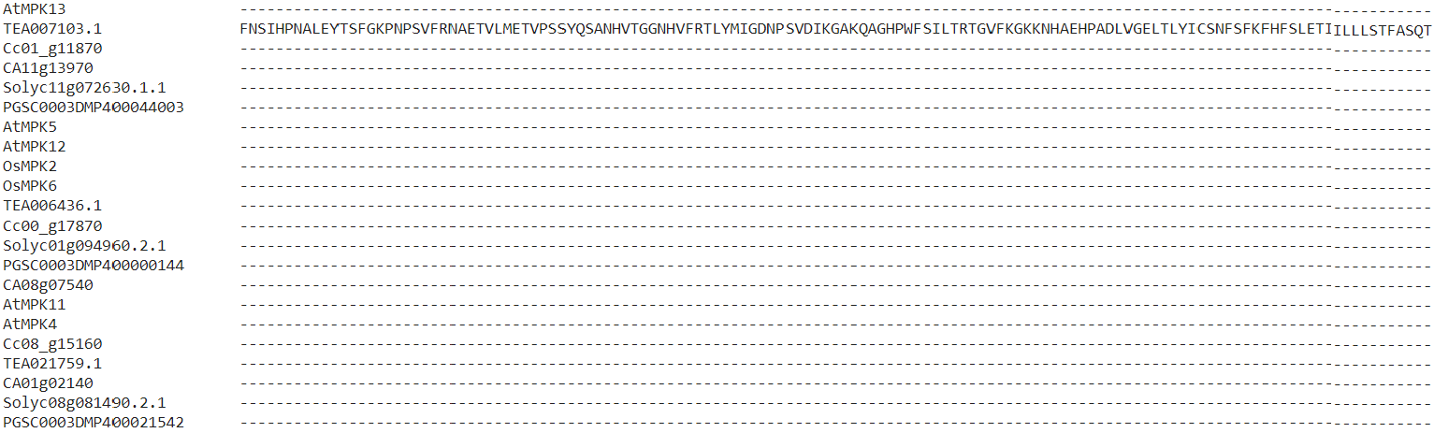

Clade B IGxGxYGxV IKKIxxxF DAxRxLRE
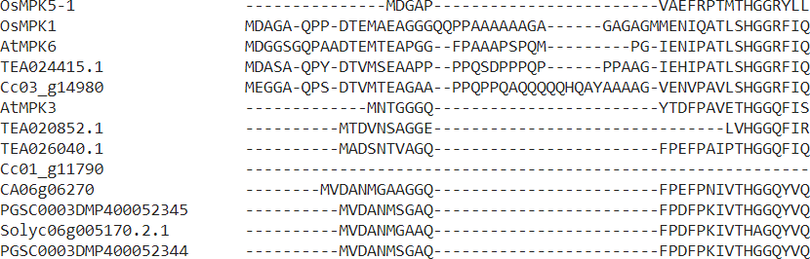
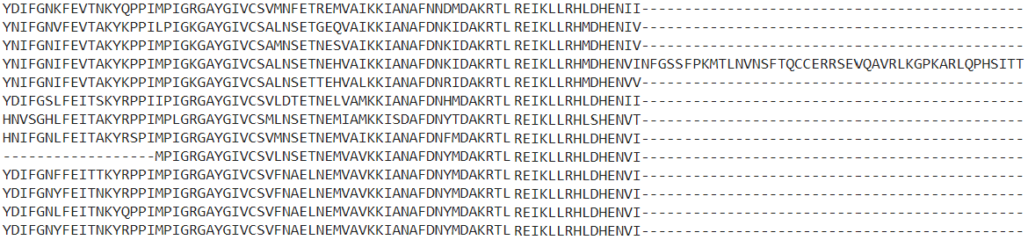

FxDIYxxxELM DLxxVI QxLRxLKYxH HRDLKPxN LxNxNCxLKIxDFGLAR TRWYRAPEL
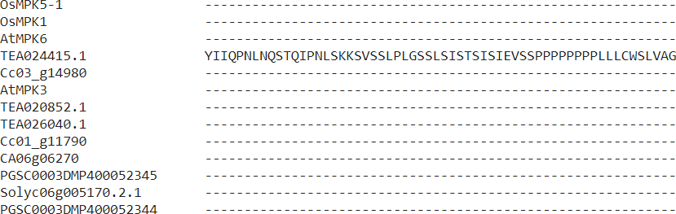
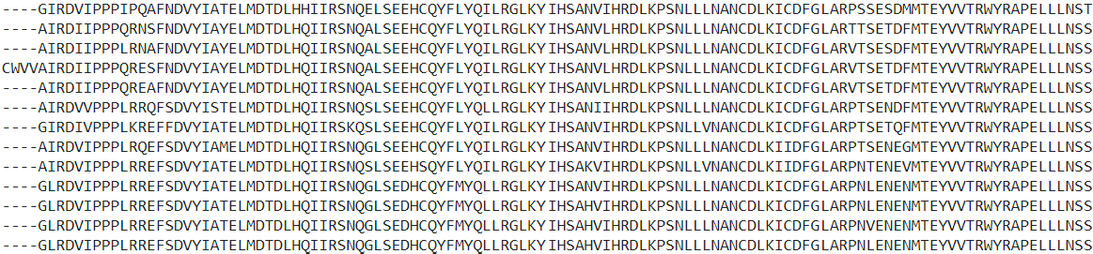

IDxWS^{V} GC
I

KMLTFDP^{K} ^{Q} RITVE^{D} AL
R K E

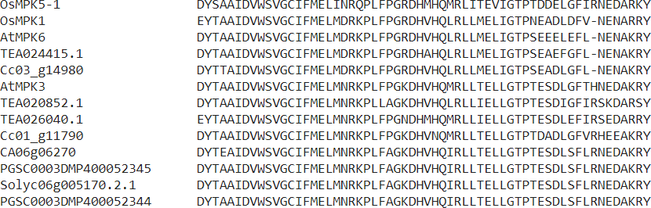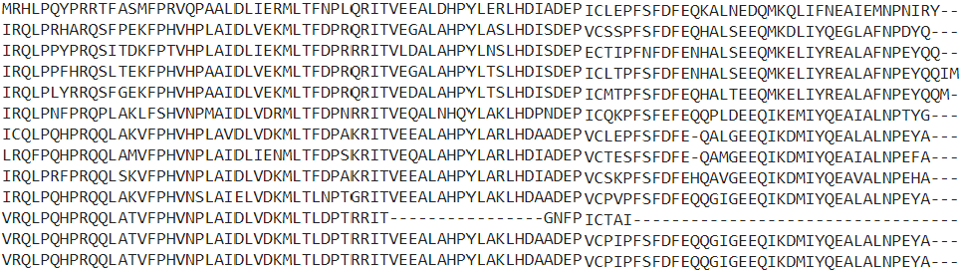

Clade C

IGxGxYGxV IKKIxxxF DAxRxLRE FxDIYxxxELM DLxxVI

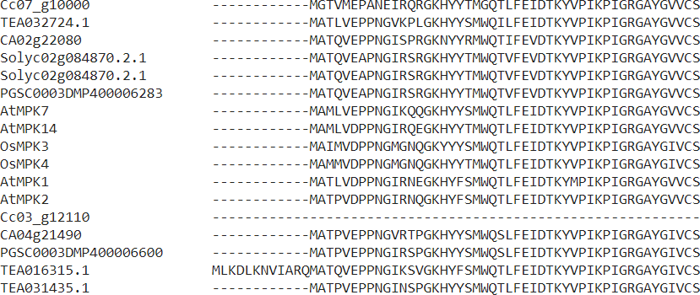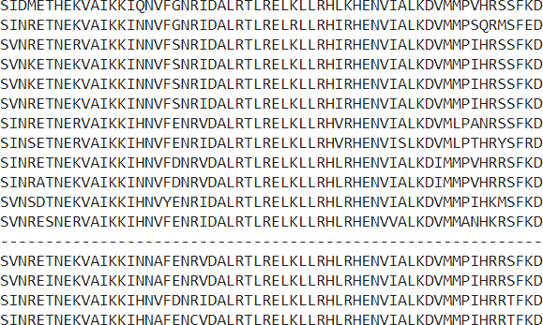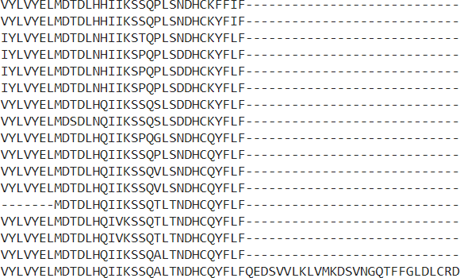

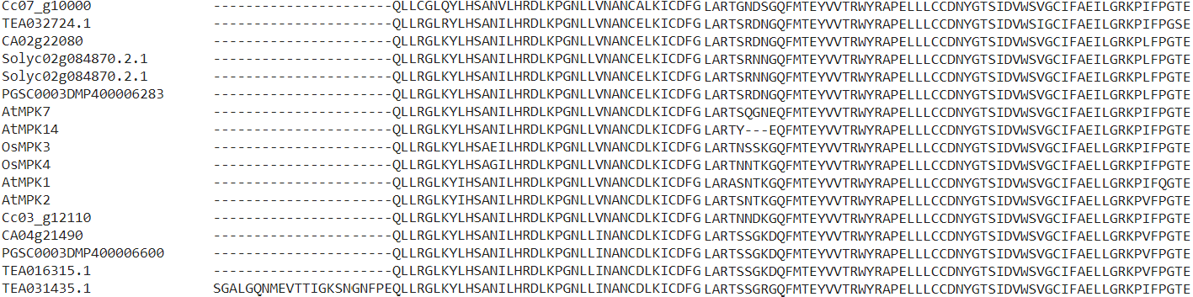
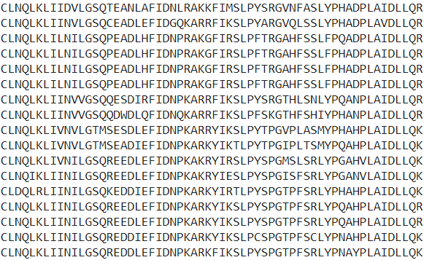
QxLRx LKYxH HRDLKPxN LxNxNCxLKIxDFGLAR TRWYRAPEL IDxWS^{V} GC K
I

MLTFDP^{K} ^{Q} RITVE^{D} AL
R K E
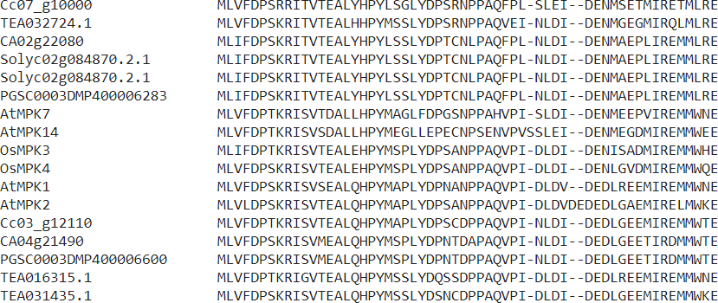
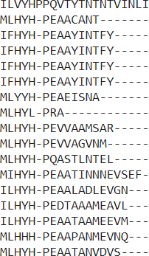

Clade D

IGxGxYGxV IKKIxxxF DAxRxLRE FxDIYxxxELM DLxxVI QxLRxLKYxH HRDLKPxN LxNxNCxLKIxDFGLAR
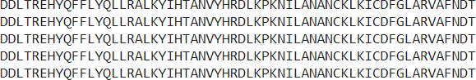

TRWYRAPEL IDxWS^{V}IGC LLE^{R}KLLAFDPKDRPTAEEAL
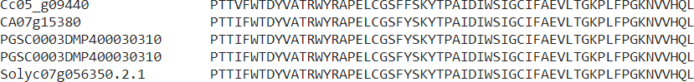

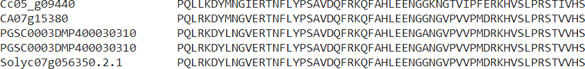
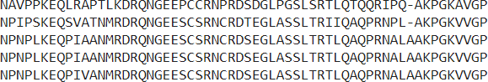
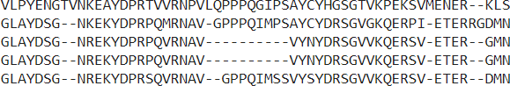

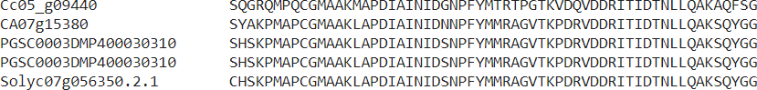
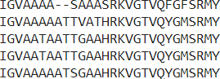

Clade E
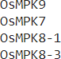

Clade F

IGxGxYGxV IKKIxxxF DAxRxLRE FxDIYxxxELM DLxxVI QxLRxLKYxH HRDLKPxN LxNxNCxLKIxD
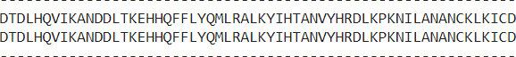
FGLAR TRWYRAPEL IDxWS IGC K

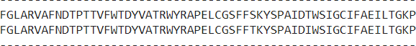

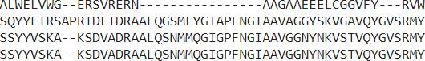

IGxGxYGxV IKKIxxxF DAxRxLRE FxDIYxxxELM DLxxVI QxLRxLKYxH HR
V LLE^{R} LLAFDPKDRPTAEEAL

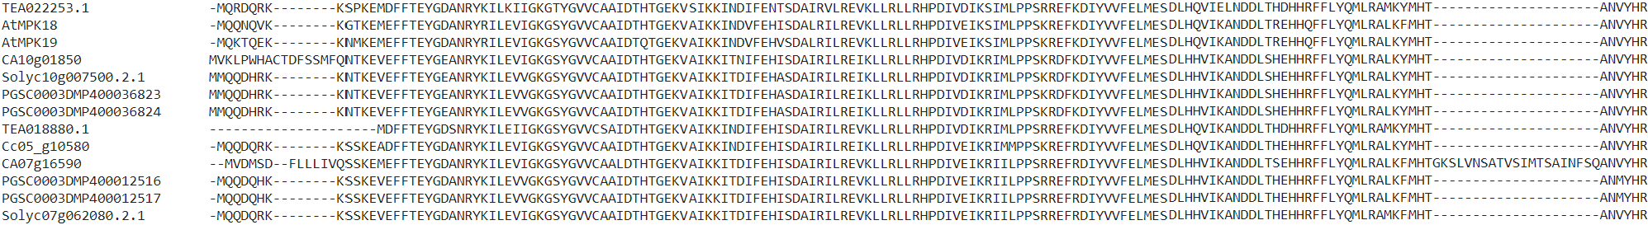
DLKPxN LxNxNCxLKIxDFGLAR TRWYRAPEL
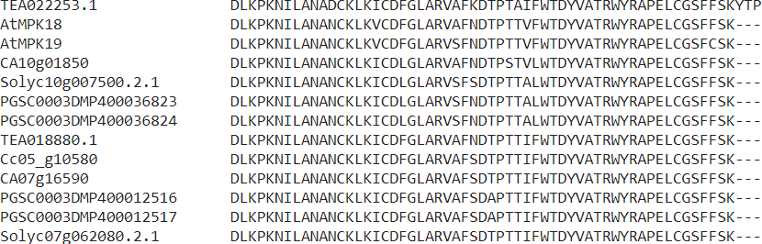
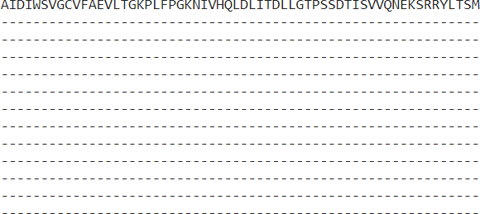
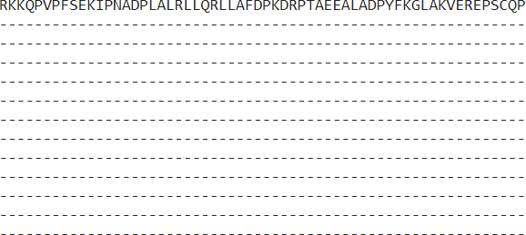

IDxWS^{V} GC
I
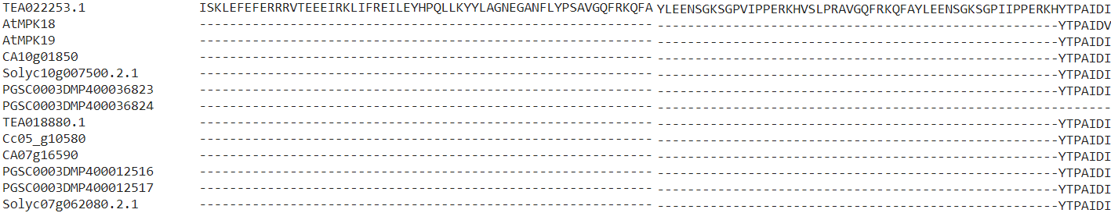
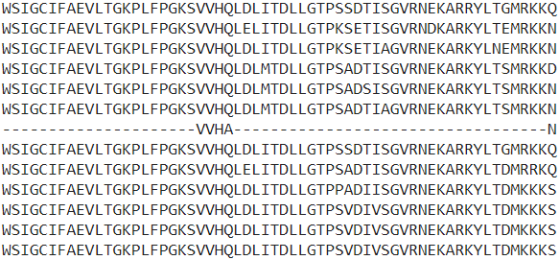

LLE^{R}KLLAFDPKDRPTAEEAL
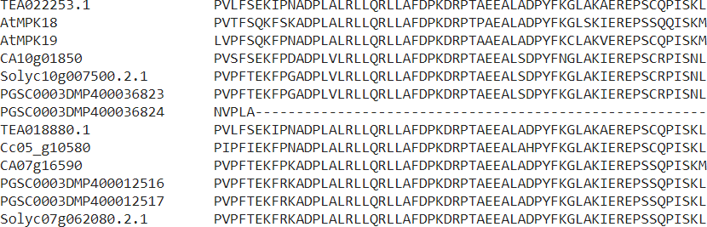
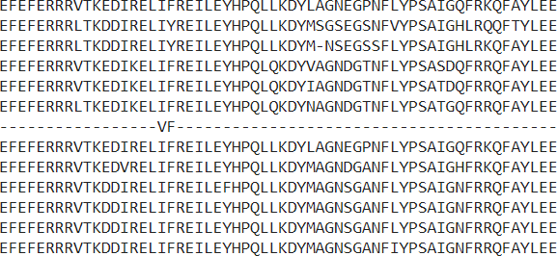
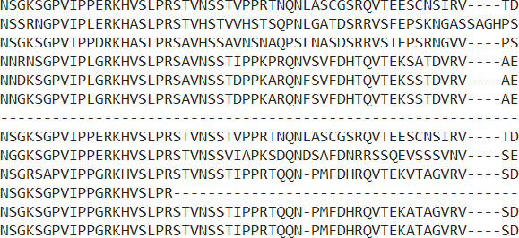

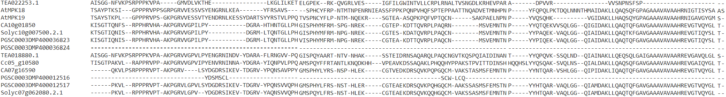

Clade G

IGxGxYGxV IKKIxxxF

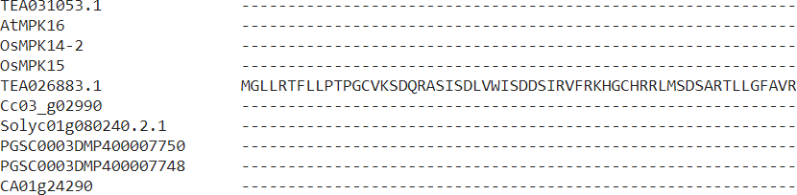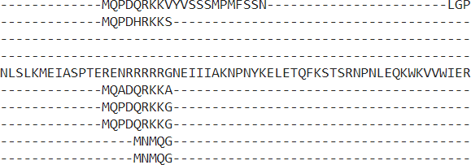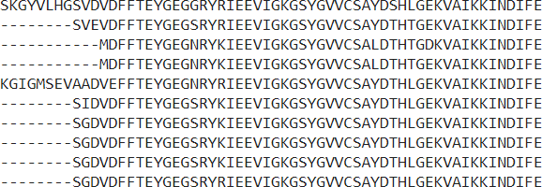

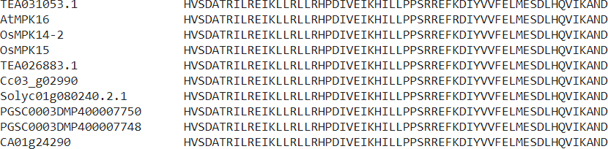
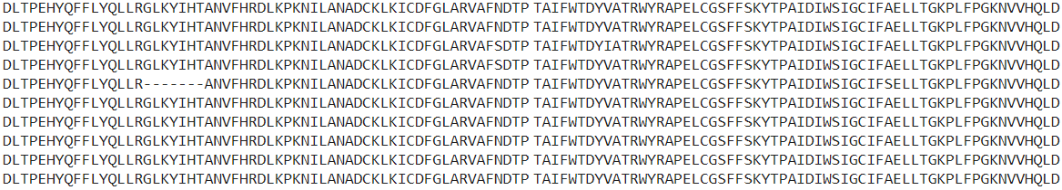
DAxRxLRE FxDIYxxxELM DLxxVI QxLRxLKYxH HRDLKPxN LxNxNCxLKIxDFGLAR TRWYRAPEL IDxWSVIGC

LLE^{R}KLLAFDPKDRPTAEEAL
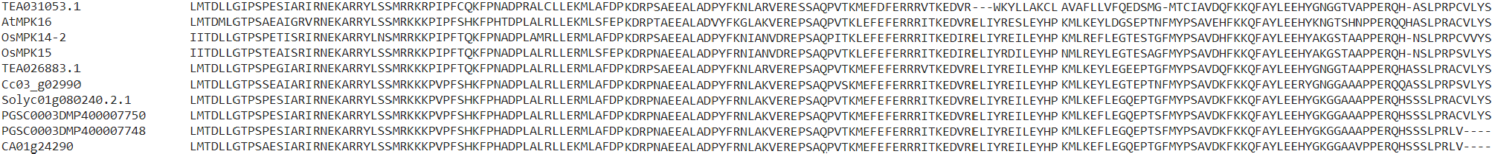

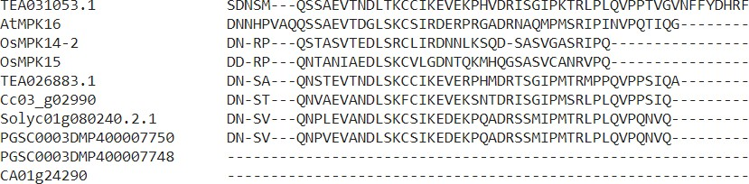
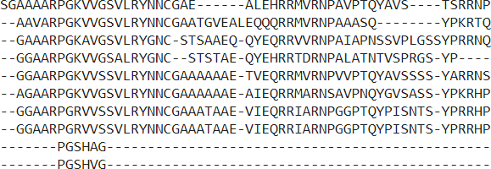
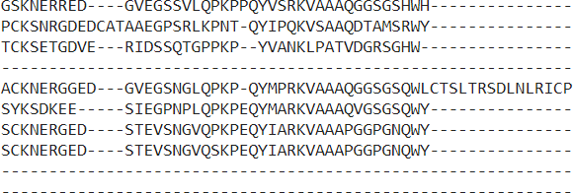

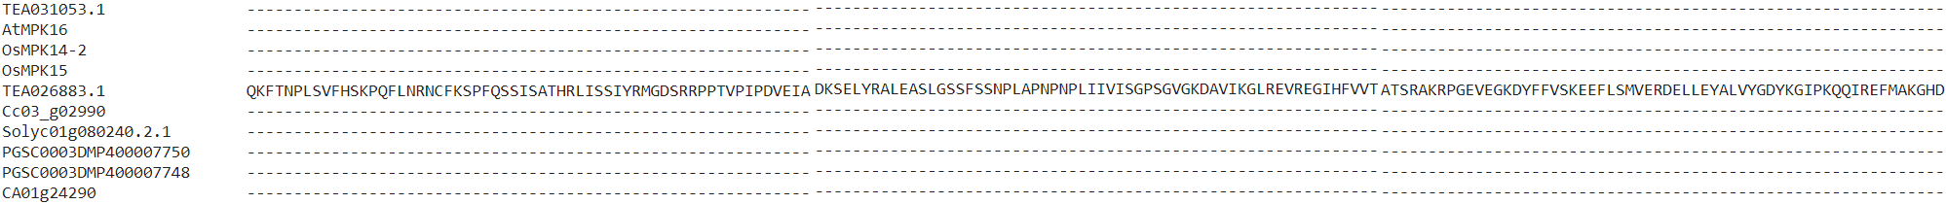

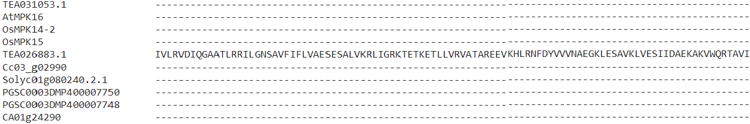

Clade H

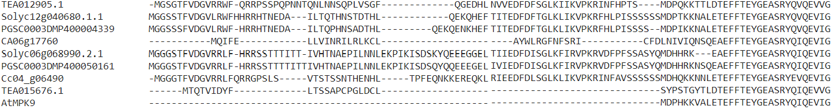
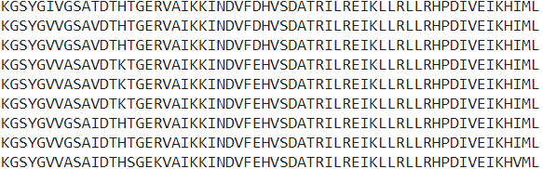
IGxGxYGxV IKKIxxxF DAxRxLRE

FxDIYxxxELM DLxxVI QxLRxLKYxH HRDLKPxN LxNxNCxLKIxDFGLAR TRWYRAPEL IDxWS^{V} GC
I

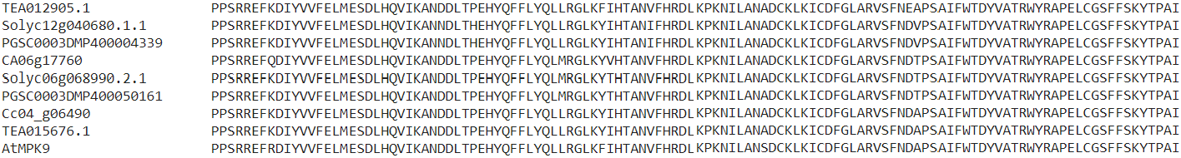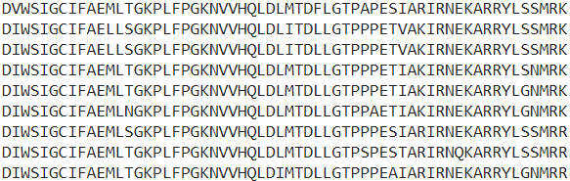

LLE^{R}KLLAFDPKDRPTAEE AL
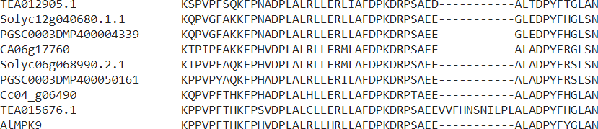
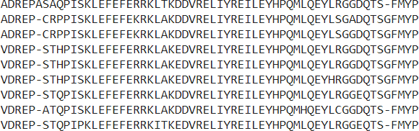
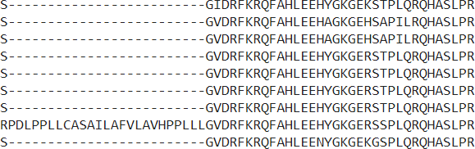

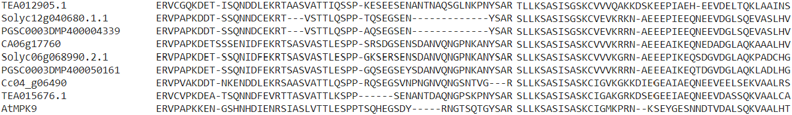

Clade I

IGxGxYGxV IKKIxxxF DAxRxLRE F

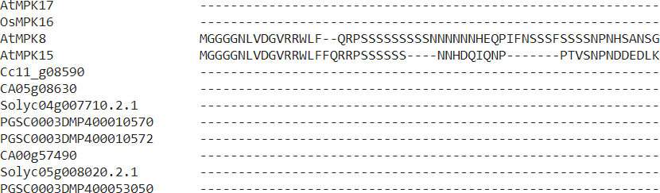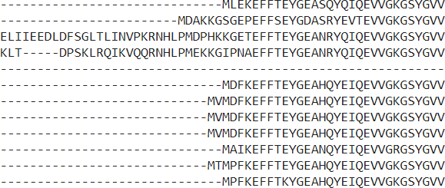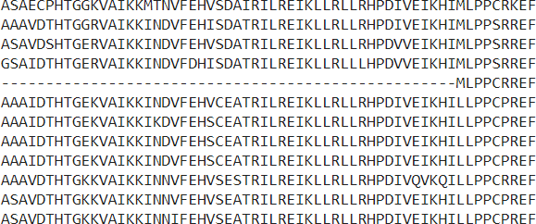

xDIYxxxELM DLxxVI QxLRxLKYxH HRDLKPxN LxNxNCxLKIxDFGLAR TRWYRAPEL IDxWS^{V} GC
I
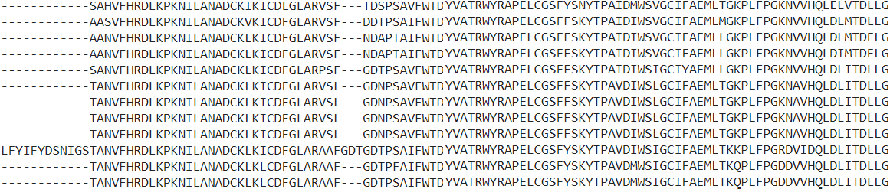
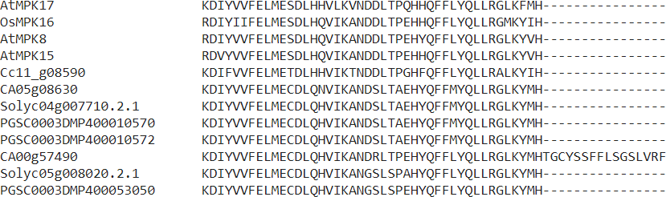

LLE^{R}KLLAFDPKDRPTAEEAL
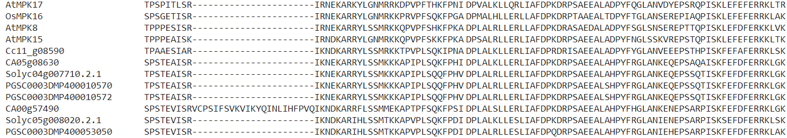
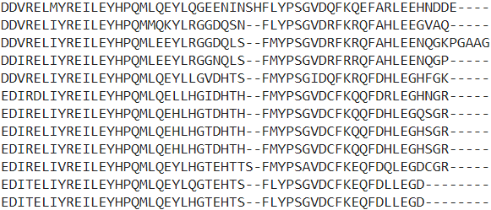

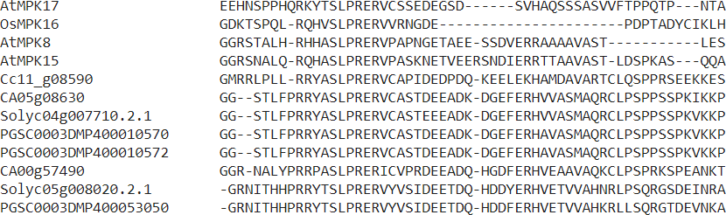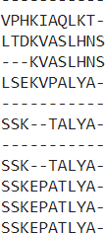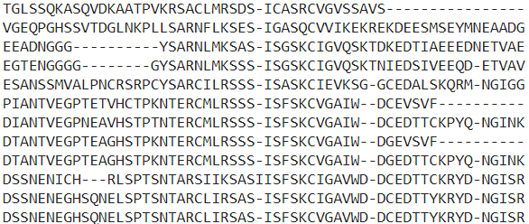

Clade J

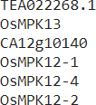

VI QxLRxLKYxH

IGxGxYGxV IKKIxxxF DAxRxLRE FxDIYxxxELM

HRDLKPxN LxNxNCxLKIxDFGLAR TRWYRAPEL IDxWS^{V} GC
I

LLE^{R} LLAFDPKDRPTAEEAL
K

DLxx

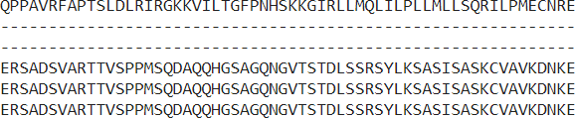
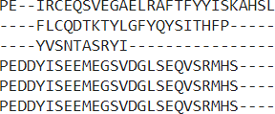

Supplementary Fig. S7 Alignment of domains in MPKs. All the MPK protein sequences were subjected to alignment by MUSCLE tool owing to their sequence diversities. Sequences that are highlighted are ATP binding signature, marked in blue, the catalytic C loop, marked in light red colour, the activation T loop, marked in green colour, CD domain, marked in light blue colour. Clades D to J show sequence derivations from the T(E/D)Y activation loop and are marked in a lighter shade of green colour.

