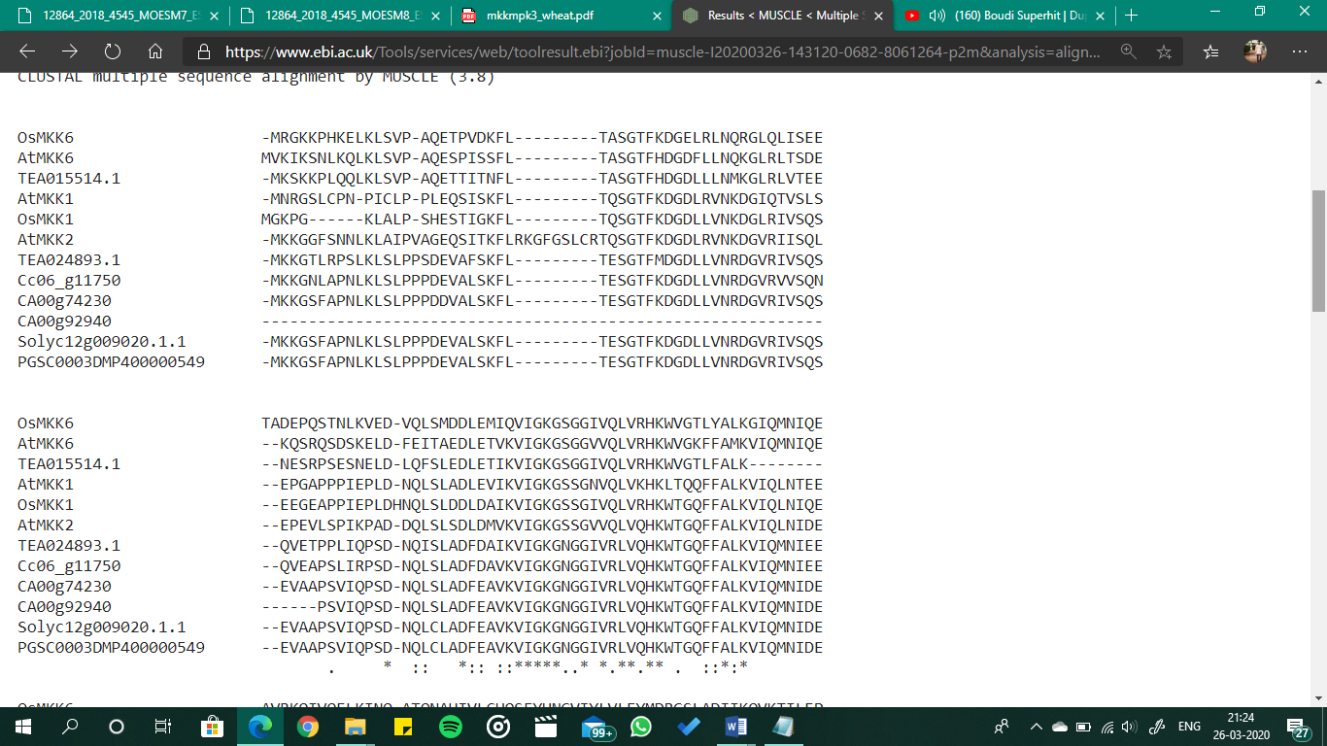
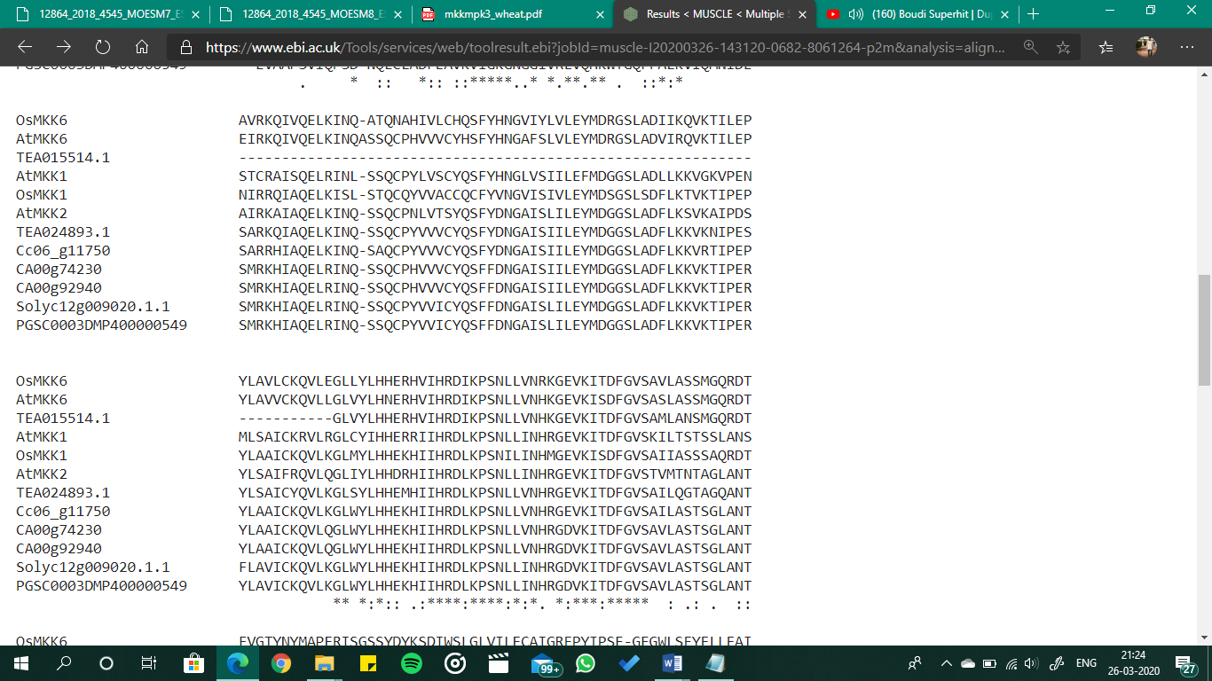
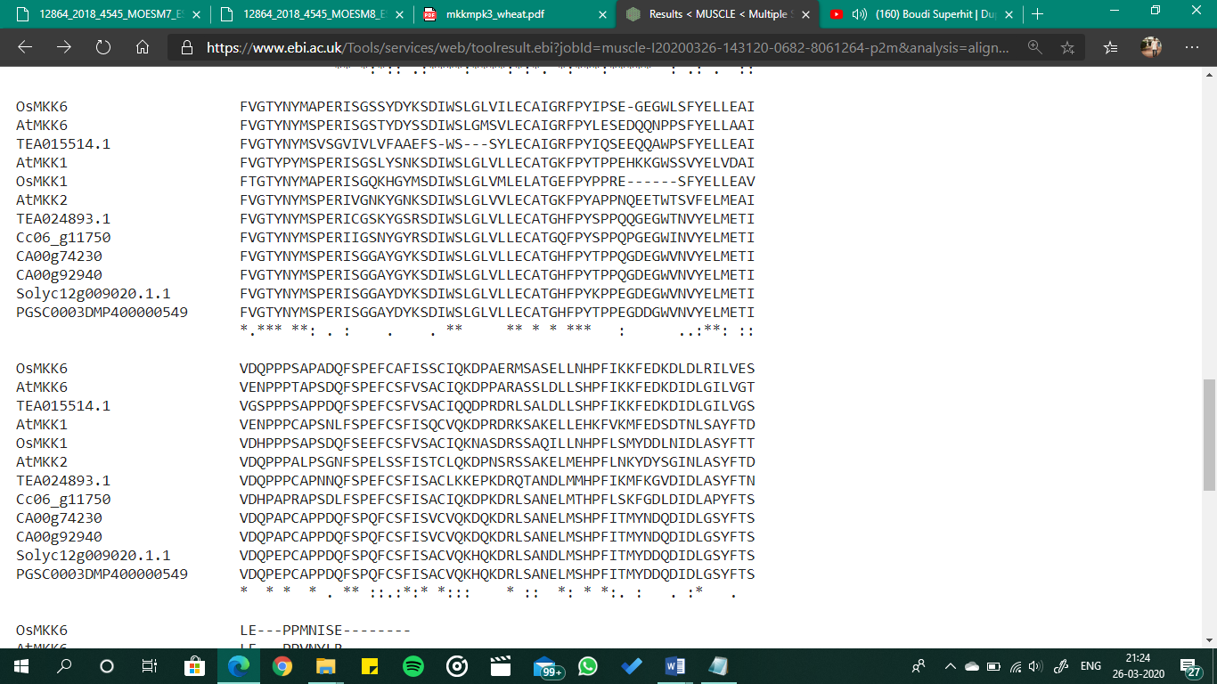
Additional MKK domains
Clade A f
GxGxxG
DΨK

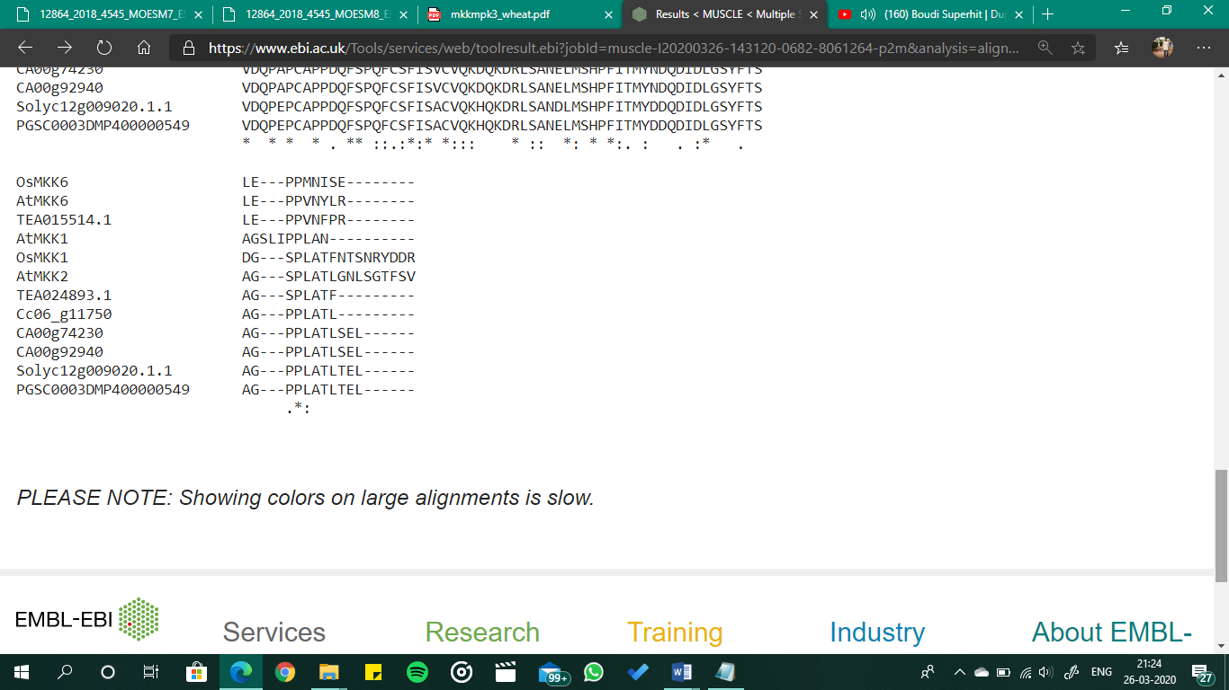
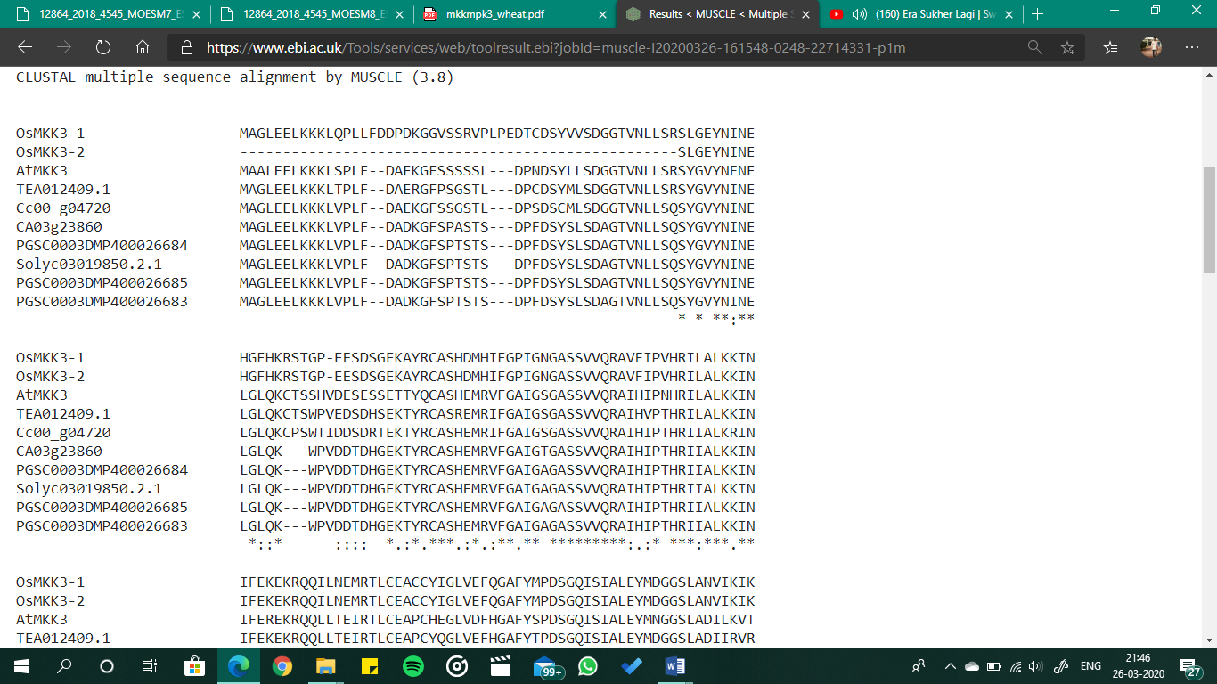
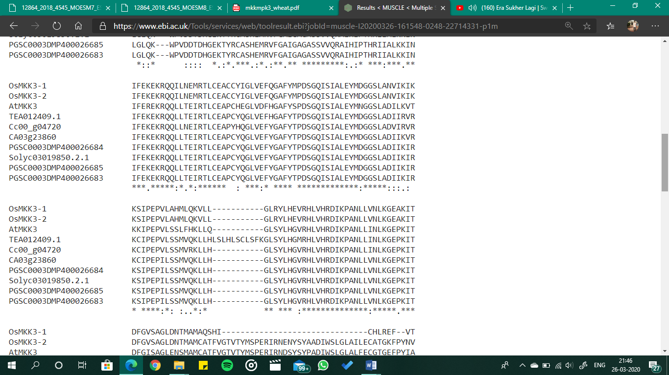
Clade B f
GxxGxG
DΨK

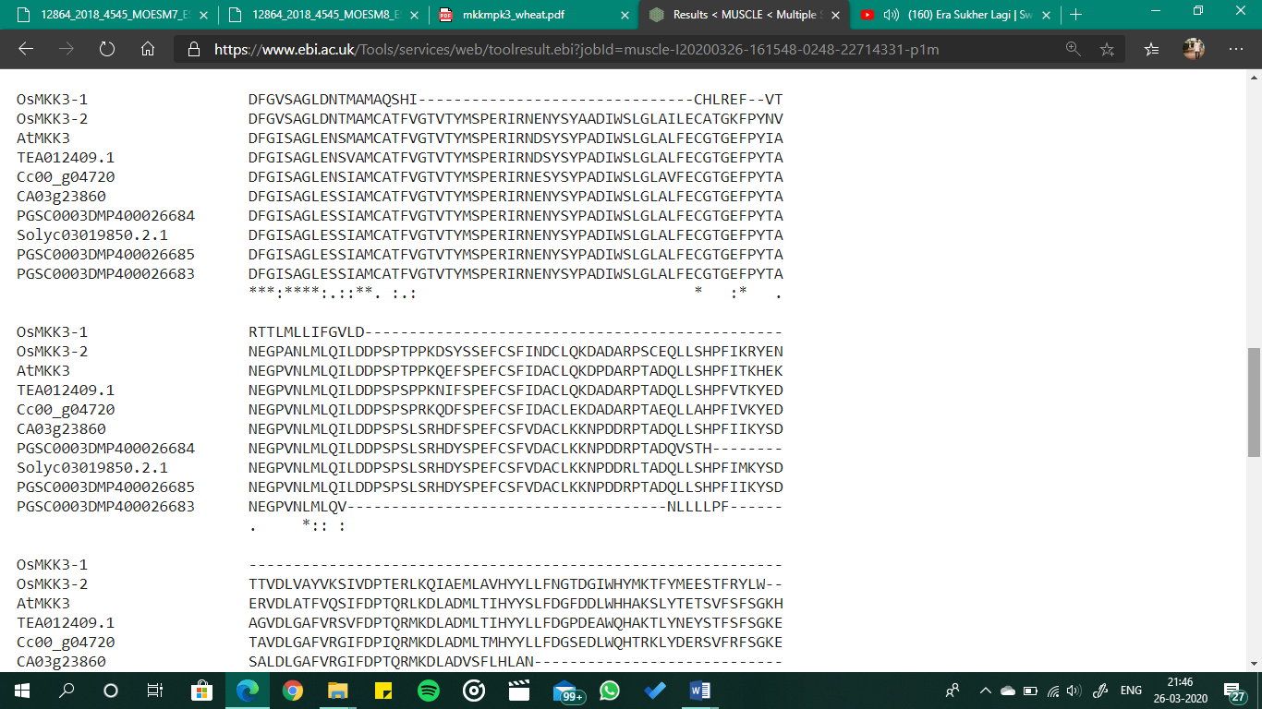
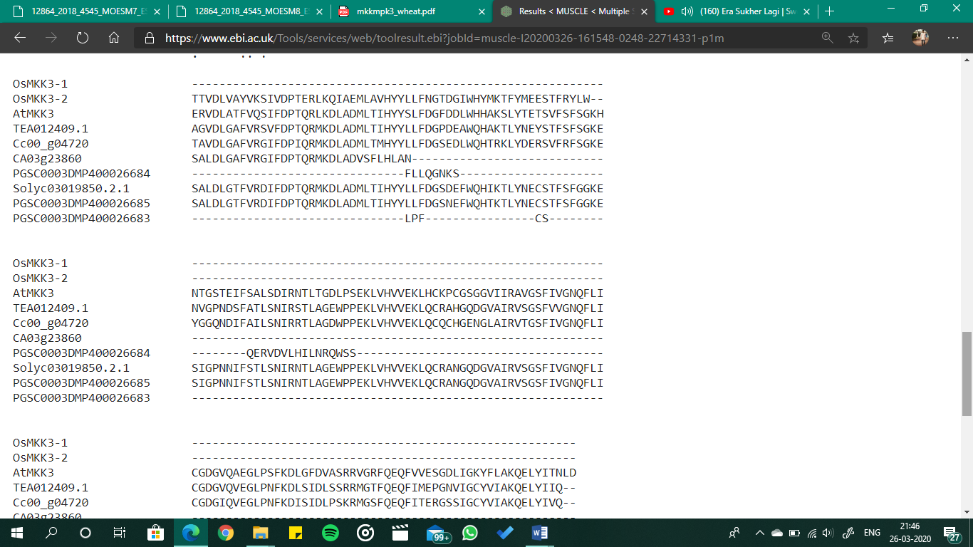
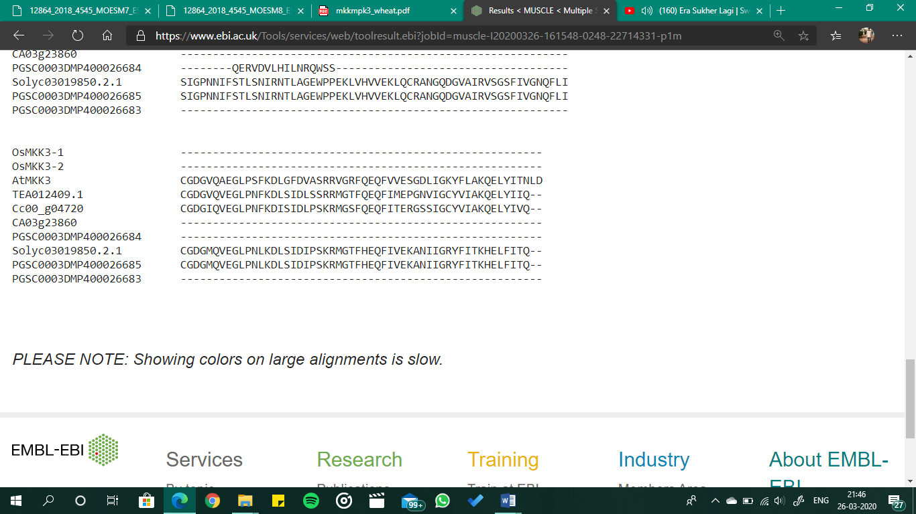

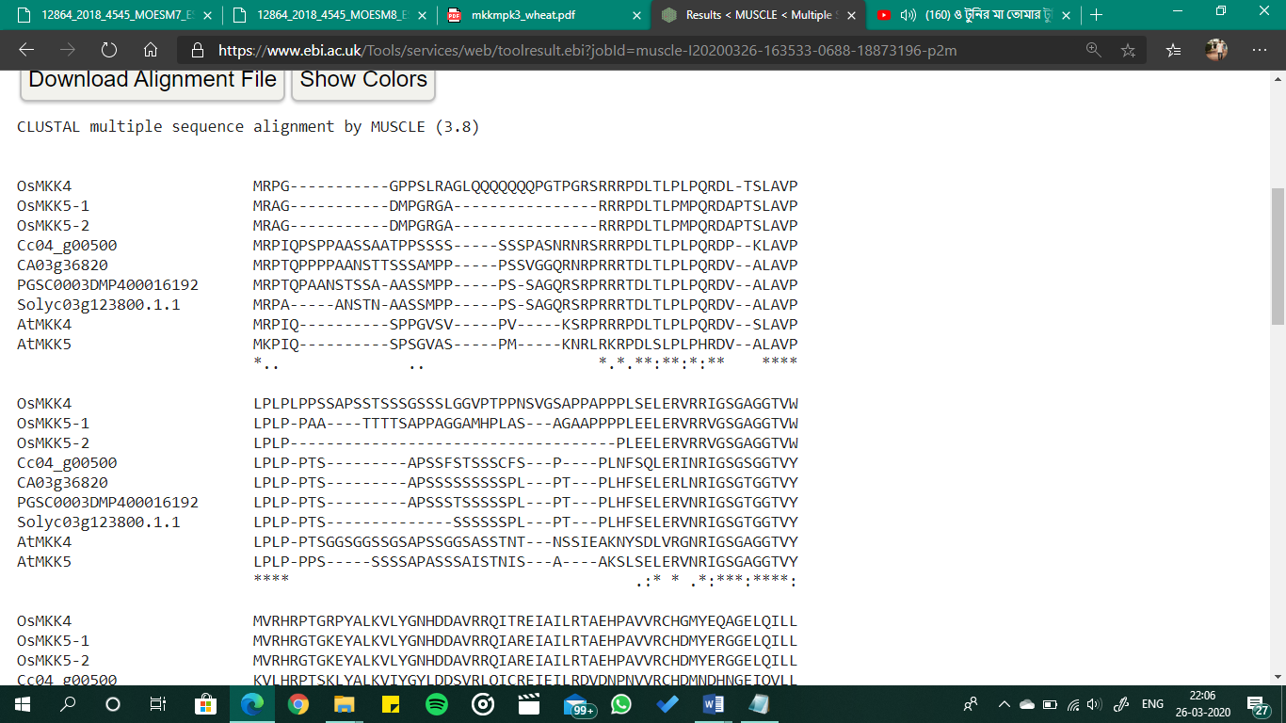
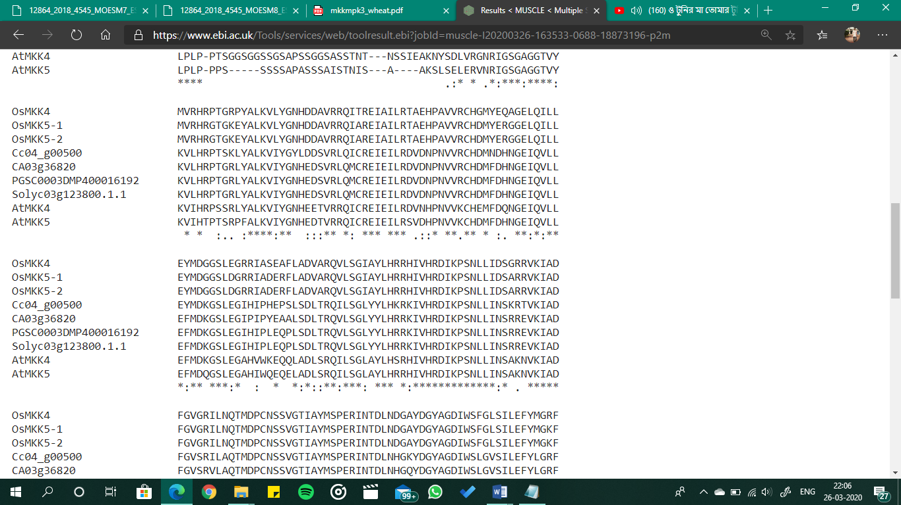
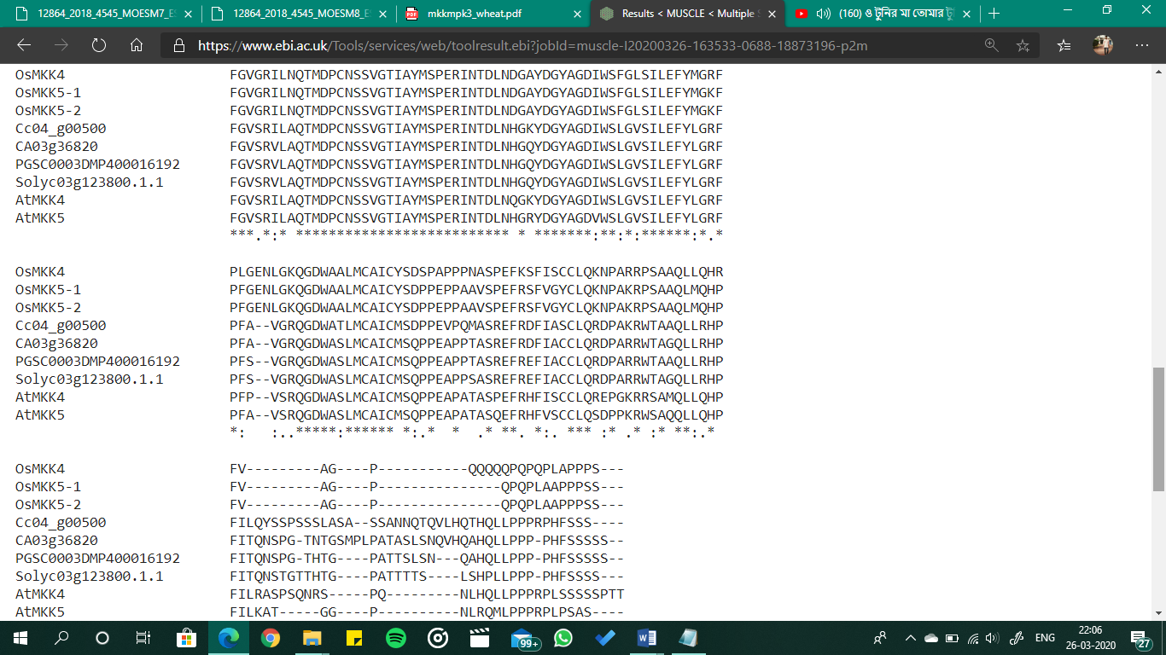
Clade C f
GxGxxG
DΨK

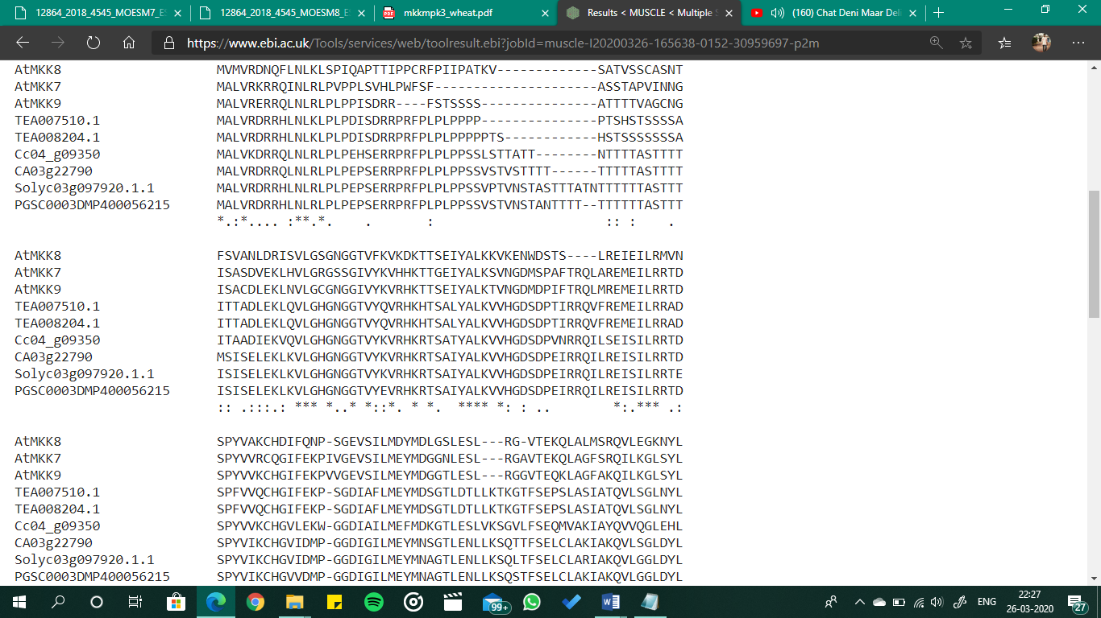
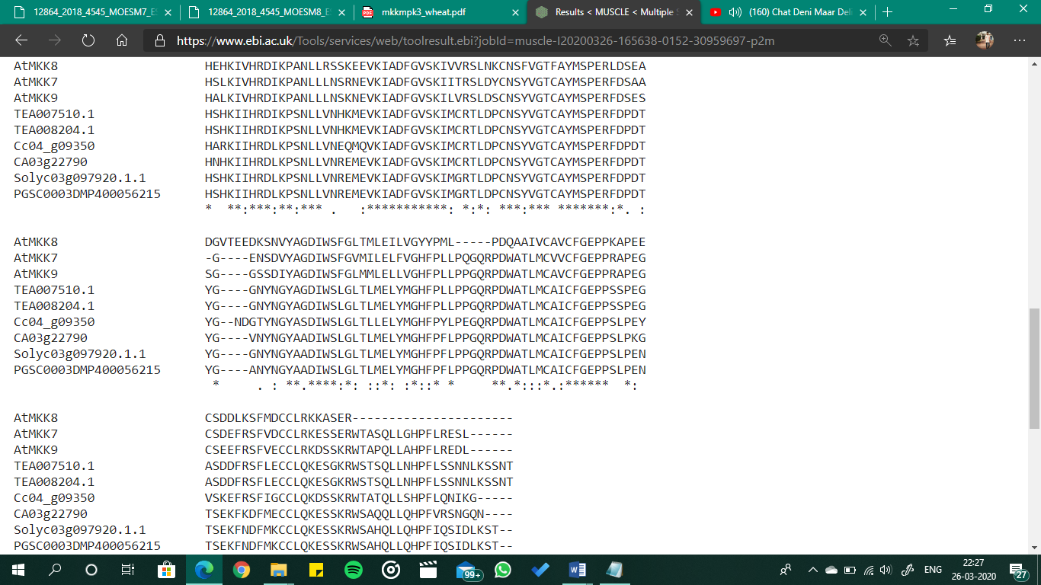
Clade D f
GxGxxG
DΨK

Supplementary Fig. S8 Alignment of domains in MKKs. All the MKK protein sequences were subjected to alignment by MUSCLE tool owing to their sequence diversities. Sequences that are highlighted are ATP binding signature, marked in blue that consists the P loop consensus sequence (GxGxxG), the catalytic C loop, marked in light red colour that consists the DΨK consensus, the activation T loop, marked in green colour and NTF2 domain marked in greyish colour. Clade C and D show sequence derivations from the S/TxxxxxS/T activation loop and are marked in a lighter shade of green colour.

